The Archaeology of Early State
in Italy: New Data and Acquisitions
Alessandro Guidi
Università di Roma Tre
Abstract
During the last five years, many new data have contributed to
a better definition of the problem of State emergence in protohistoric Central and Northern Italy, especially in the fields of settlement, organization and ritual.
In the north-east of the Italian peninsula researches in Oppeano and Baldaria and recent excavations in Este and Padua are drastically changing our perception of the emergence of the cities in these regions. In terms of ritual data from Etruria, Latium and North-Eastern Italy support the idea that alongside cult activities performed by some male and female members of the élite, there is evidence of some peculiar deposition determined by an archaic corpus of laws.
The paper explores all these new perspectives and the most recent studies of the problem of ethnicity and the interpretation of primitive art objects. All the new data confirm and better define
the picture already given in my preceding articles on this subject.
FOREWORD
At 2004 ‘Hierarchy and Power’ congress I presented a paper (later published in Social Evolution & History) that intended to be
a complete review of the archaeological record of early state formation in Central and Northern Italy (Guidi 2006). Many things changed from then: recent discoveries, researches and studies help us to consider the problem under a new light (some data already in Guidi 2008a).
Carefully examining the new data we see that the number of sites in which we can recognize protourban centres of the Early Iron Age has largely increased; besides, we now can add to the three items treated in my previous paper (settlement, burials and religion) the evidence for other three fields of enquiry – art, law and ethnicity – crucial in the transition from protourban to urban phase.
Before going into details we must also remember that new and important adjustments were made also (notwithstanding a wide and rough debate) in the absolute chronology (for a diagram comparing Italy, European and Aegean sequences see Table 1): the beginning of the Iron Age is established, by many scholars, around the middle of the 10th century BC, while the boundary between Early Iron Age 1 and 2 can now be fixed in the second half of the 9th century BC (Bartoloni and Delpino 2005).
Table 1
Compared chronology between Italy, Central Europe and the Aegean
 | ITALY | CENTRAL  EUROPE | AEGEAN
1700 | Middle Bronze Age 1 | Bronzezeit B 1 | Middle Helladic
1700 | Middle Bronze Age 1 | Bronzezeit B 1 | Late Helladic I
 | Middle Bronze Age 2 | Bronzezeit B 2 | Late Helladic II
1350 | Middle Bronze Age 3 | Bronzezeit C | Late Helladic III A
 | Recent Bronze Age | Bronzezeit D | Late Helladic III B
1200 | Recent Bronze Age | Hallstatt A1 | Late Helladic III C
 | Final Bronze Age 1 |  | Late Helladic III C
 | Final Bronze Age 1 |  | Submycaenean
 | Final Bronze Age 2 | Hallstatt A2 | Submycaenean
950 | Final Bronze Age 3 | Hallstatt B1 | Protogeometric
850 | Early Iron Age 1 | Hallstatt B2/3 | Early Geometric
850 | Early Iron Age 1 | Hallstatt B2/3 | Middle Geometric
730 | Early Iron Age 2 | Hallstatt C1a | Late Geometric
625 | Early Iron Age 3 | Hallstatt C1b/2
525 | Early Iron Age 4 | Hallstatt D

Besides, as a proof of an ever growing interest in this debate,
a very interesting article on simulation models for the emergence of the state in Etruria was published in late 2004 (Cecconi et al. 2004).
The authors studying a long period from 2200 to 730 ca. a.C. demonstrate the importance of a high defensive potential for
the settlements of the Bronze and the Early Iron Age, especially in the transition to the protourban phase. Subdividing the southern Etruria territory in settlement cells (that with defended areas weighting more than the others) they simulate the gradual increase of percentage of defended sites (Fig. 1, black line), a figure astonishingly similar to that derived from real data (Fig. 1, grey line); also the major protourban centres' areas of influence designed with this method show that they are similar to the territories known from the written sources (Fig. 2).
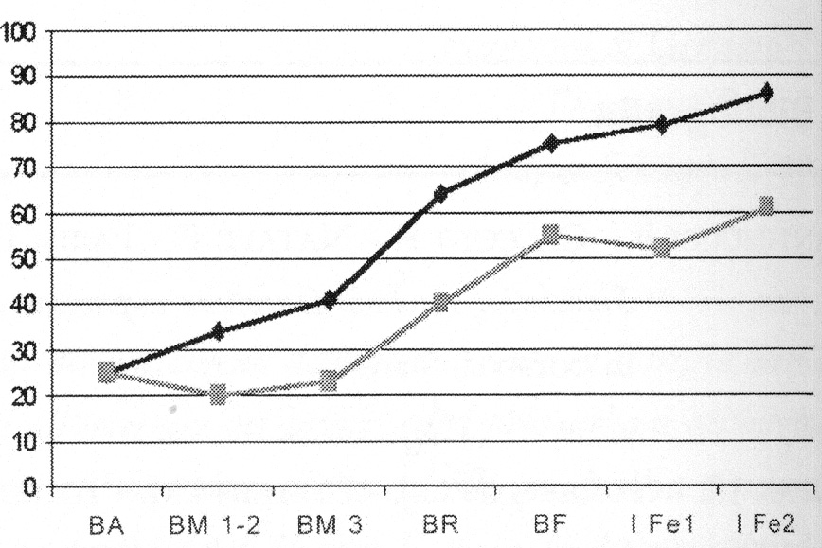
Fig. 1. Etruria: number of defended sites from the Early Bronze Age (BA) to the Early Iron Age (Fe). Black line = simulation; grey line = real data (from Cecconi et al. 2004)
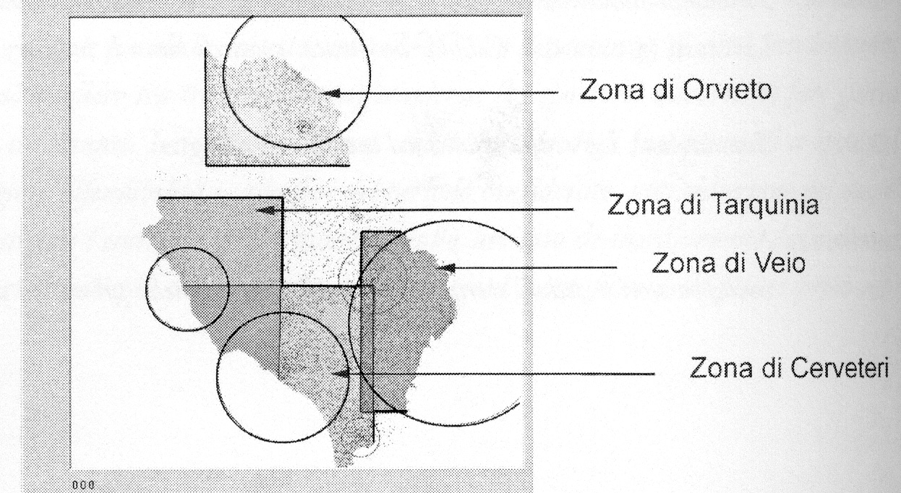
Fig. 2. Etruria: reconstruction, from simulation data, of single protourban centres territories data (from Cecconi et al. 2004)
SETTLEMENT
We know new data on the diffusion of Villanovan pottery on
the Veii plateaux thanks to the recent revision of pottery found in the Ward-Perkins survey in the Sixties (di Gennaro, Schiappelli, and Amoroso 2004). A recent excavation at Campetti, always in Veii, brought to the light a sector of the earlier defence walls of the city, a rampart made by stones mixed with earth dated the first half of the 8th century BC (Boitani, Neri, and Biagi 2007–2008).
At the same time, the studies conducted by Phil Perkins at Doganella and recent surveys and excavations directed by Andrea Zifferero in Marsiliana D'Albegna (two sites located near Grosseto in the ancient territory of Vulci) demonstrated the existence of big 100 ha centres also in the early historical periods (Perkins and Walzer 1990; Camilli et al. 2006).
Thanks to Francesca Fulminante (Fulminante n.d.) we now have a careful reconstruction of the process that carried Rome to begin a big protourban centre in the Early Iron Age, a real synoecism between at least two big villages (Quirinal-Capitol and Velia-Palatine) that carried to a unified centre of more than 200 ha; moreover, the excavations by Andrea Carandini on the Palatine northern slopes allowed us to identify in the urban phase the first Domus Regia (the king's palace) (Carandini 2007) (Fig. 3).
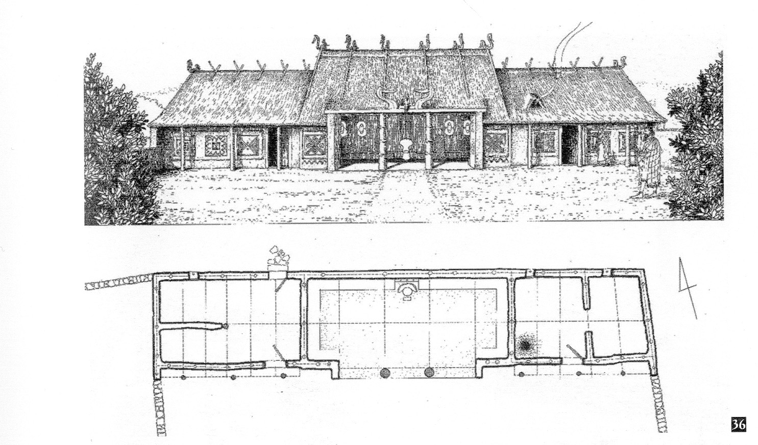
Fig. 3. Reconstruction of the plan (below) and layout of the Domus Regia (from Carandini 2007)
For the question of a ‘secondary’ diffusion of the urban model
I have recently studied the area located immediately southeast of the ancient Latium (Fig. 4) characterized by big centres of 40–60 ha (the big dots) of the Early Iron Age: it is now possible to identify at least five smaller (20–30 ha) and later (the end of the 8th – the beginning of the 7th century) protourban centres (the little dots) coinciding with the cities of the literary tradition (Guidi 2007).
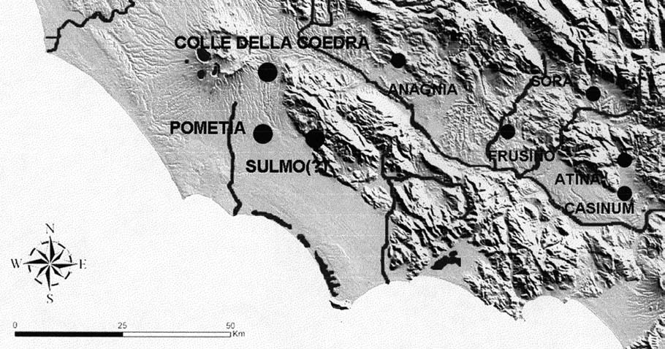
Fig. 4. Southern Latium. Big dots = earlier (the 9th–8th cent. BC) protourban sites. Little dots = later (the end of the 8th–7th cent. BC) protourban sites
In North-Eastern Italy where the size of some Final Bronze Age sites like Montagnana (it is not still clear if it is a really unitary centre) seems incredible (60 ha), my survey on the protourban site of Oppeano allowed to demonstrate how it was completely occupied (80 ha) already in the very beginning (Early Iron Age 1) of the Iron Age (Guidi 2008b).
It is possible to perceive a similar trend toward an earlier dating also for the major centres of Este and Padua.
In the first case thanks to the data of new emergency excavation we now know many other aspects of the internal structure including various levels of the city fortification and a road leading to a peer in correspondence with the river surrounding the settlement (Balista and Ruta Serafini 2008). A synthesis book published in 2005 on pre-roman Padua was the occasion for a general reconsi- deration of all the data including a suggestive computer-graphic reconstruction of the city and its cemeteries (De Min et al. 2005).
Thanks to the surveys conducted in Baldaria (Fig. 5) in occasion of some emergency excavations it was also possible to reconstruct a 100 ha area for this 8th century protourban centre (Rossi 2005).
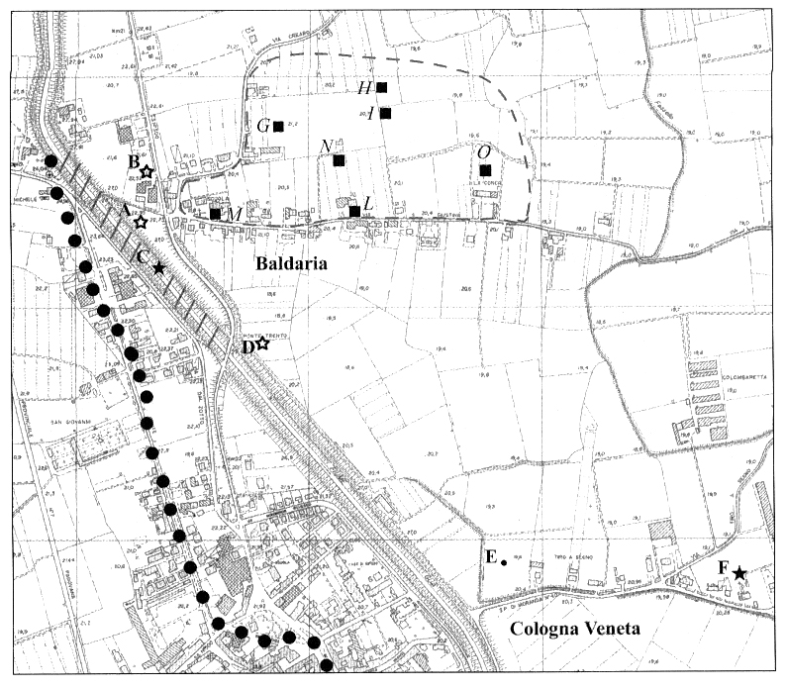
Fig. 5. Cologna Veneta: the hatched line represents the protourban site extension (from Rossi 2005)
The new data allow us to make some preliminary observations (see Guidi 2008a) on the change in settlement pattern between the protourban and the urban phase.
A first set of hypotheses can be proposed for the emergence and development of the protourban phase.
a) Type of formation process.
We can observe:
– progressive growth of the centre (Caere, Tarquinia, Bisentium, Latium Vetus, Como, Oppeano, Oderzo, Ancona?);
– displacement between Final Bronze Age 3 and Early Iron Age 1 from a little site to a big adjoining centre (Veii, Este);
– the incorporation of neighbouring sites in a big centre (Vulci, Castelletto Ticino, North-Eastern Italy);
– synoecism (Rome);
– colonization from another protourban centre or from more adjoining protourban centres (Campania, Verucchio, Bologna, Fermo?);
– consequence of Centre/Periphery relationships (Sabine, Friuli/Slovenia, Southern Latium).
b) Beginning of the process.
Three different periods seem to be interesting:
– Final Bronze Age 3 (Etruria, Lavinium, Este, Oppeano);
– Early Iron Age 1 and 2 (Latium Vetus, Castelletto Ticino, Oderzo, Treviso, Padua, Campania, Verucchio, Bologna, Fermo?);
– Early Iron Age 3 and 4 (Sabine, Southern Latium, Altino, Cologna Veneta, Concordia, Palse, Friuli/Slovenia, Como).
c) Sites size range.
– 80/150 ha (Etruria, Rome, Campania, Este, Padova, Fermo?, Oppeano, Altino, Como, Castelletto Ticino, Cologna Veneta, Bologna);
– 40/60 ha (Latium Vetus, Ancona, Verucchio, Oderzo, Concordia, Treviso);
– 20/30 ha (Sabine, Southern Latium, Friuli/Slovenia, Concordia).
Another set of hypotheses can be proposed (only in cases in which the archaeological evidence was well studied) also for
the transition from the protourban to urban phase.
a) Type of transformation.
It is possible to observe three processes:
– Reorganization (Veii, Vulci, Caere, Campania, Sabine, Bologna, Verucchio, North-Eastern Italy);
– Growth/Expansion (Rome, Ardea, Gabii, Visentium);
– Contraction/Reduction (Tarquinia).
b) Age of transformation.
– the second half of the 8th century BC (Tyrrhenian Central Italy);
– the end of the 7th – the beginning of the 6th century BC (North-Eastern Italy).
BURIAL
It is now possible to reconsider (or criticize?) the idea of an egalitarian Villanovan society in the beginning of Early Iron Age 1.
The new data regard two classes of archaeological evidence:
1) the traditional graves; we can quote a rich warrior grave with a bronze cup from Tarquinia (Iaia 1999: 40–42) and the well-known rich female grave with Sardinian bronzes from Vulci, recently dated (Moretti Sgubini et al. n.d.) to the first part of Early Iron Age 1.
Not less impressing are the recently published fragments of alabaster vases from a grave in Tarquinia (Babbi et al. 2004).
2) the second class of findings regards two exceptional graves in Veii settlement area.
Under the already mentioned 8th century walls, in Campetti, inside an E.I.A. 1 hut, Francesca Boitani found a grave pertaining to an adult (35–40 years) female; the hut was associated with a complex pottery kiln, a fact probably to interpret as a clear allusion to
a social role of the woman, in the field of pottery production (Boitani, Neri, and Biagi 2007–2008).
Even more impressive is the grave excavated by Gilda Bartoloni in Piazza D'Armi, the acropolis of Veii.
Here in the centre of a hut a fossa containing the remains of
a 25–30 year-old man, C14 dated at the beginning of E.I.A. 1, was surrounded by post-holes. The reconstruction proposed is that of
a little hut-shaped ‘funerary chapel’ (Fig. 6) whose importance is confirmed by the superimposition of a later two rooms big hut. Gilda Bartoloni proposed the attribution of this grave to a member of the élite, perhaps the king of Veii Villanovan protourban centre (Bartoloni 2002–2003, 2007–2008).
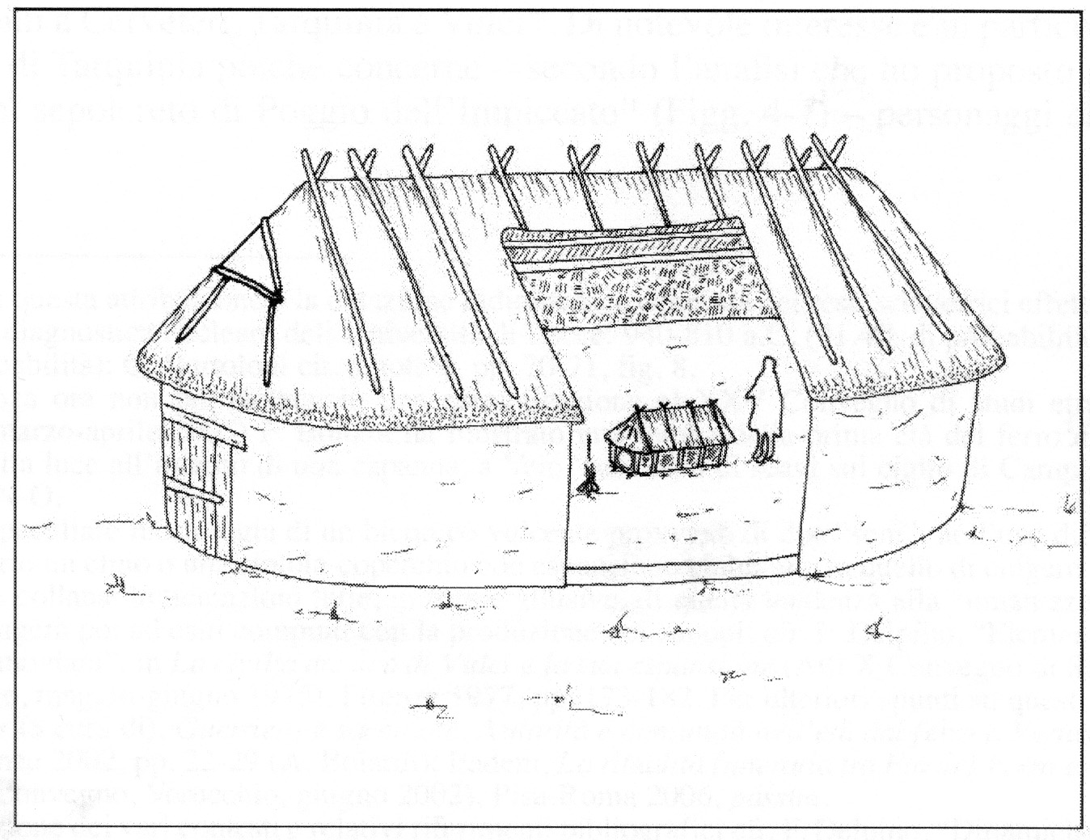
Fig. 6. Reconstruction of Veii male hut-burial (from Bartoloni
2007–2008)
RELIGION
In the field of archaic religion one of the main discoveries of the last years is the open air cult-site of the Final Bronze Age under
the well-known Diana sanctuary, in Nemi (Bruni 2009). The first protohistorical temples were huts of the second half of the 8th century BC (the period of transition to the urban phase), also these stagraphically covered by the archaic period temples: the latter were found in Lanuvium and in Velitrae, the present Velletri (Ghini and Infarinato 2009).
A precious work of reconstruction of the various phases of development of the Tarquinia sacred area was made by Maria Bonghi Jovino (2007–2008: 774–775; Fig. 3), while the Carandini's excavations in Rome gave the opportunity to locate the hut-shaped first temple of Vesta (second half of the 8th century BC) in the Forum (Carandini 2007) (Fig. 7).
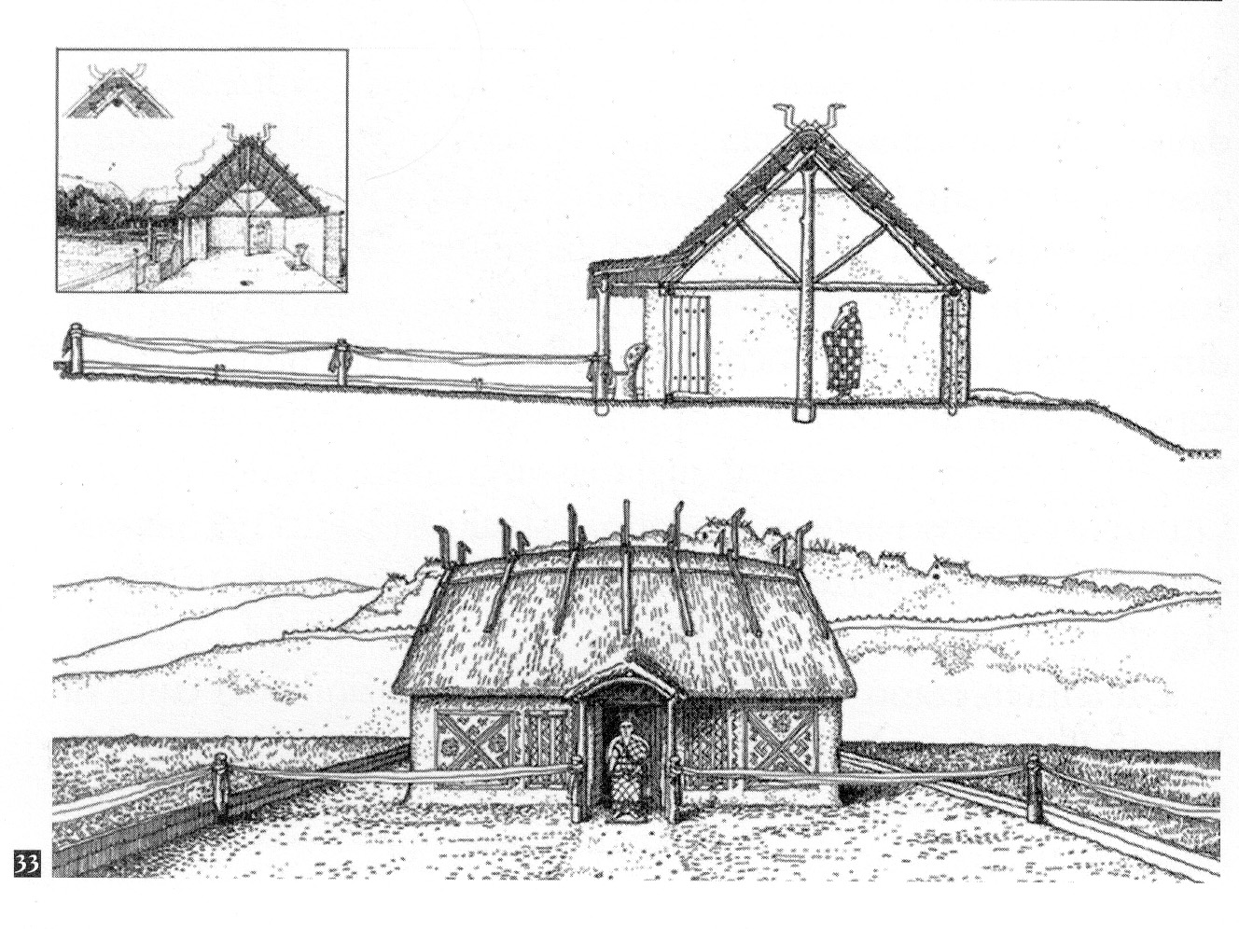
Fig. 7. Vesta temple: reconstruction (from Carandini 2007)

A recent publication by Andrea Babbi (2008) was the occasion to show many ‘ritual’ vases, whose presence in grave furnitures of Early Iron Age 1 clearly reveals a specific role of the deceased. New discoveries in the centre of Rome and in the countryside around the city allowed to fill the chronological ‘gap’ between Final Bronze Age 3 male burials with the miniature sacred shields (the ancilia of the Latin tradition) and the Veii warrior burial of
the end of the 8th century with the same shields, in natural size, thanks to new grave furnitures with miniature shields dated to Early Iron Age 1 (De Santis 2009, n.d.).
I have recently paid my attention to the class of female rich graves of the 8th century BC curiously located in the Latial settlements where normally only children were buried (Guidi 2007–2008).
The first example is the grave of a 18 year-old woman found in Ardea under the temple of Colle della Noce together with the protohistorical huts (probably also hut-temples) with a very rich furniture. The second is an equally rich grave of a young woman from Caracupa under the polygonal walls of a hilltop settlement and near an archaic votive deposition. Here the decoration with schematized men and women is often recurrent on the vases. Even more impressive is the presence of a kernos, again with a handle in the shape of a schematized human figure comparable with the already seen Villanovan vases.
The literary sources about Rome and Alba tell us that in these centres only the Vestals (a sort of archaic priestesses devoted to the cult of Vesta) had, among others, the privilege to be buried inside the pomerium. For this reasons I think these are graves of Vestals, again typical of a period of transition to the urban phase with
the definitive birth of a sort of State religion.
ART
Another crucial evidence of the early urban period is the appearance of an artistic production, generally with the aim to glorify the élites. The famous cult wagon from the rich female tomb of Bisenzio was defined, more than 10 years ago by Mario Torelli, as a sort of incunabulum of the early Etruscan aristocracy (Torelli 1997).
The crowd of bronze figurines seems to recall many concepts and moments of the aristocratic way of life, the house and the family, the war and the hunting activities. Recently Michele Cupitò has made an iconographic analysis of these figurines interpreting them on the ground of the opposition between domestic and wild animals as a metaphor of different economic activities or even of the subdivision of land around the city between agricultural areas and pastures, or even woodlands (Cupitò 2003, 2005). The same role in the Venetian territory in the 7th – 6th century BC can be attributed to the well-known Situlenkunst (art of the situlae).
Luca Zaghetto has studied the iconography of these bronze vessels proposing to break down single motifs and images as words or phrases made by single words to build a sort of syntax arriving to detect a typology of representations using it to reinterpretate famous art objects as situlae or bronze lids as complex scenes of
the aristocratic way of life (Zaghetto 2002).
LAW
The reinterpretation of the old data and the new discoveries allowed to identify in the centre of Rome two examples of ritual killing and deposition of people. One is the case of the male, female and child graves in the area of Equus Domitiani in the Forum stratigraphically datable in the second half of the 8th century BC, the other three similar skeletons in the Carcer Mamertinus interpreted by Mario Torelli as a ritual of extermination (Filippi 2007–2008; Torelli 2007–2008).
True capital punishments are documented also in the late 8th century phase sacred area of Tarquinia where a serious anthropological analysis by Francesco Mallegni helps us to reconstruct the successive stages of the killing of a 30–35 year-old man while the careful examination of a 8 year-old child skeleton lacking the skull allows to understand that he was beheaded (Mallegni and Lippi 2007–2008).
In North-Eastern Italy in the 6th century BC we have an analogous evidence particularly in the case of the few inhumations documented in the graveyards: one of them is a grave from Gazzo with an individual buried prone (Salzani 2008: 55–56; Fig. 5). I found
a similar evidence in Oppeano settlement area where a 35–40 year-old man was found in a similar prone position in the fillings of
a big hollow (Guidi, Candelato, and Saracino n.d.).
It is clear that in all these cases we deal with capital punishments that suggest the existence of a corpus of laws, another typical characteristic of the mature early state.
ETHNICITY
More than 50 years ago Massimo Pallottino noted an almost perfect equivalence between the diffusion of the prohistorical cultures and the corresponding languages a fact that later allowed other scholars like Adriano La Regina to propose reconstructions of the territory pertaining to the different Italic ethne (La Regina 1970).
As a matter of fact, ethnicity is one of the main characteristics of complex societies and it is possible to see it very well in the archaeological record of protohistorical Italy as we can see also in the recent proposal of reconstruction of the territories of the ethne
in the Abruzzi region by D'Ercole (Copersino and D'Ercole 2005) based on the data gathered in the Iron Age cemeteries (Fig. 8).
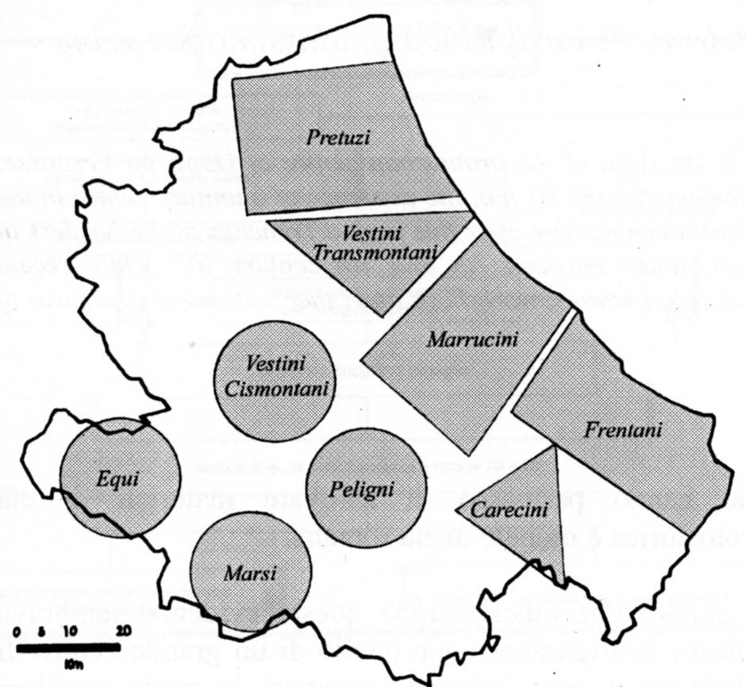
Fig. 8. Abruzzi: schematic reconstruction of ancient ethne territories
(from Copersino and D'Ercole 2005)
Another example is the definition by Piercarlo Innico of the ceramic shapes typical of the Volscan culture whose diffusion in
the 7th century not by chance coincides with the territories of the protourban centres in the area located immediately southeast of
the ancient Latium (Innico 2006).
Ethnicity allows us to individuate in the Iron Age cemeteries groups of graves with allochtonous material, the archaeological correlate of real movements of people, as in the case of the diffusion of material pertaining to a human group coming from southern Italy in the Early Iron Age 1 phase of the Latial necropolis of Osteria dell'Osa (Bietti Sestieri and De Santis 2004).
CONCLUSION
It is time to think over an explanation for the birth of the State in our country finally divorced by the old idea of a diffusion of the new social organization from more advanced populations (Greeks? Phoenicians?). The archaeological evidence points toward a totally internal process that occurred between the end of the Bronze Age and the first two centuries of the Early Iron Age in many parts of Central and Northern Italy.
The task for the future will be the verification of this hypothesis through small or medium-scale territorial projects, the only possibility to see the process in its formative, mature and advanced/terminal phases. Only in this way the problem of relationships with other populations will deal with trying to individuate all the real influences that in many fields (specially the ideological one) these contacts brought to pre-roman Italy.
REFERENCES
Babbi, A.
2008. La piccola plastica fittile antropomorfa dell'Italia antica dal Bronzo finale all'orientalizzante. Pisa: Fabrizio Serra Editore.
Babbi, A., Testa, G., Barbieri, M., and Cancellieri, S.
2004. Un vaso in pietra con immagine antropomorfa dalla necropoli delle Arcatelle di Tarquinia. Considerazioni storiche, archeologiche e mineralogiche. In Acts of the 6th meeting ‘Preistoria e Protostoria in Etruria’ (Valentano, 2002) (pp. 351–369). Milano.
Balista, C., and Ruta Serafini, A.
2008. Spazi urbani e spazi sacri a Este. In I Veneti Antichi. Novità e aggiornamenti (Atti del Convegno di Studio, Isola della Scala, 2005). (pp. 79–100). Varie: Cierre Edizioni.
Bartoloni, G.
2002–2003. Una cappella funeraria al centro del pianoro di Piazza d'Armi – Veio. Annali di archeologia e storia antica, n. s. 9–10: 63–78.
2007–2008. La sepoltura al centro del pianoro di Piazza d'Armi-Veio. Scienze dell'Antichità 14(2): 821–832.
Bartoloni, G., and Delpino, F. (eds.)
2005. Oriente e Occidente. Metodi e discipline a confronto. Pisa-Roma: Istituti Editoriali e Poligrafici Internazionali.
Bietti Sestieri, A. M., and De Santis, A.
2004. Elementi per una ricostruzione storica dei rapporti fra le comunità delle regioni tirreniche centro-meridionali nella I età del ferro. Analisi di affinità e differenze di cultura materiale e sviluppo socio-politico fra la ‘cultura delle tombe a fossa’ in Calabria e Campania e la cultura laziale. In Atti XXXVII Riunione dell'Istituto Italiano di Preistoria e Protostoria (pp. 587–615). Firenze: Istituto Italiano di Preistoria e Protostoria.
Boitani, F., Neri, S., and Biagi, F.
2007–2008. La donna delle Fornaci di Veio-Campetti. Scienze
dell'Antichità 14(2): 833–868.
Bonghi Jovino, M.
2007–2008. L'ultima dimora. Sacrifici umani e rituali sacri in Etruria. Nuovi dati sulle sepolture nell'abitato di Tarquinia. Scienze dell'Antichità 14(2): 771–793.
Bruni, N.
2009. Testimonianze protostoriche al santuario di Diana a Nemi. In Ghini, G. (ed.), Lazio e Sabina, Scoperte, Scavi e Ricerche. 5 (pp. 305–310). Roma.
Camilli, A., Del Re, A., Sanchirico, C., Santoro, E., and Zifferero, A.
2006. Manciano (GR). Nuove ricerche a Marsiliana d'Albegna: l'esplorazione archeologica della tenuta Corsini. Notiziario della Soprintendenza per i Beni Archeologici della Toscana 2: 350–361.
Carandini, A.
2007. Roma. Il primo giorno. Roma: Bari.
Cecconi, F., di Gennaro, F., Parisi, D., and Schiappelli, A.
2004. Protostoria virtuale in Etruria meridionale; simulazione della nascita dei centri proto urbani. In Acts of the 6th meeting ‘Preistoria e Protostoria in Etruria’ (Valentano, 2002) (pp. 553–560). Milano.
Copersino, M. R., and D'Ercole, V.
2005. Proposta di definizione degli ambiti culturali e territoriali dei popoli italici in Abruzzo nel I millennio a.C. In Attema, P., Nijboer, A. (eds.), Atti 6th Conference of Italian Archaeology (Groningen, 2003), B.A.R. 1452(II): 713–719.
Cupitò, M.
2003. Il sistema figurativo del carrello di Bisenzio: iconografia del potere aristocratico e del kosmos socio-politico proto urbano. Antenor 4: 91–118.
2005. Addenda interpretativi sul sistema figurativo del carrello di Bisenzio. In Attema, P., Nijboer, A., and Zifferero, A. (eds.), Papers in Italian Archaeology VI – Communities and Settlements from the Neolithic to the Early Medieval Period. Proceedings of the 6th Conference of Italian Archaeology (Groningen Institute of Archaeology, The Netherlands, April 15–17, 2003). Vol. II, BAR IS 1452(II): 739–741. Oxford.
De Min, M., Gamba, M., Gambacurta, G., and Ruta Serafini, A. (eds.)
2005. La città invisibile. Padova preromana. Trent'anni di scavi e ricerche. Bologna: Edizioni Tipoarte.
De Santis, A.
2009. Il Lazio antico fra l'età del bronzo finale e la I età del ferro. In Drago Troccoli, L. (ed.), Il Lazio dai Colli Albani ai Monti Lepini tra preistoria ed età moderna (pp. 107–141). Roma: Edizioni Quasar.
n.d. Il processo storico nel Lazio antico tra la tarda età del bronzo e la prima età del ferro. Proceedings of the Congress Preistoria e Protostoria in Etruria IX (Valentano – Pitigliano, 2008).
di Gennaro, F., Schiappelli, A., and Amoroso, A.
2004. Un confronto tra gli organismi protostatali delle due sponde del Tevere. Le prime fasi di Veio e Crustumerio. In Patterson, H. (ed.), Bridging the Tiber. Approaches to Regional Archaeology in the Middle Tiber Valley (pp. 147–178). London: The British School at Rome.
Filippi, D.
2007–2008. Dalla Domus Regia al Foro: depositi di fondazione e di obliterazione della prima età regia. Scienze dell'Antichità 14(2): 617–638.
Fulminante, F.
n.d. The Ager Romanus antiquus from the Bronze Age to the Republican Period. How a Small Village in Latium Vetus Became a Great City. Exploring Urbanisation and State Formation in Central Italy from
a Landscape Perspective Combined with Funerary Analysis toward an Holistic Approach. PhD Dissertation. University of Cambridge.
Ghini, G., and Infarinato, A. C.
2009. Il Tempio delle Stimmate a Velletri: primi risultati delle indagini 2005–2006. In Ghini, G. (ed.), Lazio e Sabina, Scoperte, Scavi e Ricerche. 5 (pp. 311–324). Roma.
Guidi, A.
2006. The Archaeology of Early State in Italy. Social Evolution & History 5(2): 55–99.
2007. Note sulla formazione delle città nel Lazio meridionale. L'esempio di Cassino. In Polito, E. (ed.), Casinum Oppidum. Atti della giornata di studio su Cassino preromana (Cassino, 2004) (pp. 9–16). Cassino: Biblioteca comunale.
2007–2008. Sepolti tra i vivi. L'evidenza laziale. Scienze dell'Antichità 14(2): 711–721.
2008a. Archeologia dell'Early State: il caso di studio italiano. Ocnus 16: 175–192.
2008b. Per un tentativo di sintesi dei dati sul popolamento. In Guidi, A., and Salzani, L. (eds.), Oppeano. Vecchi e nuovi dati sul centro protourbano, Quaderni di Archeologia del Veneto (pp. 165–172). Venezia: Quasar-Canova.
Guidi, A., Candelato, F., and Saracino, M.
n.d. Indagini archeologiche presso l'area ‘ex Fornace’: questioni aperte. Verona Congress 2008 Proceedings.
Iaia, C.
1999. Simbolismo funerario e ideologia alle origini di una civiltà urbana. Firenze: Edizioni All'Insegna del Giglio.
Innico, P.
2006. Atina: il museo archeologico. L'epoca preromana. Atina: Comune di Atina.
La Regina, A.
1970. Note sulla formazione dei centri urbani in area sabellica. Congress Proceedings ‘La città etrusca e italica preromana’. Imola.
Mallegni, F., and Lippi, B.
2007–2008. Considerazioni sugli inumati nell'area sacra dell'abitato di Tarquinia. Scienze dell'Antichità 14(2): 795–804.
Moretti Sgubini, A. M., Arancio, M. L., and Pellegrini, E.
n.d. Corredi funerari femminili di rango a Vulci nell'età del ferro: il caso della Tomba dei Bronzetti sardi. In Proceedings of the Congress Preistoria e Protostoria in Etruria IX (Valentano – Pitigliano, 2008).
Perkins, P., and Walzer, L.
1990. Survey of an Etruscan City at Doganella. Papers of the British School at Rome 58: 2–143.
Rossi, S.
2005. La necropoli del ‘Fiume Nuovo’. Topografia dei rinvenimenti, aggiornamenti e spunti critici sulla protostoria di Baldaria e di Cologna Veneta. In Leonardi, G., Rossi, S. (ed.), Archeologia e idrografia del Veronese a cent'anni dalla deviazione del fiume Guà (1904–2004). Atti giornata di studio (Cologna Veneta, 2004) (pp. 267–292). Padova.
Salzani, L.
2008. Necropoli dei Veneti antichi nel territorio Veronese. In I Veneti Antichi. Novità e aggiornamenti (Atti del Convegno di Studio, Isola della Scala, 2005). (pp. 37–58). Varie: Cierre Edizioni.
Torelli, M.
1997. Il rango, il rito e l'immagine. Alle origini della rappresen-tazione storica romana. Milano: Electa.
2007–2008. Exterminatio. Scienze dell'Antichità 14(2): 805–820.
Zaghetto, L.
2002. Dalla ‘parola’ alle ‘frasi’: unità semplici e unità strutturate nel linguaggio delle immagini. Il caso dell'Arte delle Situle. In Colpo, I., Favaretto, I., and Ghedini, F. (eds.), Iconografia 2001. Studi sull'immagine (atti del Convegno – Padova, 2001) (pp. 31–43). Quaderni di Antenor.

