Fragile states in mid-first millennium BC
temperate western Europe?
The view from Bourges
Ian Ralston
School of History, Classics and Archaeology,
University of Edinburgh

Abstract
This paper considers the short-lived emergence of complex societies in the mid-first millennium BC in western temperate Europe, effectively preceding by some four centuries the major phase of the establishment of secondary states in the decades prior to their conquest by the late Roman Republic. The evidence for the initial phase is essentially archaeological; it consists in the main of small-scale heavily-enclosed sites surrounded by wealthy barrow burials, both types including high-status imports from the Mediterranean world. Bourges, located further west than most sites with these characteristics, represents a variation on the normal spatial arrangements of such sites and, being more extensive (perhaps
c. 200 ha), on their overall scale. Associations between high-quality imports and craft sectors around Bourges intimate a less top-down organization than apparent elsewhere. Likely modeled on north Italian exemplars, the expansion and floruit of Bourges
c. 500 BC only endured for about three generations before its near-abandonment.
Introduction: two chronologically-separate periods of greater complexity
During the Iron Age of western temperate Europe, accumulating archaeological evidence has long indicated two distinct periods at which societies with many of the characteristics of state-level societies emerged. The second of these in chronological terms is characteristic of the decades before the Roman conquest of Gaul in the middle of the last century BC (e.g., Haselgrove 2006; Collis 2007). At this period a series of Celtic societies, some run by traditional aristocracies or even by kings, and others by elected magistracies (although drawn from the same hereditary elite groups), were in due course overcome within less than a decade by the late Republican armies of Julius Caesar. Literary testimonies, not least that offered within Caesar's de Bello gallico, whilst inevitably composed by cultural outsiders from the literate civilizations of the Mediterranean Basin and to that extent open to charges of cultural bias, provide many indications of the complexity of these indigenous societies, not least in terms of the degree to which they were controlled by the secular and religious elites, including amongst the latter the druids. If the ‘top-down’ organization of these societies is manifested in the historical sources, it is only slightly less visible in the archaeological record, most notably in the spatial organization and other aspects of the oppida, the major settlements of the period, some of which are named and described in the written records, and some of which are known to a lesser or greater extent from campaigns of archaeological excavation (Guichard et al. 2000; Fichtl 2000). Oppida excavated to a sufficient scale often display many of the characteristics of urbanizing sites, albeit with their own idiosyncrasies. A key example is that recognizable public architecture, monumental in scale, within their interiors has proved elusive, although not entirely absent. Its place is however taken by architecturally-elaborate enclosing walls in some instances extending to several kilometres in length, which give the appearance of being deliberate single creations that were designed through their conspicuous consumption of resources to symbolize the importance of the spaces they enclosed (Ralston 2006; Fichtl 2010).
It is not the purpose of the present paper to evaluate this set of evidence in any detail, although it is worth pointing out that the appearance of secondary early states at the very end of the temperate European Iron Age would conform reasonably well with the expectations of world systems approaches, in which both push and pull factors, commercial, military and political amongst others, from an expanding Mediterranean core increasingly dominated by the Roman Republic, might be anticipated to have been influential (e.g., Nash 1988). Indeed, in some views, the subsequent successful development and the physical extension of the north-western provinces of the Roman Empire coincide in considerable measure with the physical extension of territories containing indigenous societies with such characteristics, which may have eased in some measure their assimilation into the Roman Empire.
Rather the purpose here is to rehearse some new evidence from an altogether-earlier series of sites belonging to the sixth and fifth centuries BC and which occur across a more restricted zone of west-central Europe, from the fringes of Bavaria west to central France; the northernmost potential outlier occupies one of the low hills of western Flanders. The cultural phases concerned lie within the final period of the First Iron Age of temperate Europe, Hallstatt D, from c. 600 BC through to about the end of the first quarter of the fifth century BC; some of these sites were still in existence at the beginning (phase A) of the Second, La Tène, Iron Age. Within the zone identified above, hierarchically-organized societies are apparent at this time, manifested archaeologically by distributions of elaborate barrow burials with internal wooden chambers and wealthy grave-goods including vehicles and high-status imports from the Mediterranean world – such as painted Attic pottery, and elaborate bronze vessels of north Italian, Etruscan and western Greek manufacture (Wells 1980). Models of these societies have been framed around evidence from a suite of geographically-restricted areas within the zone defined above in which such richly-accompanied burials (Fürstengräber) have been identified, and from enclosed settlement sites – notably for example at the Heuneburg adjacent to the Danube valley in Baden-Wurttemburg – where the archaeological excavation has revealed indications of similar wealth, and in the immediate hinterlands of which the Fürstengräber are clustered (e.g., Wells 1980; Cunliffe 2008: ch. 9). Such centers of power, usually termed Fürstensitze, have been modeled in a variety of ways in the latter half of the twentieth century, initially in terms akin to the feudal states of medieval Europe (Kimmig 1969), but more frequently thereafter by considering the archaeological evidence they furnish as an indication of ‘top-down’ inter-relationships between the elites resident within them and their principal dependents further afield, and between these same paramount elites and the societies to the south of them (Frankenstein and Rowlands 1978; Wells 1980). In such perspectives, the availability of exotic commodities from the Mediterranean world has been considered very significant in cementing relationships of dependence and reward amongst the graded elites in the vicinity of these key sites.
Given their earlier chronology, these Fürstensitze and their territories are essentially archaeological phenomena, in contrast to the oppida of the end of the Iron Age, for the evaluation of which archaeological evidence, classical historical testimony and ancient toponyms can frequently and usefully be combined. It therefore follows that, depending on how much archaeological fieldwork and excavation has been done on any given site, the amount of identified evidence on which a claim of ‘Fürstensitz’ status may be entered can be very variable. In the most fully-examined cases – generally sites now in rural settings – the quantities of evidence known can be significant and can be evolving rapidly, as active field research continues (Krausse 2008): this is the case at the Heuneburg, already mentioned, and on other sites which have seen substantial recent research fieldwork, notably Mont Lassois on the Upper Seine near Châtillon-sur-Seine in northern Burgundy, and in the territory around the spectacular hill-fort on the Ipf-bei-Bopfingen dominating the Nördlinger Reis of northern Bavaria. In other cases, only some components of the Fürstensitz-Fürstengräber ‘package’ have so far been identified. Thus, wealthy graves such as that at Eberdingen-Hochdorf are known around the conspicuous hill of the Hohenasperg in Baden-Wurttemburg, but the hill itself, crowned by a castle now converted into a high-security prison, has not been excavated. There are other groups of rich graves around particular hills that are strong candidates for Fürstensitze, both topographically and locationally, but where supporting artefact finds and architectural information from the assumed central site are either rare or absent. In contrast to the oppida, for which archaeological evidence has been recovered from within modern towns on numbers of occasions – a reflection of the fact that some oppida were retained as the sites of Gallo-Roman and then subsequent towns – known cases where such Hallstatt D sites occur within modern settlements – and can thus be discovered during archaeological work preliminary to urban renewal – are meantime few. Examples would include the small quantities of material, but incorporating five Attic sherds, recovered in exploratory work at the Festung Marienberg, the impressive seventeenth century fortress within the city of Würzburg, Franconia (Mainfränkisches Museum Würzburg 1995). For such reasons, the absolute number of Fürstensitze varies somewhat according to the thresholds for inclusion within the category that are set by individual scholars but normally about twenty, or slightly fewer, examples are mapped (e.g., Härke 1982: figs 4–5; Brun and Chaume 1997; Cunliffe 2008: fig. 9.19).
In general, they are relatively accessible to each other, being of the order of two to five days walk from their nearest neighbours (Brun 1988: 128). Where further excavation has been taken, it is also apparent that within the overall use-period for this class of sites, most seem to have been at their most power for a rather briefer span. Thus recent work has shown that at the Heuneburg itself, at which the central fortifications and the internal buildings were repeatedly rebuilt during Hallstatt D, there was an extensive settlement occupying some 50 ha (approximately ten times greater in area than the central enclosed ‘acropolis’ of the site and its outer enclosure) in its immediate surroundings (Kurz 2008a, 2008b; Bofinger 2007), but only during the two generations or so of Hallstatt D1 (Kurz 2010), whereas Mont Lassois seems to have enjoyed its zenith during the two to three generations of the Hallstatt D3 phase. These sites and their hinterlands have thus been envisaged as rather short-lived, unstable, ephemeral principalities. They none the less represent a significant stage in the cultural and political development of later prehistoric temperate Europe, albeit one which was not consolidated, but which rather gave way to subsequent collapse (e.g., Demoule 1999: table 11.10; Cunliffe 2008) and was in some cases accompanied by the displacement of the most dynamic regions to the northern periphery of the zone occupied by these principalities. Although some of the Fürstensitze sites were later reoccupied – the Heuneburg in medieval times for example, and the Glauberg in Hesse (Hessisches Landesmuseum 2008) rather earlier – relatively few seem to have witnessed significant use during the subsequent urbanizing phase of the Late la Tène oppida: here the late Iron Age refortification of Mont Lassois is one of few exceptions (Chaume 2001: 33–48).
Bourges – Avaricum
It is against this background that the accumulating evidence from the modern city of Bourges, in the département of Cher, central France, needs to be assessed (Fig. 1). Bourges, which occupies
a promontory at the confluence of two affluents of the Loire in
the Champagne berrichonne, a limestone plain towards the southern margin of the Paris Basin, is placed eccentrically westward of the other established Fürstensitze, at some 200 km from Mont Lassois distinctly beyond the normal distance range from the nearest candidates for sites of this category. Bourges has also had a distinctly different settlement trajectory from the other ‘princely seats’ over the last two and a half millennia, since it was an important oppidum (the capital of the civitas of the Bituriges cubi) at the end of the Second Iron Age, besieged – and named and described – by Julius Caesar in his account of the campaign of 52 BC at the end of the Gallic War (Krausz and Ralston 2009). Thereafter the core of the site became a significant Gallo-Roman centre and, whilst it would be difficult to demonstrate completely unbroken settlement continuity thereafter, Bourges undoubtedly remained a population node of considerable importance through the medieval centuries and into the recent period.
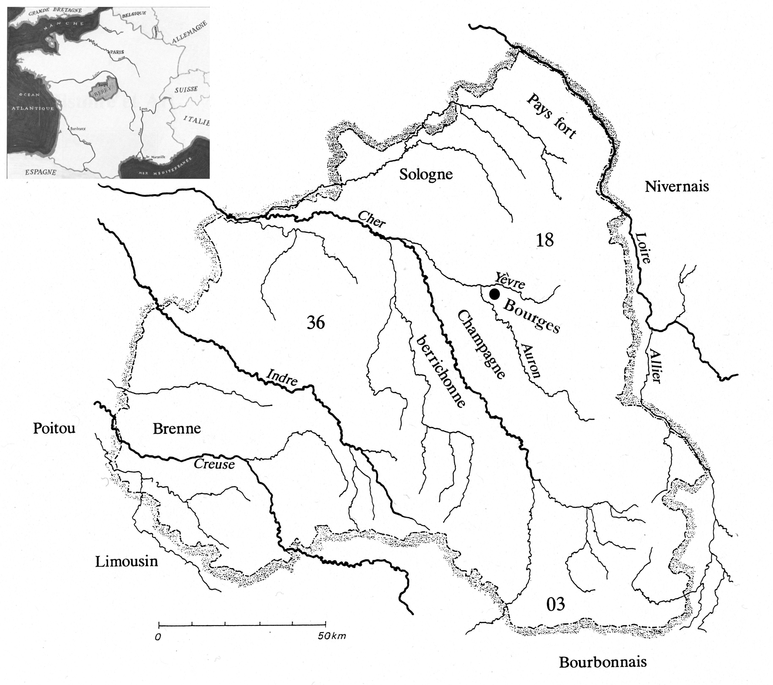
Fig. 1. The position of Bourges – Avaricum within Berry (the civitas Biturigum of the first century BC)
In terms of wider geopolitical and cultural considerations in protohistoric times, Bourges sits near the interface between the western fringes of the north Alpine European cultural province and that occupying the Atlantic and Channel coastlands of France which shared traits more widely – at some periods at least – along the Atlantic seaways and into the British Isles (Milcent 2007:
fig. 3). By the Late Iron Age, taking the boundaries of the early Christian diocese of Bourges as indicative of the territorial limits of the Bituriges, Bourges is the most north-easterly of the significant oppida of the civitas (Batardy et al. 2001: 76–80; Buchsenschutz et al. 2010), its eccentric position – perhaps attributable to the defensive advantages of the low marsh-girt interfluvial promontory on which it is placed, and to the existence of rich iron deposits in its immediate hinterland – highlighted by the record of another tribe, the Boii, having been resettled along their eastern march. For the period with which we are primarily concerned, too, mapping of the wealthier barrows of the earlier Iron Age within the hinterland of Bourges emphasizes that, whilst they can be considered to occupy a number of radial bands in the landscape around Bourges, almost all are focused to the west or south of the core of the modern city (Batardy et al. 2001: 94–99; Milcent 2007: fig. 20; Buchsenschutz and Ralston forthcoming), again intimating that the site is not a conventional ‘central place’ but perhaps, more especially to the east, much closer to a cultural or political frontier.
The circumstances of Bourges' subsequent settlement history dictate that what is known of the site in the first millennium BC is conditioned by the many factors influencing the survival and detection of archaeological remains in what are now actively-changing urban and peri-urban settings. These cannot be rehearsed in detail here (see e.g., Ralston 2007), but in both the later nineteenth and twentieth centuries significant archaeological work was done as the town and its industries developed which, pieced together, begins to provide a tolerable overview of the site in the years around 500 BC, although very significant lacunae – not least concerning the existence, position and complexity of the fortifications that may be surmised to have existed at that time. Given subsequent use, redevelopment of, and topographic alteration to, the site, this uncertainty is hardly exceptional: the position of the Late la Tène fortifications described during their siege by Julius Caesar is also largely uncertain, with the exception of a length of substantial ditch detected during construction of the new town hall in the 1990s, and set across the easiest access to the site. Most students however concur that the principal enclosure probably encircled the highest portion of the promontory, around the cathedral, as did subsequent Gallo-Roman and medieval fortification lines (Troadec 1996), although how far down its skirts the enceinte was set is unknown.
For the nineteenth century, Bourges has a claim to have employed the first ‘City Archaeologist’: Jules Dumoutet was appointed to record what had been disturbed when a series of military developments, e.g., the building of a foundry for cannon, had taken place. And, alongside his work, important data was also recorded by a number of distinguished local scholars such that significant material, primarily from graves in and around Bourges, has long been well-known. In the later twentieth century, following some successful, if small-scale, salvage interventions by the municipal archaeological service, more substantial rescue and research fieldwork became possible, both – although still on a limited scale – within the core of the town, where remains of the mid-first millennium BC survive albeit at considerable depth, but also (and at more extensive scales) towards its periphery as both ‘greenfield’ sites are developed for settlement and recreational use and – very importantly here – ‘brownfield’ sites become available for archaeological assessment prior to redevelopment. Given that the key areas for the recognition of protohistoric (particularly funerary) archaeological remains were those taken over for military use in the later nineteenth century (the ‘Etablissements militaires’ south-east of the city centre), rapid reduction in modern military activity has provided opportunities for the re-evaluation of this zone. These continue at the time of writing (Augier pers. comm.). It is remarkable how much more successful this approach has been for the period around 500 BC than for the detection of evidence related to the oppidum of 52 BC (cf. Troadec 1996; Batardy et al. 2001, passim). In such a dynamic environment, further discoveries continue to be made, such that any overview is likely to require reassessment.
Consideration of the topography is important for any understanding of the nature and extent of the protohistoric settlement in Bourges. The town, focused on the cathedral of Saint Etienne, occupies the apex of a long, gentle-sided promontory east of the Auron valley: the marshy surroundings of the river Yèvre originally formed its northern limit (Fig. 2). Their confluence occurs immediately to the north-west of the city centre. Although now much reduced, the Auron was navigable as far upstream as the city in early modern times; Roman port facilities were examined nearby. The Yèvre likely served as a through-route from the Loire, so that Avaricum may have been a transhipment centre.
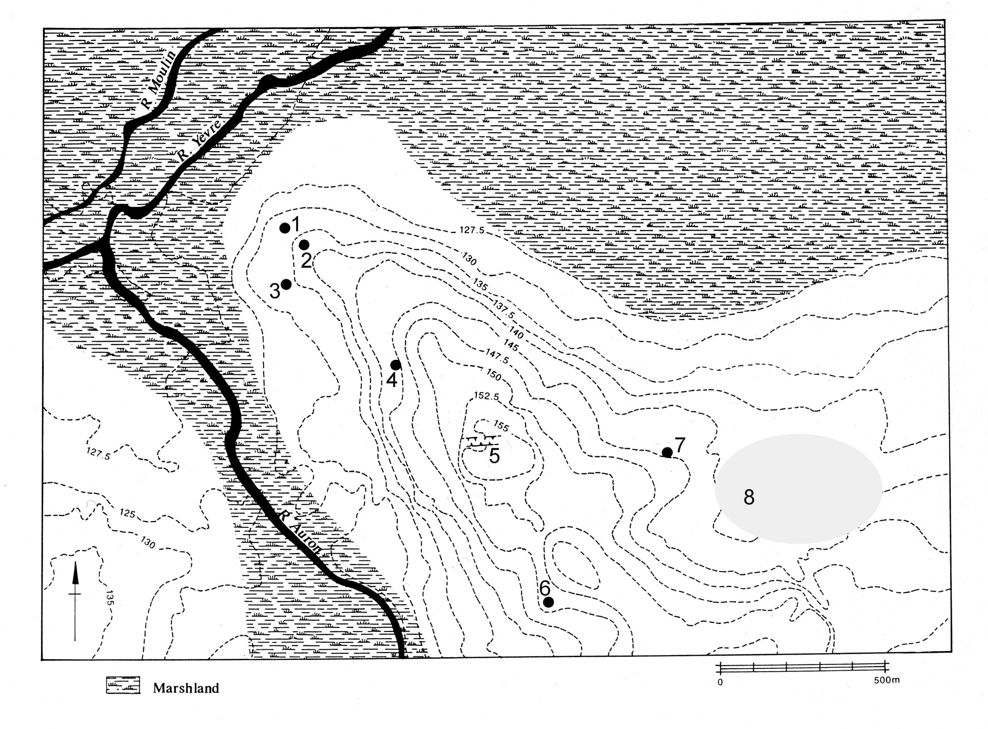
Fig. 2. Map of the Bourges promontory, showing selected sites primarily of the fifth century BC
1: Hôtel Dieu; 2: Littré; 3: rue de la Nation; 4: enclos des Jacobins;
5: position of later second-first century BC ditch; 6: Hôpital militaire Baudens; 7: Saint Martin des Champs; 8: Etablissements militaires (principal 19th century discoveries)
Finds from the commune have long hinted at the major importance of this location around the mid first millennium BC (Milcent 2004). Where known, either burials, or ‘special deposits’ within the marshy lowlands, are mostly indicated; some less well-known finds perhaps indicate domestic occupation within the Etablissements militaires. The sequence now available however derives from excavations as well as the reconsideration of earlier discoveries, the renewed study of the Mediterranean imports initially by Gran-Aymerich and Almagro (e.g., 1991), and the development of a local pottery sequence, refined by Mme Laurence Augier.
A ‘high water mark’ in terms of settlement size early in the fifth century BC is indicated.
Littré and the assumed core
of the Fürstensitz
A number of locations buried deeply within the core of the present-day town have revealed significant First Iron Age traces since 1980. These span the later sixth to perhaps the early fourth centuries BC (Augier et al. 2007). Until 2000, the examined areas were diminutive. Key sites are dispersed topographically on the north (notably Littré) and western slopes (Jacobins shopping centre) of the promontory. Littré produced elements of a wealthy, probably aristocratic, dwelling. Its three phases date between the later sixth and the mid-fifth century BC, and were fortuitously protected by later masonry. From successive builds, southern imports including Attic Black- and Red-Figure sherds were recovered, along with painted wall-plaster and animal bones indicating a protein intake rich in game. Such discoveries were initially limited to the promontory around and north-west of the cathedral, thus lying within the Roman and medieval defences (and, inferentially, the earlier Iron Age fortification circuit).
Subsequently a research excavation was mounted in the courtyard of Bourges's medieval hospital, the Hôtel-Dieu, to extend our knowledge of this early occupation. This site occupies a terrace projecting north-westwards towards the lowlands bordering the Yèvre; it offered scope for more extensive examination of the early features than had hitherto been feasible by re-excavating within the basement of a nineteenth-century building, where rich deposits encountered at Littré, located about a hundred metres away, might continue. The Iron Age deposits did indeed survive at the Hôtel-Dieu. Although early Roman and subsequent disturbance had occurred, structural traces – including a massive dump of clay suitable for building – survived, accompanied by ceramics comparable to the later phases of Littré, notably locally-made pottery finished on the slow wheel
(a type represented in Hallstatt D3 but more common on La Tène A sites) and Massaliote amphorae (Augier et al. 2007).
There is no evidence that this settlement was enclosed during its fifth century BC heyday, but the assumption, on analogy with other ‘princely seats’, is that it was. The massive ditch (Ralston 2006: ill. 30); and the murus gallicus formerly juxtaposed with it) of the late Iron Age oppidum may completely have eradicated all traces of previous fortifications. In the absence of much topo-graphic variation nearby, however, there is no compelling case as to why an earlier fortification must have been built at this position, nor that any enclosure need have been univallate. In this regard, Milcent's (2007) re-identification of an undated but substantial ditch in the nineteenth century work at the Etablissements militaires is perhaps significant. It allows the possibility that the system of enclosure of First Iron Age Bourges may have been more than a simple enclosure cutting off and perhaps encircling the apex of the promontory. Whilst inevitably speculative, a more complex arrangement with subsidiary enclosed spaces would not be out of line with the emerging pattern of enclosure and fortification that are being revealed for example around mont Lassois, the Glauberg (Hessisches Landesmuseum 2008), and more especially the Heuneburg. At the Heuneburg, although the innermost line surrounding the summit above the Danube corresponds closely to that anticipated for any Iron Age contour fort, the subsidiary lines of enclosure revealed by more recent investigations are considerably less directly related to the local topography. Nothing is securely demonstrated in the case of Bourges, although we certainly know that big ditches, defensive in scale if not clearly so in intent, were cut elsewhere on the periphery of the site in the earlier Iron Age, as at Chemin de Gionne (Buchsenschutz and Ralston 2001: fig. 66).
Areas given over to craft industries
Beyond and to the south-east of the oppidum ditch, further significant discoveries were made by the mid-1980s. The key site, Saint Martin des Champs, lay astride the easiest approach to the promontory, nearly 1.5 km south-east of the settlement sites at its apex (Milcent 2007). Key structural evidence consisted of rectilinear semi-sunken workshops, disrupted by the insertion of medieval burials, interspersed with a few post-holes and storage features. Here artisans produced jewellery in copper alloy and lignite, crafted bone and horn, engaged in textile production (spinning, sewing and weaving) and worked both iron and copper alloys (Augier et al. 2009). Activity continued for perhaps the first three-quarters of the fifth century BC, clearly beginning later than, e.g., at Littré. These artisans had access to southern imports, including Attic Red-Figure pottery and Massaliote amphorae. A fragment of an Etruscan bronze dish was also discarded here. The best parallel for St. Martin is the unenclosed site of Bragny-sur-Saône which, occupying at least 3 ha, included evidence for diverse crafts (Collet and Flouest 1997). Saint Martin may have been as sizeable and this site certainly continued in use into Early La Tène. The imports occur in a very different setting than the ‘top-tier and top-down’ contexts that underscore models of temperate European interaction with their southern neighbours at this time. Twenty years ago, Josset (1990) could already argue that elite wealth had been more widely distributed across the upper echelons of the society around Bourges than in comparable constellations further east, and the recurrent recovery of Mediterranean imports from craft areas has since emphasized this characteristic. Comparable workshops have subsequently been recovered closer to the modern town centre at the Baudens military hospital and elsewhere.
The most substantial recent extension to fifth century Bourges has been the identification, across the Yèvre marshlands and no less than 3 km from the Cathedral and thus the core of the site, of
a further extensive area (Port Sec Sud and Port Sec Nord) of workshops akin to those at Saint Martin (Augier et al. 2009; Buchsenschutz and Ralston forthcoming). Workshops here are dispersed across the landscape, accompanied by few other broadly-contemporary features (Figs 3 and 4). Post-holes at Port Sec are very rare; buildings must usually have been built in styles not conducive to a good archaeological survival. Other structures must however have existed, as the volume and unabraded nature of finds recovered from the workshops indicate their derivation from nearby roofed buildings. Craft industries present include copper-alloy jewellery manufacture (sometimes with detailing in bone or coral), spinning and weaving. The presence of ornate pins alongside brooches suggests that fifth century fashions here were slightly conservative compared to what was favoured further east. The relatively low density of features at Port Sec points to this site sitting close to the limit between ‘town’ and ‘country’. Imports – Attic Red Figure, Massaliote and (an occasional) Etruscan amphora sherds, céramique à pâte claire from southern France, a triangular bronze arrowhead – suggest however that the wealth and range of activities present at Port Sec must have been intimately linked across the marshy river valley to the settlement on the Bourges promontory itself. Artefacts indicate a brief effervescence for Port Sec, precisely in the decades around 500 BC with, for example, few instances of such classic archaeological indications of longevity as intercutting features. Provisionally, we may suggest that Port Sec, while including the same structural elements as found elsewhere differs from other sites around the core of the settlement in the proportions of the structural types represented, and in their spatial arrangement. For example, the Port Sec workshops do not show the relatively-organized spatial pattern noted at Saint Martin, although there are indications that many are distributed in
a roughly linear fashion, perhaps along minor roadways.
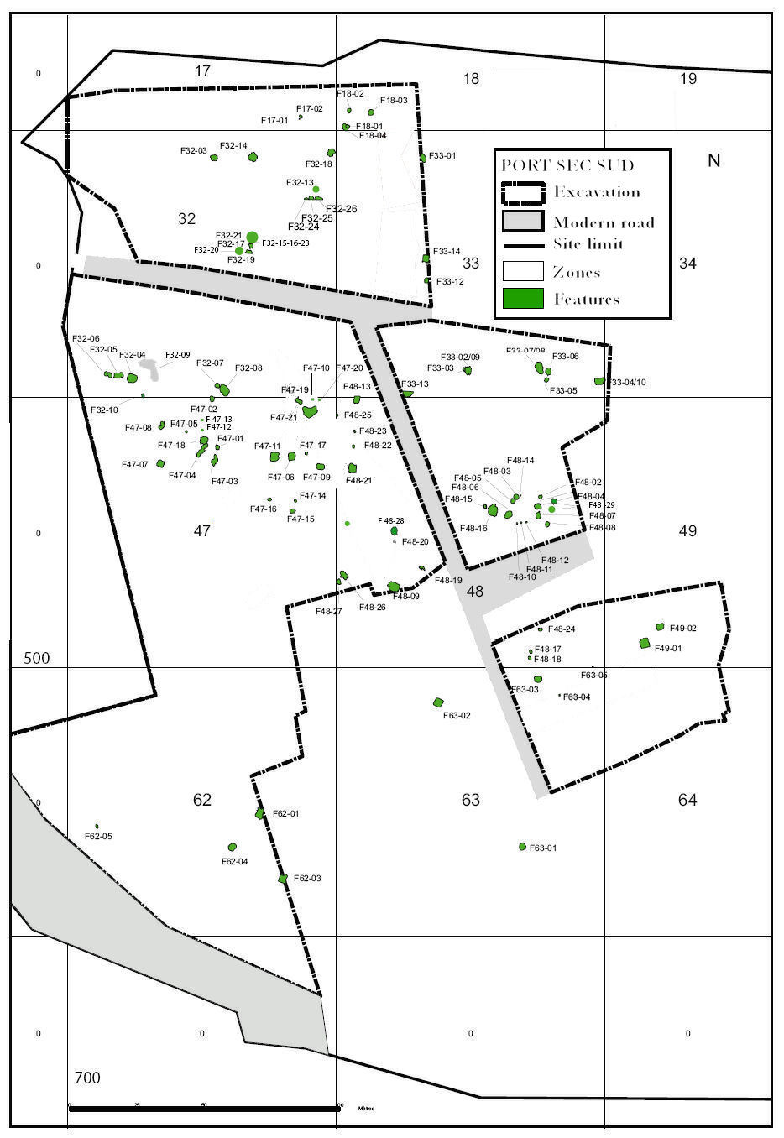
Fig. 3. Excavations within the former military base of Port Sec Sud revealed extensive areas of scattered features (primarily semi-subterranean workshops like that illustrated in Fig. 4)
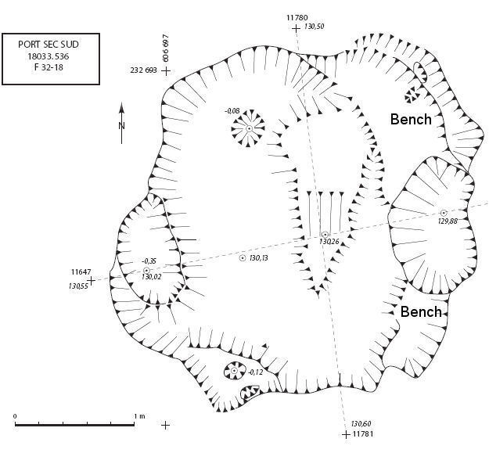
Fig. 4. A semi-sunken workshop of the kind found at several sites marginal to Bourges. Alongside evidence for craft activities, such features frequently produce evidence of Mediterranean imports
Lazenay and the Auron valley
on the South-West periphery of Bourges
Various projects in this sector, upstream from the town centre and now developed for recreational purposes and housing, allow fuller assessment of the changing character of the evidence as the periphery of Bourges is reached approaching 5 km from the core of the site (Buchsenschutz and Ralston 2001).
At Chassepins for example, at the foot of a slope bordering the Auron flood-plain, traces of the Iron Age settlement, delimited by
a substantial ditch, seemingly for a palisade, were encountered. This consisted of a scatter of pits, post-holes and quarry scoops, most of which were considerably older than the middle La Tène stockade. This site was in use for much of the Iron Age. It seems essentially rural in character.
Some 400 m away, at Chemin de Gionne, structural evidence was dominated by substantial storage pits, distributed in a narrow band along the foot of the same slope. An alignment of these possibly formed the site's western limit (Buchsenschutz and Ralston 2001: fig. 55). To the south-east, increasingly intermittent features continue towards Chassepins. Structural evidence for buildings is spartan: few postholes and no coherent plans were identified. Manifestly later than some storage pits, which it intersects, is a detached length of substantial V-cut ditch. This site clearly has time-depth, although few storage pits impinge on each other. The scale of these storage features indicates farmers sufficiently confident to deposit on occasion 6 tonnes, and standardly 2 to 3 tonnes, of grain, in a single pit. An accomplished agricultural system is indicated. The size of the individual pits and the apparent duration of the site's use for storage, as well as the occurrence of storage pits elsewhere, indicate the agriculture use of (and inferentially settlement on) Lazenay for much of the Iron Age. Horse bones from Gionne are perhaps, with rare imported ceramics, an indication of relative prosperity. Finds, including a sherd of fifth-century Greek Red Figure and one of Campanian bowl datable to the late third century BC (Gran-Aymerich 2001), intimate ‘urban’ links. There were, however, no amphorae. Evidence for iron work is sparse. The earliest finds from a storage pit again indicate the fifth century BC, although others (including potin coins) from the upper ditch fill indicate continuing use over perhaps three centuries.
Eight adult skeletons were recovered from these storage pits. Some betoken post-mortem decapitation (Delattre 2001) and some wore fourth-century copper alloy bracelets (Buchsenschutz and Ralston 2001: fig. 93). Post-storage use of these pits was thus – in some instances at least – not for routine disposal of domestic rubbish, echoing interpretations of examples at southern British sites (Hill 1995). Milcent (2004) has noted how the condition of skeletons seen by Dumoutet at the Etablissements militaires resembled those encountered at Gionne, suggesting that such practices were more widespread around Bourges, and perhaps indicating that the Etablissements also had been used for farming settlement before becoming a key sector for protohistoric burial.
Excavations at Les Carrières de Bachon offer a different perspective on the status and use of the Lazenay area. Close to the summit of a ridge east of the Auron, the eroded remains of a very substantial barrow of composite construction, surrounded by a major ditch some 40 m in diameter, were identified. Although robbed in antiquity, this produced a central grave containing the rich interment of a young child and a secondary dry-stone cist that probably held an adult female burial. Sealed by the barrow were traces of a pyre including fitments of a burnt vehicle with, secondarily inserted into it, a gold ram's head pin, the first known gold jewellery – of La Tène A – from Bourges. A robber's trench, dug down through the limestone capped turf mound had emptied a central pit (Milcent et al. 2001; final publication forthcoming). Another barrow, at Les Grands Danjons, across the Auron 3 km west of central Bourges, may also have included a vehicle from a robbed secondary grave datable to Hallstatt D3 (Milcent 2004: 276). These are components of the first series of rich burials south and west of the apparent Fürstensitz.
Wider perspectives
The Auron valley provides further indications of substantial wealth from the period around 500 BC. For example, upstream and so to the south, at Saint Denis de Palin, some 15 km from Lazenay, the examination of two groups of differently-sized barrows on the plateau-edge produced a range of good-quality finds datable to Hallstatt D and the beginning of la Tène (Favière et al. 1964). This area may thus include a satellite tier of important settlements and burials around Bourges. The linear distance from Bourges is about twice that between the Cathedral hill and the barrows at Morthomiers, towards the River Cher valley, one of which produced an imported Etruscan Schnabelkanne (Willaume 1985: 98).
Even before the recent excavations, some 18 copper alloy objects of Etruscan or Italic manufacture and largely of the second quarter of the first millennium BC had been recovered from Bourges and its immediate hinterland, although in some instances this provenance may have been unscrupulously added to enhance value (Bailly 1993). The importance of Bourges towards the end of the Hallstatt Iron Age is further underscored by the number of these finds, although none of the graves that are known is of first-rank Fürstengrab status.
In any assessment of the nature and scale of the settlement, the uncertainty about whether, where, and indeed how elaborately the core of sixth-fifth century BC Bourges-Avaricum was enclosed is significant. The consequences for the distribution of potentially urban functions amongst the known sites that have been examined around the town are considerable. Of the sites towards the periphery, Saint-Martin-des-Champs and Port Sec are, by their scale and the nature of the discoveries made there, undoubtedly amongst the most important. While it has been suggested that the Saint-Martin-des-Champs workshops were not enclosed within the fifth century enceinte, assuming the latter to have been on the same alignment as the major later Iron Age ditch, this is not certain. It is certainly possible by comparison with the outer enclosures at the Heuneburg and the Glauberg to hypothesize that Saint Martin lay within the sixth to fifth century BC enclosed zone, although supporting evidence is absent. It is much harder to envisage Port Sec being other than unenclosed. As a corollary, it is also conceivable (although not demonstrable) that the elite settlement of the end of Hallstatt D and the very beginning of La Tène, centred on Littré and the Hôtel-Dieu, was not within the postulated innermost defence, in a manner akin to the major buildings at Talhau below the Heuneburg (Kurz 2000), or the rich subsidiary settlements below the Ipf bei Bopfingen (Krause et al. 2008), also in Baden-Wurttemburg.
That such speculations are possible simply emphasizes the fact that, despite the very impressive headway that has been made in the study of protohistoric Bourges, much of its form and topographic detail remains to be clarified. To say so is in no way to belittle what has been achieved. It is salutary to remember that across temperate Europe the archaeological evidence available only a generation ago for the ‘princely seats’ and cognate settlements came almost entirely from the examination of sites now located in the countryside, as is apparent from the syntheses of the period (e.g., Wells 1980). Bourges presents amongst the first significant fruits of ‘urban archaeology’ applied to this aspect of the First Iron Age, joining pioneering work like that reported across the Rhine by Pauli and others on the Cathedral Hill at Breisach (Bender et al. 1993, with Beilage 2) and matched too by relatively recent discoveries from Lyons (e.g., Carrara et al. 2009).
Bourges' supra-regional role as a major node of settlement and trade at the cusp of the First and Second Iron Ages has been considered in particular by Milcent (2004, 2007). It can be argued that Bourges' rapid growth – it may have attained 150–200 ha, allowing for discontinuities in settlement due to the presence of wetlands and other impedances to settlement – and privileged status reflect its position at the interface between two major blocs of west European protohistory as mentioned above. Its floruit, continuing into La Tène A, seems to have been of the order of three generations long; and its decline appears swift. Inevitably, in any consideration of what this huge but short-lived agglomeration represented,
the nature, scale and impact of the interplay with the civilizations of the Mediterranean basin loom large. At this interim stage in the assessment of what has been termed a ‘princely complex’, a key point to retain is the usefulness of the data from Bourges in providing grounds for qualifying the frequent application of Wallerstein's world systems theory back in time to these First Iron Age societies whose rise far preceded the period for which that approach was originally devised. The variability in the kinds of evidence recovered across the agglomeration at Bourges, and its chronological patterning, strongly indicate that an uncritical application of this theory, in which both push and pull factors from the supposedly stronger cultures to the south are seen entirely to dominate local circumstances, is inapplicable. It might, however, be noted that the pioneers of this approach, such as Susan Frankenstein and Mike Rowlands, appreciated that a fuller understanding of individual temperate European societies was an essential prerequisite to the further development of the idea (e.g., 1978: 109–110):
The differential development of such [local social] systems and their dependence on each other for their own local evolution determines the nature of the kind of interaction that occurs between them. It must be obvious therefore that we will be unable to understand what form this will take until we have a clear understanding of the internal structure of such local societies…
The evidence from Bourges indicates a different, slightly later, pattern of growth than some classic Fürstensitze, and the extension of the reach of the site into the surrounding landscape to an extent (notably to the south and west) not generally demonstrable in temperate Europe. Much remains to be discovered by further archaeological work about the fragile state which may have existed in Bourges and its fifth century surroundings, including many dimensions of how the society it contained may have been structured (cf. papers in Kohring and Wynne-Jones 2007). On the one hand, the nature of the other settlements in these surroundings is meantime substantially unknown; on the other, the influence of north Italian models of settlement and socio-political organization (cf., e.g., Häussler 2000; Pearce 1998) on the emergence and form of Bourges is still to be clarified.
References
Augier, L., Baron, A., Filippini, A., Milcent, P.-Y., Pescher, B., and Salin, M.
2009. Les activités artisanales de la fin du VIe et du Ve s. Avant J.-C. attestées sur le site de Bourges (Cher). In Buchsenschutz et al. 2009: 39–66.
Augier, L., Buchsenschutz, O., and Ralston, I. (eds.)
2007. Un complexe princier de l'âge du Fer, L'habitat du promontoire de Bourges (Cher) (VIe–IVe s. avant J.-C.). Supplément à la Revue archéologique du centre de la France 32. Bourges: Édition de Bourges Plus, Service d'archéologie préventive; Tours: FERACF.
Bailly, P.
1993. A propos des Etrusques et du Berry: publications, colloques, expositions et observations récentes. Cahiers d'Archéologie et d'Histoire du Berry 116: 15–18.
Batardy, C., Buchsenschutz, O., and Dumasy, F. (eds.)
2001. Le Berry antique: Atlas 2000. (Supplément à la Revue archéologique du centre de la France 21.) Tours: Revue archéologique du Centre de la France.
Bender, H., Pauli, L., and Stork, I.
1993. Der Münsterberg in Breisach II: Hallstatt- und Latènezeit. Müncher Beiträge zur Vor- und Frühgeschichte, Band 40. München: Beck.
Bofinger, J.
2007. Flugzeug, Laser, Sonde, Spaten. Esslingen: Landesamt für Denkmalpflege.
Brun, P.
1988. Les résidences princières comme centres territoriaux: éléments de vérification. In Mohen, J.-P., Duval, A., and Eluère, C. (eds.), Les Princes Celtes et la Méditerranée (pp. 129–144). Paris: La Documentation Française.
Brun, P., and Chaume, B. (eds.)
1997. Vix et les éphémères principautés celtiques; les VIe – Ve siècles avant J.-C. en Europe centre-occidentale. Paris: Errance.
Buchsenschutz, O., Chardenoux, M.-B., Krausz, S., and Vaginay, M. (eds.)
2009. L'âge du Fer dans la boucle de la Loire: les gaulois sont dans la ville. Actes XXXII Colloque de l'Association française pour l'Etude de l'âge du Fer. Revue archéologique du Centre de la France; supplément 35. Tours: FERACF.
Buchsenschutz, O., Krausz, S., and Ralston, I.
2010. Architecture et chronologie des remparts celtiques du Berry et du Limousin. In Fichtl 2010: 297–313.
Buchsenschutz, O., and Ralston, I.
2001. L'occupation de l'âge du Fer dans la vallée de l'Auron
à Bourges: installations agricoles, funéraires et cultuelles (Xe – Ier siècle avant J-C). Supplément à la Revue archéologique du centre de la France 22. Bourges: Édition de Bourges Plus, Service d'archéologie préventive; Tours: FERACF.
2010. La place du complexe princier de Bourges (Cher) dans l'âge du Fer régional à la lumière des fouilles récentes de Port Sec. Stuttgart: Kolloquium des DFG-Schwerpunktprogramms 1171. In print.
Carrara, S., Monin, M., Bertrand, E., and Mège, C.
2009. Les habitats de la fin du VIe et du Ve s. avant J.-C., rue du Mont-d'Or à Lyon-Vaise (Rhône). Association française pour l'Etude de l'Age du Fer Bulletin 27: 13–18.
Chaume, B.
2001. Vix et son territoire à l'Age du Fer: fouilles du mont Lassois et environnement du site princier. Montagnac: Monique Mergoil.
Collet, S., and Flouest, J.-L.
1997. Activités métallurgiques et commerce avec le monde méditerranéen au Ve siècle avant J.-C. à Bragy-sur-Saône (Saône-et-Loire). In Brun and Chaume 1997: 165–172.
Collis, J.
2007. The Polities of Gaul, Britain and Ireland in the Late Iron Age. In Haselgrove, C., and Moore, T. (eds.), The Later Iron Age in Britain and beyond (pp. 523–528). Oxford: Oxbow.
Cunliffe, B. W.
2008. Europe between the Oceans 9000 BC – AD 1000. New Haven; London: Yale University Press.
Delattre, V.
2001. Les sépultures en réutilisation des silos. In Buchsenschutz and Ralston 2001: 103–108.
Demoule, J.-P.
1999. Chronologie et société dans les nécropoles celtiques de la culture Aisne-Marne du VIe au IIIe siècle avant notre ère. Amiens: Revue archéologique de Picardie numéro spécial 15.
Favière, J., Boudet, R. and Nicolle, J.
1964. Un tertre funéraire protohistorique à Saint-Denis-de-Palin (Cher). Gallia 22: 222–247.
Fichtl, S.
2000. La ville celtique. Les oppida de 150 av. J.-C. à 15 ap. J.-C. Paris: Errance.
2010 (ed.). Murus celticus: architecture et fonctions des remparts de l'âge du Fer. Collection Bibracte 19. Actes table ronde, Glux-en-Glenne, oct. 2006. Glux-en-Glenne: Bibracte, Centre archéologique européen.
Frankenstein, S., and Rowlands, M.
1978. The Internal Structure and Regional Context of Early Iron Age Society in South-West Germany. Institute of Archaeology Bulletin 15: 73–112.
Gran-Aymerich, J.
2001. Les artefacts: la céramique importée. In Buchsenschutz and Ralston 2001: 129–133.
Gran-Aymerich, J., and Almagro Gorbea, M.
1991. Les fouilles récentes à Bourges et les recherches sur les importations étrusco-italiques. Bulletin de la Société nationale des Antiquaires de France: 312–339.
Guichard, V., and Perrin, F. (eds.)
2002. L'aristocratie celte à la fin de l'âge du Fer (du IIe siècle avant J.-C. au Ier siècle après J.-C.). Collection Bibracte 5. Glux-en-Glenne: Centre archéologique européen du Mont Beuvray.
Guichard, V., Sievers, S., and Urban, O.-H. (eds.)
2000. Les processus d'urbanisation à l'âge du Fer. Collection Bibracte 4. Glux-en-Glenne: Centre archéologique européen du Mont Beuvray.
Härke, H.
1982. Early Iron Age Hill Settlement in West Central Europe: Patterns and Development. Oxford Journal of Archaeology 1: 187–211.
Haselgrove, C. (ed.)
2006. Les mutations de la fin de l'âge du Fer. Collection Bibracte 12/4. Glux-en-Glenne: Centre archéologique européen.
Häussler, R.
2000. The Dynamics of State Societies in North-West Italy. In Herring, E., and Lomas, K. (eds.), The Emergence of State Identities in Italy in the First Millennium BC. Accordia Specialist Studies on Italy 8 (pp. 131–156). London.
Hessisches Landesmuseum Darmstadt und Landesamt für Denkmalpflege Hessen (herausgegeben von)
2008. Der Glauberg in keltischer Zeit: zum neuesten Stand der Forschung. Fundberichte aus Hessen Beiheft 6. Wiesbaden: Landesamt für Denkmalpflege Hessen.
Hill, J. D.
1995. Ritual and Rubbish in the Iron Age of Wessex. A Study on the Formation of a Specific Archaeological Record. British Archaeological Reports, British Series 242. Oxford: Tempus Reparatum.
Josset, D.
1990. Centre. In Adam, R., Josset, D., Piel, T., and Chateignier, C. (eds.), Répertoire des importations étrusques et italiques en Gaule. Caesarodunum supplement 3 (pp. 12–38). Tours: Caesarodunum.
Kohring, S., and Wynne-Jones, S. (eds.)
2007. Socialising Complexity: Structure, Interaction and Power in Archaeological Discourse. Oxford: Oxbow.
Kimmig, W.
1969. Zur Problem späthallstattischer Adelsitze. In Otto, K.-H., and Frey, O.-H. (eds.), Siedlung, Burg and Stadt. Studien zu ihren Anfängen (pp. 95–113). Berlin: Deutsche Akademie des Wissenschaften.
Krause, R., Euler, D., and Fuhrmann, K.
2008. Der frühkeltische Fürstensitz auf dem Ipf bei Bopfingen im Nördlinger Ries (Ostalbkreis, Baden-Württemburg). In Krausse 2008: 249–298.
Krausse, D. (ed.)
2008. Frühe Zentralisierungs- und Urbanisierungsprozesse. Zur Genese und Entwicklung frühkeltischer Fürstensitze und ihres territorialen Umlandes. Forschungen und Berichte zur Vor- und Frühgeschichte in Baden-Württemberg. Vol. 101. Stuttgart: Konrad Theiss.
Krausz, S., and Ralston, I.
2009. Le siège d'Avaricum en 52 av. J.-C. ou comment les Gaulois se sont défendus contre les Romains. In Buchsenschutz et al. 2009: 145–156.
Kurz, S.
2000. Die Heuneburg-Aussensiedlung: Befunde und Funde. Forschungen und Berichte zur Vor- und Frühgeschichte in Baden-Württemberg. Vol. 72. Stuttgart: Konrad Theiss.
2008a. Neue Forschungen im Umfeld der Heuneburg. In Krausse 2008: 163–183.
2008b. Zur Interpretation der Strukturen in der Heuneburg-Aussensiedlung. In Hessisches Landesmuseum 2008: 159–170.
2010. Die Heuneburg an der oberen Donau: zum Stand der neuesten Forschungen. Lecture to 34th International Colloquium of the Association française pour l'Etude de l'âge du Fer: Aschaffenburg, Germany, May 2010.
Mainfränkisches Museum Würzburg
1995. Luxusgeschirr keltischer Fürsten: Griechische Keramik nördlich des Alpen. Exhibition Catalogue, Mainfränkisches Museum Würzburg.
Milcent, P.-Y.
2004. Le premier âge du Fer en France centrale. Mémoires de la Société préhistorique française 34. 2 vols. Paris: Société préhistorique française.
2007. Bourges-Avaricum. Un centre proto-urbain celtique du Ve siècle avant J.-C. Les fouilles du quartier de Saint-Martin-des-Champs et les découvertes des Etablissements militaires. Bituriga Monographie. 2 vols. Bourges: Service D'archéologie Municipal.
Milcent, P.-Y. (dir.) with Augier, L., Berthet, A.-L., Durand, R., Gaultier, M., Lucas, J., Martin, S., Moulherat, C., Ralston, I., and Richard, H.
2001. Le tumulus aristocratique des Carriиres à Bachon, Lazenay, Bourges, site no 18.033.521AH. Unpublished report. Service d'archéologie municipal de la ville de Bourges. Université de Tou-louse II – Le Mirail. UMR 8546 du CNRS, ENS. Bourges.
Nash, D.
1988. Imperial Expansion under the Roman Republic. In Rowlands, M., Larson, M., and Kristiansen, K. (eds.), Centre and Periphery in the Ancient World (pp. 87–103). Cambridge: Cambridge University Press.
Pearce, M.
1998. Urbanization and State Formation in Early Iron Age Northern Italy: Golasecca and Este. Atti del XIII Congress, Unione internazionale delle Science preistorische e protohistoriche. Vol. 4 (pp. 571–576). Forlì: ABACO.
Ralston, I.
2006. Celtic Fortifications. Stroud, Gloucestershire: Tempus.
2007. Bourges and the Earlier Iron Age: An Interim View. In de Jersey, P., Gosden, C., Hamerow, H., and Lock, G. (eds.), Communities and Connections (pp. 217–239). Oxford: Oxford University Press.
Troadec, J.
1996. Bourges. Paris: Ministère de la Culture, Direction du Patrimoine, Document d'Evaluation du Patrimoine des Villes de France, 14.
Wells, P.
1980. Culture Contact and Culture Change: Early Iron Age Central Europe and the Mediterranean World. Cambridge: Cambridge University Press.
Willaume, M.
1985. Le Berry à l'Age du Fer HaC – La Tène II, précedé du catalogue des collections de l'Age du Fer du Musée de Bourges. Oxford: British Archaeological Reports International Series 247.

