Congratulations on the 80th Anniversary of Professor Henri Johannes Maria Claessen
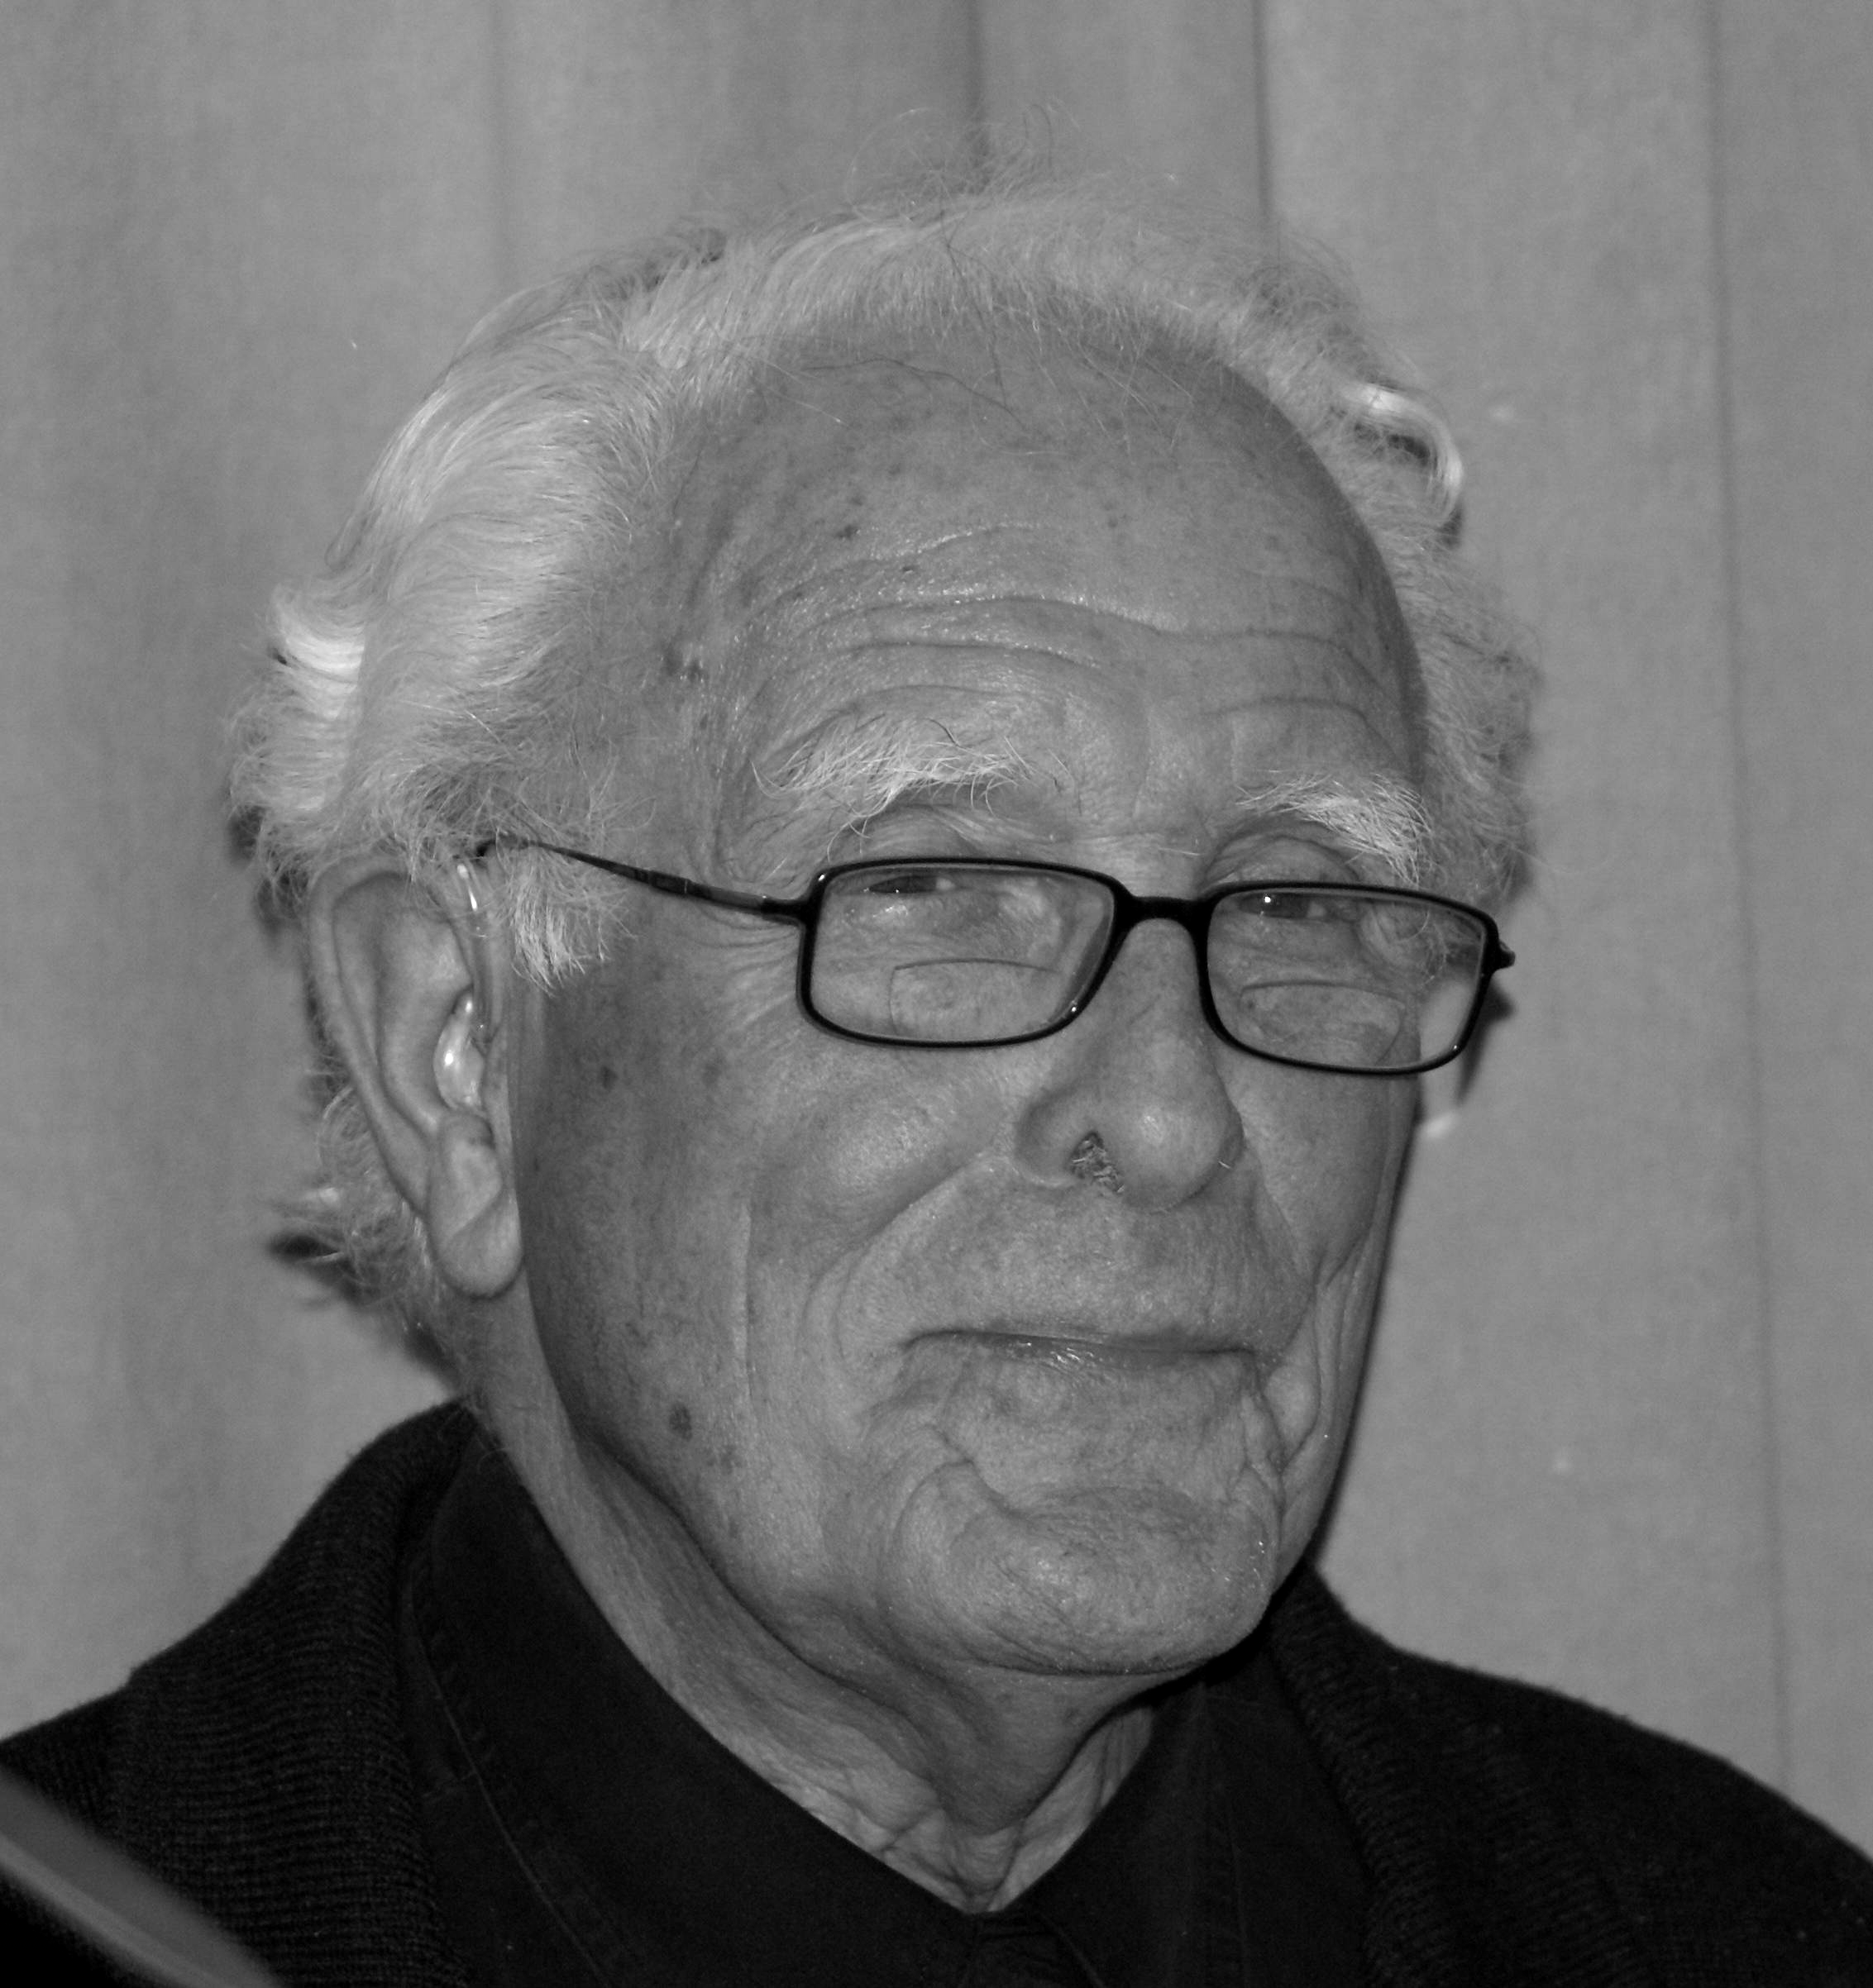
We are happy to congratulate our friend, colleague and scientific collaborator Henri Claessen with his 80th birthday and regard this opportunity as our great honour and privilege. We want to express our deep respect to and appre-ciation of his work. We cordially wish Professor Claessen many happy returns of the day, satis-faction from the work he has al-ready accomplished and the work he will complete in the future, peace of mind and personal happiness!
The Journal Editors have received many letters of congra-tulation addressed to Henri J. M. Claessen on the occasion of his anniversary. Hereafter we publish only some of them.
Herbert Barry III
Henri J. M. Claessen is the source of a great variety of valuable contributions to our knowledge about the origin and development of political states. His contributions began with his Ph.D. dissertation on five early states, in 1970 at the University of Amsterdam in the Netherlands. Born in 1930, he has attained the age of 80 years as a retired Professor at Leiden University. Some of his contributions are summarized in his recent article ‘On Early States – Structure, Development, and Fall’ (2010) in ‘Social Evolution & History’ Vol. 9, No. 1.
Claessen's many articles and books on early states include some with coauthors and also include books he edited that contain contributions by other authors. His detailed examinations and descriptions have been applied to more than 20 early states. He has concluded that a large population, territory, and a legitimized, sacred ruler are necessary but not sufficient conditions for the development of states.
Early states are especially important as the initial precursors of contemporary great nations. Early states also differentiate humans from other species. Social communities, which are prominent in humans, also characterize other social mammals, such as the great apes, wolves, elephants, and dolphins. Some insects, notably honey bees and ants, have hereditarily determined functions that are highly specialized in their communities. A unique attribute of humans is the development of political states, which integrate multiple communities.

Renée Hagesteijn
For me, Henri Claessen has been the main motivation to become
an anthropologist. He has been active as a social geographer and anthropologist for over 50 years now. He has made a significant contribution to international theory building and comparative data collection in the field of state formation research. He is a well known scholar, has an impressive list of publications, is an outstanding net worker, an excellent and kind teacher, inspiring mentor and a loyal friend. It is a privilege, an honour and a joy to know him and to work with him.

Anatoly Khazanov
Dear Henri,
For many years, I am honored and privileged to call you my very dear and close friend. You have influenced my scholarship, and you were my staunch, faithful, and unfailing supporter during the most difficult period of my life. I and other members of my family always cherish the memory of your and Iet's hospitality, when we were your guests in Wassenaar. Your seminal studies have opened a new chapter in the study of early states and many other related questions. Your exceptional decency, intellectual honesty, and human warmth that you always reveal in relations with your colleagues are exemplary indeed. Please, accept our respect, affection, and love.
Yours as ever,
Anatoly Khazanov
Donald Kurtz
Dear Hans,
Among the many virtues and enviable qualities you have displayed over the years that I have known you, nearly 40 now, to me – even though your name and fame may be synonymous with the study of the early state – you represent the epitome of a very rare university character, a true scholarly gentlemen, one of the very few that I have known in my 50+ year career as a student of anthropology. I cherish our communication, exchanges, arguments, and discussions and wish we could spend more time together. On your 80th birthday I will have a glass of wine and salute you and wish you many more birthdays and many more successes.
In sincere friendship and collegiality, happy birthday,
Don

Peter Skalník
When I met Hans Claessen at Chicago in 1973 his age was just 42 and I was 15 years younger. Our then papers were similar in scope and we almost immediately agreed on closer cooperation. Probably all of those who will read these lines know the results of this cooperation. Today Hans is 38 years older, so am I, so are we all born earlier. During all those years irrespective of our further destinities we kept contact, exchanged views, remained good close colleagues. Let me just express my deepest gratitude to Hans for his support, criticism and care. Long he live for many more years!

Jianping Yi
Chinese scholars greatly benefit from his contributions to the study of early state. From the 1950s to 1970s in China social evolution was only explained by Marxism. Such a situation started to be changed by the end of the 1970s when China began to open her door. Now we talk more and more about the studies of Henri J. M. Claessen, Elman R. Service, Morton H. Fried, Robert L. Carneiro, and others. ‘Early State’ and ‘Chiefdom’ finally become two of the most important concepts of social evolution in our country.
I personally owed him a lot too.
BRIEF PROFILE OF HENRI J. M. CLAESSEN*
Henri J. M. Claessen (born 1930) is a famous cultural anthropologist. He is Professor of Social Anthropology at Leiden University (van Meijl 1995), a honorary member of several scholarly institutions (Koninklijk Instituut voor Taal-, Land- en Volkenkunde [Royal Institute for Languages and Anthropology of the Royal Academy of Sciences]); Center for Asian and Pacific Studies (University of Nijmegen); Honorary Lifetime Member of the IUAES (International Union of Anthropological and Ethnological Sciences).

Background and education
He studied geography, history and anthropology at Amsterdam University (1950–1956). After his MA Claessen became a teacher of social geography in Sint Adelbert College (1956–1970), a period during which he prepared his PhD thesis under A. Köbben's supervision. He obtained his PhD at Amsterdam (1970). After that he was appointed Associate Professor at Leiden University in the Department of Anthropology. In 1984 he became full Professor there, in 1989–1991 he was the Dean of Faculty of Social Sciences (Faculteit der Sociale Wetenschappen) and in 1994 he retired from the University. In 1981–1982 Claessen was Fellow in The Netherlands Institute for Advanced Studies (Bondarenko 2009: 220). From 1977–1994 he was Editor of Bijdragen tot de Taal-, Land- en Volkenkunde. In this period Henri J. M. Claessen was also active in the IUAES where he served as Vice-President from 1982–1992.

Early State Research
Henri Claessen has devoted much of his scholarly career to the study of Early States. The concept of the early state introduced by Henri J. M. Claessen and Peter Skalník appears to have been the last among the great epoch-making political-anthropological theories of the 60s and 70s of the last century (Grinin 2008: 67). Claessen's thesis Of Princes and Peoples, a comparative study of the political organization of five Early States (Tahiti, Tonga, Dahomey, Buganda and the Realm of the Incas) where the emphasis came to be the central political organization (which has remained an important theme in much of Claessen's work), lay at the basis of The Early State (1978) which he edited with Peter Skalník. In 1981, again with Peter Skalník, he edited The Study of the State. In later years he edited with M. Estellie Smith and Pieter van de Velde Development and Decline (1985). In this work the emphasis fell on evolutionary aspects of state formation. With Pieter van de Velde he edited in 1987 Early State Dynamics, and in 1991 Early State Economics. To connect matters of ideology and legitimacy, he edited with Jarich G. Oosten in 1996 Ideology and the Formation of Early States. In his Structural Change he presented a survey of evolution and evolutionism in cultural anthropology. With Renée Hagesteijn and Pieter van de Velde he edited a special issue of Social Evolution & History under the title Thirty Years of Early State Research (2008).

SELECTED WORKS
1978. The Early State: A Structural Approach. In Claessen, H. J. M., and Skalník, P. (eds.), The Early State (pp. 533–596). The Hague: Mouton.
1978. With P. Kloos. Evolutie en evolutionisme. Assen/Amsterdam: Van Gorcum.
1981. Specific Features of the African Early State. In Claessen, H. J. M., and Skalník, P. (eds.), The Study of the State (pp. 59–86). The Hague: Mouton.
1981. With P. van de Velde. Een intercultureel model voor het feodalisme. In van de Velde, P. (ed.), Evomatica (pp. 203–215). Leiden: Institute of Cultural Anthropology Publication.
1983. Evolutionary or not evolutionary; That's the question. Reviews in Anthropology 10: 21–24.
1984. The Internal Dynamics of the Early State. Current Anthro-pology 25: 365–379.
1984. With P. van de Velde. Complexe interactie. Een proces-model ter verklaring van de evolutie van de sociaal-politieke organisatie. Antropologische Verkenningen 3: 120–136.
1985. From the Franks to France; The Evolution of a Political Organization. In Claessen, H. J. M., van de Velde, P., and Smith, M. E. (eds.), Development and Decline (pp. 196–218). South Hadley, MA: Bergin & Garvey.
1989. Evolutionism in Development. Vienne Contributions to Ethnology and Anthropology 5: 231–247.
1991. Verdwenen koninkrijken en verloren beschavingen [Disap-peared Kingdoms and Lost Civilizations]. Assen: Van Gorcum.
1996. Ideology and the formation of early states: Data from Polynesia. In Claessen, H. J. M., and Oosten, J. G. (eds.), Ideology and the formation of early states (pp. 339–358). Leiden: Brill.
2000. Structural Change; Evolution and Evolutionism in Cultural Anthropology. Leiden: CNWS Press.
2002. Was the State Inevitable? Social Evolution & History 1(1): 101–117.
2005. Early State Intricacies. Social Evolution & History 4(2): 151–158.
2006. With M. A. van Bakel: Theme and variations. The deve-lopment of differences in Polynesian socio-political organizations. Bijdragen tot de Taal-, Land- en Volkenkunde 162: 218–268.
2008. Before the Early State and After. Social Evolution & History 7(1): 4–18.
2009. Learning and training. Education in eighteenth century traditional Polynesia. Bijdragen tot de Taal-, Land- en Volkeknkunde 165: 324–356.
2010. On early states – structure, development, and fall. Social Evolution & History 9(1): 3–51.
note

* See also the entry on Henri J. M. Claessen at en.wikipedia.org.

REFERENCES

Bondarenko, D. M.

2009. Claessen H. J. M. In Osipov, Yu. M. (ed.), Great Russian Encyclopedia. Vol. 14 (p. 220). Moscow: Russian Encyclopedia.

Grinin, L. E.

2008. Early State, Developed State, Mature State: The Statehood Evolutionary Sequence. Social Evolution & History. Thirty Years of Early State Research. Special Issue 7(1): 67–81.

van Meijl, T.

1995. Valedictory lecture by Professor Henri J. M. Claessen. Oceania Newsletter 15, March.

