War Cycles

Arno Tausch
Innsbruck University
ABSTRACT
By re-analyzing latest conflict data (great power battle fatalities from all wars, Goldstein 1988 and COW/PRIO 2005) from 1495 to 2002 and as yet unpublished UNIDO data about the growth of world industrial production 1740–2004 it is shown that the long Kuznets and Kondratiev swings and cycles of capitalist world development that play such an important role in the analysis of global war since 1495 have indeed not ended after the end of Communism, and that instability, and not stability, characterizes the world economy, and that there is an indented ‘W’ shaped pattern of global conflict since 1495 that did not end with the end of the Cold War. To this effect, we present in this work new conflict data for the involvement of the Great Powers (from 1945 onwards UN Permanent Security Council members + Germany, before 1945 definition Goldstein 1988, based on the works of Levy, see page 235 in Goldstein 1988) in wars (annual battle fatalities) for the entire period 1945–2002, based on standard peace research data (PRIO Oslo, Correlates of War data).
World hegemonies that characterize the workings of world capitalism arise and they also end. Work by Attinà and Modelski suggests that we most probably will not escape the fatal cycle of global leaderships and global contenders. Since the mid 1960s, the defense pact aggregation index that measures the percentage share of defense pact members in the total number of states in the international system i.e. the control that existing, established mechanisms of world political leadership exercise over global politics, has declined, suggesting that the era of global power by the United States, which was established in 1945, definitely comes to an end and that our era is pretty similar to the era 1850–1878, which was characterized by the de-legitimation of the then British leadership, followed by the de-concentration of the international system and the era of coalition-building between 1878–1914, which ended, as we all too well know, in the catastrophe of 1914.
Our hypothesis is – also in view of developments beyond the 1990s – that the belle époque of globalization from 1960–1990 did not bring about a more stable, egalitarian and peaceful world.
JEL classification: F5 – International Relations and International Political Economy; F52 – National Security; Economic Nationalism; F59 – International Relations and International Political Economy: Other.
Introduction
One of the most intriguing features of world systems theory is its prediction of the recurrence of global wars in the world capitalist system. By re-analyzing latest conflict data (great power battle fatalities from all wars, Goldstein 1988 and COW/PRIO 2005) from 1595 to 2002 and as yet unpublished UNIDO data about the growth of world industrial production 1740–2004 it is shown that the long Kuznets and Kondratieff swings and cycles of capitalist world development that play such an important role in the analysis of global war since 1495 have indeed not ended after the end of Communism, and that instability, and not stability, characterizes the world economy, and that there is an indented ‘W’ shaped pattern of global conflict since 1495 that did not end with the end of the Cold War.
To this effect, we present new conflict data for the involvement of the Great Powers (UN Permanent Security Council members + Germany) in wars (annual battle fatalities) for the entire period 1945–2002 based on standard peace research data (PRIO Oslo, Correlates of War data). Data before 1945 are from the well-known data series, presented by Joshua Goldstein.

Cycle of World Wars Depressions
There were voices that predicted the ‘end of history’ in the 1990s. The world systems approach takes a more cautious line and would not preclude – at least in principle – a repetition of the insane economic cycles and major power rivalries that characterized the course of history since 1450 and which produced three devastating global wars, 1618–1648; 1793–1815; and 1914–1945 (see the by now classic contribution by Goldstein 1988). We would like to test here these world system theory propositions with new data of world industrial production growth from 1740 through to 2004 (based up to 1975 on Goldstein, and from 1975 onwards on as yet unpublished data and estimates by the United Nations Industrial Development Organization in Vienna, kindly put to our disposal by its Statistical Director Dr. Tetsuo Yamada) and new data about great power battle fatalities from all wars, 1945–2002 (based on PRIO/Correlates of War data). In view of the methodological critique by several authors, including Beck (1991) and Silverberg (2005), against the ‘long wave school’ it would seem appropriate rather to talk about ‘tendencies’ or ‘waves’ and not about ‘cycles’. Silverberg's recent research paper applies spectral density analysis to two famous world system time series, Modelski's and Thompson's seapower index and the Levy-Goldstein great power fatalities data series, see below. However, we try to show by using Kondratieff's classic techniques of polynomial regressions that there are several cycles, and not one cycle, of global economics and politics.
The recurrence of major power wars in the capitalist world economy from 1495 to the present is one of the most intriguing features of the existing international system. The x-axis in Graph 1 presents the number of years after the end of the major power wars, i.e. 1648, 1816, and 1945. Each world political cycle up to now corresponded to a ‘W’-pattern of untransformed annual battle fatalities from major power wars in thousands.
The untransformed data for the war cycle 1495–1648 are statistically well explained by a polynomial expression of the 6th order over time; R^{^2} is 91.7 %; 1649–1816 yields an R^{^2} of 33.6 %; while a polynomial expression of the 6th order over time explains 50.1 % of war intensity 1817–1945. The international system is indeed characterized according to Goldstein by the following sequence of cycles:
global war → world hegemony of the dominant power → de-legitimization of the international order →
de-concentration of the global system → global war,
et cetera
The duration of these sub-phases of the international order is approximately one Kondratieff cycle each (an economic cycle of 50 to 60 years duration, see below), so the unit of time of the international system can be symbolized by the expression – one Kondratieff – 1_{K}. An entire hegemonic cycle lasts 3 Kondratieff cycles.
Different sub-schools, like Goldstein, Russett, Weede or the present author (Tausch 1997–2000) thought it unlikely that a major confrontation between the centers of ‘world capitalism’ might characterize the 21st Century, and that there are other, more likely candidates for such a terrible scenario. It is important to remember that there are pre-conditions for such a ‘democratic peace’ between the major centers of global power, mainly the maintenance of democracy in the countries concerned. Christopher K. Chase-Dunn and Bruce Podobnik wrote the most consistent, provocative scenario about global conflict involving the European Union. They think in earnest that – what they term – a European Union under the leadership of Germany – will be involved – with a chance of 50/50 – in a major global military confrontation with the United States by 2020! Immanuel Maurice Wallerstein, on the other hand, thinks it entirely likely that in the end we will be confronted with a major warfare between Europe and Asia in the 21st Century (Wallerstein 2000).
Although this might be termed an absolute exaggeration of projective social scientific writing, a more careful re-reading of the world systems approach – especially the writings of Giovanni Arrighi, George Modelski, Andre Gunder Frank and Immanuel Wallerstein – does suggest that the 21st Century will be characterized by a further shift of the world economic centers of gravity towards Asia, and that the maintenance of peace of such an enlarged Europe to the outside world will depend on European Union democracy, technical innovation, and the avoidance of what Arrighi has called – in allusion to the concept of power of historical Venice – a ‘terra ferma’ constellation, i.e. the territorial concept of power and the exploitation of the hinterland – the terra ferma. In the history of the world economy, such major geographical shifts of economic activities and of military power – like in 1340, 1560, 1750 and 1930 – were always associated with major wars and with a very deep economic depression.
We agree with Modelski (1999) that global challengers in the world system were always characterized by the interaction of (a) a large army, (b) a large economy, (c) a closed, controlled society, and (d) weak, ethnocentric media. Russett's hypothesis about the great probability of peace between democracies is an all-important, further element in this debate.
At any rate, the future of the open society in Europe, the exact fulfillment of the Copenhagen criteria of a functioning democracy and market economy in the EU enlargement process, and the future democratization of the Union – also in face of the darker sides of the European heritage and the very idea of an economically united Europe under authoritarian premises under Nazi rule before 1945 (Laughland 1998) – become decisive whether or not Europe will become a global challenger in Modelski's sense, and will determine whether Europe is a new challenger of the new evolving global leadership along the Pacific axis that could fit into the pattern, described by Modelski, as including (a) an oceanic navy, (b) lead industries and fiscal strength, (c) a democratic potential, party system, and (d) a strong active media.
A relatively closed society, combined with high customs, a reliance on military land power, exploitative relations with the internal and immediate external peripheries (the hinterland of Northern Italy before the great Italian wars of the 13th and 14th century, the Spanish colonies and internal peripheries in Hapsburg Europe before the global war 1618, the French internal peripheries and colonies before the Napoleonic Wars, and Germany's ‘Drang nach Osten’ before 1914) and a relatively weak technological home-base characterized the attempts at world power, while the successful world hegemons (the United Provinces of the Netherlands, the United Kingdom, and the United States) were each time the practical opposites on all or most of these dimensions: a naval, knowledge-driven and world-market concept of power, a society open to migration, low customs, a large sea power and a smaller, but mobile and disciplined and readily deployable land-army, and a strong technological home-base.
Significant for hegemonic success is also the strong social role of the urban merchant class that is in stark contrast to the ties between the land and capitalism, characteristic of the ‘rentier’ political economy of Hapsburg Europe, France, and Germany, the historic challengers that lost the world leadership contest (see Graph 2 [a, b, c, d]).
World hegemonies that characterized the workings of world capitalism, arise and they also end. As it is well-known in world system research, especially from the works of Arrighi and Silver, there are signal crises of world capitalism (the usual Kondratieff depressions), and there are terminal crises of the world system, when hegemonies end. Peaceful transitions from one hegemony to the other are among the most intricate questions of peace research and peace policy of our time.
These moments of world hegemony transformation, as Arrighi and Silver and as Boswell (1999) have shown, are especially dangerous culminations of world depressions and are characterized by a subsequent fight for world hegemony, like during the great crash of the early 1340s, which marked the beginning of the Genoese age (Arrighi) or Portuguese and Genoese age (Modelski), the crash of the 1560s, which marked the beginning of the Dutch era, the depression of the 1750s and 1760s, which marked the beginning of the British era, and the Great Depression in the 1930s, which was the terminal crisis of British world capitalist dominance (Arrighi 1995). Regulation can be successful, like after 1560, and 1930, and deregulation can be successful, like after 1340, 1760, and – most probably – the 1980s (compiled from Arrighi 1995).
A serious debate about the aspects of Genoa's hegemony is beyond the limits of this essay, and would presuppose an enormous amount of details about Italian Medieval and early modern history. It seems important to remind readers here – as the mathematician and anthropologist Douglas White from the University of California at Irvine has shown in an interesting reaction to Arrighi's theory (http://eclectic.ss.uci.edu/~drwhite/Anthro179a/inflate1text.htm) – that Genoa's ascent began in 1298, when Genoa's fleet defeats the Venetian fleet.
The following historical data are less contentious: 1648: Treaty of Westphalia, consolidation of Dutch hegemony; 1797: The British fleet defeats Dutch fleet at Battle of Camperdown. Britain establishes hegemony. 1919: The British ‘century’ came to an end only when the World War exhausted its energies and drained its reserves. 1945: the cycle of the US hegemony begins.
A world hegemony evolves and declines during at least two Kondratieff cycles. We think it fairly safe to assume that there is no such early forthcoming terminal crisis of the capitalist system, but that the risk for such a crisis rapidly increases after 2020 or 2030. Even at the risk of gross oversimplification, the following scheme could be drawn (see Graph 3: Terminal Crises of Capitalism).
There seems to be ample evidence, reproduced, among others, in Tausch (2003) that the terminal crises of capitalism, like Tsunami waves of world politics, have devastating consequences for the well-being of the great majority of humanity. Evidence, based on the works of Andre Gunder Frank and Rudolph Rummel suggests that as a consequence of the terrible world depressions of the 1350s (coinciding with the Black Death) and 1750s, Europe lost significantly its share in total world population, while the earthquake of world politics 1900–1950 had an estimated 187.7 million victims in terms of political repression, genocide and democide, i.e. a good part of all the estimated total victims (482 million human beings) of democide, wars and repression in total human history. Among the major world systems researchers of our time, the late Andre Gunder Frank was most active in championing the idea that there are major economic cycles dating back 5000 years in human history. This idea was put forward by him for example in 1994, in an important paper which he presented to the New England Historical Association. A more final word by Frank on these large cycles is to be found, among others, in his ‘ReOrient’ 1998: 248ff.
For Modelski, the following larger cycles hold: see Table 1: K-waves: the sequence of global leading sectors according to Modelski and Table 2: The Co-evolution of Global Economics and Politics according to Modelski.
The Conflict Clock
So, where are we now? 1870? 1913? 1938? World systems theory is full of speculation about the future, and much of world systems research writing projects a major global war by around 2020 or 2030. Just let us quote from famous world systems researchers:
a) Goldstein (2005) returned to his ‘conflict clock’ (Goldstein 1988: 259). Looking back on his predictions and his work, he now defines 2000 as the war trough year, to be followed by a 2005 price trough and real wage peak, 2010 an expansion phase, 2015 a production peak, 2020 an investment peak, 2025 an innovation trough and 2025 a war peak, and 2030 a price peak. Goldstein is clear about his prediction about the 2020s as the next real danger zone of world politics: ‘In my 1988 book I pointed to the period around the 2020s as a potential danger zone, and it still worries me’ (Goldstein 2005: 8).
b) Chase-Dunn and Podobnik (1999) see a 50/50 chance of global war by around 2020, with the most likely contenders of the US being either a United Europe under German leadership or
Japan.
c) Boswell (1999) presents a list of 10 system evolution steps, starting by the relative decline of the United States, followed by imperial rivalry and global war between 2010 and 2020, to be followed by another world system sequence, ending by 2080 or 2090 in yet another cycle of relative decline of the hegemon who won the last world war by 2010/2020…
d) Work by Attinà and Modelski also suggests that we most probably will not escape the fatal cycle of global leaderships and global contenders. Since the mid 1960s, the defense pact aggregation index that measures the percentage share of defense pact members in the total number of states in the international system i.e. the control that existing, established mechanisms of world political leadership exercise over global politics, has declined, suggesting that the era of global power by the United States which was established in 1945 definitely comes to an end and that our era is pretty similar to the era 1850–1878, which was characterized by the de-legitimation of the then British leadership, followed by the de-concentration of the international system and the era of coalition-building between 1878–1914, which ended, as we all too well know, in the catastrophy of 1914. Goldstein interprets the past global political cycles as:
global war → world hegemony of the dominant power → de-legitimization of the international order → de-concentration of the global system → global war et cetera
Attinà interprets the global political cycles of the world system in accordance with Modelski as:
global war macrodecision → global power execution → de-legitimization and agenda setting → de-concentration and coalition building → global war macrodecision et cetera
The defense pact aggregation index neatly measures, Attinà argues, these cycles. In our Graph 4, we compare these cycles with the long swing of world economic development and come to the conclusion that these two cyclical movements are roughly in parallel. The tsunami crisis of world politics precedes the tsunami economic crisis? (See Graph 4a: Global political leadership and the long cycles of world development: declining growth rates and world political de-concentration – the evidence for the period after the Congress of Vienna 1814–1815 and Graph 4b: Global political leadership and the long cycles of world development: world political de-concentration and economic stagnation (B-phases of 100 year logistic cycles in the tradition of Wallerstein) – the evidence for the period after the Congress of Vienna 1814–1815.)
At any rate, the contemporary geographic and systemic selective retreat of the respects for ‘civil rights’ (standard Western concept¹) – an average positive trend development 1995–2003 notwithstanding – suggests that ‘freedom’ (standard Western concept) is on the retreat precisely in those regions, where there were gains in ‘freedom’ and ‘human rights’ owing to the transformations of 1989 and the second and third wave of democratization of the 1980s and 1990s, thus partially contradicting the liberal globalist optimism inherent in the analysis by Soysa and Gleditsch (2002). The retreat of ‘democracy and human rights’ will most probably go hand in hand with a more conflict-oriented foreign policy in years to come. Under the weight of globalization and the openings of markets, the weak economies and societies of the former communist world and several democracies of the South witness a retreat of civil liberties, exacerbated by the recent wave of increasing human rights abuses in the context of the ‘global war on terror’ (see Graph 5: The Regions of the retreat of the respect for civil rights, 1995–2003: a) the evidence on a world level; b) the evidence for the ‘North Atlantic arena’).
Recently, researchers have dealt with the specific aspects of the long-term relative decline of the United States in global politics. But at this stage, it is important to look into the cycles of reform and regime tightening in Eastern Europe. Just as during the world depression of the 1930s democracy could not survive in the region (Polanyi 1944), today the danger arises that instability and not democratization will triumph in the end, especially in countries like those of the former USSR. The turning points in the long waves between the ascents and decline phases (B-phases) were always the beginnings of political decay in the region, while the ascent phases were associated with authoritarian modernization; time-lags between the Western cycle and the Eastern semi-periphery and periphery have to be taken into account. The decisive-kairos-years are (dates before 1756 from Goldstein 1988): 1509, 1539, 1575, 1621, 1689, 1756, 1832, 1885, 1932, and 1975.
The former hegemonic contenders from earlier global wars slowly slide into an acceptance of their status in the international system. The real power struggle erupts already soon after the great hegemonic war, and through the ups and downs of the history of the system evolves slowly into the hegemonic challenge. Seen in such a way, not 1989, but Korea and Vietnam could become rather the benchmarks of the future W-structure of conflict in the international arena (see Table 3: Projected Logic of World Power Competition 1495–2002).
The triumphalism of America being the unrivalled military hegemonic power of our world notwithstanding, we believe that a serious strategic and political science analysis quickly reveals the direct manpower and other military constraints against continued U.S. military and political dominance in world affairs (Adams 2005). It is often said that like Old Rome, America is without parallels in terms of military strength.
But such claims are a simple myth, resting upon military spending figures that just demonstrate that the Pentagon spends a real lot of money converted into international exchange rates that are still favorable to the US Dollar but which are exchange rates untenable in the long run in view of the huge double deficits of the US economy. What is unparalleled in human history is not the ‘bang’ that the US Conventional Forces can deliver on the ground, especially in a guerrilla warfare situation, but the ‘buck’ that went to the Pentagon defense contractors, indeed an amount really unparalleled around the globe. The US budget deficit is now (2007) at 1.9 % of GDP, and the current account balance deficit per GDP is 5.4 %, and economic growth only 1.9 %, as stated by ‘Economist’ Country Briefings, September 2007. Compare this to the +2.44 % budget data when President George W. Bush took over in 2000, as well as the current account deficit that was still at 4.19 % of GDP the same year. What military manpower is concerned, even the ‘smaller’ wars in Iraq and in Afghanistan show the extreme limits of the current extremely capital intensive U.S. military doctrine, and for manpower reasons alone the US would be in no position to fight several conventional wars at the same time, let alone fighting another major confrontation at the same time as fighting the insurgencies in Iraq and Afghanistan.
Our final synopsis about world system tendencies towards peace or towards conflict do not support the generalized hypothesis that with global capitalism peace is ‘around the corner’. Apart from the well-known data on conflicts per decade in the world system over the last 500 years (Brecke 1999) that show no secular trend towards peace under globalization, we are especially preoccupied about the economic growth and war intensity connection that seems to have evolved in the world system, if not earlier, than at least since 1946. It is entirely possible that a military Keynesian consensus will emerge in the world system, but that will be a consensus towards warfare (see Graph 6: War intensity and world industrial production growth since 1946: a) the original data;
b) three-year sliding averages; c) the stylized relationships over time).
Also, the relationship between declining world political order (as measured by the Attinà defense pact index), declining world economic growth (as measured by the rates of world industrial production growth), war intensity (that only leveled off in the 1990s in order to increase anew, see above) and rising world inequality (as measured by the rising world GINI inequality index, calculated by Schultz) have to be reconsidered. Our hypothesis is – also in view of developments beyond the 1990s – that the belle époque of globalization 1960–1990 did not bring about a more stable, egalitarian and peaceful world (see Graph 7: War intensity, growth, alliance stability and world income inequality 1960–1990).
What does all this mean in terms of the concept of the
‘balance of power’? To quote again from Colin S. Gray as perhaps the most influential strategist in the United States military apparatus:
(…) high-tech transformation will have only modest value, because war is a duel and all of America's foes out to 2020 will be significantly asymmetrical. The more intelligent among them, as well as the geographically more fortunate and the luckier, will pursue ways of war that do not test US strengths. Second, the military potential of this transformation, as with all past transformations, is being undercut by the unstoppable processes of diffusion which spread technology and ideas. Third, the transformation that is being sought appears to be oblivious to the fact claimed here already, that there is more to war than warfare. War is about the peace it will shape (Gray 2005: 20–21).
A model of a more inclusive global governance that accommodates major and economically already powerful Muslim nations like Indonesia, Turkey, Egypt, Bangladesh, Malaysia, and Morocco would quickly come to term with the problem of terrorism to which there seems to be no end in sight (see Graph 8: Gobal terrorism and the global political/economic cycle. Legend: our own compilations from the data quoted above and http://www.state. gov/s/ct/rls/pgtrpt/2003/).
Conclusion
This essay has shown that serious quantitative analysis cannot overlook the tragic W-pattern of global war that was already established by Joshua Goldstein in his doctoral thesis in 1988. New evidence seems to suggest that this cycle has not ended with the end of the cold war, and that preventive social action against ‘the globalization of warfare’ is needed to assure for us, for our children and our habitat a peaceful co-existence in the 21st century.
NOTE
¹ We cannot really enter here into the vast debate about human rights on global scale. Some notes should be permitted, nevertheless: since this article is only intended to show mega-trends in quantitative terms, it suffices to remind readers here of the fact that recent quantitative trends, based on Freedom House indicators, indeed are contradicting the liberal globalist optimism about the spread of ‘human rights and democracy’. But in future, phenomena, such as gender empowerment, gender development, and victimization by common criminality could theoretically be included in future human rights statistics. Whether social policy related infant mortality rates in, say, the Bronx in New York or in West Virginia or New Orleans or environmental policy related infant mortality rates in, say, Archangelsk, Vyborg, Koryazhma, Novodvinsk, Sycktyvkaar, or Tcherepovetz should be included in future statistics of human rights or civil rights is another matter, not debated here. For reason of simplicity, our model uses here only the standard ‘Freedom House’ data series, but some kind of methodological caution should be kept in mind in using this concept. A more sophisticated quantitative approach should also evaluate trends in religious freedom, trade union freedom etc. Taking all these indicators into consideration, the present author doubts whether the performance of countries like Russia over the last decade is as negative as ‘Freedom House’ portrays it.
References
Adams, K. R.
2005. New Great Powers: Who Will They Be, and How Will They Rise? Paper, prepared for presentation at the 2005 Annual Meeting of the International Studies Association. Honolulu, Hawaii, March 2–5, 2005, available at: http://www.umt.edu/polsci/faculty/adams/greatpower.rtf
Akerman, J.
1936. Economic Progress and Economic Crises. London and Basingstoke: Macmillan.
Arrighi, G.
1995. The Long 20th Century. Money, Power, and the Origins of Our Times. London, New York: Verso.
Arrighi, G., and Silver, B. J.
1999. Chaos and Governance in the Modern World System. Minneapolis: University of Minnesota Press.
Attinà, F.
2005. State Aggregation in Defense Pacts: Systematic Explanations. Jean Monnet Working Papers in Comparative and International Politics, Jean Monnet Centre EuroMed, Department of Political Studies, University of Catania, available at: http://www.fscpo.unict.it/EuroMed/ jmwp56.pdf
Beck, N.
1991. The Illusion of Cycles in International Relations. International Studies Quarterly 35: 455–476.
Bergesen, A.
1983a. 1914 Again? Another Cycle of Interstate Competition and War. In McGowan, P., and Kegley, Ch. W. Jr. (eds.), Foreign Policy and the Modern World-System (pp. 255–273). Beverly Hills: Sage.
1983b. Modeling Long Waves of Crisis in the World-System. In Bergesen, A. (ed.), Crisis in the World System (pp. 73–92). Beverly Hills: Sage.
Bergesen, A., and Fernandez, R.
1999. Who Has the Most Fortune 500 Firms? A Network Analysis of Global Economic Competition, 1956–1989. In Bornschier and Chase-Dunn 1999b: 151–173.
Bornschier, V.
1996. Western Society in Transition. New Brunswick, N. J.: Transaction Publishers.
1999. Hegemonic Transition, West European Unification and the Future Structure of the Core. In Bornschier and Chase-Dunn 1999b: 77–98.
Bornschier, V. (ed.)
1994. Conflicts and New Departures in World Society. New Brunswick, N.: Transaction Publishers.
Bornschier, V., and Chase-Dunn, Ch. K.
1985. Transnational Corporations and Underdevelopment. New York, NY: Praeger.
1999a. Technological Change, Globalization and Hegemonic Rivalry. In Bornschier and Chase-Dunn 1999b: 285–302.
1999b (eds.). The Future of Global Conflict. London, Thousand Oaks and New Delhi: Sage Publications.
Bornschier, V., and Nollert, M.
1994. Political Conflict and Labor Disputes at the Core: An Encompassing Review for the Post-War Era. In Bornschier, V., and Lengyel, P. (eds.), Conflicts and New Departures in World Society (pp. 377–403). New Brunswick and London: Transaction Publishers, World Society Studies.
Bornschier, V., and Suter, Chr.
1992. Long Waves in the World System. In Bornschier, V., and Lengyel, P. (eds.), Waves, Formations and Values in the World System (pp. 15–50). New Brunswick and London: Transaction Publishers.
Boswell, T.
1989. Revolutions in the World System. Greenwich CT: Greenwood.
1997. Review on George Modelski and William R. Thompson (1996). Journal of World Systems Research 3(2). Electronic journal, available at http://csf.colorado.edu/wsystems/jwsr.html
1999. Hegemony and Bifurcation Points in World History. In Bornschier and Chase-Dunn 1999b: 263–284.
Boswell, T., and Chase-Dunn, Ch. K.
2000. The Spiral of Capitalism and Socialism. Toward Global Democracy. Boulder, Colorado: Lynne Rienner.
Boswell, T., and Dixon, W. J.
1990. Dependency and Rebellion: A Cross-National Analysis. American Sociological Review 55(August): 540–559.
Boswell, T., and Sweat, M.
1991. Hegemony, Long Waves, and Major Wars: A Time Series Analysis of Systemic Dynamics, 1496–1967. International Studies Quarterly 35(2): 123–149.
Brecke P.
1999. Violent Conflicts 1400 A.D. to the Present in Different Regions of the World. The Sam Nunn School of International Affairs, Georgia Institute of Technology, Atlanta, GA 30332–0610, available at http://www.inta.gatech.edu/peter/PSS99_paper.html
Chase-Dunn, Ch. K.
1991. Global Formation: Structures of the World Economy. London, Oxford, New York: Basil Blackwell.
1996. Conflict among Core States: World System Cycles and Trends. Department of Sociology, Johns Hopkins University, available from the Internet at http://csf.colorado.edu/wsystems/archive/papers/c-d&hall/ warprop.htm
2000. World State Formation: Historical Processes and Emergent Necessity. Department of Sociology, Johns Hopkins University, available from the Internet at http://www.jhu.edu
Chase-Dunn, Ch. K., and Grime, P.
1995. World-Systems Analysis. Annual Review of Sociology 21: 387–417.
Chase-Dunn, Ch. K., and Hall, Th. D.
1997. Rise and Demise. Comparing World-Systems. Boulder, Colorado: Westview Press.
Chase-Dunn, Ch. K., and Podobnik, B.
1995. The Next World War: World-System Cycles and Trends. Journal of World Systems Research 1, 6 (unpaginated electronic journal at world-wide-web site of the World System Network: http://csf. colorado.edu/wsystems/jwsr.html).
Chojnacki, S.
2004. Anything New or More of the Same? Types of War in the Contemporary International System. Paper, prepared for the 5th Pan-European International Relations Conference ‘Constructing World Orders’,
The Hague, September 9–11, 2004, available at: http://www.polwiss.fu-berlin.de/frieden/pdf/Chojnacki-Anything-New.pdf
Deutsch, K. W.
1960. Ansaetze zu einer Bestandsaufnahme von Tendenzen in der vergleichenden und internationalen Politik. In Krippendorff, E. (ed.), Political Science. Amerikanische Beitraege zur Politikwissenschaft. Tuebingen: J. C. B. Mohr.
1966. Nationalism and Social Communication. An Inquiry into the Foundations of Nationality. Cambridge, Massachusetts and London:
M. I. T. Press.
1978. The Analysis of International Relations. Englewood Cliffs,
N. J.: Prentice Hall.
1979. Tides among Nations. New York: Free Press.
1982. Major Changes in Political Science. In Andrews, W. G. (ed.), International Handbook of Political Science (pp. 9–33). Westport, Con.: Greenwood Press.
Devezas, T. C., and Corredine, J. T.
2001. The Biological Determinants of Long-wave Behavior in Socio-economic Growth and Development. Technological Forecasting & Social Change 68: 1–57.
Fischer–Welt–Almanach
current issues. Der Fischer Welt - Almanach. Zahlen, Daten, Fakten. Frankfurt a. M.: Fischer Taschenbuch Verlag.
Frank, A. G.
1994. World System History. University of Amsterdam, 23 April 1994, Prepared for presentation at the annual meeting of The New England Historical Association, Bentley College, Waltham, Mass., April 23, 1994, available at: http://www.hartford-hwp.com/archives/10/034.html
1998. ReOrient: Global Economy in the Asian Age. Ewing, USA: University of California Press.
Frank, A. G., and Gills, B. (eds.)
1993. The World System: Five Hundred or Five Thousand Years? London, New York: Routledge, Kegan & Paul.
Fukuyama, F.
1991. Liberal Democracy as a Global Phenomenon. PS: Political Science and Politics (Washington D. C.) 24(4): 659–664.
Galganek, A.
1992. Zmiana w globalnym systemie miedzynarodowym. Supercycle i wojna hegemoniczna. Poznan: Uniwersytet im. Adama Mickiewicza w Poznanie, Seria Nauki Polityczne, 13 (entire).
Gierus, J.
1998. Russia's Road to Modernity. Warsaw: Instytut Studiow Politycznych, Polskiej Akademii Nauk.
Goldfrank, W.
1999. Beyond Cycles of Hegemony: Economic, Social and Military Factors. In Bornschier and Chase-Dunn 1999b: 66–76.
Goldfrank, W. L.
1978. Fascism and the World Economy. In Kaplan, B. H. (ed.), Social Change in the Capitalist World Economy (pp. 75–117). Beverly Hills: Sage.
1982. The Soviet Trajectory. In Chase-Dunn, Ch. K. (ed.), Socialist States in the World-System (pp. 147–156). Beverly Hills: Sage.
1990. Fascism and the Great Transformation. In Polanyi-Levitt, K. (ed.), The Life and Work of Karl Polanyi (quoted from the author's typescript). Montreal: Black Rose.
Goldstein, J. S.
1985. Kondratieff Waves as War Cycles. International Studies Quarterly 29(4): 411–444.
Goldstein, J. S.
1988. Long Cycles. Prosperity and War in the Modern Age. New Haven and London: Yale University Press.
1996. International Relations. New York, NY: Harper Collins, College Publishers, 2nd edition.
2001. War and Gender: How Gender Shapes the War System and Vice Versa. Cambridge: at the University Press, http://www. american.edu/
academic.depts/sis/goldtext/wargendr.htm
2005. The Predictive Power of Long Wave Theory, 1989–2004. Prepared for NATO conference on Kondratieff Waves and Warfare, Covilha, Portugal, Feb. 2005, available at: http://www.joshuagoldstein.com/jgkond.htm
Gray, C. S.
2005. How Has War Changed Since the End of the Cold War? Parameters. U.S. Army War College Quarterly Spring: 14–26, available at: http://carlisle-www.army.mil/usawc/Parameters/05spring/gray.htm
Hettne, B.
2004. In Search of World Order. In Hettne, B., and Oden, B. (eds.), Global Governance in the 21st Century: Alternative Perspectives on World Order (pp. 6–25). Stockholm: Almkvist & Wiksell. Available also at: http://www.egdi.gov.se/pdf/study/study2002_2.pdf
Hilferding, R.
1915. Europaer, nicht Mitteleuropaer. Der Kampf (Vienna) 8 (11–12): 357–365.
Hopkins, T. K.
1982. The Study of the Capitalist World-Economy. Some Introductory Considerations. In Hopkins, T. K., and Wallerstein, I. et al. (eds.), World Systems Analysis. Theory and Methodology (pp. 3–38). Beverly Hills: Sage.
Hopkins, T. K., Wallerstein, I. et al.
1982. Patterns of Development of the Modern World System. In Hopkins, T. K., Wallerstein, I. et al. (eds.), World Systems Analysis. Theory and Methodology (pp. 41–82). Beverly Hills: Sage.
Huntington, S. P.
1991. The Third Wave: Democratization in the Late Twentieth Century. Norman, Oklahoma: University of Oklahoma Press.
1993. The Clash of Civilizations? Foreign Affairs, Summer: 22–49.
1996. The Clash of Civilizations and the Remaking of World Order. New York: Simon & Schuster.
Jabber, P.
2001. Impact of the War on Terror on Certain Aspects of US Policy in the Middle East. A Medium-Term Assessment. Prepared for the United States National Intelligence Council. Available at: http://www.fas.org/ irp/nic/jabber_paper.htm
Jourdon, Ph.
2005. Wars on the Borders of Europe, and Socio-Economical Long Cycles. Université de Montpellier, I, UFR de Sciences Economiques, available at http://www.sceco.univ-montp1.fr/webenseignants/poudou/ JourdonPhiPort.pdf
Kennedy, P.
1989. The Rise and Fall of the Great Powers. Economic Change and Military Conflict from 1500 to 2000. New York: Vintage Books.
1993. In Vorbereitung auf das 21. Jahrhundert. Frankfurt a.M.: S. Fischer TB.
Kiljunen, K.
2000. Global Governance. Draft: Finnish Parliament.
Kinder, H., and Hilgemann, W.
1978. The Penguin Atlas of World History. 2 vols. London; Harmondsworth: Penguin Reference Books.
Köhler, G.
1975. Imperialism as a Level of Analysis in Correlates of War Research. Journal of Conflict Resolution 10: 48–62. French version: L'imperialisme, dimension de l'analyse des aspects correlatifs de la guerre (1976) Impact: science et societe (UNESCO) 28: 47–56.
1976. An Empirical Table of Structural Violence (with Norman Alcock). Journal of Peace Research 13: 343–356.
1980. Structural and Armed Violence in the 20th Century: Magnitudes and Trends (with William Eckhardt). International Interactions 8: 347–375.
1981a. Approaches to the Study of the Causes of War. UNESCO Yearbook on Peace and Conflict Studies 1980 (pp. 115–127). Paris, France: UNESCO.
1981b. Toward Indicators of Detente: An Extension of the Zurich Content Analysis. In Frei, D. (ed.), Definitions and Measurements of Detente: East and West Perspectives (pp. 39–55). Cambridge, USA: Oelschlager, Gunn & Hain.
Köhler, G., and Tausch, A.
2002. Global Keynesianism: Unequal Exchange and Global Exploitation. Huntington, NY: Nova Science.
Laughland, J.
1998. The Tainted Source. The Undemocratic Origins of the European Idea. London: Warner Books, Little, Brown and Company.
Mittelman, J.
1994. The Globalization of Social Conflict. In Bornschier, V., and Lengyel, P. (eds.), Conflicts and New Departures in World Society
(pp. 317–337). New Brunswick and London: Transaction Publishers, World Society Studies.
Modelski, G.
1983. Long Cycles of World Leadership. In Thompson, W. R. (ed.), Contending Approaches to World System Analysis (pp. 115–139). Beverly Hills: Sage.
1987. Long Cycles in World Politics. Basingstoke: Macmillan.
1995. The Evolution of Global Politics. Journal of World Systems Research 1(7). Electronic journal, available at http://csf.colorado.edu/ wsystems/jwsr.html
1996. Portuguese Seapower and the Evolution of Global Politics. Lecture, delivered to the Academia de Marinha, Lisboa, October 15, 1996; available at http://faculty.washington.edu/modelski/MARINHA. html
1999. From Leadership to Organization: The Evolution of Global Politics. In Bornschier and Chase-Dunn 1999b: 11–39.
2000a. Kondratieff Waves. Internet publication at ‘The Evolutionary World Politics Homepage’, http://faculty.washington.edu/modelski/ IPEKWAVE.html
2000b. Time, Calendars, and IR: Evolution of Global Politics in the 21st Century. Internet publication at ‘The ‘Evolutionary World Politics Homepage’, http://faculty.washington.edu/modelski/time.html.
Muller, E. N.
1988. Democracy, Economic Development, and Income Inequality. American Sociological Review 53: 50–68.
1995. Economic Determinants of Democracy. American Sociological Review 60(6): 966–982.
Muller, E. N., and Seligson, M.
1987. Inequality and Insurgency. American Political Science Review 81(2): 425–452.
Nollert, M.
1994. World Economic Integration and Political Conflict in Latin America. In Bornschier, V., and Lengyel, P. (eds.), Conflicts and New Departures in World Society (pp. 159–179). New Brunswick and London: Transaction Publishers.
O'Neill, H.
1997. Globalization, Competitiveness and Human Security: Challenges for Development Policy and Institutional Change. The European Journal of Development Research 9(1), June: 7–37.
Oden, B.
2004. Alternatives Forms of International Governance and Development Cooperation. In Hettne, B., and Oden, B. (eds.), Global Governance in the 21st Century: Alternative Perspectives on World Order
(pp. 184–202). Stockholm: Almkvist & Wiksell. Available also at: http://www.egdi.gov.se/pdf/study/study2002_2.pdf
Polanyi, K.
1944/1957. The Great Transformation. Boston: Beacon.
1979. Oekonomie und Gesellschaft. Frankfurt a. M.: Suhrkamp taschenbuch wissenschaft.
Pollins, B. M.
1996. Global Political Order, Economic Change, and Armed Conflict: Coevolving Systems and the Use of Force. American Political Science Review 90(1): 103–117.
Ramonet, I.
1998. Die neuen Herren der Welt. Internationale Politik an der Jahrtausendwende. Zürich: Rotpunkt-Verlag.
Ray, J. L.
1983. The ‘World System’ and the Global Political System: A Crucial Relationship? In Mc Gowan, P., and Kegley, Ch. W. Jr. (eds.), Foreign Policy and the Modern World-System (pp. 13–34). Beverly Hills: Sage.
Rummel, R. R.
1994. Power, Genocide and Mass Murder. Journal of Peace Research 31(1): 1–10.
1995. Democracy, Power, Genocide, and Mass Murder. The Journal of Conflict Resolution 39(1): 3–26.
Russett, B.
1967. International Regions and the International System. A Study in Political Ecology. Westport, Con.: Greenwood Press.
1994. The Democratic Peace. In Bornschier, V., and Lengyel, P. (eds.), Conflicts and New Departures in World Society (pp. 21–43).
New Brunswick and London: Transaction Publishers.
Scandella, L.
1998. Le Kondratieff. Essai de théorie des cycles longs économiques et politiques. Paris: Economica, Economie poche.
Schulz, B.
1999. Germany, the USA and Future Intercore Conflict. In Bornschier and Chase-Dunn 1999b: 226–243.
Schumpeter, J. A.
1942/1950. Kapitalismus, Sozialismus und Demokratie. Munich:
A. Francke.
1980. Capitalism, Socialism and Democracy. 5thed. New York: Harper and Brothers.
SEF (Stiftung Entwicklung und Frieden)
current issues. Globale Trends: Fakten, Analysen, Prognosen (ed. by I. Hauchler). Frankfurt, Germany: Fischer.
Senghaas, D.
1985. The European Experience: a Historical Critique of Development Theory. Leamington Spa, Warwickshire; Dover, N H: Berg Publishers.
1989. Transcending Collective Violence, the Civilizing Process and the Peace Problem. In Vaerynen, R. et al. (eds.), The Quest for Peace
(pp. 3–18). London, Beverly Hills: Sage.
1994. Wohin driftet die Welt?: uber die Zukunft friedlicher Koexistenz. Frankfurt am Main: Suhrkamp.
Silver, B. J.
1994. Cycles of Hegemony and Labor Unrest in the Contemporary World. In Bornschier, V., and Lengyel, P. (eds.), Conflicts and New Departures in World Society. World Society Studies. Vol. 3 (pp. 339–359). New Brunswick; London: Transaction Publishers.
Silverberg, G.
2005. When is a Wave a Wave? Long Waves as Empirical and Theoretical Constructs from a Complex Systems Perspective. Maastricht
Economic Research Institute on Innovation and Technology, MERIT
Infonomics Research Memorandum series, 016, available at: http://edata.ub.unimaas.nl/www-edocs/loader/file.asp?id=1057
So, A. Y.
1990. Social Change and Development. Modernization, Dependency, and World-System Theories. Newbury Park, CA.: Sage Library of Social Research.
Soysa, I., de, and Gleditsch, N. P.
2002. The Liberal Globalist Case. In Hettne, B., and Oden, B. (eds.), Global Governance in the 21st Century: Alternative Perspectives on World Order (pp. 26–23). Stockholm: Almkvist & Wiksell. Available also at: http://www.egdi.gov.se/pdf/study/study2002_2.pdf
Tausch, A.
1986. Positions within the Global Order, Patterns of Defense Policies, and National Development: Austria and Pakistan Compared. In Farooq Hasanat, S., and Pelinka, A. (eds.), Security for the Weak Nations. A Multiple Perspective. A Joint Project of Pakistani and Austrian Scholars (pp. 245–255). Izharsons, Lahore.
1989a. Armas Socialistas, Subdesarrollo y violencia estructural en el Tercer Mundo. Revista Internacional de Sociologia, CSIC, Madrid 47(4): 583–716.
1989b. Stable Third World Democracy and the European Model.
A Quantitative Essay. In Bablewski, Z., and Hettine, B. (eds.), Crisis in Development (The European Perspectives Project of the United Nations University) (pp. 131–161). University of Gothenburg, PADRIGU-Papers.
1990. Quantitative Aspects of a Socio-liberal Theory of World Development. Economic Papers, Warsaw School of Economics, Research Institute for Developing Countries 23: 64–167.
1997. Schwierige Heimkehr. Sozialpolitik, Migration, Transforma-tion, und die Osterweiterung der Europaeischen Union. Munich: Eberhard.
1998. Transnational Integration and National Disintegration. Electronic book publication, World Systems Archive, University of Califor-nia at Riverside, available at: http://wsarch.ucr.edu/archive/papers/ tausch/ t1/tausch1.htm and http://wsarch.ucr.edu/archive/papers/tausch/t2/ tausch2.htm
2001. Mature Economy. In Barry Jones, R. J. (ed.), Routledge Encyclopedia of Political Economy. Vol. 2 (pp. 1007–1008). London; New York: Routledge.
2002a. Evropeiskii Sojus i budushaja mirovaja sistema. Evropa 2(3): 23–62. Warsaw: Polish Institute for International Affairs (in Russian language) http://www.pism.pl/pdf/Europa%203%20Tausz.pdf
2002b. The European Union and the World System. In Stemplowski, R. (ed.), The European Union in the World System Perspective (pp. 45–93). Warsaw: Collections PISM (Polish Institute for International Affairs).
2003a. The European Union: Global Challenge or Global Governance? 14 World System Hypotheses and Two Scenarios on the Future of the Union. In Kohler, G., and Chaves, E. J. (eds.), Globalization: Critical Perspectives (pp. 93–197). Hauppauge, New York: Nova Science Publishers.
2003b. Jevropejskaja perspektiva: po puti k sosdaniju ‘obshtshevo srjedisemnomorskovo doma’ i integrirovaniju polozytelnovo potencjala obshestvjennovo razvitija islamskich stran. Evropa 4(9): 87–109. Warsaw, Polish Institute for International Affairs (in Russian language), also available at http://www.pism.pl/pdf/Europa%209%20Tausch.pdf
2003c. Social Cohesion, Sustainable Development and Turkey's Accession to the European Union. Alternatives: Turkish Journal of International Relations 2, 1, Spring http://www.alternativesjournal.net and http://www.alternativesjournal.net/volume2/number1/tausch.htm
2004a. Towards a European Perspective for the Common Mediterranean Huse and the Positive Development Capability of Islamic Countries. In Attina, F., and Rossi, R. (eds.)‚ European Neighbourhood Policy: Political, Economic and Social Issues (pp. 145–168). Università degli Studi di Catania Facoltà di Scienze Politiche, available at: http://www.fscpo.unict.it/EuroMed/cjmEBOOKSengl.htm
2004b. Waiting for the Next Tsunami. Asia Times 5(21): 1–5; http://www.atimes.com/atimes/archive/10_20_2004.html
2004c. Europa – groß und mächtig? In Rosecker, M., and Müller, B. (eds.), Solidarität. Gesellschaft, Gemeinschaft und Individuum in Vergangenheit, Gegenwart und Zukunft (pp. 98–126). Wiener Neustadt: Verein Alltag Verlag.
2005. Is Islam really a Development Blockade? 12 Predictors of Development, Including Membership in the Organization of Islamic Conference, and their Influence on 14 Indicators of Development in 109 Countries of the World with Completely Available Data. Ankara Center
for Turkish Policy Studies, ANKAM, Insight Turkey 7(1): 124–135.
PDF version available at http://www.insightturkey.com/tausch2005_
multivariate_analysis_world_dev.pdf
Tausch, A., and Herrmann, P.
2002. Globalization and European Integration. Huntington, NY: Nova Science.
Tausch, A., and Prager, F.
1993. Towards a Socio-Liberal Theory of World Development. Basingstoke; New York: Macmillan/St. Martin's Press.
Thompson, W. R.
1983a. The World-Economy, the Long Cycle, and the Question of World-System Time. In Mc Gowan, P., and Kegley, Ch. W. Jr. (eds.), Foreign Policy and the Modern World System (pp. 35–62). Beverly Hills: Sage.
1983b. Cycles, Capabilities and War: An Ecumenical View. In Thompson, W. R. (ed.), Contending Approaches to World System Analysis (pp. 141–163). Beverly Hills: Sage.
UNDP – United Nations Development Programme
1998. The Shrinking State. UN New York: UNDP.
2004. Reducing Disaster Risk. A Challenge for Development. A Global Report. UNDP Bureau for Crisis Prevention and Recovery, available at: http://www.undp.org/bcpr/disred/documents/publications/rdr/ english/rdr_english.pdf
current issues. Human Development Report. New York and Oxford: Oxford University Press.
United Nations Economic Commission for Latin America, ECLAC/CEPAL
2002. Globalización y desarrollo. available at: http://www.eclac. cl/cgibin/getProd.asp?xml=/publicaciones/xml/6/10026/P10026.xml&xsl=/tpl/p9f.xsl&base=/MDG/tpl/top-bottom.xsl
United States Department of State current issues. Country Reports on Human Rights Practices. Washington D.C.: US Government Printing Office.
United States Government
2002. The National Security Strategy of the United States of America. The White House, Washington D.C., available at: http://www.state.gov/documents/organization/15538.pdf
Vaerynen, R.
1987. Global Power Dynamics and Collective Violence. In Vaerynen, R. et al. (eds.), The Quest for Peace. Transcending Collective Violence and War among Societies, Cultures and States (pp. 80–96). London: Sage.
Wallerstein, I.
1983a. Crises: The World Economy, the Movements, and the Ideologies. In Bergesen, A. (ed.), Crises in the World-System (pp. 21–36). Beverly Hills: Sage.
1983b. Historical Capitalism. London: Verso.
1984. Der historische Kapitalismus. Uebersetzt von Uta Lehmann - Grube mit einem Nachwort herausgegeben von Hans Heinrich Nolte. Westberlin: Argument - Verlag.
2000. The Essential Wallerstein. New York: The New Press.
Weede, E.
1992. Mensch und Gesellschaft. Soziologie aus der Perspektive des methodoligischen Individualismus. Tuebingen: J. C. B. Mohr.
1994. Determinanten der Kriegsverhuetung waehrend des Kalten Krieges und danach: Nukleare Abschreckung, Demokratie und Freihandel. Politische Vierteljahresschrift 35(1): 62–84.
1999. Future Hegemonic Rivalry between China and the West? In Bornschier and Chase-Dunn 1999b: 244–262.

Table 1

K-waves: the sequence of global leading sectors
according to Modelski
K-wave | From about | Leading sector | Major innovation
K1 | 930 | Printing, paper | Learning society, book printing
K2 | 990 | National market formation | North-south market unification
K3 | 1060 | Fiscal/administrative framework | Monetization, paper money
K4 | 1120 | Maritime trade expansion | Compass, large junks
K5 | 1190 | Champagne fairs | European market organized
K6 | 1250 | Black Sea trade | Innovations from East Asia
K7 | 1310 | Venetian galley fleets | New markets in North Europe
K8 | 1350 | Pepper trade | Alexandria-connection institutionalized
K9 | 1430 | Guinea gold | ‘Discovery’ of African trade
K10 | 1494 | Indian spices | Operating oceanic route
K11 | 1540 | Atlantic, Baltic trades | American silver
K12 | 1580 | Asian trade | Dutch East Indies Co. VOC
K13 | 1640 | Amerasian trade | Plantations
K14 | 1688 | Amerasian trade | Tobacco
K15 | 1740 | Cotton, iron | Factory production
K16 | 1792 | Steam, rail | New forms of transport
K17 | 1850 | Electrics, chemicals, steel | Invention of invention
K18 | 1914 | Electronics, autos, aerospace | New products
K19 | 1972 | Information industries | Computers
K-20 | 2026

Table 2

The Co-evolution of Global Economics and Politics
according to Modelski
Approx  Date | K-waves (global leading sectors) | Long cycles  (world powers after 1500)
930 | K1 Printing and paper | LC1 Northern Sung
990 | K2 National market
1060 | K3 Fiscal framework | LC2 Southern Sung
1120 | K4 Maritime trade
1190 | K5 Champagne Fair | LC3 Genoa
1250 | K6 Black Sea trade
1300 | K7 Galley fleets | LC4 Venice
1360 | K8 Pepper
1430 | K9 Guinea gold | LC5 Portugal
1492 | K10 Indian spices
1540 | K11 Atlantic, Baltic | LC6 Dutch Republic
1580 | K12 Asian trade (VOC)
1640 | K13 Amerasian trade | LC8 Britain I
1688 | K14 Amerasian trade
1740 | K15 Cotton, iron | LC9 Britain II
1792 | K16 Steam, rail
1850 | K17 Electrics, chemicals, steel | LC10 United States
1914 | K18 Autos, air, electronics
1972 | K19 Information industries

Legend for Table 1 and 2: quoted from George Modelski 2002, publicly available from: http://faculty.washington.edu/modelski/Evoweconomy.html

Table 3

Projected Logic of World Power Competition 1495-2002
Role in War | Thirty Years War | Napoleonic Wars | WW I+II
losing economic contender | Hapsburgs | France | Germany
new hegemon | Netherlands | Britain | United States
newly emerging challenger which was an economically decimated member of the winning coalition | France | Germany | China and Russia
past contender for systemic hegemony, joining the war effort of the winning coalition | Sweden | Hapsburgs, Portugal | France

Source: our own compilations and projections, based on Tausch 1991 and 1997

The tendency towards war in the capitalist world economy, 1495–1975

3
5
2,5
4,5
4
2
3,5
1495–1648
The world political cycle 1945 - 2002
1649–1816
1,5
2,5
1817–1945
1945–
1
1,5
2
1
0,5
0,5
0
0
1
13
25
37
49
61
73
85
97
109
121
133
145
157

Graph 1. War Intensity in the World System since 1495 and Global War Cycles 1495ff; 1649ff; 1817ff. and 1945ff.

Legend: y-axis: war intensity in the world economy. x-axis: passage of time since the beginning of a world political cycle, starting points 1495, 1649, 1817 and 1945. Calculated with EXCEL from Goldstein's original data. War intensity = nat. logarithm from (1 + battle fatalities from great-power wars ^{^0.10}).

Graph 2a. War Cycles 1495–1975.
1495-1648: Evolution of Hapsburg-Versus-the-Rest Constellation; Genesis of the Thirty Years War

Legend: in this and in all following graphs and tables, very small decimal numbers are abridged according to established mathematical conventions, contained in the EXCEL routine. For example, the number 0,000141972 will be abridged to 1E-04, i.e. a decimal number rounded to 0,0001 and starting at the fourth number after the decimal point with three zeros after the comma. 9E-10 equals thus a decimal number with 9 zeros after the comma, i.e. 0,0000000009. The first regression slope is negative (thus the sign – 9E-10), the second positive (thus the + 4E-07). According to statistical practice, there are regressions using first order polynomial expressions (i.e. y = a + b₁*x), second order polynomial expressions (i.e. y = a + b₁*x + b₂*x²), and so forth. In his classic essays, N. Kondratieff calculated by hand polynomial swings of the fifth and sixth order in the world economy. We keep to that tradition, and our above equation is a polynomial regression of the 6th degree, i.e. y = a + b₁*x⁶ + b₂*x⁵ + b₃*x⁴ + b₄*x³ + b₅*x² + b₆*x. The dependent variable is y = war intensity (untransformed).

Graph 2b. War Cycles 1495–1975.
1649–1816: Evolution of the France-Versus-the-Rest Constellation: Genesis of the Napoleonic Wars
y = war intensity (untransformed)

Graph 2c. War Cycles 1495–1975.
1817–1945: Evolution of the Germany Versus-the-Rest Constellation: Genesis of German World Power Challenge
y = war intensity (untransformed)

The world political cycle 1945 - 2002
y = 0,0103x
5
- 1,1917x
4
+ 43,979x
3
- 571,29x
2
- 247,47x + 159530
R
2
= 0,1948
-100000
0
100000
200000
300000
400000
500000
600000
700000
800000
1946
1949
1952
1955
1958
1961
1964
1967
1970
1973
1976
1979
1982
1985
1988
1991
1994
1997
2000
GPW an.
battle
fatalities
Polynomisch
(GPW an.
battle
fatalities)

Graph 2d. War Cycles 1495–1975.
1946–2002: Towards Delegitimation of Global Leadership by USA?
Legend: Polynomisch = polynomial expression of the 5th order
y = war intensity (untransformed)
The time distance between the terminal crises of Capitalism
0
50
100
150
200
250
1340
1560
1750
1930
terminal crisis
time distance to the next
terminal crisis

Graph 3. terminal crises of capitalism
Source: our own compilation from Arrighi, 1995, and Tausch, 1998. The above graph can be interpreted only as a very rough simplification. The left hand scale is measured in numbers of years that passed between one hegemonic crisis and the next one. The simple linear trend would suggest that the next terminal crisis would happen somewhere in the 21st Century.
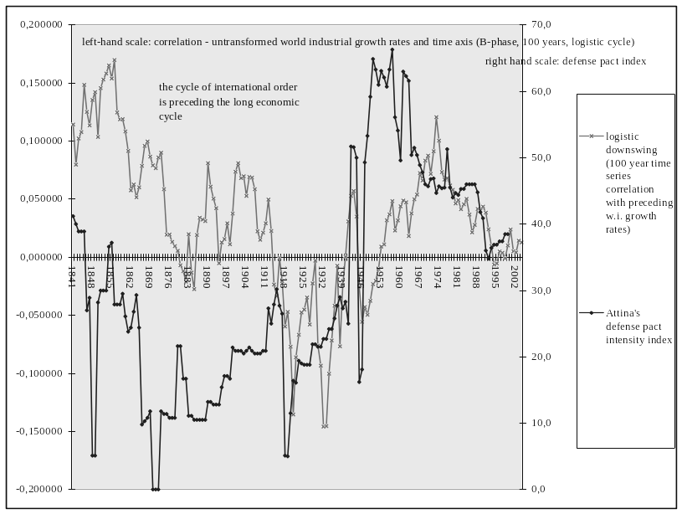
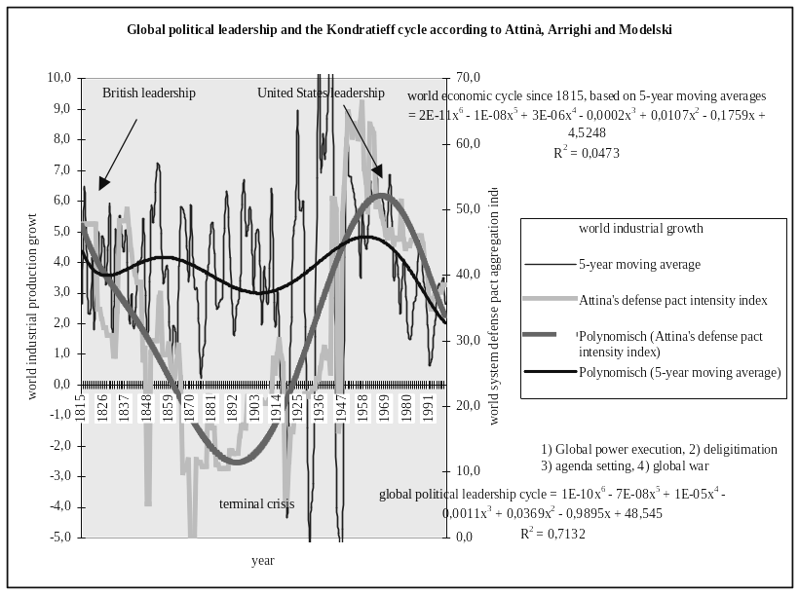
Graph 4a. Global political leadership and the long cycles of world development: declining growth rates and world political de-concentration – the evidence for the period after the Congress of Vienna 1814–1815
Graph 4b. Global political leadership and the long cycles of world development: world political de-concentration and economic stagnation (B-phases of 100 year logistic cycles in the tradition of Wallerstein) – the evidence for the period after the Congress of Vienna 1814–1815
Legend: our own compilations and calculations, based on the cited works of Arrighi, Attinà, Goldstein and Modelski, and UNIDO world industrial production data 1976–2004.

Graph 5a. The regions of the retreat of the respect for civil rights, 1995–2003. The evidence on a world level
Legend: civil rights violations 2003, predicted by the level of civil rights violations, 1995. The dark zones are the countries, where the respect for civil rights (standard Western concept) diminished above the world trend during that period. Source: our own calculations from the Freedom House EXCEL table, available at http://www.freedomhouse.org/ratings/ allscore04.xls
Graph 5b. The regions of the retreat of the respect for civil rights, 1995–2003.The evidence for the ‘North Atlantic arena’
Legend: civil rights violations 2003, predicted by the level of civil rights violations, 1995. The dark zones are the countries, where the respect for civil rights (standard Western concept) diminished above the world trend during that period. Source: our own calculations from the Freedom House EXCEL table, available at http://www.freedomhouse.org/ratings/
allscore04.xls

Graph 6a. War intensity and world industrial production growth since 1946. The original data
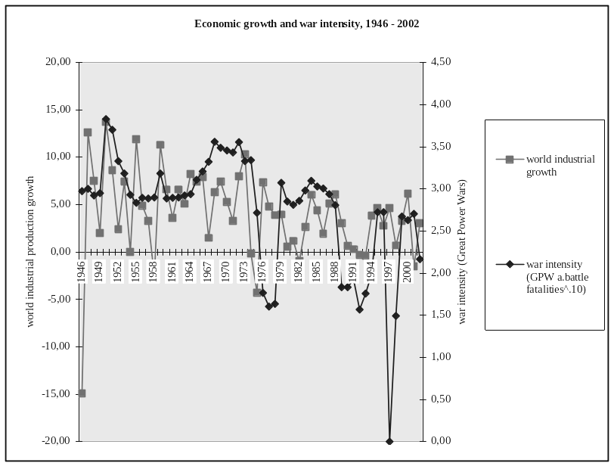
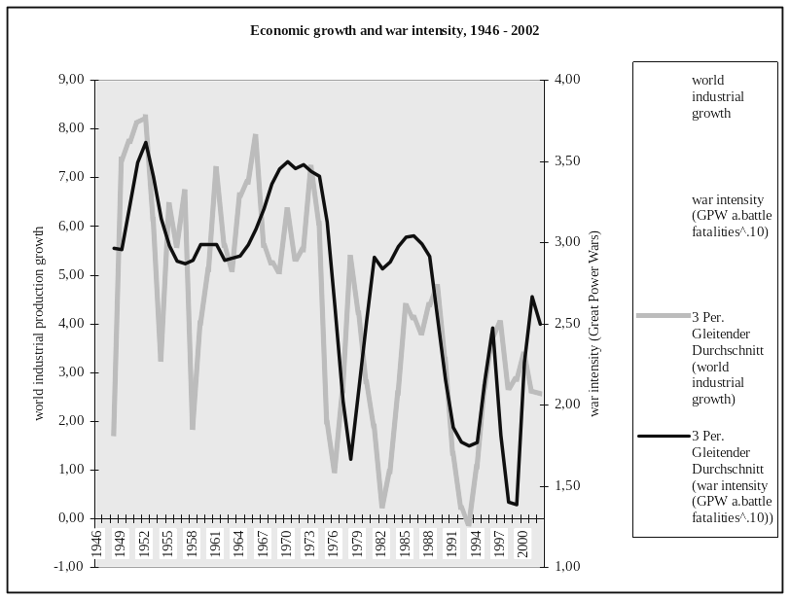
Graph 6b. War intensity and world industrial production growth since 1946. Three-year sliding averages
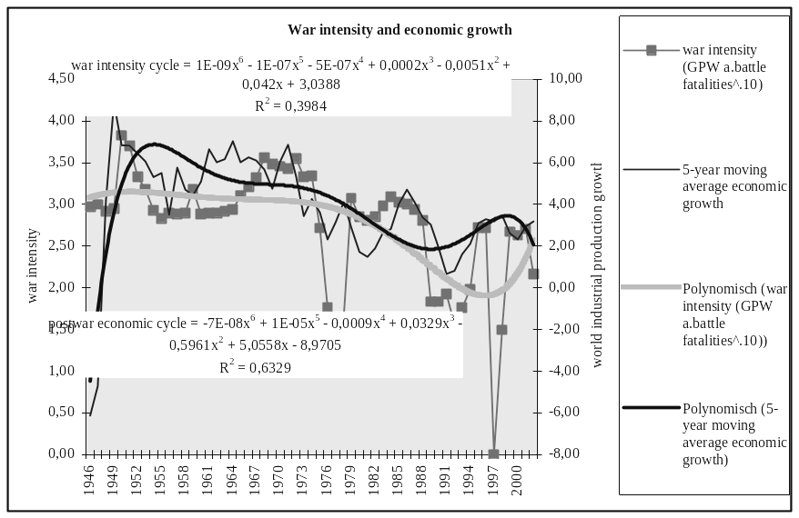
Graph 6c. War intensity and world industrial production growth since 1946. The stylized relationships over time
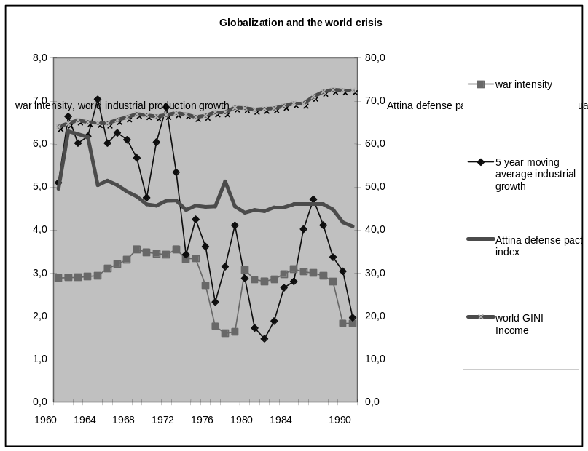
Graph 7. War intensity, growth, alliance stability and world income inequality 1960–1990

Graph 8. global terrorism and the global political/economic cycle
Source: Global economics and conflict data Tausch, 2007; data on global terrorism: United States Department of State, available at: http://www.state.gov/s/ct/rls/crt/2003/

