Stellar Evolution and Social Evolution:

A Study in Parallel Processes*
Robert L. Carneiro
American Museum of Natural History, New York
Abstract
The process of evolution can be seen at work in all domains of nature. It has seemed instructive to point out a number of parallels between the development of stars and the development of human societies. For example, the use of the comparative method has been prominent in the study of evolution in both fields. Also, there are parallels between the two, such as the use of stages to distinguish significant phases of the evolutionary process, the manifestation of both multilinear and unilinear evolution in both, and differential rates of evolution among stars and societies. Pointing out these parallels, which anthropology shares with the more advanced and sophisticated science of astronomy, may help bolster anthropologists in their belief that the evolutionary approach in their own field is a valid one, capable of producing substantial results.
In his book First Principles (1862), published a scant three year after Darwin's The Origin of Species, Herbert Spencer portrayed evolution as something far beyond ‘descent with modification’. He saw it as a much broader process, a process which had manifested itself throughout the Universe, from the tiniest microorganisms to the largest galaxies. The evolution of the stars, then, was clearly within his purview.
And, as a field of astronomical research, stellar evolution has been pursued with increasing vigor and impressive results since Spencer's time. In fact, it is not too much to say that what astronomers and astrophysicists have been able to accomplish in reconstructing the process of cosmic evolution stands as one of the greatest intellectual triumphs of all time.
Social Evolution & History, Vol. 4 No. 1, March 2005 136–159
© 2005 ‘Uchitel’ Publishing House
Spencer (1896: 373) defined evolution as, essentially, a change from simplicity to complexity. And this is still the way astronomers regard it as it manifests itself in the unfolding of the cosmos. Thus the great astrophysicist George Gamow (1952: 20) wrote:
…the basic features which characterize the universe as we know it today are the direct result of some evolutionary developments which must have begun a few billion years ago... With such an assumption, the problem of scientific cosmogony can be formulated as an attempt to reconstruct the evolutionary process which led from the simplicity of the early days of creation to the present immense complexity of the universe…
For some years it has seemed to me that certain striking parallels exist between the evolution of stars and the evolution of human societies, parallels which anthropologists are barely aware of. And while a recognition of these parallels may mean very little to the powerful and sophisticated science of astronomy, it just may be of some interest and value to the fragile and beleaguered field of cultural evolution. Therefore it seems worthwhile to try to point out some of these parallels.
THE COMPARATIVE METHOD IN ASTRONOMY
To begin with, the parallels between stellar and social evolution are not be found simply in the outcome of the two processes. They also exist in the methods used by both astronomy and anthropology in arriving at them. Indeed, the principal tool used by astronomers in studying stellar evolution is the very one first employed by nineteenth-century anthropologists in studying the development of societies, namely, the comparative method. While astronomers never seem to call it by this term, that is precisely what it is.
Consider the problem astronomers face in trying to understand how the stars have evolved. The period of observation of any astronomer – or even all of them put together – is so infinitesimally small compared to the life history of a star that, except for a few dramatic events like a supernova, during an astronomer's lifetime no appreciable change can be detected in the vast majority of the stars he studies. How, then, is he to proceed in ascertaining just how stars have evolved?
As early as the eighteenth century, the distinguished astronomer Sir John Herschel, whose study of the heavens suggested to him that stars might be born out of the condensation of gaseous matter, argued for the utility of comparing many different stars when no single one could be observed for very long:
…to continue the simile I have borrowed from the vegetable kingdom, is it not almost the same thing, whether we live successively to witness the germination, blooming, foliage, fecundity, fading, withering and corruption of a plant, or whether a vast number of specimens, selected from every stage through which the plant passes in the course of its existence, be brought at once to our view? (Quoted in Pagels 1985: 7)
Herschel could hardly have put the matter more precisely: where a process cannot be observed over its entire course in any one individual, it is equivalent to observe it as manifested by a number of individuals, each representing a different stage of that process. In effect, then, what Herschel was saying was that from the comparison of synchronic data one could draw diachronic conclusions. This is the very heart of the comparative method, in astronomy or ethnology.
THE COMPARATIVE METHOD IN ANTHROPOLOGY
As we shall soon see, the type of comparison advocated by Herschel has borne rich fruit in astronomy. In ethnology, the method was widely used in the nineteenth century and yielded substantial and illuminating results. Today, however, the comparative method in ethnology is often decried or ignored, especially when it is used as an adjunct to the study of cultural evolution. For example, George P. Murdock (1966: 97), one of the few ethnologists who ever cited astronomy as a science which made extensive use of comparison, nevertheless failed to recognize the fact that the main reason astronomers compared individual stars was to draw inferences about their evolution.
Although writing thirty years before Murdock, the British anthropologist A. M. Hocart provided what stands as an answer to those who, like Murdock, are fearful of using ethnological comparisons to deduce the course of social evolution:
Astronomy is universally acknowledged to be one of the most exact of sciences; yet it is not afraid to venture into those remote ages for which we cannot hope ever to find direct evidence. Whereas the historian is afraid to discuss the growth of society through a paltry ten thousand years except he has documents for each step, the astronomer coolly reconstructs the history of the solar system for millions of years from observation of the present only. He sees nebulae, suns, dead stars; he supposes that all these represent different stages through which our own solar system has passed or will pass. He imagines a course of development which will explain all the existing facts. Time may modify his scheme, but it does not modify his method (Hocart 1970: 12).
Hocart was writing during a period when anti-evolutionism was still in the ascendancy in anthropology. Astronomy too, it appears, had its own brief fling with anti-evolutionism. Nobel Prize winning astrophysicist Steven Weinberg recalls:
…the urge to trace the history of the universe back to its beginnings is irresistible. ... However, an aura of the disreputable always surrounded such research. I remember that during the time that I was a student and then began my own research... in the 1950s, the study of the early universe was widely regarded as not the sort of thing to which a respectable scientist would devote his time (Weinberg 1979: 1, 2).
With this much of a background, let us look now at how the comparative method was applied by astronomers and what results flowed from it.
THE HERTZSPRUNG-RUSSELL DIAGRAM
The story may be said to begin at Harvard College Observatory in the 1880s when E. C. Pickering and Annie Cannon began to analyse the emission spectra of the visible stars. The stars they examined were placed into several ‘spectral classes’, each class being designated by a letter of the alphabet. Eventually the number of spectral classes was reduced to seven, the letters designating them being O, B, A, F, G, K, and M. It was not known then just what these differences in the spectral classes represented. The observations had been made, but the interpretations had yet to follow. (Recently, the classes L and T have been added to include the newly discovered ‘brown dwarfs’.)
The first great step forward toward interpreting the significance of differences in the spectra of the visible stars was made independently by the Danish astronomer Ejnar Hertzsprung and the American astronomer Henry Norris Russell. Hertzsprung and Russell asked themselves if the luminosity of stars was correlated with their surface temperatures, and, for each star they had observed, they plotted one value against the other. This graphic plotting of the luminosity versus the surface temperature of stars has come to be known as a Hertzsprung-Russell diagram, or, simply, an H-R diagram.
Figure 1 is an H-R diagram which shows that stars are not randomly distributed over the entire graph but are concentrated in certain areas, while being totally lacking in others. The greatest number of stars by far fall along a diagonal running from the lower right-hand corner of the diagram toward the upper left-hand corner. This slightly curved line is now known as the main sequence. (To make the H-R diagram a little more familiar, in Figure 2 the position of several well known stars has been plotted.)
The patterns made by the distribution of stars on an H-R diagram were certainly distinct, but what did they mean? Basically, the interpretation astronomers now make of these patterns is that they reveal sequences in stellar evolution. Stars occurring in different areas of an H-R diagram are at different stages of an overall evolutionary process. Thus, the comparison of certain values of a great many stars, observed at essentially a single point in time, led astronomers to acquire an understanding of how stars as a whole had evolved. The H-R diagram thus contributed mightily to the advancement of astronomical knowledge. And, as Marcia Bartusiak (1993: 82) has observed, ‘This famous graph remains the cornerstone of all astronomical research related to the evolution of stars’.
The important point to keep in mind here is that by plotting stars on an H-R diagram synchronic data had led to a diachronic explanation. Of course, this understanding did not come all at once. Decades of hard work were required for astronomers and astrophysicists to achieve it. And, though the picture of stellar evolution is not absolutely complete, the basic processes are well understood.
Now, in a simplified way, I would like to trace the course of stellar evolution as astronomers have pieced it together. Moreover, along the way, I will try to point out parallels which I think exist between stellar evolution and social evolution.
STAGE AND PROCESS IN STELLAR EVOLUTION
The first discrete population of stars to be identified and labelled were those on the ‘main sequence’, and stars known as red giants and white dwarfs. Later, other categories were added, such as protostars, red dwarfs, brown dwarfs, black dwarfs, subgiants, and supergiants. Shortly, the evolutionary relationship among them will be examined.
First, though, we should note that these types of stars are more than just types; they are also stages. And this fact accounts for a large measure of the differences between them. The same is true of human societies. They differ not just because they are, somehow, different sorts of things, but because they are at different stages of the same general process. Thus, for example, the Powhatan differed from the Paiute for many reasons, but one of the major ones was that they had progressed farther along a specifiable evolutionary track.
The concept of stages is not at all incompatible with that of process. Astronomers recognize that stages in stellar evolution are convenient and useful labels for successive and distinct forms in a process through which all stars have passed. Now, it has become fashionable for some ethnologists and archaeologists who proclaim themselves friendly to evolution to assert that they are not interested in stages, but only in process, as if that were a sign of greater intellectual maturity. Wrong! Stages play the same role in anthropology that they do in astronomy. They designate important way stations along a path that many societies are following. The process of political evolution has passed through certain stages – band, autonomous village, chiefdom, and state, to name the major ones – which label significant contrasting forms of a unitary progression (see Carneiro 2000).
In order to lay the basis for additional parallels between stellar evolution and social evolution, let us take a typical star, one about the size of the sun, and follow its development as it would appear on an H-R diagram. Figure 3 depicts this evolution.
EARLY STAGES IN THE EVOLUTION OF A STAR
The first thing to note is that the main sequence on an H-R diagram, which appears as a long belt running diagonally from lower right to upper left, does not represent the evolutionary path of any given star. The actual ‘life track’ of a star differs from this, and is rather more complicated.
The life of a star begins when a diffuse cloud of gas and interstellar dust, about 100 times the diameter of the sun, becomes a discrete entity and begins to contract. As it does so, it generates increasing amounts of gravitational energy. About half of this energy is radiated away in the form of heat and light, and thus, at a certain point, the newly forming object becomes visible. At this stage the large luminous body is called a protostar. The other half of its gravitational energy remains within the protostar as heat. As contraction continues, the internal temperature of the protostar keeps rising, and when it reaches 5 million degrees Kelvin, it is hot enough for thermonuclear reactions to begin at its core. At this point in its travels on the H-R diagram the star reaches the main sequence. By far the largest number of visible stars lie on the main sequence, and most of a star's life will be spent there.
For the thermonuclear reaction that powers a star to occur, the cloud of contracting gas and interstellar dust must have a certain minimum mass. Astrophysicists have calculated that this mass must be at least 80 times that of the planet Jupiter. Otherwise, gravitational contraction would be unable to generate a high enough temperature to start the reaction. The resulting body would not be a star at all, but a sub-stellar object called a brown dwarf, so faint as to be all but invisible in the night sky. So faint, in fact, that the existence of brown dwarfs was posited on theoretical grounds before one was actually observed.
A cut above brown dwarfs on the scale of celestial objects are red dwarfs. These are small stars, with a mass as little as one-tenth or less that of the sun. But, unlike brown dwarfs, red dwarf are true stars, burning hydrogen into helium, and thus occupying a place on the main sequence of an H-R diagram. It is a lowly place, to be sure (the extreme lower right-hand corner) in terms of both luminosity and surface temperature. Moreover, red dwarfs burn hydrogen so slowly that they are extremely long-lived. Their life span, in fact, is to be measured in trillions, rather than billions, of years. Not only are they relatively stable in terms of remaining virtually unchanged for an incredibly long span of time, they are also thought to be the most abundant type of stars in the Universe (Martin et al. 1997: 523).
RED DWARFS AND VILLAGES: A PARALLEL
Can we find a parallel to red dwarfs among human societies? I think so. In certain respects, we can equate red dwarfs with villages. Over the course of history, the village has been not only the smallest unit of human settlement, but also the most common. And here we come to a most interesting relationship that seems to apply universally, regardless of what sorts of phenomena are being studied. This is the inverse relationship that exists between size and abundance. Astrophysicists have found this relationship to hold, for example, between the atomic weight of a chemical element and its abundance in the solar system: by and large, the heavier the element, the scarcer it is. Thus, for every trillion atoms of hydrogen (atomic weight 1) there are 100 million atoms of nitrogen (atomic weight 14), 1,000 atoms of strontium (atomic weight 88), and
1 atom of uranium (atomic weight 238).
Curiously enough, the same relationship appears to hold in the animal kingdom. A number of years ago, G. Evelyn Hutchinson and Robert MacArthur pointed out that there is an inverse ratio between the number of species of mammals in a taxonomic group and the characteristic size of those species (Blackburn and Gaston 1994: 471). As an example of this relationship, we can cite the fact that there are fewer species of deer than there are of mice, and fewer species of elephants than there are of deer.
Turning to the size and frequency of socio-political units, although this relationship may no longer hold true, it certainly did so up until about A. D. 1000. The autonomous village, the smallest of political units, was the most common. There were more of them than of multi-village chiefdoms, and more chiefdoms than there were states.
Although over the course of history many villages have lost their autonomy and have become incorporated into larger political units, if we focus on their internal structure we find that they remained pretty much the same. They have proved to be remarkably stable units. Indeed, as tightly integrated social units, they have frequently outlasted the overarching political structure of which they often became a part. Thus the early villages of fellahin, the Egyptian peasants that already existed in Predynastic times, remained as enduring settlements long after the Old and New Kingdoms had fallen by the wayside.
In summary, I think it is safe to say, without straining the parallels unduly, that in terms of abundance, stability, and duration the villages that populated the Earth can be said to be roughly comparable to the red dwarfs that populate the heavens.
THE FORCES OF FUSION IN STARS AND SOCIETIES
We have seen that thermonuclear reactions, beginning with the conversion of hydrogen into helium, are what power the evolution of the stars. Just as the formation of helium in a star's interior requires overcoming the repulsive tendencies between hydrogen nuclei, so the problem in chiefdom formation requires overcoming the strongly-held political autonomy of individual villages. The creation of chiefdoms, then, like the creation of helium, consists essentially of fusing together elementary units, previously separate, into larger and more complex wholes.
This process, however, takes place against the will, so to speak, of the elementary units involved. In stars, it is heat that overcomes the repulsive tendency of individual atoms and causes them to fuse together. In the case of human societies, it is warfare. In each case, a strong force was required to achieve the resulting integration. The parallel becomes clearer when we examine more closely the corresponding fusion processes involved.
How fast the conversion of hydrogen into helium takes place within a star depends not only on temperature, but also on the density of the hydrogen nuclei available for the reaction. Astrophysicists have calculated that the rate of hydrogen burning in a star is proportional to the square of the number of hydrogen nuclei present (Wyatt and Kaler 1974: 375). Therefore, if the density of nuclei in a stellar core is doubled, the rate of hydrogen burning is quadrupled. Consequently, the more densely packed the atoms taking part in a thermonuclear reaction, the more rapidly the star will evolve.
Anthropologists generally agree that the overcoming of village autonomy and the onset of chiefdom-formation are closely geared to the density of population, especially as measured by the number of villages in a given area. That being the case, the following question now readily suggests itself: Is it possible that the force that leads to the aggregation of autonomous villages into chiefdoms is proportional not to the first power of the number of villages, but to the square of that number? Were this true, it would mean that if we doubled the number of villages in a designated area, we would not simple halve the time it would take for a chiefdom to emerge, but quarter it.
This is indeed an intriguing possibility. It would present us with a rather striking quantitative regularity in the development of culture. However, so lagging is the study of social evolution compared to that of stellar evolution that anthropologists have not even raised this possibility, let alone explored it. However, this is not the first time that a law of squares has been proposed in anthropology. In accounting for village splitting, it has been suggested that the tendency for an autonomous village to fission may proportional to the square of its population (Carneiro 1987: 100).
THE LIFE HISTORY OF STARS
Let us return now to the life history of stars and, having left red dwarfs behind, let us examine stars of a larger magnitude, more typical of the ones we see in the night sky. On the H-R diagram in Figure 3 the evolutionary track of such a star is represented. It begins as a luminous but rather cool body of gas which grows less luminous as it contracts. Thus we see the line representing it sliding down the luminosity scale. But, at the same time that the star is contracting, its surface temperature is increasing. This moves the star to the left on the H-R diagram, until we find it on the main sequence.
After spending much of its life at about the same point on the main sequence, the star becomes more luminous again but its surface temperature decreases. Looking at Figure 3 we see that the star has now climbed into the area of red giants. From here, the star begins to increase its surface temperature, but its luminosity declines and eventually it plunges sharply down to the bottom of the H-R diagram, where, still quite hot but very dim, it becomes a white dwarf.
All stars of roughly the same mass as the sun go through these same stages in essentially the same way. Were we to plot the life history of another star of the same mass as the sun, its track, if not exactly superimposed on that of the sun, would be very closely parallel to it. In the language of anthropology, we can say that stars of this class size manifest unilinear evolution. That is to say, a single line of development can be said to characterize their life history.
UNILINEARITY AND MULTILINEARITY
If from stars we turn to states, we can say that in their development, states have run a roughly similar course. To a large extent, they have evolved unilinearly. They have gone from bands to autonomous villages, to chiefdoms, to states, in that order, with no skipping or inverting of stages. For example, we do not find states appearing before autonomous villages, or chiefdoms before bands, any more than white dwarfs come on the scene before red giants.
The similarity in the general evolutionary track followed by evolving societies reflects in part a similar response to common and insistent structural challenges posed to societies as they encompass more and more settlements and grow correspondingly in size. This increase in ‘social mass’ requires societies to elaborate their structure and thus to become more complex. More specifically, this is manifested by the development of successively higher levels of socio-cultural integration as societies seek to maintain themselves as viable, functioning entities. This is a point that was stressed by Julian Steward (1955: 43–63) in his discussion of cultural evolution.
However, external conditions also play a role in a society's evolution. If these conditions are sufficiently different from society to society, we can expect the structural outcomes to be different as well. Thus, arising in very different environments, the Inca and the Maya followed rather different developmental paths. They both formed states, but of markedly different kinds. And whenever we find large enough differences in the ways societies evolved, we speak of them as exhibiting multilinear evolution. While not actually coining the term ‘multilinear evolution’, it was Julian Steward who gave the concept great currency in his study of societies which, while evolving in the same general direction, had not followed quite the same path.
MULTILINEARITY IN STELLAR EVOLUTION
Multilinear evolution, it turns out, can also be found in astronomy. Stars as well as societies may evolve in substantially different ways. And the principal factor determining the differences in the evolution of stars is their mass. Astronomers have found that stars having a mass greater than 1.4 times that of the sun evolve differently from the sun. Figure 4 shows the evolutionary track of a star with 5 times the solar mass, and it is readily apparent if we compare Figures 3 and 4 that the path of a 5-solar-mass star across the H-R diagram is quite different from that of the sun. Having collected and concentrated much more gas and interstellar dust, a star of this size begins life as a more luminous body than did the sun. It then moves directly to the left on the H-R diagram and reaches the main sequence at a higher point than did the sun. This means that when a star of this magnitude reaches the main sequence it is considerably hotter and more luminous than the sun. Its larger mass has given it a greater surface area from which to radiate light, and has also permitted it to generate higher temperatures.
This fact, incidentally, explains why the main sequence forms such a long belt of stars. Since stars of greater mass reach the main sequence at higher points, and since stellar masses vary by a factor of 750 (their range being from .08 to 60 times the solar mass), the dots representing them are distributed all along the diagonal on an H-R diagram.
Now, when a large star finally veers off the main sequences, its subsequent path on the diagram appears more erratic than the sun's, zigzagging back and forth across the top of the diagram. First, a massive star becomes a red giant or supergiant, but then it heats up again until it glows blue-white. It continues to oscillate between these two states for some time before finally plunging down the diagram and ending up at the bottom as a white dwarf – still hot, but much less luminous.
In this comparison, then, between the sun and a 5-solar-mass star we have an instance of what might be called bilinear evolution. Stars of 5 solar masses evolve alike, but rather differently from stars of only 1 solar mass. When we compare even more massive stars, however, the situation becomes frankly multilinear. For example, a star with a mass 10 times or greater than that of the sun may not end its days quietly as a white dwarf at all, but may instead explode in a gigantic burst of energy known as a supernova, ending up as a neutron star if it is substantially more massive than the sun, or a black hole if it is even bigger.
These are the sorts of evolutionary tracks which stars follow on an H-R diagram. But, just as with social evolution, the study of stellar evolution is not concerned with tracks and stages alone. It is also concerned with process. Astronomers and anthropologists alike are out to discover just why it is that their respective phenomena evolve as they do. Here the achievements of astronomy in working out the underlying modes of stellar evolution have been truly remarkable. Through theoretical calculations as well as from empirical observations, astronomers and astrophysicists have constructed a detailed and compelling picture of the life history of stars.
UNDERLYING PROCESSES OF STELLAR EVOLUTION
Let me sketch briefly the internal processes that determine why stars follow the evolutionary paths they do. As we have seen, the initial phase of stellar evolution consists of the contraction of interstellar dust until it forms a glowing mass known as a protostar. With continued contraction, the initial temperature of a protostar increases and its size decreases until the point is reached at which the glowing object is called a star. Once a star attains a core temperature of 5 million degrees, thermonuclear reactions begin. In these reactions – called ‘hydrogen burning’ – four hydrogen nuclei are fused together to form an atom of helium. With this reaction well underway, the protostar has become a fully fledged star.
The star soon reaches a state of equilibrium, the radiation pressure generated by nuclear fusion at its core balancing the inward pressure of gravitational contraction. It is then that the star attains the main sequence, the exact point at which it reaches it depending upon its mass. The greater its mass, the higher up on the diagonal it lands. How long it will remain on the main sequence also depends on its mass. A star with the mass of the sun is destined to stay on the main sequence a long time. The sun, in fact, is estimated to have been on the main sequence for some 5 billion years, and is expected to remain there for another 5 billion.
Sooner or later, though, every star except the smallest, moves up and to the right on the H-R diagram, away from the main sequence. Why does this happen?
Through continued thermonuclear reactions, a star's core is entirely converted from hydrogen to helium. The helium core, being denser, exerts a more powerful gravitational force and contracts further. This contraction generates more heat, bringing about an increase in hydrogen burning, which is now taking place only in the outer shell, surrounding the core. Under the radiation pressure of this higher rate of thermonuclear reaction, the envelope of gas surrounding the star's core expands and, as it does so, the star becomes larger and therefore more luminous. But, as this outer envelope grows in size, it also becomes more attenuated, and so its temperature falls. Viewed by an astronomer on Earth, the star has grown both brighter and cooler. Thus, on the H-R diagram it has moved up and to the right and is now a red giant.
What happens next? As the star continues to contract, its core will reach a temperature in excess of 100 million degrees. When this point is reached, the core is hot enough for helium burning to begin, forming carbon. The star's gaseous envelope now ceases to expand and, in fact, reverses, so the star begins its retreat from the red giant phase. This involves a decrease in both luminosity and surface temperature as the star moves down and to the right on the H-R diagram, and again approaches the diagonal of the main sequence.
But, having become unstable, the star is not destined to stay on the main sequence very long. Due to the continuing effect of gravitation, further contraction takes place, raising the star's internal temperature even higher. With that, new kinds of thermonuclear reactions become possible. Helium is now burned to form carbon, and then, with carbon as the nuclear fuel, heavier elements are successively produced, with neon, oxygen, magnesium, and silicon arising in that order (Pagels 1985: 44). Finally, as the internal temperature grows even hotter, silicon atoms fuse to form iron. The internal structure of the star now consists of several concentric shells of various elements around an iron core.
SOCIETAL PARALLELS
Certain parallels can be said to exist between the processes just described for a star and those undergone by an evolving society. To begin with, both entities are becoming more complex. A star does so by producing a succession of new chemical elements, each of which has a higher atomic weight than the constituent atoms from which it was made. Likewise, a society evolves by forming an increasingly greater number and variety of social units and segments, the newer ones tending to incorporate the smaller ones that preceded it.
A further parallel can be detected. The chemical elements being produced in its interior by an evolving star are not distributed randomly throughout its mass. They are arranged in a series of shells around a central core, their position depending on when during the evolutionary process they were formed. Similarly, the structural features arising in an evolving society are not disparate bits and pieces, distributed haphazardly within it, but are arranged in an orderly fashion. Social, economic, and political institutions have their distinct levels of organization. Generally speaking, the more numerous and varied the segments of a society, the more they are likely to be grouped together into successive, more inclusive levels of socio-cultural integration, as Julian Steward (1955: 43–63) emphasized.
BACK TO THE STARS
The final outcome of stellar evolution depends on the mass of a star. If it is not much greater than that of the sun, it will successively expel its outer gaseous envelope, and then, its nuclear furnace now turned off, its only source of energy is gravitational contraction. Reduced in size to a white dwarf, the star will continue to shine feebly for billions of years. At last, though, even this source of energy runs out and the star becomes a black dwarf, a totally dead and invisible object.
Now, if the mass of a star is greater than 10 times the solar mass, a very different fate awaits it. Its iron core gets hotter and hotter until it finally collapses. Under the enormous pressure produced by this collapse, electrons are forced into the nuclei of their atoms, forming neutrons and neutrinos. Then, no longer able to accommodate the incalculable pressure thus generated, the interior of the star rebounds outward, tearing the star apart and causing it to burst forth in a spectacular astronomical event known as a supernova. In this colossal explosion, a star ejects as much as 90 per cent of its material into space. All elements heavier than iron – elements that could not be formed before – are now produced through the enormously high temperature that only a supernova can generate. Supernovas, in fact, are the source of all the heavier elements encountered throughout the Universe, including those found on Earth.
THE COMPARISON WITH SOCIETIES
This picture of the process of stellar evolution is certainly a dramatic and compelling one. Do we have anything to match it in anthropology? I think we do, and the parallel I would draw is with the origin and evolution of the state. From one perspective, state formation certainly involves an increase in mass – the aggregation and integration of smaller political units into larger ones. This may be likened to the capture and condensation of gas particles by a star during its early phases. Just as a brown dwarf cannot develop into a true star for lack of sufficient mass, a society cannot form a state unless it encompasses a certain minimum number of people. With a ‘social mass’ below some critical level, the maximum size a society can hope to attain may be that of a small chiefdom, but not a state.
From this point on, stellar evolution manifests two processes which are parallel to those exhibited by social evolution: one is external and the other internal. The external processes are changes in the luminosity and surface temperature of a star. The internal processes are the series of nuclear reactions which build up successively heavier elements.
In their own evolution, states reveal similar kinds of external and internal changes. Externally, the origination of a state is much like the formation of a protostar. Each involves the coalescing of diffuse and disparate material into a more compact and cohesive whole. In state formation, a number of autonomous units – first villages, and then chiefdoms – are brought together to form increasingly larger political aggregates.
Internally, first as a chiefdom and then as a state, a polity continues to elaborate its structure in order to accommodate and integrate its growing mass. New structural features are continually being developed to accomplish this. In a relatively advanced state, for example, specialized ministries, such as those of agriculture, interior, finance, and war, may be created to carry out various functions which are important for the state to control, supervise, or regulate.
PRIMARY AND SECONDARY STARS AND STATES
We come now to another aspect of stellar evolution for which social evolution provides a ready parallel. This is the distinction, first made by the astronomer Walter Baade in 1942, between two classes of stars which he labelled Population I and Population II. Despite bearing the higher number, Population II stars are the older, and thus more primitive or pristine, of the two stellar populations. Population II stars were formed early in cosmic history and consist almost entirely of hydrogen, with a bit of helium thrown in. But no heavier elements are present in them. These Population II stars were formed directly from the elemental, primeval cosmic matter spewed out by the Big Bang. During most of their lives, these stars, if of moderate size, behaved in the manner already described for the sun.
In the later stages of their lives, however, Population II stars of very massive size develop internal temperatures great enough to produce heavier elements up to iron. But that is the end of the line for them. ‘An iron core cannot produce any further energy by fusion, no matter how hot and dense it becomes’ (Kaler 1999: 43). Thus they have reached the limits of nucleosynthesis. But then something dramatic happens. These stars undergo the cataclysmic explosion of a supernova and, in the tremendous heat thus generated, all the heavier elements above iron are created. But the explosive force of the supernova not only creates these elements, it ejects them far out into space in enormous quantities.
The clouds of interstellar dust formed by the disintegration and spewing forth of the material of Population II stars provide the ‘seed bed’ for the formation of new stars. These new, ‘second-generation’ stars are identifiably different in chemical composition from their predecessors. The cosmic dust that they gather and condense contains – although only in relatively tiny amounts – many of the heavier elements which first-generation (Population II) stars completely lacked. The sun is an example of such a second-generation (or third- or fourth- generation?) star, containing more than 60 of the known elements (Motz 1975: 109).
Now, what parallel to this do we find in social evolution? The most obvious one is the distinction first made by Morton Fried (1967: 231–235) between pristine and secondary states. Pristine states are those which evolved entirely on their own, before there were any other states around to copy or to borrow from. Secondary states are those which were formed later, generally in the same region as pristine states. To varying degrees, they were familiar with, and were able to incorporate, inventions and developments made by the preceding pristine states, like the Assyrian Empire, which arose out of the ashes, so to speak, of the Babylonian Empire, which preceded it. With this assist, secondary states were often able to evolve faster than pristine ones. And that brings us to the subject of rates of evolution.
RATES OF EVOLUTION
Anthropologists are well aware that not all societies have evolved at the same rate or to the same degree. For example, those societies living in the Nile Valley and along the Tigris–Euphrates around 5000 B. C. evolved much faster during the ensuing three millennia than those living in, say, the Congo basin or on the Baltic shore. And so it is with stars. They evolve at very different rates. The principal variable involved in determining the rate of evolution of a star is its mass. The larger it is, the faster it evolves.
In the case of human societies, however, the process is more complicated. The principal variables determining how fast a society will evolve are, as I have argued elsewhere (Carneiro 1970), population pressure, warfare, and, especially, environmental circumscription. The more tightly hemmed in autonomous villages are in a valley or on an island, the sooner warfare will lead them to coalesce and integrate into larger political units: first chiefdoms and then states. Thus the Minoans, sharply bounded by the sea on the island of Crete, were able to form a state well before one could emerge on the mainland of Europe, with its extensive and relatively unbounded expanses.
As just noted, the principal determinant of the rate of a star's evolution is its mass. Consequently, a massive star will reach the main sequence earlier and leave it sooner than a smaller one like the sun. Thus, while a star of the same mass as the sun will remain on the main sequence for some 10 billion years, a star with 5 times the solar mass will remain there only 68 million years, and one of 30 solar masses will leave the main sequence after a stay of only
5 million years.
Why do massive stars evolve so much more rapidly than stars of moderate size? The answer is that, being larger, they generate much greater pressures and temperatures in their cores, permitting thermonuclear reactions to take place much more vigorously
and therefore to proceed at a much higher rate. The supergiant
star Rigel in the constellation Orion, for example, consumes
its nuclear fuel of hydrogen at a rate 60,000 faster than the sun (Motz 1975: 116–117).
As we have seen, a star stays on the main sequence as long as it is burning hydrogen, during which stage it is in thermodynamic equilibrium. But when 12 per cent of its mass has been converted into helium (the so-called Chandrasekhar limit), the star, which was previously in balance between radiation pressure pushing out and gravitation pushing in, becomes unstable and moves away from the main sequence and toward the area of the red giants. Moreover, it does so very rapidly. So rapidly, in fact, that the area on the H-R diagram between the main sequence and the red giants is nearly vacant. Stars move through this region so fast that very few of them have been caught in mid-passage.
Mathematically, a star's life span is inversely proportional to the cube of its mass. Thus, of two stars, if one of them is twice as large as the other, it will survive only 1/8 as long.
Anyone familiar with chemistry will note a similarity between what I have just described and the principle of mass action. According to that principle, the speed of a chemical reaction is directly proportional to the number of units – molecules, atoms, ions, etc. – entering into the reaction.
The analogy we find in social evolution is that larger societies – societies with more people, more elaborate social structures, and a greater inventory of culture traits – evolve faster than smaller ones. Other factors being equal, the number of new cultural elements – traits, customs, practices, institutions – generated by a society is directly proportional to the number it already has. The recognition of this relationship is by no means new. It was expressed some
80 years ago by William F. Ogburn in his book Social Change. There Ogburn pointed out that the number of inventions a society makes per unit of time varies directly as the size of its culture base (Ogburn 1922: 103–118).
CONCLUSION
So there we have it. There are indeed a number of parallels between stellar evolution as astronomers and astrophysicists have revealed it and social evolution as anthropologists have reconstructed it. Both sets of scientists make effective use of the comparative method. Both find in their phenomena distinct sequences and stages of development. Some of these sequences can be termed unilinear, while others are multilinear. Both sets of scientists attempt to lay bare the driving forces underlying the sequences they observe. Both find in the entities they study differential rates of evolution which are closely related to their size. And finally, both astronomy and astrophysics, on the one hand, and anthropology, on the other, see in the evolution of their phenomena a progression from simple, diffuse, and inchoate beginnings to a level of development in which complexity is a common and prominent feature.
As I stated earlier, astronomy may little benefit from recognition of this parallelism with anthropology. But it may help stiffen the sinews of those anthropologists who have come to doubt the validity of the evolutionary approach in their own field. This article may permit them to see more clearly that what culture has done is to take up the torch of a universal process which began eons ago with the Big Bang, and which continues, at an accelerated pace, throughout the Universe. This process has seen stars evolve to the point where, in at least one tiny corner of a particular galaxy, conditions developed which allowed a presumptuous primate to arise. And those intricate social arrangements which he devised and calls ‘culture’, he regards, in his less modest moments, as the capstone of cosmic evolution.
NOTE
* This article first appeared in the Journal of the Steward Anthropological Society, vol. 28, nos 1–2, pp. 1–23, 2000, although not actually published until August 2004.
I would like to thank Neil de Grasse Tyson and Michael Shara, astrophysicists and colleagues at the American Museum of Natural History, for reading an earlier version of this paper and offering their incisive and informed comments. However, for any errors that may remain in the paper, the author is alone responsible.
REFERENCES
Aller, L. H.
1991. Atoms, Stars, and Nebulae. 3rd edition. Cambridge: Cambridge University Press.
Bartusiak, M.
1993 Through a Universe Darkly. New York: Avon Books.
Blackburn, T. M., and Gaston, K. J.
1994. Animal Body Size Distributions: Patterns, Mechanisms, and Implications. Trends in Ecology and Evolution 9: 471–474.
Carneiro, R. L.
1970. A Theory of the Origin of the State. Science 169: 733–738.
1987. Village Splitting as a Function of Population Size. In Donald, L. (ed.), Themes in Ethnology and Culture History (pp. 94–124). Meerut, India: For Folklore Institute, Archana Publications.
2000. Process vs. Stages: A False Dichotomy in Tracing the Rise of the State. In Kradin, N. N. et al. (eds.), Alternatives of Social Evolution (pp. 52–58). Vladivostok: Far Eastern Branch of the Russian Academy of Sciences.
Fried, M. H.
1967. The Evolution of Political Society. New York: Random House.
Friedman, H.
1990. The Astronomer's Universe. New York: W. W. Norton & Company.
Gamow, G.
1952. The Creation of the Universe. New York: The Viking Press.
Hocart, A. M.
1970. Kings and Councillors. Chicago: University of Chicago Press.
Kaler, J. B.
1999. Stellar Evolution. Sky & Telescope March: 40–47.
Maffei, P.
1982. The Universe in Times. Cambridge, Mass.: MIT Press.
Martin, E. L., Rebolo, R., and Zapatero-Osorio, M. R.
1997. The Discovery of Brown Dwarfs. American Scientist 85: 522–529.
Motz, L.
1975. The Universe, Its Beginning and End. New York: Charles Scribner's Sons.
Murdock, G. P.
1966. Cross-Cultural Sampling. Ethnology 5: 97–114.
Ogburn, W. F.
1922. Social Change. New York: Ben Huebsch.
Pagels, H.
1985. Perfect Symmetry. New York: Bantam Books.
Spencer, H.
1862. First Principles. 1st edition. London: Williams & Norgate.
1896. First Principles. 4th edition. New York: D. Appleton and Company.
Steward, J. H.
1955. Theory of Culture Change. Urbana: University of Illinois Press.
Weinberg, S.
1979. The First Three Minutes; A Modern View of the Origin of the Universe. New York: Bantam Books.
Wyatt, S., and Kaler, J.
1974. Principles of Astronomy: A Short Version. Boston: Allyn and Bacon, Inc.
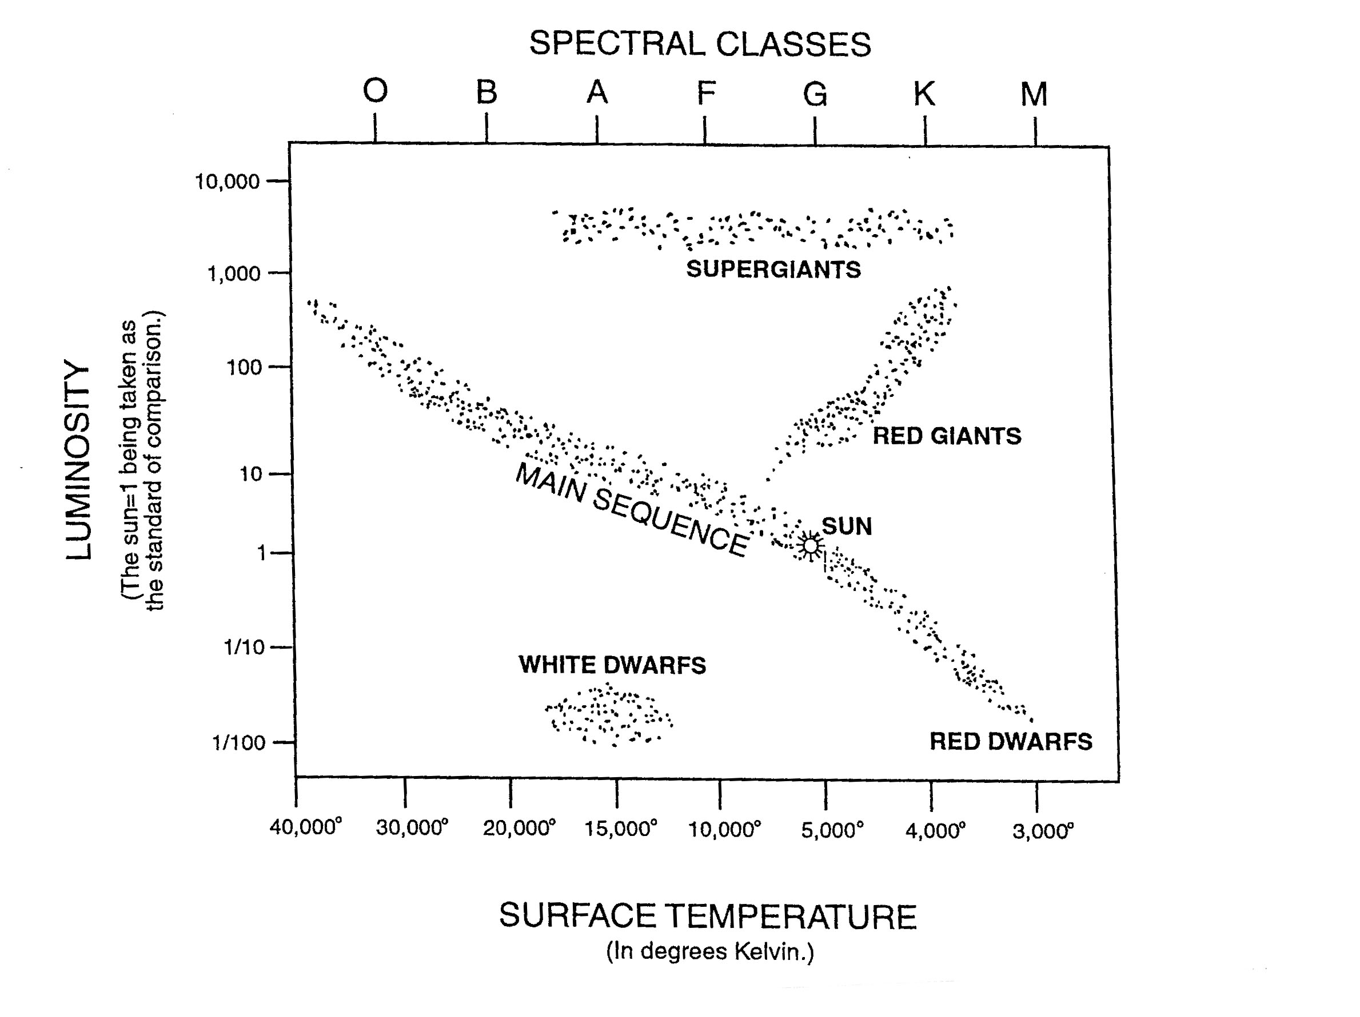Fig. 1. Hertzsprung-Russell (H-R) Diagram
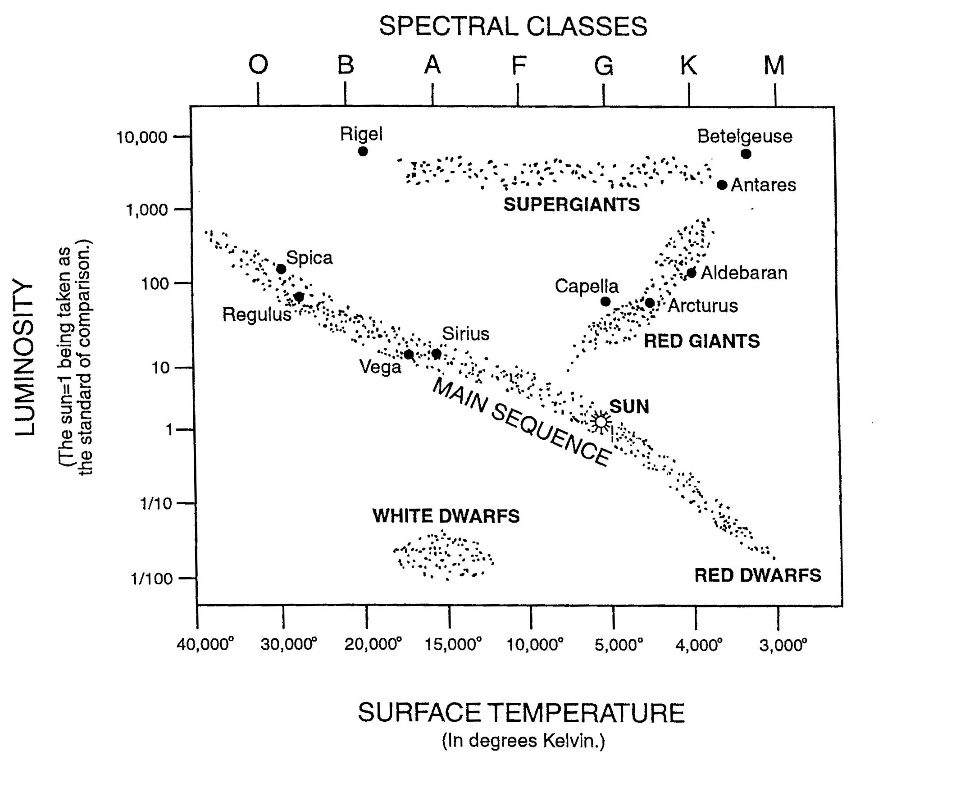
Fig. 2. H-R Diagram locating some well-known stars
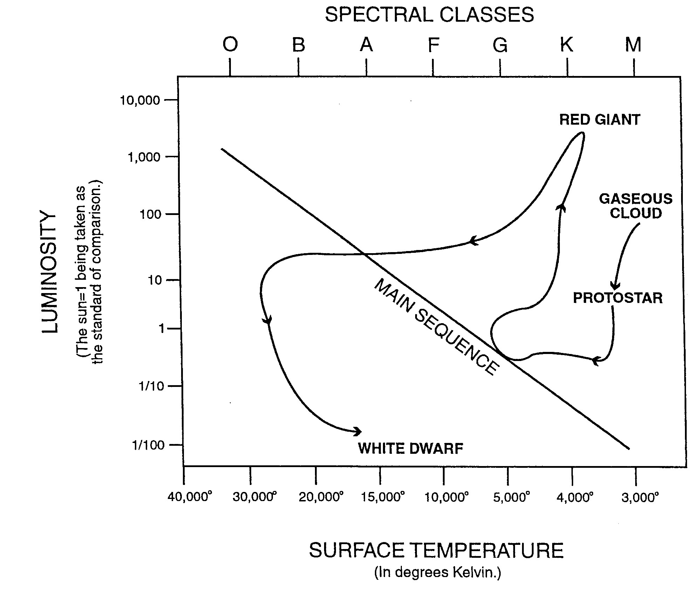
Fig. 3. Evolutionary track of a star with the same mass as the Sun
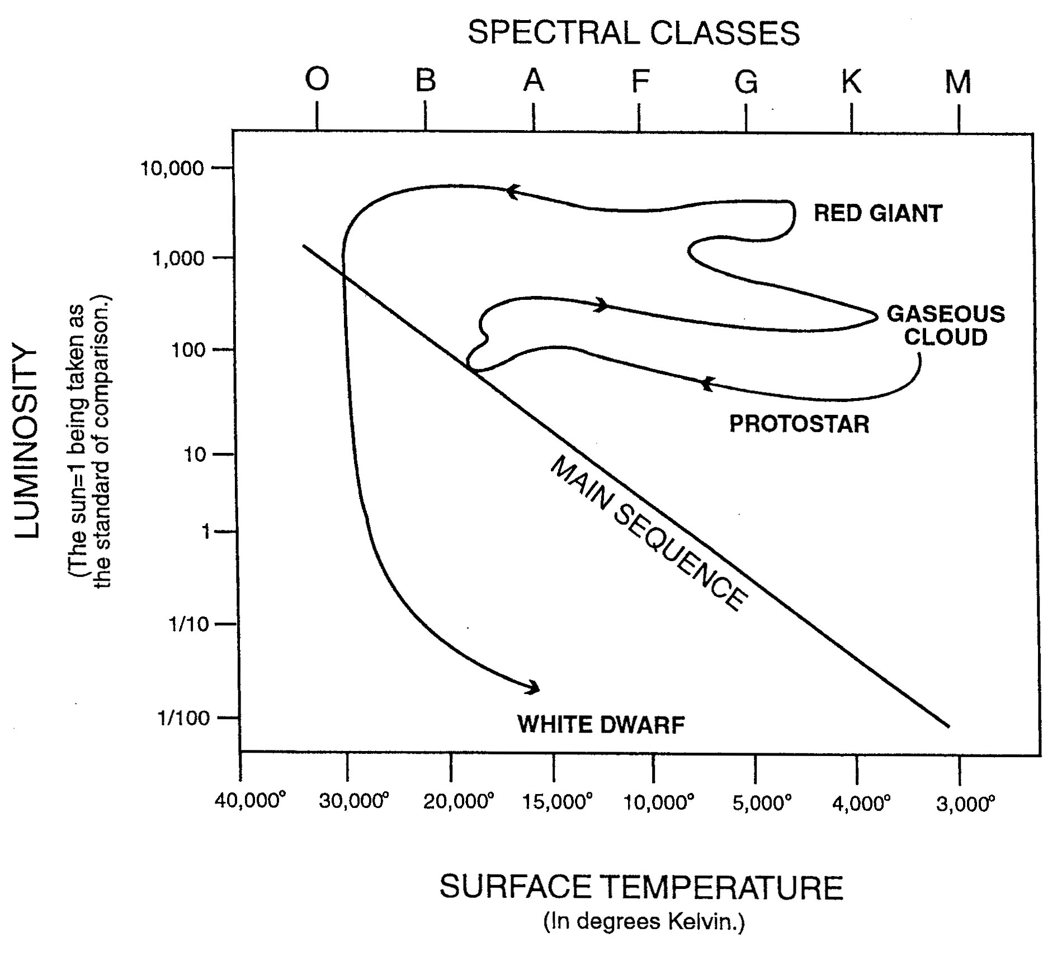
Fig. 4. Evolutionary track of a star with 5 times the mass
of the Sun

