Big History or Big Theory?
Uncovering the Laws of Life*
Graeme Donald Snooks

Institute of Advanced Studies
Australian National University, Canberra
ABSTRACT
What is the point of big history? There are two possibilities. It can be employed – in the way much scholarly work is – as a form of intellectual entertainment; or, alternatively, as a basis for constructing big theory. Why big theory? Because it is essential, if we wish to examine the nature and society of mankind, to explore critical problems in society and formulate remedial policy, and to make sensible and useful predictions about the future. Once our choice has been made, the issues become whether big history should be written forwards (starting with the big bang) or backwards (starting with today), how we get from big history to big theory, how we can uncover the laws of life – as in The Collapse of Darwinism (Snooks 2003) – and whether we can employ the same general dynamic theory to explain and predict the fluctuating fortunes of inorganic as well as of organic structures.
WHY BOTHER WITH BIG HISTORY?
One of the most rapidly developing subjects in the social sciences over the past decade has been what is variously known as universal history, big history, global history, and world history. When David Christian and I first debated the nature and merits of ‘big history’ – during a conference at Monash University in Australia at the beginning of the 1990s – few scholars had a professional interest in this subject. Since then there has been an explosion of papers given at national and international conferences, of books published, and
Social Evolution & History, Vol. 4 No. 1, March 2005 160–188
© 2005 ‘Uchitel’ Publishing House
of journals – like this one – established to deal with the issue of how societies, species, dynasties, planets, solar systems, galaxies, and even universes have emerged, expanded, stagnated, and collapsed, only to repeat this process again and again, possibly endlessly. Predictably this subject has divided into distinct and, often, mutually exclusive groups that have emerged along discipline lines, which include historians, historical sociologists, anthropologists, historical economists, and behavioural scientists. Each group tends to refer to their own literature and to ignore that of the others.
How do we account for the rapid emergence of big history? Needless to say, individuals and small national groups – including Heraclitus, Plato, Hegel, Marx, Spencer, Spengler, Toynbee, Comte, J. S. Mill, H. T. Buckle, together with some of the German historicists, Russian Marxists, and Western apologists – have always been attracted to these bigger issues. What requires explanation is why the interests of individuals became an international movement during the last decade of the twentieth century and the first decade of the twenty-first century.
While this might become a significant subject of study in its own right, the dynamic-strategy theory, which I have been developing for the past few decades, suggests that it is a response to the need (‘strategic demand’) to understand the underlying dynamic forces of our era. Forces responsible for the rapid development of globalization, the rise and fall of great powers such as the USSR, the rise and stagnation of Japan, the rise and rise of Europe and the USA, and the challenge posed by the emergence of that sleeping giant China. We need to understand these issues, among others, in order both to survive the global changes that are currently unfolding, and to face the future confidently. In turn, this need has fed a desire among some of us to understand the emergence and future not only of our own – and related – species, but of the world and universe in which we live.
Why bother with big history? It is through big history that we can best come to understand human nature, the way society works, and where we might be heading. This is necessary if we wish to resolve economic, political, social, and psychological problems that surround us daily. Of course, for some historians and their readers big history meets a different need – that of diversionary entertainment, which leads them away from these centrally important issues. I assume this is not the concern of readers of these pages.
How can big history throw light on these contemporary problems? Big history is essential to provide the insights required to model the fluctuating fortunes – past, present, and future – of human society and life. Big history, in other words, is the source of big theory. While there is a degree of consensus on this, I detect a divergence of views about the way this theory should be constructed – ranging from eclecticism to innovation.
The eclectic approach is that big history should be used to draw together current theories on aspects of our deep past from various disciplines in the natural sciences, the social sciences, the behavioural sciences, and the humanities. David Christian, in this volume, enthusiastically advocates ‘booty raids into neighbouring disciplines’ – disciplines concerned with the origins of life, the planet, the galaxy, and even the Universe. And he endorses the ‘consilience’ program of E. O. Wilson (1998), which is more subversive than it appears at first sight.
What Christian does not make clear is that Wilson's program is directed not towards drawing all the sciences together, but rather to engineering a sociobiological takeover of all branches of knowledge, including the social sciences and humanities. This long-held objective is made clear in Wilson's magnum opus, Sociobiology: The New Synthesis (1975: 4), where he asserts:
It may not be too much to say that sociology and the other social sciences, as well as the humanities, are the last branches of biology waiting to be included in the Modern Synthesis [neo-Darwinism]. One of the functions of sociobiology, then, is to reformulate the foundations of the social sciences in a way that draws these subjects into the Modern Synthesis.
Owing to the resistance Wilson encountered from social scientists over the following decades, his tone, if not his intent, in Consilience (1998) is more conciliatory. Rather than demanding unconditional surrender from social scientists, as he did in the 1970s, Wilson merely insists that we play a junior role in his great sociobiological scheme. He still insists, with a degree of shrillness, that human culture will only be fully understood through the biological study of both the human brain and human nature. It is, therefore, worth laying bare the true objectives of Wilson's ‘consilience’ program, which I suspect few practitioners of big history will be willing to endorse.
Wilson's unreformed belief in the central role played by genetics in human behaviour is conveyed rather aptly by his provocative metaphor of the ‘genetic leash’. Employed at least as early as the 1970s in On Human Nature (1978), the ‘genetic leash’ concept was still part of his vocabulary as recently as the turn of the century in Consilience (1998). In responding to a rhetorical question on that earlier occasion, Wilson (1978: 167) proclaimed:
Can the cultural evolution of higher ethical values gain a direction and momentum of its own and completely replace genetic evolution? I think not. The genes hold culture on a leash. The leash is very long, but inevitably values will be constrained in accordance with their effects on the human gene pool.
The human ‘dog’, therefore, is under the direct control of its ‘master’ the gene. This is, of course, merely an alternative metaphor – although far more provocative and offensive – to Richard Dawkins' ‘selfish gene’ (Dawkins 1976). Both metaphors, as I have attempted to demonstrate (Snooks 2003: chs 6–8), are, like the underlying neo-Darwinist theory, entirely misleading.
Despite his more conciliatory tone in Consilience, Wilson continues to hold his former gene-centric views and to employ the ‘genetic leash’ metaphor. When discussing the alleged parallel ‘evolution’ (or ‘coevolution’) of genes and culture throughout mankind's history in this book, Wilson asks rhetorically: ‘How tight was the genetic leash? That is the key question, and it is possible to give only a partial answer’. And that answer is:
In general the epigenetic rules are strong enough to be visibly constraining. They have left an indelible stamp on the behaviour of people in even the most sophisticated societies (Wilson 1998: 158)
Also, when explaining that different scholars have different views on how tight the ‘leash’ is, Wilson (1998: 143) writes:
Nurturists think that culture is held on a very long genetic leash, if held at all, so that cultures of different societies can diverge from one another indefinitely. Hereditarians believe the leash is short, causing cultures to evolve major features in common.
Wilson and his followers, who are in the ‘hereditarian’ camp, regard the ‘genetic leash’ as tight and binding. If the ‘leash’ is loose or, worse, has been slipped, they have no theory of their own about human society. Yet, even Wilson is forced to admit that there is very little hard evidence – as ‘coevolution’ is ‘an infant field of study’ – of any connection between the genes and the ‘epigenetic rules’ that are meant to govern us all.
The point I wish to make here is that sociobiology, as discussed in detail in The Collapse of Darwinism (Snooks 2003: ch. 8), has nothing at all to tell us about human nature or societal change. It is for this reason that this fanciful form of natural science has failed to assume the mantle of handmaiden to universal knowledge claimed for it by Wilson and other sociobiologists more than a generation ago.
If universal knowledge ever exists, it will only emerge from historical studies – from a systematic study of the way man and society have interacted with each other. History is the only true social laboratory. Everything else is the product of metaphysical thinking – of deductive logic. Realist knowledge can only be based on pattern recognition and inductive generalization – what I call ‘strategic thinking’ (Snooks 2005a). It is deductive logic that must be held on a tight leash – a ‘methodological leash’ – if we are to enjoy the conditional benefits it can bestow. Our approach to theory-building, therefore, should be innovative rather than eclectic.
But what sort of history can provide the basis for universal knowledge? The answer is comparative history of both a spatial and temporal kind, and at both a micro and macro level. While we need to go back into deep history to examine the transformations of human society over vast periods of time, we also need to study the way societies and individuals have interacted together. It is also essential to recognize that human decision-making occurs not at the global level but at the level of individuals, organizations, and nations. In the long-run only individual societies pursue the ‘dynamic strategies’ that drive the transformations of human existence. This is achieved, as I show in Global Transition (Snooks 1999), through the dynamic process of ‘global strategic transition’, by which poorer societies are gradually drawn into the vortex of the ‘global strategic core’ of interacting richer societies.
As many readers of this journal will realize, it is possible to increase our understanding of the transformations of human society by making comparisons with the transformations achieved by other life forms, thereby pushing our analysis back at least 3,800 million years (myrs) in the history of life on Earth. By doing so – and by employing the historical techniques of pattern-recognition and inductive generalization – we can revolutionize current thinking in the natural sciences about the emergence and transformation of life on our planet. Some even claim it is possible to cast further light on all this by pursuing deep history back beyond the formation of our solar system and galaxy to the big bang that began it all. However this final step is resolved – so far little has been achieved – there can be no doubt that the historical approach to reality will be the foundation of universal knowledge. An original, rather than an eclectic, response on our part is required.
SHOULD BIG HISTORY BE WRITTEN
BACKWARDS OR FORWARDS?
Surely, to understand the history of life on Earth, we should begin with the big bang and move forward in time to the present. It seems to make sense to begin at the beginning and to proceed to the end, as we currently know it. Certainly most histories are presented in this manner. But the question I wish to propose is: should they be generated (or ‘written’) in this way?
I intend to argue, contrary to conventional expectation, that whenever big history exceeds the span of human civilization it should be written backwards, beginning with the familiar and gradually reaching back into the deep past. Why? Because a backward-looking historian is less likely to be misled by fanciful ideas that often seem plausible about life forms or galaxies far distant from our own, precisely because we know so little about them. Although not immune, we are less likely to adopt fixed and fanciful ideas about existence if we begin with things closest to us. Also, we should write big history backwards because we are less likely to lose sight of our primary objective, which is to understand the interaction between human nature and human society in the present and future, and to make sensible policy prescriptions to ease the problems of existence. Anything else is diversionary entertainment. We move back in time to provide context and deeper understanding for the present and future. This is the method of what I call ‘deep history’.
Only by practising ‘deep history’ can we possibly develop a general dynamic theory to explain our current world and its future. The simple but powerful test – what I call the ‘reality test’ – of this hypothesis is to ask ourselves: what persuasive general theory has been constructed by writing big history forwards? What physical or biological theory can explain – in the sense of being able to predict – the following sample of happenings in human history: the rise and fall of great civilizations like Rome; the emergence and future of modern globalization; the rise and fall of the USSR; the rise and (temporary) stagnation of Japan; the switching between economic ‘miracle’ to ‘meltdown’ to ‘normalcy’ in Southeast Asia; the rise and rise (also temporary) of Europe and the USA; the apparent economic success of Australia but failure of Argentina; the role of fertility and population change in the success of nations; the role of inflation in the success and failure of societies; the appropriateness of Western democracy to the Third World; the fact that all the great Victorian thinkers – Darwin, Marx, and Freud – were fundamentally wrong; and the existence and role of truth, ethics, good and evil. The answer is: none. Only by writing big history backwards – which is how the successful dynamic-strategy theory was constructed – can we explain all these diverse issues, and much more. Test it and see.
Yet this is only the first stage in reality testing. If we really are able to explain the dynamics of human society, we must also be able to explain the dynamics of nature. My point here is a simple one. If we posses a general theory that we claim can explain one part of life, either human society or nature, then it must also be able to explain the other part. Why? Because there is no great divide between human society and nature. Human society emerged from nature in exactly the same way that all other species and their ‘societies’ emerged from the distant past – by pursuing the same set of dynamic strategies. Any general theory of life that claims to explain one part of life but is unable to explain another part is fatally flawed. Such – as we shall see – is the lot of Darwinism. I call this the ‘principle of methodological universality’.
What of the divide between organic and inorganic structures? Is it possible to develop a general dynamic theory that can explain the transformations of both life and non-life? Currently I am investigating the possibility of generalizing the dynamic-strategy theory to see if this is possible. While the jury is still out on this one, it is highly likely that it will not be possible. The divide between organic and inorganic structures may well be too wide to be bridged theoretically. We may just have to be content with possessing two separate theories that have unique as well as some common features. What is clear, however, is that theories pillaged from the natural sciences are unable to explain the fluctuating fortunes of human society. The best test of this is to ask how these ‘theories’ can be used to develop formal models in the social sciences (economics, politics, sociology, demography), behavioural sciences (psychology and psychiatry), and philosophy (human values) in order to solve current problems and provide remedial policy. The answer is that they are unable to do so. In contrast, the dynamic-strategy theory has already been employed for this purpose, and, in The Collapse of Darwinism (Snooks 2003), has made inroads into the biological sciences. All aspiring theorists must be able to satisfy this ‘universality test’.
Most so-called ‘theories’ from the natural sciences – including chaos-complexity theory, self-organization theory, path-depen-dence, entropy, etc. – are not endogenous dynamic theories at all. At best they are either physical laws or simple supply-side hypotheses. For example, entropy, which is a law derived from observing the physical world, is no more capable of explaining the fluctuating fortunes of human society or life than are the laws of gravity or light transmission. While such laws provide the fundamental rules for the physical conditions of life, it is the individual life forms that decide whether to play the game of life and, if so, how it should be played (Snooks 1996: chs 2–4). To explain the dynamics of human society and life, we need to model the game-players in their interaction with the social environment, not to focus on the underlying physical rules. Also the supply-side hypotheses – chaos-complexity, self-organization, path-dependence, etc. – are not endogenous dynamic theories, because they are unable to show how these ‘systems’ are self-sustaining or how real-world outcomes are determined solely from supply-side conditions (see Snooks 2005a).

FROM BIG HISTORY TO BIG THEORY
But how can theory be derived from history? The flippant answer – ‘with great difficulty’ – is also the correct answer. The ancient Greeks knew how difficult it was to study a world in flux and to derive a general dynamic theory together with all its underlying laws. It is far easier, they decided, to examine a world in equilibrium and to do so by employing deductive rather than inductive thought. This is something with which most social and natural scientists today agree. The only problem is that the types of issues that can be examined by employing equilibrium analysis are usually fairly trivial – such as sorting out the determinants of the price of popcorn. Certainly this approach, which has been widely adopted, is responsible for excluding the centrally important issue of dynamics from the agenda of the life sciences.
There is also the problem of understanding what big theory really is. It should be realized that big theory is concerned not just with identifying the nature of the dynamic process – an exercise in typology – but more importantly with modelling that process. Some contemporary historians believe they are able to ‘explain’ the dynamics of human society, life, and the Universe, merely by isolating one of the major inputs into the process of transformation, without developing an endogenous dynamic theory to show how the system as a whole works. Any general dynamic theory must be self-starting and self-sustaining, and it must be able to replicate and predict the real processes by which life and/or the physical world are transformed. In other words, it must possess an endogenous driving force together with a fully integrated dynamic mechanism that can transmit this force into the reality we observe around us.
There has been a two-fold response by historicist scholars to the difficulty of deriving theory from history. The ‘metaphysical’ historicists from Plato to Marx focused on ideal sociopolitical forms that constituted in their minds either the beginning or end of history. Dynamics in this framework is the mysterious transition of society – something not successfully modelled by these thinkers – toward or away from these ideal states, which they regarded as either regress (Plato) or progress (Marx). As discussed in detail in The Laws of History (Snooks 1998a: ch. 3), the ‘laws’ of destiny governing this type of supposed transition have no empirical validity.
The ‘positive’ historicists, from Comte to Rostow, attempted to come to grips with a world in flux by focusing on historical outcomes. These outcomes are either the trends detected in key variables over time, or are the stages through which, it is asserted, all successful societies have passed. In both cases the general conditions of economic progress are associated with these outcomes. Either the actual trends in variables such as population change, energy use, or wealth accumulation are regarded (wrongly) as historical laws in themselves, which can be extrapolated (once again wrongly) into the future, or the conditions required to achieve certain stages of progress are given a law-like authority and are extrapolated onto less successful societies. In both cases, predictions about the future are precariously based on historical patterns that can never be regarded as universally applicable. They focus on the ephemeral rather than the eternal aspects of societal change. This, of course, is the old historicist fallacy that was rightly attacked by Karl Popper, who, in The Poverty of Historicism (1957), accused historicists of a lack of imagination. A whole younger generation of historians, who have recently discovered the heady heights of global history, appear to have forgotten this trap for the unwary – this destroyer of reputations.
But the ‘antihistoricists’, such as Popper, are also guilty of a failure of the imagination. They have been unable to imagine a form of historicism that could discover and formulate the laws of history. Such a form of historicism has been recently pioneered. I call it ‘existential’ historicism, because it is concerned with exposing the reality of human existence. This approach to generalization and law-seeking, which was discussed briefly in an earlier issue of this journal (Snooks 2002) and in detail in The Laws of History (Snooks 1998a), involves an exploration of the dynamic processes or mechanisms that underlie and drive the patterns – the ‘timescapes’ – that can be observed in the fluctuating fortunes of human society and life.
The existential historicist neither confuses trends with laws nor attempts to extrapolate them into the unknown. Rather, through inductive thinking he constructs a general dynamic theory that can explain the observed historical patterns, and uses this theory both to isolate the laws of history and nature, and to make predictions about unknown situations, such as the future. In The Laws of History I have shown that this is a quaternary system of analysis – called the ‘existential quaternary’ method – which involves the four steps of identifying relevant historical patterns (timescapes), constructing a general dynamic theory, deriving specific historical mechanisms, and developing a theory of institutional change.
This inductive method gave rise to the ‘dynamic-strategy’ theory (Snooks 1996) that has subsequently been employed to examine the fluctuating fortunes of human society (Snooks 1996, 1997) and nature (Snooks 2003); to derive the laws of both history and life (Snooks 1998a, 2003); to develop formal models of economic, political, and social change (Snooks 1998b, 1999); to make future predictions and formulate remedial policy (Snooks 1996, 1997, 2000, 2003); and, in The Collapse of Darwinism (Snooks 2003), to challenge conventional thinking about the entire process of ‘evolution’, which I prefer to call ‘biotransition’. And in the process of publication are two further volumes on the cognitive sciences (Snooks 2005a) and the philosophy of human values (2005b). The inductive method has been found to be particularly fruitful.
BACK BEYOND THE DAWN OF HUMAN SOCIETY
The universality principle
To understand an even deeper past – life from its beginnings some 3,800 myrs ago to the emergence of man – we need to start with what we know most about and work progressively back in time. We are more likely to develop a general theory capable of explaining the dynamics of life as a whole in this way than if we begin with other life forms, particularly those now extinct, and move forward to our own era.
The latter path was chosen by Charles Darwin in the mid-nineteenth century and was continued by the neo-Darwinists throughout the twentieth. The Origin of Species (1859), in which Darwin presented his theory of natural selection, was written without reference to mankind at all. When he moved forward in time to extend natural selection to man and society in The Descent of Man (1871), he had to admit failure (Snooks 2003: ch. 4). Social scientists in the nineteenth century attempting to follow Darwin's lead – the so-called ‘social Darwinists’ – were vilified by the majority of their colleagues, because they dared to suggest that man was not fundamentally different to the rest of nature. It offended Victorian sensibilities. Since then, most neo-Darwinists have been careful to state that, while natural selection can explain the ‘evolution’ of life until the emergence of modern man, it cannot account for the development of human society or civilization. Natural selection is not relevant to human society, we are told, because it is ‘artificial’. Richard Dawkins, for example, tells us in his distinctive manner:
Adoption and contraception [behaviour that violates the central dogma of Darwinism], like reading, mathematics, and stress-induced illnesses are products of an animal that is living in an environment radically different from the one in which its genes were naturally selected. The question, about the adaptive significance of behaviour in an artificial world, should never have been put; and although a silly question may deserve a silly answer, it is wiser to give no answer at all and to explain why (Dawkins 1982: 36; my emphasis).
This, of course, is a very silly answer. All animals at some stage live in very different environments to those in which they emerged as new species. This is one of the causes, according to the Darwinists themselves, for ‘descent with modification’. In any case, why should we regard human society as any more artificial than the ‘society’ of any other animal species? Surely it is just more developed and more complex. Civilization is something that has emerged from the strategic pursuit that we and all other forms of life have been engaged with since the very beginning. It is not something that has been imposed on humans by some alien force. Rather it is the outcome of the very dynamic strategies that life forms have been employing, in order to survive and prosper, for some 1.9 myrs, not just the past few thousand years (Snooks 1996, 1997, 2003). Even pre-urban hunter-gatherer societies practised behaviour – such as birth control (infanticide), adoption, and homosexuality – that violated central Darwinian dogma. In what fundamental ways are these simple hunter-gatherer societies more ‘artificial’ than, or radically different to, those of the early hominids or pongids? Dawkins and his colleagues prefer to ‘give no answer’ to difficult questions of this nature. The bottom line is that neither Charles Darwin nor the neo-Darwinists can explain the behaviour of either the early hominids or modern man.
This is an extremely damaging position for the neo-Darwinists to find themselves in. It is a major reason behind the determination of sociobiolgists such as Edward Wilson to attempt to find ways of making natural selection appear relevant to human society. The premise underlying the entire argument in this article is, as we have seen, that, if a theory purports to explain one major phase of the history of life on Earth, it must be able to explain all other phases. Even if it has to be generalized further to do so. This is the ‘universality principle’. In The Collapse of Darwinism (Snooks 2003: chs 2–7), I show that both Darwin's original theory of natural selection and the distorted version fashioned by the neo-Darwinists since the 1920s have failed in this respect. I also show that both forms of Darwinism – and they are very different – employ methodologies that are fatally flawed.

What is the dynamic-strategy theory?
The dynamic-strategy theory is capable of explaining how and why a society/species/dynasty emerges, flourishes, stagnates, and, sometimes, collapses. It is a theory concerned with the way organisms – including man – attempt to achieve their objectives in a variety of physical and social environments, why and how these ways are eventually exhausted, and why a previously successful society/species/dynasty falters and is extinguished. It is a theory of life that possesses universal validity.
Essentially the dynamic-strategy theory consists of a self-starting and self-sustaining interaction between the organism and its society. This dynamic process takes place within the context of a largely stable physical environment, which occasionally changes in random and unsystematic ways. It is, in other words, an endogenous dynamic theory. All other theories, which usually explain life forms as driven by asteroid attacks, massive volcanic eruptions, or major climatic changes, are exogenous in nature. In its most general form the dynamic-strategy theory consists of four interrelated internal elements and one external and random force. These elements include:
- The competitive driving force of individuals needing to survive and prosper – the concept of the ‘materialist organism’ driven by ‘strategic desire’ – provides the theory with its self-starting and self-sustaining nature;
- The fourfold ‘dynamic strategies’ – including genetic/technological change, family multiplication, commerce (or symbiosis), and conquest – are employed by individual organisms through the process of ‘strategic selection’ (which displaces natural selection) to achieve their material objectives;
- The ‘strategic struggle’ is the main ‘political’ instrument by which established individuals/species (‘old strategists’) attempt to maintain their control over the sources of their prosperity, and by which emerging individuals/species (‘new strategists’) attempt to usurp such control;
- The constraining force operating on the dynamics of a society/species/dynasty is the eventual exhaustion not of natural resources but of the dominant dynamic strategy – or, at a higher level in the dynamic process, the genetic/technological paradigm – which leads to the emergence of internal and external conflict and collapse;
- Exogenous shocks, both physical (continental drift, volcanic action, asteroid impact, climate change) and biological (disease and invasion), impact randomly and distortingly on this endogenously driven and shaped dynamic system.
The dynamic-strategy theory, therefore, treats life as a ‘strategic pursuit’ in which organisms adopt one of four dynamic strategies in order to achieve the universal objective of survival and prosperity. This choice is based on a trial-and-error process of what works best. These same four dynamic strategies have been identified in life as well as human society (Snooks 2003: ch. 9). The all-important driving force in this dynamic system, which provides the self-starting and self-sustaining dynamics, is the ‘materialist organism’ (or ‘materialist man’), striving at all times, irrespective of the degree of competition, to increase its access to natural resources in order to ensure sufficient fuel to maintain its metabolic processes. It is the most basic force in life – a force I call ‘strategic desire’ – which can be detected in man as well as all other life forms (Snooks 2003: chs 9 and 11). More intense competition merely raises the stakes of the strategic pursuit.
The development path taken by a society/species/dynasty – consisting of a series of ‘great waves’ – is determined by the unfolding dynamic strategy (which generates ‘strategic demand’), and the sequence of dynamic strategies adopted by the organism. There is nothing teleological about this unfolding process, which is an outcome of organisms exploring their strategic opportunities on a daily basis in order to gain better access to natural resources. There is no preordained outcome. Successful individual strategies for survival and prosperity become the dynamic strategies of entire societies/species/dynasties through the process of what I have called ‘strategic imitation’, whereby the conspicuously successful ‘strategic pioneers’ are imitated by the vast mass of ‘strategic followers’. In this way, individual ‘choice’ and action are incorporated into my macro-biological/macro-economic theory. The development path of life, therefore, is an outcome of individual/group exploitation and exhaustion of a dynamic strategy or sequence of strategies. Once replacement strategies are no longer available, the society/species/dynasty collapses. Hence, the rise and fall of groups of organisms at all levels of existence, which generates the ‘great waves’ pattern, are the outcome of the strategic pursuit of the individuals they contain. The dynamic-strategy theory, which is a demand-side theory, can explain both the micro and macro aspects of both human society and life. This is something that the usual supply-side theories – the chaos, complexity, and self-organization theories – are totally unable to do (Snooks 2005a).
Under the ‘dynamic strategy of genetic change’, the physical and instinctual characteristics of organisms are changed in order to use existing natural resources more intensively or to gain access to previously unattainable resources. The outcome of pursuing the genetic strategy is the emergence of new species, or what I call new ‘genetic styles’ (to be compared with ‘technological styles’ in human society). On the other hand, the ‘family-multiplication strategy’, which consists of procreation and migration, generates a demand for physical and instinctual characteristics that increase fertility and mobility in order to bring more natural resources into family hands; the ‘commerce (or symbiotic) strategy’ demands characteristics that provide a monopoly over certain resources and/or services that can be exchanged for mutual benefit; and the ‘conquest strategy’ demands weapons of offence and defence to forcibly extract resources from and defend resources against one's neighbours. The mechanism by which these physical and instinctual changes in organisms are achieved brings us to the centrally important, and radically new, concept of ‘strategic selection’.
Strategic selection distinguishes the dynamic-strategy theory from all other theories of life. It displaces the ‘divine selection’ of the creationists and the ‘natural selection’ of the Darwinists. Strategic selection empowers the organism and removes it from the clutches of gods, genes, and blind chance. It formally recognizes the dignity and power that all organisms clearly possess and, in particular, reinstates the humanism of mankind that the neo-Darwinists and other physical theorists of life have done their best to demolish.
While I will attempt a brief outline of strategic selection here, a full and unambiguous explanation will require a close reading of The Collapse of Darwinism (Snooks 2003: especially chs 10 and 12). Organisms respond to the dynamic ‘strategic demand’ for a variety of inputs required in the strategic pursuit – inputs such as skills, infrastructure, institutions (rules), organizations, and biological/technological characteristics. Strategic demand constantly changes owing to the unfolding of the dominant dynamic strategy. (It is this characteristic that makes the dynamic-strategy theory unique in the life sciences – it is responsible for creating a demand-side theory.) Those organisms possessing the physical and instinctual characteristics required by the prevailing dynamic strategy will be, on average, conspicuously more successful in gaining access to natural resources than those who do not possess them. This success will attract the attention of other organisms with similar characteristics. Through cooperative activity these similarly gifted organisms will maximize their individual as well as group success. If of a different gender they will mate together and pass on their successful characteristics to at least some of their offspring. They may even cull – or allow their stronger offspring to cull – those offspring that do not share these successful characteristics. This is undertaken by individuals in animal and human society alike to increase the probability of their survival and prosperity.
The point of strategic selection is that individual organisms – rather than gods, genes, or fate – are responsible for selecting comrades, mates, and siblings that possess the necessary characteristics to jointly pursue the prevailing dynamic strategy successfully. It is important to realize that strategic selection operates under varying degrees of competition, not just intense Darwinian competition (which in reality has always led to conquest and extinction rather than genetic change and speciation), and that it responds to each of the four dynamic strategies, not just the genetic strategy. Also, it is all about the welfare of the self and not that of future generations or of the so-called ‘selfish gene’ as the neo-Darwinists claim.
If the prevailing dynamic strategy happens to be genetic change, organisms will seek out associates that possess the characteristics required to reinforce their own, in order to gain greater access to existing natural resources. If and when they mate, these advantages will be passed on to some of their offspring. The others, as we have seen, are usually culled by parents or more fortunate siblings. In this way, new species will gradually emerge. There is no role here for either a divine selector or a mechanical natural selector. Selection is undertaken by the organisms themselves in the course of their strategic pursuit. It is revealing that this type of genetic change, which is associated with speciation, only occurs in reality when competition is minimal and resources are abundant: a situation in which Darwin regarded natural selection as totally inoperative. The reason is that the genetic strategy takes time and the guarantee of long-run monopoly ‘profits’ to be successful. Darwinian ‘survival of the fittest’, therefore, is a total fiction.
Under the genetic strategy, organisms will only seek out associates who possess the correct characteristics. Hence, those other characteristics that would assist nongenetic strategies are, at this time, rightly rejected. Mutations that do not contribute to the success of the prevailing dynamic strategy are completely ignored. Individuals possessing them are regarded as ‘freaks’ or ‘mutants’, are boycotted, isolated, and often destroyed.
Once the genetic strategy has been exhausted and new species have emerged, organisms will pursue either the family-multiplication or commerce (symbiotic) strategies. As these nongenetic strategies require only slight modifications to the physical structure of organisms, the genetic profile of the species involved will, after the initial phase of relatively rapid change (over, say, hundreds of thousands of years), approximate the horizontal (for millions of years), before being extinguished. This explains the so-called ‘punctuated equilibria’ that palaeontologists (Eldredge and Gould 1972) have detected in the fossil record – the pattern is right but their ‘theory’ is wrong, because they have persisted with Darwinism.
With the exhaustion of these nongenetic, and relatively peaceful, strategies, competition becomes extremely intense and resources very scarce. The Darwinian scenario at last. But instead of pursuing the genetic strategy that results in speciation (resource-accessing ‘technology’), this mature species turns to the conquest strategy, which requires only add-on ‘technology’, such as body armour, club tails, and slashing teeth and claws, which is essential in warfare. These biological add-ons require much less time and resources than the complete biological transformation involved in speciation. In such circumstances, organisms select their associates and mates on the basis of war skills, and reject those that could, in the much longer run, lead to the development of new species. The outcome of Darwinian intense competition, therefore, is not speciation as the theory of natural selection claims, but war and, eventually, extinction. Hence, organisms are not only largely responsible for their own fate, but collectively they determine, through the process of ‘strategic imitation’, the great historical patterns and mechanisms of life.
And what of exogenous events? Life and history, as demonstrated in my ‘Strategic Pursuit of Life’ series of books (Snooks 1993–2005), are certainly not systematically driven and shaped by the catastrophes, climate changes, or other natural forces favoured by most natural scientists, and by their followers in the social sciences. If they were, there would be no laws of life or history, no great timescapes; only the random outcomes of a great cosmic lottery. External forces only play a role when a species/dynasty has exhausted its strategic sequence and faces inevitable collapse. Even laws of physics, such as entropy, are unable to account for the fluctuating fortunes of life and human society. Exogenous forces merely provide the physical context within which the game of life is played. The rise and fall of societies, species, and dynasties are the outcome of individuals engaged in the strategic pursuit. It has been the task or the dynamic-strategy theory to show how.

A realist theory of life
Over the past few decades I have developed and applied the dynamic-strategy theory to the social and behavioural sciences, where it has proven useful in explaining and predicting a wide range of phenomena in human society. It has provided the basis for establishing formal dynamic models in a number of specialized disciplines, including:
- history and sociology (Snooks 1996, 1997, 1998a);
- economics, politics, law, and demography (Snooks 1993, 1998b, 1999, 2000);
- philosophy (Snooks 1998a, 2005b);
- psychology, psychiatry, and the cognitive sciences (Snooks 2005a).
This work is becoming part of the literature in these disciplines, which deal with the nature and society of man.
In the rest of this article it will be briefly shown how the dynamic-strategy theory was employed in The Collapse of Darwinism to analyse the dynamic mechanisms that underlie the historical patterns of life, and to uncover the laws of life. This was achieved by identifying these timescapes and interpreting them through the above general dynamic theory. Not only does this enable us to analyse the past but also to make sensible predictions about the future. These theoretically based backward and forward predictions avoid the well-known problems encountered by older forms of historicism by being based not on the historical patterns themselves but on the mechanisms underlying these patterns.
In The Collapse of Darwinism (Snooks 2003: ch. 9), I review the detailed fossil evidence to identify the major timescapes of life. This enables us to identify the ‘great waves of life’ – see Figure 1 – during which the quantity of life (or biomass) on Earth surged ahead with ever increasing energy, followed by substantial crashes. The first great wave, which was generated by the expansion of prokaryote life (blue-green algae), was about 2,000 myrs in duration; the second, driven by eukaryote life (plants and animals), was about 600 myrs long; and the third and fourth, generated by endothermic (warm-blooded) life, were about 180 myrs (dinosaurs) and 60 myrs (mammals) in duration respectively. Shorter fluctuations, ending with widespread extinctions around 435 myrs BP, 370 myrs BP, and 215 myrs BP, constitute a system of waves within waves. The reasons for identifying the great-waves timescape in Figure 1 are twofold: first, to provide a convenient visual structure for organizing a new detailed story of life (Snooks 2003: ch. 9); and second, to identify the macrobiological pattern that must be explained by any dynamic theory of life. While there is no space to focus here on the first of these, the second can be briefly discussed.
The central dynamic mechanisms underlying the great waves of life are the ‘great genetic/technological paradigm shifts’, which are presented in Figures 2 and 3. They give the appearance of a flight of stairs, which I call the ‘great steps of life’. These great steps have changed exponentially in two dimensions: increasing in height and decreasing in depth. This reflects the accelerating impact of genetic change on life between 3,800 myrs BP and 2 myrs BP, and, largely, of technological change thereafter.
In an earlier work – The Dynamic Society (Snooks 1996: 78–82, 92–95) – I discovered that this accelerating pace of biological/economic change could be described by a simple mathematical algorithm: namely y = a(3^{t-1}), where y is biomass and t is time. This reflects the fact that the length of each great biological step (or underlying great wave) was one-third of its predecessor (see Figures 1–3). As shown in a figure entitled ‘The mathematical momentum of life over the past 3 billion years’ (Snooks 1996: 80), this equation describes an exponential curve, which on an arithmetical scale approaches the vertical, but on a log scale approximates a 45 degree line. This, it seemed to me, must be a fundamental law of life, which I called the ‘law of cumulative genetic change’ (Snooks 1996: 95), and it could be extended to human society (Snooks 1996: 402). I even made predictions about the next technological paradigm shift towards the end of the twenty-first century, which I called the ‘Solar Revolution’ (Snooks 1996: 427–430). When discussing the history of our species in The Laws of History (Snooks 1998a: 216–217), I called it the ‘law of cumulative technological change’; and when analysing the wider history of life in The Collapse of Darwinism (2003: 287–288), it became the ‘law of cumulative biological/technological change’. Why go into this detail? Because Akop Nazaretyan (2005) has drawn my attention to the claim of A. D. Panov (2004), a physicist, to a more recent ‘reinvention’ of my 1996 algorithm, which was reported to the State Astronomic Institute in November 2003 as a ‘scientific discovery’. It was in fact a ‘historical discovery’ of a decade earlier. Also, as far as I am aware, Panov has not developed an endogenous general dynamic theory to explain this law of cumulative change. This has been a central task of the dynamic-strategy theory.
According to the great-steps diagrams in Figures 2 and 3, there have been six biological/economic paradigm shifts, or revolutions, over the past 3,800 myrs: the first three being genetic and the second three technological. The basis for identifying these revolutions is the impact they have on changing the access that organisms have to global resources. Without a relatively large and sudden increase in global resource access, there can be no revolution or paradigm shift. There seems to be considerable confusion in the literature on this issue, as fundamental genetic/economic revolutions are mixed up with mere institutional responses. In essence, the history of life on Earth is a story about the exponential increase in the access of organisms to natural resources.
The first genetic paradigm shift was an outcome of the ‘Prokaryotic Revolution’ driven by blue-green algae from about 3,500 myrs ago; the second arose from the ‘Eukaryotic Revolution’ driven by primitive plants and animals (including reptiles) from about 800 myrs ago; and the third had its origin in the ‘Endothermic Revolution’ begun by the protomammals about 245 myrs BP. While the next revolution – the ‘Intelligence Revolution’ – was genetic in nature, it led not to a genetic paradigm shift (as those who write history forwards might have expected), but to a series of technological paradigm shifts. These included the palaeolithic paradigm shift (the hunting revolution) beginning about 2 myrs ago; the neolithic paradigm shift (the agricultural revolution) beginning about 10,600 years BP; and the modern technological paradigm shift (the Industrial Revolution) beginning in the late eighteenth century and continuing until today. All other major institutional (such as emergence of government) or cultural (such as emergence of writing or the internet) changes are subordinate to these biological/economic paradigm shifts – they are merely responses to the strategic demand generated by the new dynamic strategies unleashed by these key revolutions. They have no independent motive force, as many scholars seem to believe.
Each great revolution followed the exhaustion of the earlier genetic or technological paradigm, and each made possible a more intensive access to natural resources. The outcome of this improved access was a higher level of biological or economic activity, measured in terms of biomass and real per capita income respectively. It was, in other words, the sequence of genetic and technological paradigm shifts that generated the increasingly energetic surging of the great waves of both life and human society seen in Figure 1. And further, this paradigmatic sequence led over billions of years to greater complexity of biological and societal organization.
What was different and momentous about the ‘Intelligence Revolution’ was that it enabled the substitution of what I call the ‘technology option’ for the long-exhausted ‘genetic option’. It was only because of this ‘strategic substitution’ that the Intelligence Revolution – a major increase in brain size/complexity – spawned technological rather than further genetic paradigm shifts. While the enabling condition for this strategic substitution was the achievement of a threshold level of brain size – in the range 700 to 1000 cubic centimetres – the driving force was provided by the strategic desire of one previously insignificant branch of the mammal dynasty – the hominids – to acquire more precise and precipitate control over the means of intensifying their access to natural resources. Initially (before 3 myrs BP) this was achieved through genetic change in brain size/complexity, then (3 to 0.15 myrs) by a combination of genetic and technological change, and finally (since 150,000 years) by technological change alone.
The ‘technology option’ liberated life from sole dependence on the very slow-acting dynamic strategy of genetic change. Of particular interest is the transition period between 3 and 0.15 myrs BP, when both the genetic and technology strategies were employed in an interacting fashion by early man. To increase their mobility – and hence the probability of their survival and prosperity – the apemen developed a more generalized type of family-multiplication strategy by changing their diet from nuts and tubers to meat and marrow. The reason is that while nuts and tubers have a limited geographical distribution, meat and marrow can be found everywhere. But to become meat-eaters, these relatively defenceless primates had to invent effective hunting tools and weapons. Although the time-honoured way was to develop biological appendages through genetic change, the apemen had, owing to their relatively large brains, a potential comparative advantage in producing detached wood/bone/stone tools and weapons, if only they could further increase their intellectual capabilities.
For the next 2 myrs or so an increase in brain size/complexity through ‘strategic selection’ in response to ‘strategic demand’, enabled the hominids to improve their tools, weapons, and institutions. In turn this improved the effectiveness of the family-multiplication strategy, which further increased the strategic demand for greater intelligence to improve tools, weapons, and institutions. And so on. In this way, genetic and technological change interacted in a joint response to strategic demand, and apeman transformed himself into modern man as he changed from scavenger to highly skilled hunter, who migrated to all parts of the globe, wiping out the megafauna as he went. Over the past 150,000 years since the emergence of modern man, our species has pursued the technology option exclusively, because at the beginning of this new age our brains were at last sufficiently large and complex to negotiate the Neolithic and Industrial Revolutions with ease. Owing to the final liberation made possible by the ‘technology option’, the growth of brain size came to an end, because technological change was more rapid, precise, and economical than genetic change. Accordingly, the pace of life accelerated and, owing to the law of cumulative technological change, will continue to do so into the future. A future that will witness a new interaction between technological and genetic change, but this time under the auspices of the ‘technology option’ (see Snooks 2003: ch. 16). Ultimately, as the ‘law of cumulative biological/technological change’ implies, the technological paradigm shift will become continuous and instantaneous rather than discrete and time-lapsed. Then mankind will face continuous economic revolution, to which we will adapt through strategic demand as we have always done.
CONCLUSIONS
The importance of big history, therefore, is not as a rather learned form of entertainment – a diversion from real issues – but as the only valid source for big theory. Put simply, there can be no big theory without big history. And big theory is essential if we are to understand man and his society. Without big theory there can be no remedial policy when the strategic process is in danger of being derailed. Without big theory we are unable to predict the future of mankind, which is important if we wish to facilitate safe passage for our species into the unknown.
It has also been argued that big history which exceeds the span of human history must be written backwards, working from what we know best back into the relative darkness of our distant past. I call this ‘deep history’. By writing history forwards we are highly likely to go astray, as the neo-Darwinists have done. We must ask, however, just how far back into our deep past can we really go. It is always possible, of course, to tell a story – indeed to tell many stories – about the Universe since the big bang, but will it ever be more than a story subject to intellectual fashions? Is it possible to develop a general dynamic theory that can encompass the development of both organic and inorganic structures? If the final answer is no, as it probably will be, then by writing history forwards we run the very real risk of distorting and trivializing the dynamics of life on Earth.
What has now become clear is that it is possible to do what has previously been thought impossible – to develop a single general dynamic theory that can explain the fluctuating fortunes not only of human society over the past 2 myrs, but also of life over the past 3,800 myrs. As shown in The Collapse of Darwinism, the dynamic-strategy theory is able not only to achieve this but also to make sensible predictions about the future of life on Earth and in the rest of the Universe. In the process, it has been demonstrated that Darwin and the neo-Darwinists – who have employed fatally flawed methodologies – have failed to develop a viable dynamic theory capable of explaining either human society or nature. They made the mistake of attempting to write history forwards.
NOTE
* I wish to thank Adrian Snooks for his encouragement and advice on this paper.
REFERENCES
Carneiro, R. L
2005. Stellar Evolution and Social Evolution: A Study in Parallel Processes. Social Evolution & History 4 (1): 136–159.
Christian, D.
2005. The Play of Scales: Macrohistory. Social Evolution & History 4 (1): 22–60.
Darwin, C.
1859. The Origin of Species by Means of Natural Selection or The Preservation of Favoured Races in the Struggle for Life. London: John Murray.
1871. The Descent of Man and Selection in Relation to Sex. London: John Murray.
Dawkins, R.
1976. The Selfish Gene. Oxford: Oxford University Press.
Eldredge, N., and Gould, S. J.
1972. Punctuated Equilibria: An Alternative to Phyletic Gradualism. In Schopt, T. J. M. (ed.), Models of Palaeobiology (pp. 82–115). San Francisco: Freeman, Cooper.
Hughes-Warrington, M.
2005. Big History. Social Evolution & History 4 (1): 7–21.
Marx, K.
1867. Das Capital.
Nazaretyan, A. P.
2005. Big (Universal) History Paradigm: Versions and Approaches. Social Evolution & History 4(1): 61–86.
Panov, A. D.
2004. The Crisis of Universal History's Planetary Cycle. Minutes of Russian Academy of Sciences 74: 537–550. [In Russian.]
Popper, K. R.
1957. The Poverty of Historicism. London: Routledge & Kegan Paul.
Snooks, G. D.
1993. Economics Without Time. A Science Blind to the Forces of Historical Change. London: Macmillan-Ann Arbor: University of Michigan Press.
1996. The Dynamic Society. Exploring the Sources of Global Change. London and New York: Routledge.
1997. The Ephemeral Civilization. Exploding the Myth of Social Evolution. London and New York: Routledge.
1998a. The Laws of History. London and New York: Routledge.
1998b. Longrun Dynamics. A General Economic and Political Theory. London: Macmillan – New York: St Martins Press.
1999. Global Transition. A General Theory of Economic Development. London: Macmillan – New York: St Martins Press.
2000. The Global Crisis Makers. An End to Progress and Liberty? London: Macmillan – New York: St Martins Press.
2002. Uncovering the Laws of Global History. Social Evolution & History 1: 25–53.
2003. The Collapse of Darwinism or The Rise of a Realist Theory of Life. Lanham, MD & Oxford: Lexington Books, Rowman & Littlefield.
2005a. The Origin of Human Nature (Forthcoming).
2005b. The Source of Human Values (Forthcoming).
Spier, F.
2005. How Big History Works: Energy Flows and the Rise and Demise of Complexity. Social Evolution & and History 4(1): 87–135.
Wilson, E. O.
1975. Sociobiology: The New Synthesis. Cambridge, MA: Belknap Press, Harvard University Press.
1978. On Human Nature. Cambridge, MA: Harvard University Press.
1998. Consilience: The Unity of Knowledge. New York: Knopf.

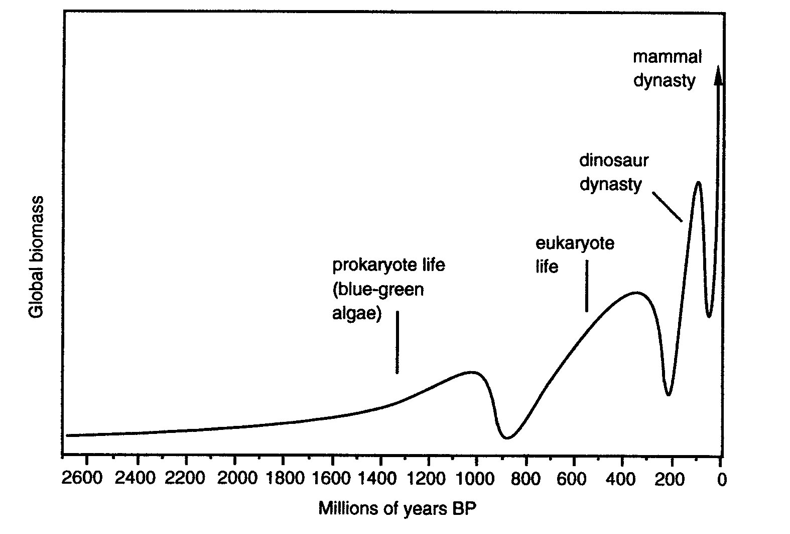
Fig. 1. The great waves of life – the past 3 billion years
Source: Snooks 2003: 155, based on Snooks 1996: 75.

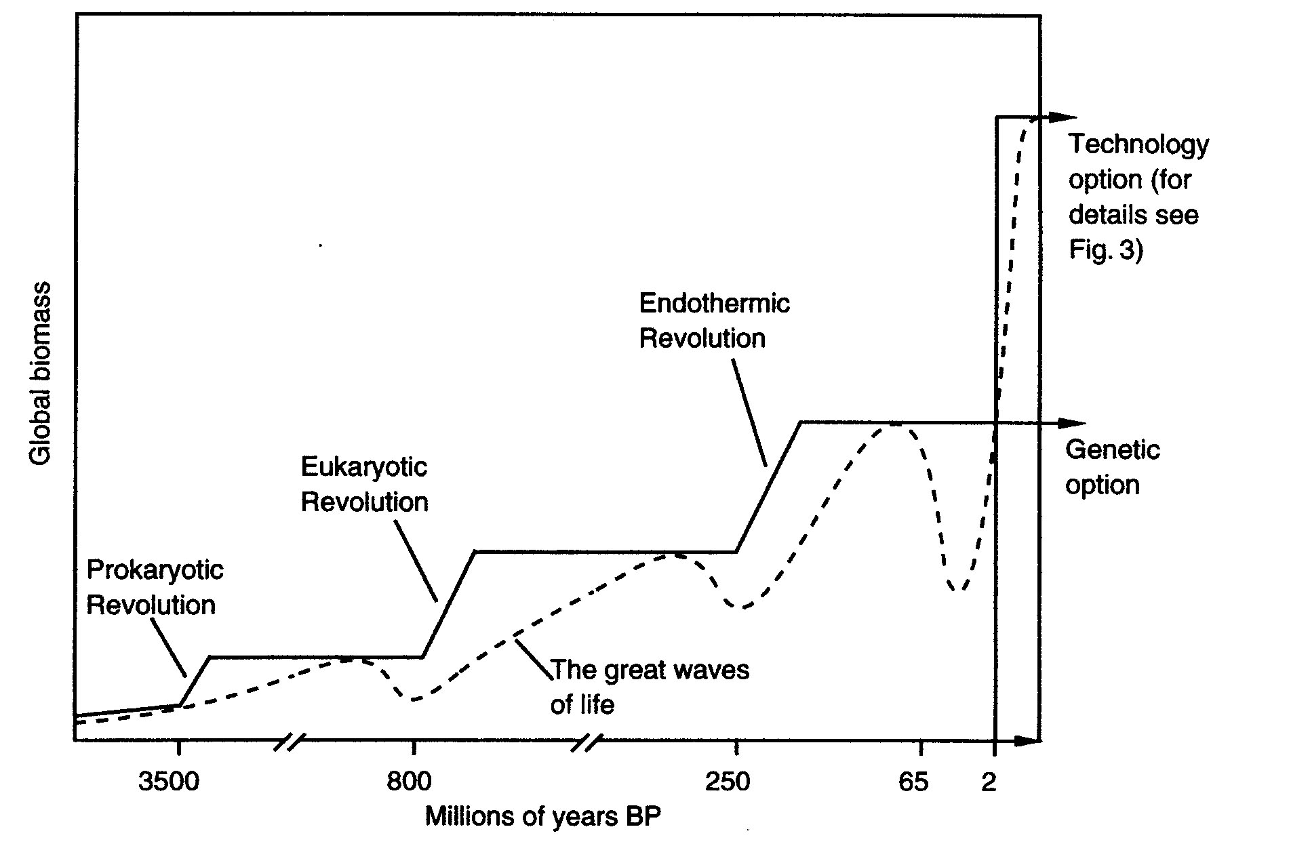
Fig. 2. The great steps of life – the past 4,000 myrs
Source: Snooks 2003: 252.

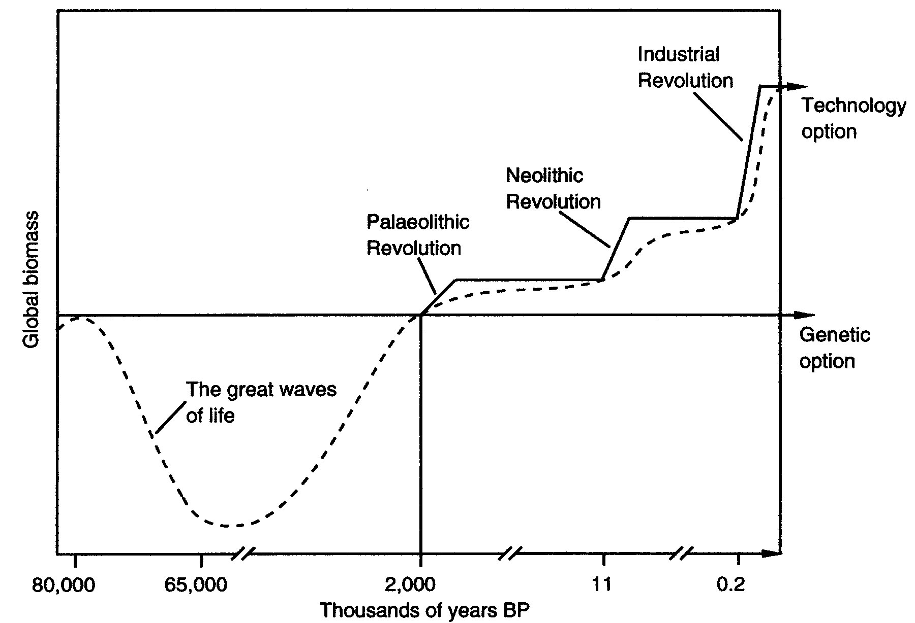

Fig. 3. The great steps of life – the past 80 myrs
Source: Snooks 2003: 253, based on Snooks 1996: 403.

