Global processes and their dynamics:
two paradigms of development

Valentina M. Bondarenko
The article substantiates the idea that the outlines of the future and present can be made visible and comprehensible by applying the author's findings – that is, the new methodology for cognition of regularities in the human community development. This methodology made it possible to define that there have been and are only two paradigms of the human system development in the entire multi-century course of the human community development. Cycles, crises, chaos and all negative phenomena are nothing else but natural products of the second, indirect paradigm of development. The new model of life organization at each local level is at the same time the former, first development paradigm, based on the direct interconnection between production and consumption of specific human beings, but raised onto the new high-tech level. Practical realization of this model is the only feasible precondition for the transition to sustainable and crisis-free development.
Keywords: systemic crisis, sustainable development, new methodology of cognition, objective, specific human being, time, efficiency criteria, two development paradigms, coordination of interests, new model of life organization.
As the number of global threats and challenges to the Mankind is growing, the tangibility of outlines of the future is a timely and widely discussed problem of our time. This conclusion is also by a number of actions and statements on the part of leading political leaders and scholars.
For example, leaders of the G-20 countries, who in 2008–2011 had quite a number of meetings at summits and economic fora, failed to identify the causes of the systemic crisis and the mechanisms to overcome it. At the recent Davos Forum, the Russian Federation President Dmitry Medvedev said: ‘As much as we need the air to breathe, we need specialists knowing how the contemporary world is organized and able to compete at the global level’.
Igor Kondrashin, a philosopher, notes in his paper that today when contemplating again on philosophy, we should first and foremost take the thought of ontological fundamentals of contemporary scientific picture of the world and reconsider them through the prism of modern scientific knowledge because until now no clear scientific idea on the world creation, as well as on the causes and driving forces of its permanent development is available, and this gives a pretext for flourishing of other scientific ideas of various kinds (Kondrashin 2011).
In his introduction to G. V. Kolodko's book Globalization, Transformation, Crisis – What's Next?, Professor Rouslan S. Grinberg wrote: ‘Economics and sociology have agreed on one point: organization and functioning of the surrounding world is the ever less comprehensible, it contains the ever more of illogicality and hence uncertainty’ (Grinberg 2011: 9).
For thirty years, I have also been searching for the objective reasons for the crisis situation in the human system development and to identify the vision of the future. To this end, it has been necessary to ascend to the world-outlook level of studies. Thus, the new methodology was worked out for the comprehension of regularities in development of the human system.
The essence and scientific novelty of the new methodological toolkit is the following: the basis is served by the found targeted and objective predetermination in the human community development. To make such a conclusion, it was necessary not only to identify the goal of development, but the final goal as well, which cannot be a sub-goal of a higher objective within the framework of the human existence in this world. That is, it was required to define the objective reason of the human system development, and to understand that each particular person, each individual does not live in order to provide the GDP growth or to manufacture the maximal possible amount of weapons for his/her own annihilation. The human individual must and can only live for the sake of the maximum development and realization of his/her spiritual and intellectual potential and at the same time for the elevation of the level of his/her consciousness and physical perfection.
In other words, in the course of his/her development each particular individual must and can reach the Supreme Reason or approach the image and liking of the Creator. Otherwise, the development could proceed along an entirely different, opposite vector. Today, we see some technologies being developed, which have no connection with the level of human development, as they can quite well work without any human involvement. For example, IBM Corporation develops the ‘Reasonable City’ project, which provides the interaction among intellectual systems of municipal services without human participation.
The currently developed biological computers can cause human cells to communicate independently with one another so that such communication would pave the way to the building of complex constructions from the given cells. Therefore, governments, business and societies face crises and problems which at large can be only prevented if all the decisions provide for continuous, evolutional and irreversible progress toward the achievement of the development goal. Only in this case it would be possible to find a way for practical realization of the Millennium Development Goals (i.e. following our logic, the sub-goals of the higher objective) proclaimed by the UN as the orientation for all peoples and nations of the Earth.
So, whether we like it or not, the societies must develop in such a way which would create a habitation area for every individual with proper conditions created for free and equal access to the maximal diversity of all the civilization benefits. This, however, should not be done for the achievement of a new level of consumption or for the superiority of technologies over people, but rather for no other purpose than attainment of the final objective – a perfect human being. This is the earthy mission of the humanity and humanity must fulfil it!
The second component of the new methodological toolkit is perceived in integrity, plus systemic and cross-disciplinary approach. Such approach proceeds from the premise of integrity – that is, the world integrity as well as the integrity of laws of nature and society; hence, the world is an integral system and can be only conceived through the all sciences unification into a single systemic and integral cross-disciplinary (or, rather, trans-disciplinary) knowledge. Therefore, it is necessary to unify them systemically through the identification of the whole system's target function as well as any part of the system in any section (civilization-related, formational, national, confessional, territorial, scientific, socio-economic, socio-technical, political, organizational, etc.), irrespectively of what particular development model (neo-liberal, Keynesian, totalitarian, or their mixture) is prevailing. Only through such knowledge, one can understand that the world financial, economic, social, organizational, scientific-technical and, in general, systemic crisis as well as all negative phenomena are the links of one and the same chain. Hence, the solution must be integral, systemic and uniform for the entire world.
Third, we have found the only possible index – time – to measure and juxtapose all processes and phenomena. With this index, we may measure and juxtapose everything that is neither measurable nor comparable in other indices. What is more important, with the time index, we may juxtapose all facets of human and societal life with the target ideal, and identify their position on the ladder of human progress in relation to the objective.
And, the fourth provision of the new methodological toolkit is that we found uniform criterion for efficiency of the human system development – that is, the time-gap between appearance of the need to approach realization of the single development objective, on the one hand, and the reality, in which society and each human individual are positioned in every given moment of time in relation to the objective.
If the time between the appearance and satisfaction of a need felt by an individual tends to reduce continuously and in the evolutional mode towards the zero, then – as far as the objective is concerned – the human system develops successfully.
Therefore, if civilizations, nations, countries, small and big communities and particular individuals are placed in different linear and spherical space of time, they would have different levels of consciousness and would never be able to agree upon their interests or understand each other. This exactly is the cause of all arising and worsening troubles of the mankind. Here comes the conclusion: the world civilization's developmental crisis, wars, terrorism, man-made catastrophes and natural disasters – all these are results produced by the effects of profound laws common for nature and society. More than that, as long as people find themselves in different linear and spherical spaces of time, it will appear that there are many different from each other local civilizations co-existing on the planet.
Therefore, all problems of societal development could be solved on the basis of the 21st century high technologies if only the following condition is observed. A developmental mode should be found which would ultimately provide for continuous, evolutional, irreversible and simultaneous achievement of the objectively set goal for every particular individual with the account of his/her individual interests.
This methodology and results of its application are described in detail in the book Forecasting the Future: A New Paradigm (Fetisov and Bondarenko 2008) as well as in many articles published in Russia and other countries.
The new methodological toolkit makes it possible:
- to go beyond the limits of the entire human system and to view the ‘past – present – future’ as a single whole in relation to the objectively set development goal;
- not to rely upon empirical and subjective data of the past and present;
- to understand the objective picture of the human system development depending on reduction (positive trend) or extension (negative trend) of the time, which is necessary to attain the single goal.
With this methodological toolkit, we are able to see that in the centuries-long course of the human community development there have been and are only two paradigms of the human system development, namely:
- there is a direct connection between production and consumption;
- production and consumption are connected indirectly.
As presented in Fig. 1 (see Appendix), the symbolic chart of the human community development shows, when, how and which development paradigm would be formed along or around the zero axis of time between the appearance and satisfaction of a need. By this chart, the mankind entire history can be divided in three phases.
The first phase is marked by the prevalence of the first developmental paradigm, expressed in the indirect connection between production and consumption. Everything that was manufactured at the level of manual labor was consumed by the mankind. Hence, the time between the appearance and satisfaction of a particular individual's need was minimal. That was the pre-industrial type of production ‘for oneself’ and, by orders – for a specific consumer at the level of households (handicraftsmen).
The emergence of such factors as primitive technologies, labor division, market, class of brokers (merchants) and money as a general equivalent of exchange of results of such labor, plus gradual territorial expansion and growth of foreign trade led to the transformation of the direct into the indirect connection between production and consumption, and hence to the formation of the second development paradigm. Its development in time and space accelerated the transition to the industrial mode of development.
The Industrial revolution, the eras of steam, railroads, steel, electricity and heavy industry as well as oil, automobiles and mass commodity consumption were accompanied with building of infrastructure for communication with consumers – that is, the network of roads, ports, shops (from small shops to grand shopping centers and highly mechanized warehouses, radio-engineering, electric-power and information networks, etc.). Those were the main landmarks.
The conveyer-type mass industrial production was formed in parallel with development of domestic and foreign trade, territorial expansion to the global scale, and mass consumption. This type of production is oriented to satisfy the demand and needs of an abstract final consumer through an unregulated, archaic market form of connection with a particular individual by prolongation of time and space.
In such conditions the uncertainty of consumption generated the appearance and later the global increasing disproportion in the time of production and the time of circulation of commodities and money as well as their throughout de-synchronization. The time of circulation is many times longer than the time of production. The dynamics of material and real factors of production broke far away from their real and (especially) virtual monetary form.
Therefore, it becomes clear, why philosophers, economists and political scientists basing on the works written with the use of empirical information on the already happened events of the past, started to state that complexity, non-linearity and chaos, cycles and crises would be an unavoidable precondition for development. This would be exactly the case unless we understand that all the afore-listed phenomena are a natural product of the second development paradigm.
Diogenes was correct when stating that it had been a disservice for the mankind to invent the plough that had enabled people to harvest products in the amounts larger than needed for their own survival.
So the current crisis of the life style model, featured by indirect interconnection in time and space between production and consumption, started long ago, since the inception of this model.
The information technologies and flexible production systems that appeared in the 1970s did not change this paradigm of development and did not consolidate the ever more clearly outlined opportunity to establish a direct connection as well as to coordinate interests between production and consumption. Information technologies became a goal as such and a means to create global markets.
Therefore, the essence of the second development paradigm is the indirect interconnection, desynchronized in time and space, between different technologies for production of commodities and consumption of the latter by particular human individuals. All crises of this development paradigm occurred at the peak of the growing disproportion in time and space between the appearance and satisfaction of a need. The current systemic crisis is the peak of the given development paradigm. Just having emerged, the globalization of all spheres of human relations started to negate itself. Why? Together with globalization of all processes and the free movement of ideas, commodities, money, and information, the conveyer mass-type of their production has been preserved and expanded in space up to the global level. The time between the appearance and satisfaction of a need, felt by an individual, has grown even more. It seems impossible to coordinate the interests of states, society, business and of a particular individual. On this long time-bound and spatial road of their movement, conditions arise in the objective mode for all negative phenomena. Poverty and inequality, primitive economy, underdeveloped production and trade, terrorism and corruption, abnormalities in nature and natural disasters, prices growth and inflation, etc. – all these are links of one and the same chain, the product of the mediated development model. In this case, the factor of time plays the most negative role.
In such circumstances, the scattered and narrowly specialized scientific knowledge undergoes a crisis of different theories' validity and their explanatory capacity to provide a subjective assessment to the occurring events.
However, the century of cosmic speeds and use of digital, nano- and other technologies generates a swift transformation of the economic and other realities, which are incompatible with such type of production and consumption – especially, with the lack of possibility to coordinate human interests and with such type of interconnection with a human individual.
At the same time, today, owing to development of information, communication and other high technologies of the 21st century, it became possible to move again to the direct connection with production and consumption – that is, to return to the first development paradigm.
An efficient means to eliminate the disproportions and de-synchronization of all processes in time and space may be only found, if and when the relations are synchronized and interests are coordinated with each individual with regard to the entire range of his/her spiritual and material needs, and when goods and services for satisfaction of the given needs are manufactured and/or extended under the given individual's order at the place of his/her residence, without manufacturing or producing anything redundant.
The afore-stated conditions can be provided through fulfillment of the two interconnected strategic tasks.
Task One is to change the content of the states' economic and social policy and to orient it toward the transition to the reproductive trajectory of in-country development. This, however, should be done in the way that the whole reproductive process would be directed to the ultimate result – that is, to the evolutionary reduction of time period between appearance and satisfaction of needs (demand) of each individual. This can be attained if commodities are manufactured only under orders of particular individuals.
To this end, it is necessary to elaborate and realize the program for reindustrialization of production. The final link in such program is thought as the smaller high-tech forms of production, containing the distributed systems and ‘re-tuned’ in the real-time mode according to an individual order with the account of his/her needs.
Task Two is to form at each local level a mechanism for real-time coordination of interests of all actors – that is, the state, business, society and the end users (particular individuals). Such coordination must be effected by means of the shared interconnection infrastructure which would be universal for all kinds of production as well as for all consumers, and would be based on the use of digital information and communication technologies, wideband television and other innovations, which are discussed broadly at all domestic and international levels.
In fact, the new model of life style at each local level, shown in Fig. 2 (see Appendix) represents the former (first) development paradigm, based on the direct interconnection between production and consumption, but advanced to a new technological level.
As long ago as at the end of the past century, when information technologies just started to develop, Alvin Toffler wrote that the day would come quite soon, when every person, working on his/her PC, would govern the technological process for manufacturing of products for his/her own consumption without producing anything redundant. In his book Technological Revolutions and Financial Capital, Carlota Perez says that
the technological revolutions occurring about every fifty years, deliver their fruit with a time lag. Two or three decades of turbulent adaptation and assimilation are required before new technologies, products, sectors and infrastructures would start facilitating the advent of the ‘golden age’ (belle époque), or ‘era of prosperity’ (Perez 2011: 17).
In other words, the production based on technologies of the 21st century, which appeared in the embryonic form some thirty years ago, again returns to the local level, to the level of household, and to human individuals. For an accelerated formation of the new or the renovated former model of life organization, it appears expedient within the shortest possible period of time to work out under the UN auspice the ‘Comprehensive Target Program for Formation of the New Life Style Model’ and to realize it simultaneously at each local level throughout the world.
For the Comprehensive Target Program to be elaborated, it would be to set up an international and cross-disciplinary team of academics and practical workers. This team should be provided with proper conditions that would enable the world community, unified by the network interaction through Internet, to participate in development of the proposed model.
The next task would be to realize the pilot project in different cities and to ensure proliferation of the new life style model throughout the planet.
In the book Forecasting the Future: A New Paradigm, I wrote
The key to the global community formation philosophy must be the following thesis: All inhabitants of the Universe have the common origin, all people are of the same common human nature; all religions have the same common divinity, while the entire global community and each specific individual share one and the same objective – in the course of their development, to reach the Supreme Reason.
The major task of the United Nations or whatever other organization to be established on the base of or within the UN, would be to start accumulating all knowledge, from emergence of the Mankind up to the present. This bank of scientific-technological information would provide any knowledge for the purpose of building technological chains between appearance and satisfaction of individual needs, and thus would provide the increasing synchronization of all processes taking place in space and shrinking in time (Fetisov and Bondarenko 2008: 269).
Realization of the given project for the whole global world would be a real breakthrough to the future – the future that can and should be formed right today, here and now, taking into account the interests of each particular human being and the whole global world. The harmonization of human relations for the current generation is the only possible chance to create a new quality of life for our contemporaries and for the future generations. The main point is not to lose time!
References
Fetisov, G. G., and Bondarenko, V. M. (eds.)
2008. Forecasting the Future: A New Paradigm. Moscow: Economika. In Russian (Фетисова, Г. Г., Бондаренко, В. М. (ред.), Прогнозирование будущего: новая парадигма. М.: Экономика).
Grinberg, R. S.
2011. Introductory Chapter. In Kolodko, G. V. Globalization, Transformation, Crisis – What is Next? Moscow: Magistr. In Russian (Гринберг, Р. С. Вводная глава. Глобализация, трансформация, кризис – что дальше? / Г. В. Колодко. М.: Магистр).
Kondrashin, I.
2011. The Realistic Understanding of the Scientific Picture of the World by Means of a New Onthological Model: Time – Space – Quality. World Philosophical Forum (Athens, October 3–7, 2011). URL: http://wpf.unesco-tlee.org/rus/offpap/top2/index.htm. In Russian (Кондрашин, И. Реалистичное понимание научной картины мира с помощью новой онтологической модели: время – пространство – качество. Всемирный философский форум, Афины, 3–7 октября 2011).
Perez, C.
2011. Technological Revolutions and Financial Capital. Moscow: DELO. In Russian (Перес, К. Технологические революции и финансовой капитал. М.: Дело).

Appendix
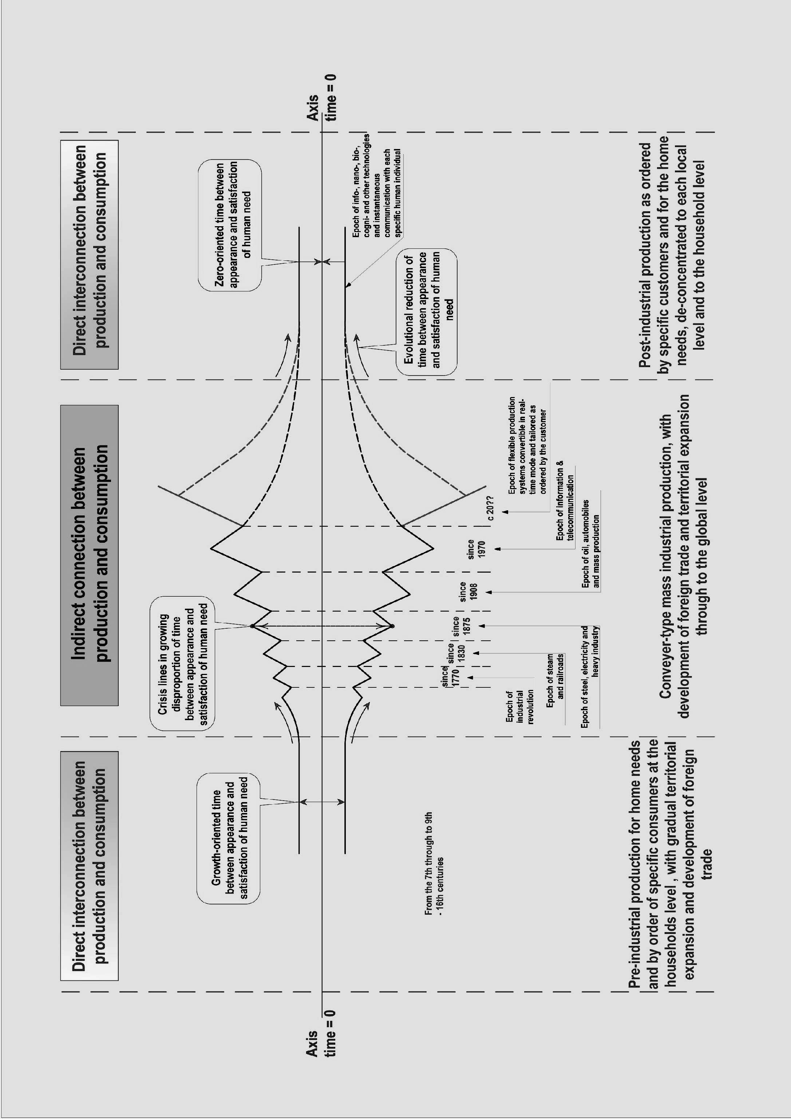
Fig. 1. The schematic outlay of the human community development

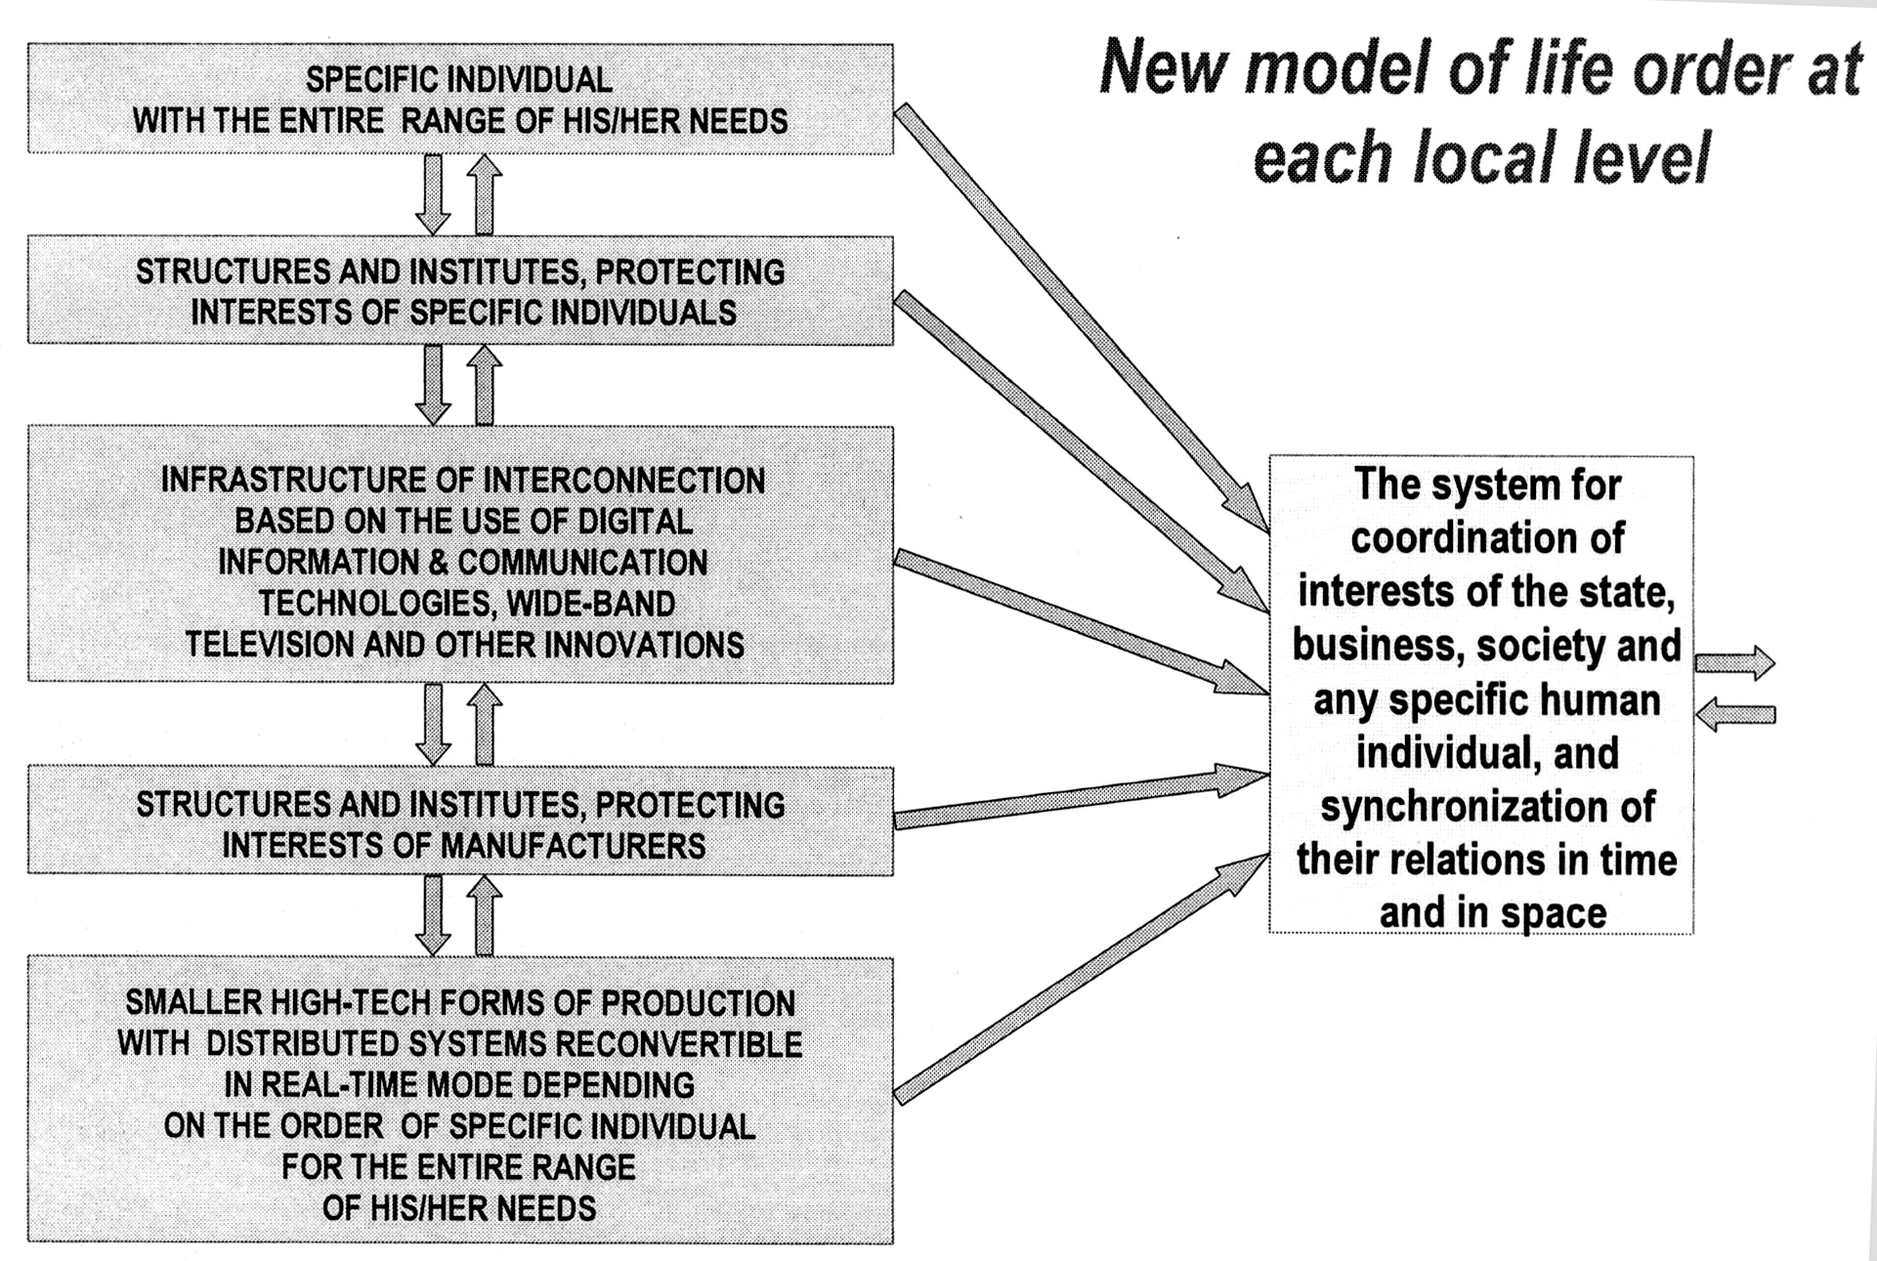
SPECIFIC INDIVIDUAL
WITH THE ENTIRE RANGE OF HIS/HER NEEDS
STRUCTURES AND INSTITUTES, PROTECTING
INTERESTS OF SPECIFIC INDIVIDUALS
INFRASTRUCTURE OF INTERCONNECTION
BASED ON THE USE OF DIGITAL
INFORMATION & COMMUNICATION
TECHNOLOGIES, WIDE-BAND
TELEVISION AND OTHER INNOVATIONS
STRUCTURES AND INSTITUTES, PROTECTING
INTERESTS OF MANUFACTURERS
SMALLER HIGH-TECH FORMS OF PRODUCTION
WITH DISTRIBUTED SYSTEMS RECONVERTIBLE
IN REAL-TIME MODE DEPENDING
ON THE ORDER OF SPECIFIC INDIVIDUAL
FOR THE ENTIRE RANGE
OF HIS/HER NEEDS
Fig. 2. New Model of Life Order at Each Local Level

