Global Unconditional Convergence
among Larger Economies after 1998?
Andrey Korotayev, Julia Zinkina,
Justislav Bogevolnov, and Artemy Malkov
We find rather strong evidence for the unconditional convergence among all the larger countries comprising the overwhelming majority of the world population and producing the overwhelming part of the world GDP after 1998. These findings are shown to be not as incongruent with the results of the previous convergence research as one may think – the previous research did not deny the convergence phenomenon per se, but rather insisted on its conditionality, whereas we suggest that the world-wide switch from the conditional to unconditional convergence pattern that we recently observe is accounted for by the point that by the late 1990s all the major developing countries and economies of the world began to satisfy (more or less) the major conditions of the conditional convergence.
Keywords: economic growth, convergence, world income distribution, human capital, core and periphery, World System.
1. Introduction
The problem of convergence has been one of the critical issues for the economic growth discourse for a few decades. This seems most obvious and natural, as one can hardly imagine a more attention-catching question than the one of ‘Is the gap between the poor and the richer increasing or decreasing?’ A huge number of works highlighted various aspects of convergence, such as the essence of the phenomenon itself; its presence or absence in the modern world, various world regions and groups of countries, or within some individual countries; the factors underlying the presence or absence of convergence etc.
Accordingly, up to date, the theory of convergence has evolved into quite a number of branches, which have been comprehensively classified by Islam (2003: 312) in the form of antinomies:
‘(a) Convergence within an economy vs. convergence across economies;
(b) Convergence in terms of growth rate vs. convergence in terms of income level;
(c) σ-convergence vs. β-convergence;
(d) Unconditional (absolute) convergence vs. conditional convergence;
(e) Global convergence vs. local or club-convergence;
(f) Income-convergence vs. TFP (total factor productivity)-convergence; and
(g) Deterministic convergence vs. stochastic convergence’.
Of greatest interest for the present paper is the essence of unconditional vs. conditional convergence problem, therefore we shall now provide a brief review of literature already existing on the subject in order to outline the borders of the phenomenon which will be the subject of our own research in the corresponding section.
2. Unconditional vs. Conditional Convergence
The cornerstone for the theory of convergence was laid in an essay Economic Backwardness in Historical Perspective by Alexander Gerschenkron (1952), who developed the ‘theory of relative backwardness’ relying on data obtained from the history of European countries. The main tenet of his theory lay out as follows: ‘the opportunities inherent in industrialization may be said to vary directly with backwardness of the country’ (Gerschenkron 1952: 6). Remarkably, Gerschenkron emphasized that the conditions inevitably required for a country to take advantage of its backwardness included ‘adequate endowments of usable resources’ and the absence of ‘great blocks to industrialization’ (Ibid.: 6). Thus, backward countries (provided that the outlined conditions are observed) were bound to grow faster than the developed economies, the former thus gradually converging with the latter.
As Samuelson and Nordhaus put it,
poorer countries have important advantages that the first pioneers along the path of industrialization did not. Developing nations can now draw upon the capital, skills, and technology of more advanced countries. A hypothesis advanced by Alexander Gerschenkron of Harvard suggests that relative backwardness itself may aid development. Countries can buy modern textile machinery, efficient pumps, miracle seeds, chemical fertilizers, and medical supplies. Because they can lean on the technologies of advanced countries, today's developing countries can grow more rapidly… As low-income countries draw upon the more productive technologies of the leaders, we would expect to see convergence of countries toward the technological frontier. Convergence occurs when those countries or regions that have initially low incomes tend to grow more rapidly than ones with high incomes (Samuelson and Nordhaus 2005: 584).
The roots of the issue of unconditional convergence are also frequently traced to
A Contribution to the Theory of Economic Growth by Robert M. Solow (1956). This work is sometimes regarded as the pioneering one in laying the tenets for the hypothesis of unconditional convergence in the economic growth among the world countries (see, e.g., Abel and Bernanke 2005: 235).¹
As Mankiw notes
The diminishing returns to capital [implied by the Solow model] have another important implication: Other things equal, it is easier for a country to grow fast if it starts out relatively poor. This effect of initial conditions on subsequent growth is sometimes called the catch-up effect. In poor countries, workers lack even the most rudimentary tools and, as a result, have low productivity. Small amounts of capital investment would substantially raise these workers' productivity. By contrast, workers in rich countries have large amounts of capital with which to work, and this partly explains their high productivity. Yet with the amount of capital per worker already so high, additional capital investment has a relatively small effect on productivity. Studies of international data on economic growth confirm this catch-up effect: Controlling for other variables such as the percentage of GDP devoted to investments, poor countries tend to grow at faster rates than rich countries (Mankiw 2008: 258).
Abel and Bernanke note that according to Solow model, if the economy is open,
the absolute convergence gets support of some additional economic forces. Since poorer countries have less capital per worker and therefore a higher marginal product of capital than the more affluent countries, investors from richer countries will be able to get greater profits by investing in poor countries. Therefore, foreign investment should provide a more rapid increase in capital stock in poor countries, even if the level of domestic savings in these countries is low (Abel and Bernanke 2005: 234).
It is easy to see that both the ‘Gershenkron’ factor and the ‘Solow’ factor of the faster growth of the peripheral (and especially semi-peripheral) economies are well mutually complementary, as the capital diffusion tends to be accompanied by technology diffusion (what is more, the capital diffusion is one of the main creators of the technology diffusion channels).
On the other hand, Solow's model implies that the output levels per capita should be higher the higher the savings rate in the country, or the lower the population growth rate.
A counterstrike to Solow's theory of diminishing returns was blown by Romer in the mid-1980s, when he published his article Increasing Returns and Long-Run Growth (1986), stating that ‘in contrast to models based on diminishing returns, growth rates can be increasing over time, the effects of small disturbances can be amplified by the actions of private agents, and large countries may always grow faster than small countries’ (Romer 1986: 1002). Thus, Romer disproved the very essence of the idea of absolute convergence.
This being a starting-point, the second half of the 1980s witnessed the emergence of a wave of works contradicting the idea of absolute convergence and stating the idea of conditional convergence instead (for a detailed literary survey see, e.g., Rassekh 1998). Baumol (1986), for instance, suggested that convergence could be observed within separate groups of countries. Thus, according to Baumol's data, remarkable convergence could be observed among the productivities of industrialized market economies. Convergence was, in Baumol's opinion, shared by planned economies. Less developed countries did not reveal any significant marks of convergence. No absolute convergence could be observed across the world as a whole.
Another substantial work refuting the hypothesis of absolute convergence was the one by Barro (1991). After examining 98 countries in the period 1960–1985, Barro stated that ‘The hypothesis that poor countries tend to grow faster than rich countries seems to be inconsistent with the cross-country evidence’ (Barro 1991: 407).
A cornerstone of counter-unconditional-convergence discourse was a watershed work by Mankiw, Romer, and Weil (1992). Examining empirically a sample of 98 countries (excluding those where oil production is the dominant industry), they proved the failure of countries to converge in per capita income during the period 1960–1985. However, of greater importance was the introduction of the notion of conditional convergence carried out in their work. After a comprehensive analysis of Minutely regarding Solow's theory, the researchers state that Solow model does not predict unconditional convergence; it predicts only that income per capita in a given country converges to that country's steady-state value, these values being different for various countries. From this assumption Mankiw, Romer, and Weil conclude that ‘Solow's model predicts convergence only after controlling for the determinants of the steady state’, nominating this phenomenon ‘conditional convergence’. The finding of conditional convergence is now considerably well established in the empirical literature, having been regarded in numerous studies on the data of the second half of the 20th century with different conditioning variables (see, e.g., Caggiano and Leonida 2009; Petrakos and Artelaris 2009; Romero-Avila 2009; Owen, Videras, and Davis 2009; Sadik 2008; Frantzen 2004; de la Fuente 2003; Jones 1997a; Caselli, Esquivel, and Lefort 1996; Sala-i-Martin 1996; King and Levine 1993; Levine and Renelt 1992; Barro 1991; De Long and Summers 1991).
Currently, with regard to unconditional convergence, the absolute majority of students seem to be in unanimous agreement over the absence of absolute convergence across the world (see, e.g., Sadik 2008; Epstein, Howlett and Schulze 2007; Seshanna and Decornez 2003; Workie 2003; Canova and Marcet 1995; Durlauf and Johnson 1995; Desdoigts 1994; Paap and van Dijk 1994). Thus, Sachs et al. (1995) note that in recent decades (1970–1995) there has been no overall tendency for the poorer countries to catch up, or converge, with the richer countries.
Sala-i-Martin, having analyzed a large cross-section of 110 countries, states that one of the main lessons to be gained from the classical approach to convergence analysis is that ‘the cross-country distribution of world GDP between 1960 and 1990 did not shrink, and poor countries have not grown faster than rich ones. Using the classical terminology, in our world there is no σ-convergence and there is no absolute β-con-vergence’ (Sala-i-Martin 1996: 1034). At the same time, Sala-i-Martin concludes that his analysis of a cross-section of countries sample exhibits sigma-divergence and conditional beta-convergence. The speed of conditional convergence is close to 2 % per year, being very similar across the large cross-section of countries, the sub-sample of OECD countries, the states within the United States, the prefectures of Japan, and regions within several European countries (Ibid.).
Much attention was given to empirical testing of the convergence hypothesis in Quah's works (see, e.g., 1996a, 1996b, 1996c). Using the model of growth and imperfect capital mobility across multiple economies to characterize the dynamics of (cross-country) income distributions, Quah tested the convergence hypothesis and came to conclusion that the evidence showed little unconditional cross-country convergence.
This idea corresponds quite well to the one expressed by Lee, Pesaran, and Smith (1997) that world countries are not converging, but diverging, which they resumed from considering international per capita output and its growth using a panel of data for 102 countries between 1960 and 1989. Much the same conclusion was almost simultaneously made by Bianchi (1997) who empirically tested the convergence hypothesis from the perspective of income distributions in a cross-section of 119 countries. By means of statistical techniques such as non-parametric density estimation and bootstrap multimodality tests, Bianchi tested for the number of modes and estimated, consistently with the detected number of modes, the income distribution of a cross-section of 119 countries in 1970, 1980 and 1989, concluding that his findings support the view of clustering and stratification of growth patterns over time, standing in sharp contrast with the unconditional convergence prediction.
One of the most recent works refuting the unconditional convergence hypothesis is the one by Acemoglu (2009), which contains a cross-country analysis of GDP per capita values between 1960 and 2000; what is more, he maintains that ‘there is a slight but noticeable increase in inequality across nations’ (Ibid.: 6).
The conclusion on the presence of divergence was shared by many researchers, for example, Gaulier, Hurlin and Jean-Pierre (1999), who based their research upon empirical evidence obtained from the analysis of 86 countries. A more recent work by Howitt and Mayer-Foulkes (2004) similarly resumed that among the countries of the world the divergence, not convergence could be observed starting from the mid-19th century.
Numerous students shared the point of view on the absence of absolute convergence throughout the countries of the world (see, e.g., Sadik 2008; Epstein and Howlett, Schulze 2007; Seshanna and Decornez 2003; Workie 2003; Canova and Marcet 1995; Durlauf and Johnson 1995; Desdoigts 1994; Paap and van Dijk 1994).
At the same time, most researchers agree that there is an obvious convergence among OECD countries. Abramovitz (1986) made a substantial attempt to prove the convergence of productivity levels among the economies of the developed countries. However, Abramovitz made a remarkable comment that the rate of convergence varied from period to period and showed a marked strength only during the first quarter-century following World War II. He also noted that the general process of convergence was also accompanied by dramatic shifts in countries' productivity rankings. His main contribution included extending the simple catch-up hypothesis in order to rationalize the fluctuating strength of the convergence process. The main conclusion made by Abramovitz stated that ‘differences among countries in productivity levels create a strong potentiality for subsequent convergence of levels, provided that countries have a “social capability” adequate to absorb more advanced technologies’ (Abramovitz 1986: 405). However, the most important remark made by Abramovitz on the basis of his empirical analysis was that ‘the long-term convergence … is only a tendency that emerges in the average experience of a group of countries’, that is he would not regard convergence as a global-scale phenomenon.
A considerable number of works has been devoted by various scholars to different aspects of convergence in OECD. Initially, there appeared some works that substantially proved the existence of convergence itself across OECD through systematic catching up in levels of total factor productivity (see, e.g., Dowrick and Nguyen 1989). Later on, the focus shifted to other aspects, such as convergence in aggregate productivity (Bernard and Jones 1996a, 1996b), convergence in international output (Bernard and Durlauf 1995; Caggiano and Leonida 2009), the impact of globalization upon convergence in OECD (Williamson 1996), various sources of convergence (i.e. government size and labor market performance) (de la Fuente 2003), technological diffusion and productivity convergence (Frantzen 2004), stochastic convergence of per capita real output (Romero-Avila 2009), country size impact upon convergence (Petrakos and Artelaris 2009), etc.
Currently, there exist a remarkable number of sources revealing the particularities of convergence process in some regions of the world or groups of countries, such as Latin America (e.g., Dobson and Ramlogan 2002; Galvao Jr. and Reis Gomes 2007 etc.), ASEAN (e.g., Lim and McAleer 2004), some particular Asian regions and countries (Li and Xu 2007; Zhang 2003), transition countries (e.g., Rapacki and Prochniak 2009).
3. Factors of Conditional Convergence
Various researchers tried to specify the factors underlying the process of convergence (or its failure). Thus, Abramovitz emphasized the importance of education and organization for the process of convergence. With respect to the convergence factors, Abramovitz (1986: 405) stated that ‘the pace of realization of a potential for catch-up depends on a number of other conditions that govern the diffusion of knowledge, the mobility of resources and the rate of investment’.
The suggested failure of unconditional convergence was attributed to different factors by various students. Thus, Bradford De Long (1988: 1148) assumed that one of the factors driving some countries towards convergence was technology becoming a public good.
Barro (1991: 437) concluded that ‘the relatively weak growth performances of countries in sub-Saharan Africa and Latin America’ and their failure to catch up with the developed countries (i.e. the absence of absolute convergence) could be attributed to the lack of human capital development, discovering the fact that in his data set of 98 countries in the period 1960–1985 the growth rate of real per capita GDP was positively related to initial human capital.
Cohen (1996: 351) stated that ‘the poor countries have failed to catch up with rich ones because the progress that they have achieved in educating their workers (which is evidenced in the convergence of domestic inputs) is not sufficient to compensate for their poor endowment in the knowledge on which the education of workers stands’. Sadik (2008) explained that simultaneous convergence among industrialized countries could be caused by the fact that technological progress diminishes the differences within the group of countries that adopt technologies but increases the gap between those countries and the rest of the world.
Milanovic (2005) devoted his study purely to specifying the reasons for catch-up failure, listing the following causes: war and civil strife, and a delay in reforms among the least developed countries (LDC). Direct foreign investment and democracy, according to Milanovic, did not have any significant influence upon the failure of catch-up process among LDC. Yifu Lin (2003), on the other hand, supports the idea that the failure of most LDCs to converge with developed countries in terms of economic performance can be explained largely by their governments' inappropriate development strategies.
Sadik maintains that ‘technological progress reduces differences between countries adopting technology and increases the gap with regions that do not industrialize’ (Sadik 2008: 352). Owen, Videras, and Davis, observing countries growth experiences over the 1970–2000 period, found evidence that ‘the quality of institutions and specifically,
the degree of law and order, helps to sort countries into different regimes’ (regimes being here quite synonymic to the notion of convergence clubs) (Owen, Videras, and Davis 2009: 265).
Sachs et al. revealed the connection between convergence and economic openness and international trade, stating that ‘the absence of overall convergence in the world economy during the past few decades might well result from the closed trading regimes of most of the poorer countries’ (Sachs et al. 1995: 37).² They present an evidence suggesting that the lack of convergence observed across the world can be ‘explained by the trade regime: open economies tend to converge, but closed economies do not. The lack of convergence in recent decades results from the fact that the poorer countries have been closed to the world’ (Ibid.: 3).³
4. Some Results of Unconditional Convergence Research
In general, the main results of the two decades of the unconditional convergence research seem to be summed by such statements as follows:
Empirical studies have shown consistent evidence of a cross-country income distribution displaying bimodality with a marked thinning in the middle. This result is interpreted as showing that poor countries are not catching up with the rich, but rather that there is evidence of club convergence, that is, polarization at the extremes of the income distribution (Cetorelli 2002: 30).
Unfortunately (from the perspective of the world's poor countries), there is little empirical support for unconditional convergence. Most studies have uncovered little tendency for poor countries to catch up with rich ones (Abel and Bernanke 2005: 235).
There is no evidence of (unconditional) convergence in the world income distribution over the postwar era (Acemoglu 2009: 17).
Acemoglu adds at this point:
Combining the postwar patterns with the origins of income differences over the past several centuries suggests that we should look for models that can simultaneously account for long periods of significant growth differences and for a distribution of world income that ultimately becomes stationary, though with large differences across countries. The latter is particularly challenging in view of the nature of the global economy today, which allows for the free flow of technologies and large flows of money and commodities across borders. We therefore need to understand how the poor economies fell behind and what prevents them today from adopting and imitating the technologies and the organizations (and importing the capital) of richer nations (Acemoglu 2009: 22).
However, we are not really sure that the paradox outlined by Acemoglu actually exists. Does not really ‘the global economy today, which allows for the free flow of technologies and large flows of money and commodities across borders’ lead to its logical outcome – the general convergence? Are poor economies of the world still generally failing to ‘adopt and imitate the technologies and the organizations (and import the capital) of richer nations’?
Our own previous research (Malkov et al. 2010; Malkov, Korotayev, and Bogevolnov 2010) has indicated that the overall pattern of divergence/convergence between the World System core⁴ (the ‘First World’) and periphery (the ‘Third World’)⁵ may be graphed as follows (see Fig. 1).
Fig. 1. Dynamics of the difference between the core and periphery with respect
to per capita GDP
Note: figures at the Y-axis denote how many times the average per capita GDP in the core was higher than the one in the periphery.
Source: Malkov et al. 2010: 234, Fig. 1. Calculations are based on the following sources: World Bank 2010; Maddison 1995, 2001, 2003, 2010.
As we see, in the early 19th century the gap in per capita GDP levels between the World System core and periphery was not very significant. However, there was an evident indicator that distinguished the World System core countries from the countries of its periphery in a rather significant way. We mean the literacy level (see Fig. 2).
Fig. 2. Dynamics of literacy for the populations of the world system core
and periphery
Source: Malkov et al. 2010: 235, Fig. 2. Data sources: Meliantsev 1996; Morrison and Murtin 2006: Table 4; UNESCO 2010.
In the age of modernization the fastest economic breakthrough was achieved by those countries that had already attained sufficiently high levels of literacy by the beginning of that age. We believe that this point is not coincidental, as it reflects the fact that the development of namely human capital became a crucial factor of economic development in modernization age (see, e.g., Denison 1962; Schultz 1963; Scholing, Timmermann 1988; Lucas 1988, etc.). Our earlier research (Korotayev, Malkov, Khaltourina 2006: 87–91) has indicated the presence of a rather strong (R² = 0.86) and significant correlation between the level of literacy in the early 19th century and per capita GDP values in the late 20th century.⁶ This, of course, provides additional support for the point that the diffusion of literacy during the modernization era was one of the most important long-term factors of the acceleration of economic growth (see also, e.g., Barro 1991; Coulombe et al. 2004; Naudé 2004; UNESCO 2005: 143). On the one hand, literate populations have many more opportunities to obtain and utilize the achievements of modernization than illiterate ones. On the other hand, literate people could be characterized by a greater innovative-activity level, which provides opportunities for modernization, development, and economic growth. Literacy does not simply facilitate the process of innovation being perceived by an individual. It also changes her or his cognition to a certain extent. This problem was studied by Luria, Vygotsky, and Shemiakin, the famous Soviet psychologists, on the basis of the results of their fieldwork in Central Asia in the 1930s. Their study shows that education has a fundamental effect on the formation of cognitive processes (perception, memory, cognition). The researchers found out that illiterate respondents, unlike literate ones, preferred concrete names for colors to abstract ones, and situational groupings of items to categorical ones (note that abstract thinking is based on category cognition). Furthermore, illiterate respondents could not solve syllogistic problems like the following one – ‘Precious metals do not get rust. Gold is a precious metal. Can gold get rust or not?’ These syllogistic problems did not make any sense to illiterate respondents because they were out of the sphere of their practical experience. Literate respondents who had at least minimal formal education solved the suggested syllogistic problems easily (Luria 1976; see also Ember 1977; Rogoff 1981).
The GDP growth rates in the core were much higher than in the World System periphery during the whole 19th century and the early 20th century (see Fig. 3).
Fig. 3. Dynamics of relative annual GDP growth rates in the World System core and periphery (nine-year moving averages), 1820–2007
Source: Malkov et al. 2010: 237, Fig. 3. Data sources: World Bank 2010; Maddison 1995, 2001, 2003, 2010. Nine-year moving averages (with consecutive decrease of the smoothing window at the edges).
In 1914–1950 the economic growth of both core and periphery experienced powerful turbulences (actually, they were expressed in the core even stronger than in the periphery, as the core in this period experienced both more powerful upswings and more profound busts). In the postwar period the GDP growth rates in the core and periphery became quite close to each other, and in the 1950s and 1960s we observe there quite similar (and, at the same time, very high) GDP growth rates. Since the late 1960s one can observe a certain trend toward the decline of the GDP growth rates in the core. Then this decline started in the periphery, but with a certain time lag, whereas in general the GDP growth rates in the periphery began to exceed the ones in the core. This gap began to grow especially fast since the mid-1980s; since that time one can trace a rather steady trend toward the GDP growth rate acceleration in the periphery against the background of the continuing trend toward its deceleration in the core.
In the meantime it is essential to take into account the fact that the periphery lags far behind the core as regards the demographic transition. In the core it started much earlier; respectively, the first phase there also began much earlier; hence it was much earlier when the core experienced the mortality decline (see, e.g., Chesnais 1992; Korotayev, Malkov, and Khaltourina 2006). That is why in the 19th century the population growth rates in the core were much higher than the ones in the periphery (see Fig. 4).
Fig. 4. Population dynamics of the World System core and periphery (thousands,
logarithmic scale), 1820–2008
Source: Malkov et al. 2010: 238, Fig. 4. Data sources: World Bank 2010; Maddison 1995, 2001, 2003, 2010.
However, after the Second World War the demographic transition in the World System core countries was finished, the fertility there dropped down, and the population growth rates declined dramatically. In the meantime, during the same period most periphery countries were well in the first phase of demographic transition (according to Chesnais's [1992] classification) – the death rates in most periphery countries declined very significantly, whereas the birth rates still remained at very high levels. As a result, in the majority of periphery countries the population growth rates reached in the 1950s and 1960s their historical maximums. In these decades, equally high annual rates of GDP growth were accompanied by the population growth rates in the periphery being much higher than in the core. As a result, per capita GDP growth rates in the core continued to exceed the ones in the periphery (see Fig. 4); correspondingly, in the 1950s and 1960s the gap between the core and periphery continued to widen (see Fig. 5).
Fig. 5. Dynamics of relative annual per capita GDP growth rates in the World System core and periphery (nine-year moving averages), 1820–2007
Source: Malkov et al. 2010: 239, Fig. 5. Data sources: World Bank 2010; Maddison 1995, 2001, 2003, 2010. Nine-year moving averages (with consecutive decrease of the smoothing window at the edges).
On the other hand, in the same decades most countries of the periphery managed to achieve a sharp increase in literacy (and some other important indicators of the human capital development), which, on the one hand, stimulated the GDP growth, and, on the other hand, contributed to a very significant decrease of fertility and population growth rates. As a result, in the early 1970s the per capita GDP growth caught up with the ones in the core, and since the late 1980s the average GDP growth of the periphery began to exceed more and more the one of the core. As a result the relative gap between the per capita GDP of the core and periphery began to decrease.
Note that the slowdown of economic growth rates in the core and the acceleration of growth rates in the periphery were accompanied (and to a considerable extent were caused) by the following processes-trends: 1a) the decrease of the share of investments in the GDP of the core (since the early 1970s); 1b) the increase in the share of investments in the GDP of the periphery (since the early 1990s); 2a) the decrease of the macroeconomic effectiveness of the investments⁷ for the core (since the late 1960s);
2b) the increase in the macroeconomic effectiveness of the World System periphery (since the early 1990s) (see Figs 6 and 7).
Fig. 6. Dynamics of the share of investments in the GDP of the core and periphery, %, 1965–2005
Note: The World System core was identified for the calculations presented in this diagram with the high-income OECD countries, whereas the World System periphery was identified with the rest of the world.
Source: Malkov et al. 2010: 240, Fig. 6. Data source for the calculations: World Bank 2010. Seven-year moving averages (with consecutive decrease of the smoothing window at the edges).
Thus, the results of our previous research suggested the presence of semi-unconditional divergence between 1800 and the late 1960s, the situation of the absence of either salient unconditional divergence or unconditional convergence for the 1970s and 1980s, and the presence of semi-unconditional convergence for the 1990s and 2000s.
Fig. 7. Dynamics of the effectiveness of investments in the GDP of the core
and periphery, 1965–2005
Note: The World System core was identified for the calculations presented in this diagram with the high-income OECD countries, whereas the World System periphery was identified with the rest of the world.
Source: Malkov et al. 2010: 242, Fig. 8. Data source for the calculations: World Bank 2010. Seven-year moving averages (with consecutive decrease of the smoothing window at the edges).
Note that most empirical tests of unconditional convergence hypothesis have been carried out on the basis of the data for the 1970s and 1980s (where we would not expect to find any unconditional convergence anyway) (see, e.g., Barro 1991; Mankiw, Romer, and Weil 1992; Sala-i-Martin 1996; Bianchi 1997; Lee, Pesaran, and Smith 1997), or on the basis of such datasets where the post-1990 convergence phase was counterbalanced by earlier divergence periods (see, e.g., Sachs et al. 1995; Acemoglu 2009). In addition, in the early 1990s the overall convergence pattern was strongly obscured by the very low (and quite often negative) per capita GDP growth rates in the post-communist economies of Eastern Europe and the former Soviet Union that were at that time in the arduous phase of transition to the market economy. Hence, as we would expect, those tests did not find any unconditional convergence. Naturally, datasets with heavy presence of the pre-1970s data rather suggested the presence of the divergence pattern.
Against this background we expected to find clear evidence for the general divergence pattern for the 1950s and 1960s, and the presence of the general convergence pattern for 1998–2008.

5. Tests
We first operationalized this hypothesis in the following way. We expected that in the 1950s and 1960s the low-income countries of 1950⁸ should have had significantly lower per capita GDP growth rates than the middle- and high-income countries of 1950⁹; whereas in 1998–2008 the low-income countries of 1998¹⁰ should have had significantly higher per capita GDP growth rates than the middle- and high-income countries of 1998.¹¹
The test has provided unequivocally positive results (see Table 1).
Table 1
Comparison between per capita GDP growth rates in low-income vs. middle-
and high-income countries in 1950–1970 and in 1998–2008
1950–1970
 | GDP in 1950 | Population in 1950 | Per capita GDP in 1950 | GDP in 1970 | Population in 1970 | Per capita GDP in 1970 | Average annual GDP growth rate in 1950–1970 | Average annual population growth rate in 1950–1970 | Average annual per capita GDP growth rate in 1950–1970
Low-income countries | $1127 bln | 1819.7 mln | $619 | $2937 bln | 2756.4  mln | $1065 | 4.91 % | 2.10 % | 2.75 %
Middle- and high-income countries | $3696 bln | 735.3 mln | $5025 | $9465 bln | 966.4 mln | $9794 | 4.82 % | 1.38 % | 3.39 %
1998–2008
 | GDP in 1998 | Population in 1998 | Per capita GDP in 1998 | GDP in 2008 | Population in 2008 | Per capita GDP in 2008 | Average annual GDP growth rate in 1950–1970 | Average annual population growth rate in 1950–1970 | Average annual per capita GDP growth rate in 1998–2008
Low-income countries | $10,252 bln | 4372 mln | $2345 | $20,398 bln | 5013 mln | $4069 | 7.12 % | 1.38 % | 5.67 %
Middle- and high-income countries | $23,770 bln | 1585 mln | $14997 | $30,904 bln | 1717 mln | $17,995 | 2.66 % | 0.81 % | 1.84 %
Note: After Maddison GDP is measured in 1990 international dollars, PPP.
Data source: Maddison 2010.
As we see, in the 1950s and 1960s (apparently belonging to the ‘divergence era’) the average per capita GDP growth rates among the high- and middle-income countries were significantly higher than among the low-income countries, whereas in 1998–2008 the average per capita GDP growth rates among the low-income countries exceeded by far the ones of the high- and middle-income countries.
At the next stage, we operationalized the divergence/convergence hypothesis in another (and rather frequently applied) way – correlating the per capita GDP at the start of a certain period with the average per capita GDP growth rates during the respective period (whereas a significant negative correlation among the countries of the world is interpreted as evidence for unconditional convergence, a significant positive one is regarded as evidence for unconditional divergence, and the absence of any significant correlation is interpreted as evidence for absence of either unconditional convergence, or unconditional divergence).
Actually, our first tests looked to be congruent with the findings of the earlier mainstream students of convergence who insist on the absence of unconditional convergence (which imply that the overall relative gap between the poor and rich countries remains pretty stable). Indeed these tests confirmed the absence of any significant unconditional convergence in 1998–2008 (see Figs 8–9).
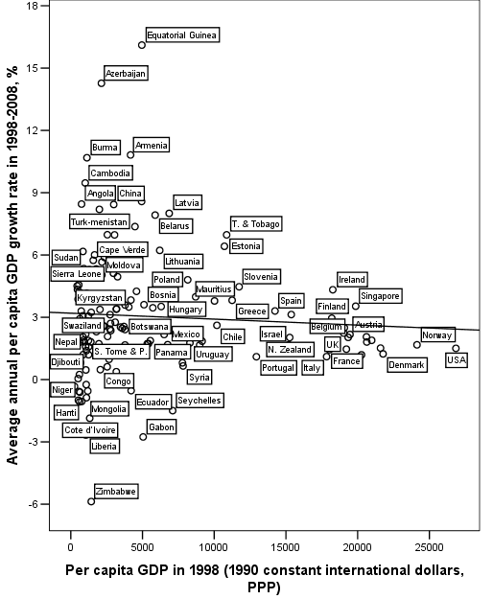
Fig. 8. Correlation between per capita GDP in 1998 and average annual per capita GDP growth rates in 1998–2008. For all countries of the world
(Maddison 2010 dataset). Scatterplot with fitted regression line
Note: r = – 0.062, p = 0.45. Source: Maddison 2010.
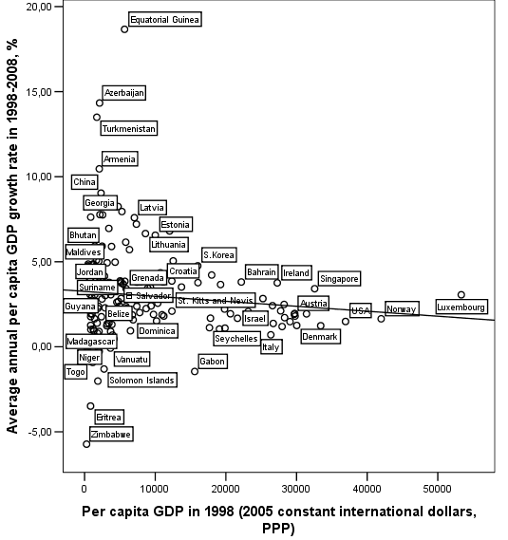
Fig. 9. Correlation between per capita GDP in 1998 and average annual per capita GDP growth rates in 1998–2008. For all countries of the world
(World Bank 2010 dataset). Scatterplot with fitted regression line
Note: r = – 0.101, p = 0.191. Source: World Bank 2010.
As we see, in both cases the correlation is in the predicted direction – it is negative, which should apparently indicate just unconditional convergence; but in both cases this correlation is very weak and totally insignificant, which should, at the face of it, indicate that the unconditional convergence hypothesis has been rejected once again.
What is more, the test did not confirm the presence of unconditional divergence in 1950–1970 either (see Fig. 10).¹²
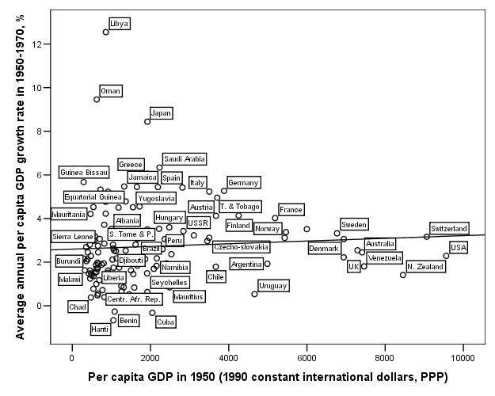
Fig. 10. Correlation between per capita GDP in 1950 and average annual per capita GDP growth rates in 1950–1970. For all countries of the world
(Maddison 2010 dataset). Scatterplot with fitted regression line
Note: r = 0.066, p = 0.453, omitting small oil-exporting countries of the Persian Gulf. Source: Maddison 2010.
However, a rather simple analysis of Figs 8–10 indicates that the absence of correlation in both cases is a result of a negative correlation between the initial value of per capita GDP and the modulus (absolute value) of deviation from the world average per capita GDP growth rate in the subsequent period (see, e.g., Fig. 11).
For example, in Maddison's dataset among the countries with per capita GDP (for 1998) exceeding $15,000 the standard deviation for the average annual per capita GDP growth rate (in 1998–2008) equals 0.82, for the countries with $5,000–15,000 it is almost three times higher (2.35), and for the countries with per capita GDP lower than $5,000 it is more than four times higher (3.37). In the World Development Indicators dataset among the countries with per capita GDP (for 1998) exceeding $20,000 the standard deviation for the average annual per capita GDP growth rate (in 1998–2008) also equals 0.82, for the countries with $10,000–20,000 it is more than twice higher (1.95), and for the countries with per capita GDP lower than $10,000 it is four times higher (3.24).
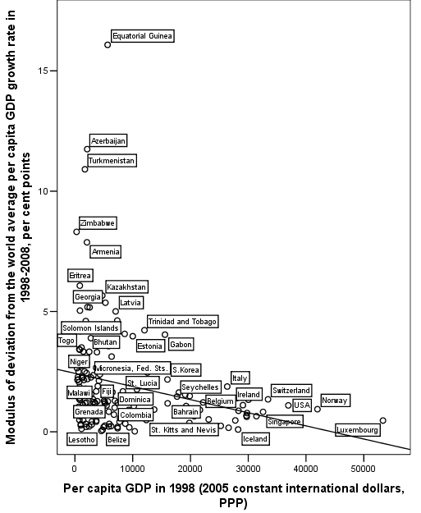
Fig. 11. Correlation between per capita GDP in 1998 and the modulus (absolute value) of deviation from the world average per capita GDP annual growth rate in 1998–2008. For all the countries of the world (World Bank 2010 dataset). Scatterplot with fitted regression line
Note: r = – 0.254, p = 0.001. Data source: World Bank 2010.
As a result we get a typical ‘fir-tree’ scatterplot for the correlation between the initial value of per capita GDP and average annual per capita GDP growth rates in the subsequent period indicating the absence of any significant correlation (and hence the absence of either general divergence or convergence).
Note that the above-mentioned huge variation in the average annual growth rates among low-income countries is produced mostly by smaller economies. For example, in the WDI dataset among smaller¹³ low-income¹⁴ economies the standard deviation for the average annual per capita GDP growth rate (in 1998–2008) equals 3.54, whereas for larger¹⁵ low-income economies it is much smaller (2.01). In Maddison's dataset among smaller¹⁶ low-income¹⁷ economies the standard deviation for the average annual per capita GDP growth rate (in 1998–2008) equals 3.53, whereas for larger¹⁸ low-income economies it is also much smaller (2.15).
Of course, this is not really surprising. Indeed, it is quite natural that larger economies tend to be more stable, whereas it is smaller economies that are more likely to experience dramatic (both positive and negative) growth rates – either particularly precipitous declines, or especially sweeping upswings.
Hence, against the above-described background it would seem a rather logical suggestion to leave in the sample larger countries (comprising overwhelming majority of the world population, and producing almost all of the world GDP), which apparently could reveal underlying patterns of general divergence/convergence obscured by ‘information noise’ produced by smaller economies.
This hypothesis worked surprisingly well (see Table 3 below). The convergence pattern became clearly visible as soon as we left in the sample countries with total GDP values (for 1998) of no less than $10 billion.¹⁹ Note that these countries produce more than 98 % of the whole world GDP and comprise more than 96 % of all population of the world (for 1998). As we see, after 1998 the ‘absence of convergence’ illusion is produced by a few dozen of small economies encompassing a very small fraction of the world population and producing a negligible percentage of the world GDP. As soon as we leave in the samples countries with total GDP values of no less than $10 billion, we immediately find significant negative correlation between per capita GDP in 1998 and per capita GDP growth rates in 1998–2008 in both datasets (see Table 3).²⁰ This negative correlation becomes much stronger and more significant as soon as we raise the cut-off level up to $20 billion.²¹ It further strengthens with the increase in cut-off level up to $30 billion,²² and becomes rather strong and unequivocally significant when we leave in the samples countries with total GDP values of no less than $40 billion (note that the respective 67 countries produce 96 % of all the world GDP and comprise more than 86 % of all the world population for 1998²³) – see Fig. 12.
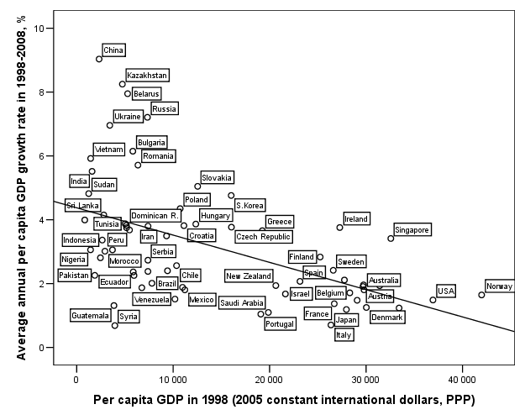
Fig. 12. Correlation between per capita GDP in 1998 and average annual per capita GDP growth rates in 1998–2008. For countries with total GDP volumes of no less than $40 billion (for 1998). Scatterplot with fitted regression line
Note: r = – 0.51, p < 0.0001. Source: World Bank 2010.
The convergence in this sample of countries comprising the overwhelming majority of the world population and producing almost all the world GDP is perfectly visible. Actually there is only one absolute outlier (a low-income economy with economic growth rates lower than in any developed economy) in the sample – Syria. As will be seen below, when we leave in the sample larger economies only, we shall confront an even clearer unconditional convergence pattern without any salient outliers at all.
The negative correlation between per capita GDP in 1998 and per capita GDP growth rates in 1998–2008 rises further when we leave in the samples countries with total GDP volumes (for 1998) of no less than $50 billion²⁴ and reaches –0.550 (for the World Bank dataset), as soon as we raise the cut-off level up to $75 billion (note that the respective 54 countries still produce 94 % of all the world GDP and comprise c.84 % of all the world population [for 1998]) – see Fig. 13.
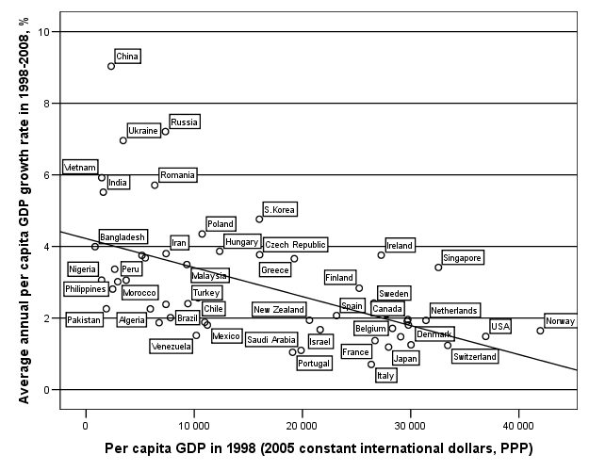
Fig. 13. Correlation between per capita GDP in 1998 and average annual per capita GDP growth rates in 1998–2008. For countries with total GDP volumes of no less than $75 billion (for 1998). Scatterplot with fitted regression line
Note: r = – 0.55, p < 0.0001. Source: World Bank 2010.
In fact, Fig. 13 suggests that we are dealing here not with a simple linear relationship between the two variables in question, but rather with a power-law one. Indeed, our mathematical analysis has supported this supposition (see Figs 14–15 and Table 2).
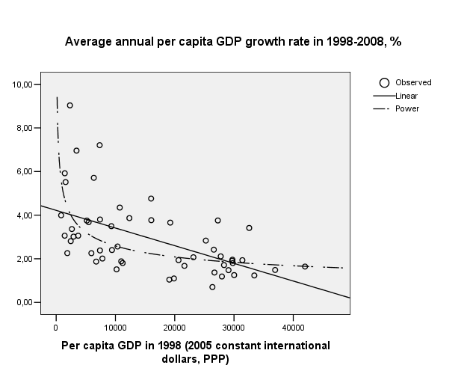
Fig. 14. Correlation between per capita GDP in 1998 and average annual per capita GDP growth rates in 1998–2008. For countries with total GDP volumes of no less than $75 billion (for 1998). Comparison between linear and power-law models
(double natural scale)
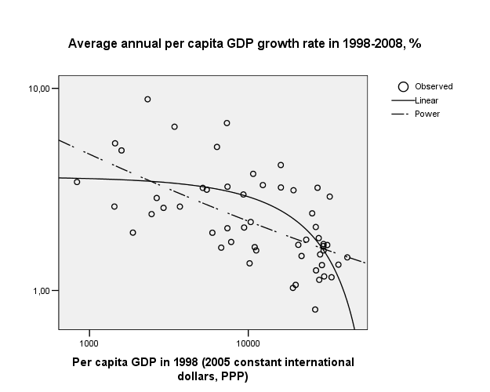
Fig. 15. Correlation between per capita GDP in 1998 and average annual per
capita GDP growth rates in 1998–2008. For countries with total GDP volumes
of no less than $75 billion (for 1998). Comparison between linear and power-law
models (double logarithmic scale)
Table 2
Comparison between linear and power-law models for countries with total GDP volumes of no less than $75 billion
As we see, the linear model in this case accounts for 30 % of the variation, whereas the power-law models accounts for 36 %. As a result, the post-1998 convergence pattern is better visible in double logarithmic scale, which will be employed thereafter, starting with Fig. 16.
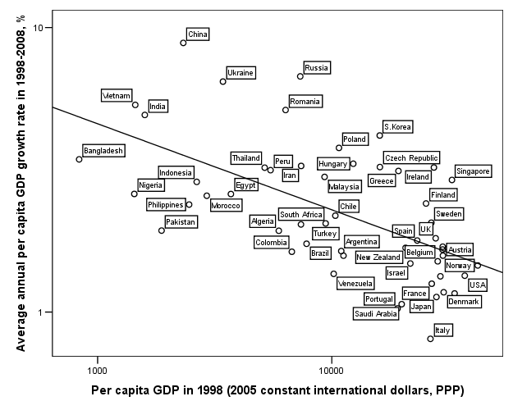
Fig. 16. Correlation between per capita GDP in 1998 and average annual per capita GDP growth rates in 1998–2008. For countries with total GDP volumes of no less than $75 billion (for 1998) (double logarithmic scale). Scatterplot with fitted power-law
regression line
Note: r = – 0.55, p < 0.0001. R² = 0.303 (linear model); R² = 0.356 (power-law model). Data source: World Bank 2010.
In no way does the growth of the correlation in question stop at the $75 billion point. It grows further when we move to $100 and 200 billion levels (see Fig. 17).²⁵
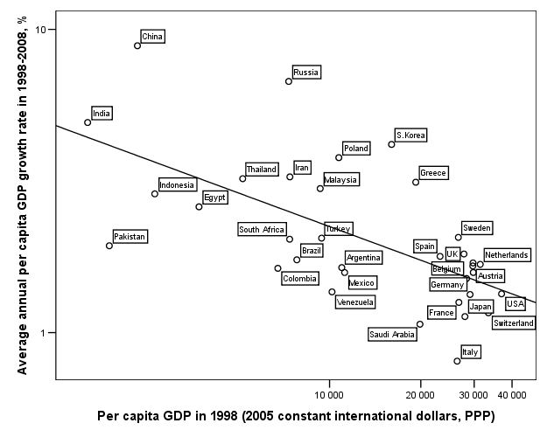
Fig. 17. Correlation between per capita GDP in 1998 and average annual per capita GDP growth rates in 1998–2008. For countries with total GDP volumes of no less than $200 billion (for 1998) (double logarithmic scale). Scatterplot with fitted power-law regression line
Note: r = – 0.564, p = 0.001. R² = 0.32 (linear model); R² = 0.40 (power-law model). Data source: World Bank 2010.
The rise of the strength of the negative correlation between per capita GDP in 1998 and per capita GDP growth rates in 1998–2008 does not stop at $200 billion cut-off point. It increases further when we move to $300 billion²⁶, and becomes unequivocally strong beyond $400 billion (see Table 3 and Fig. 18).
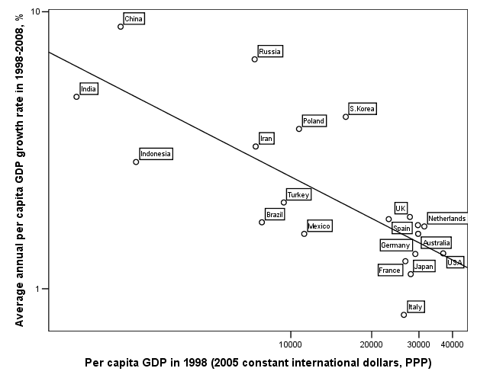
Fig. 18. Correlation between per capita GDP in 1998 and average annual per capita GDP growth rates in 1998–2008. For countries with total GDP volumes of no less than $400 billion(for 1998) (double logarithmic scale). Scatterplot with fitted power-law regression line
Note: r = – 0.7, p = 0.001. R² = 0.49 (linear model); R² = 0.56 (power-law model). Data source: World Bank 2010.
The rise of the correlation strength with the increase in cut-off levels is observed even further. For the World Bank 2010 dataset it increases to – 0.72 when we leave in the sample the economies with no less than $600 billion of total GDP, and it arrives at –0.757 level²⁷ for the largest economies with no less than $750 billion of total GDP.
It does not appear to be reasonable to move beyond this point, as by this point we already have only 13 countries in the World Bank dataset and we have just 9 countries in Maddison's one. However, even these 9 countries still encompass more than a half of the world population and produce almost two thirds of the world GDP.
Table 3
Correlations between per capita GDP in 1998
and per capita GDP growth rates in 1998–2008
World Bank 2010 Dataset
Countries with GDP in 1998 no less than (in constant 2005 international $, PPP) | Correlation between per capita GDP in 1998 and per capita GDP growth rates in 1998–2008  (Pearson's r) | Sig. (two-tailed) |  | Number of countries |  | Percentage of the world GDP produced by these countries | Percentage of the world population living in these countries
$10 billion | – 0.275 | 0.004 |  | 108 |  | 97.7 % | 94.2 %
$20 billion | – 0.329 | 0.002 |  | 85 |  | 96.9 % | 90.8 %
$30 billion | – 0.406 | 0.0002 |  | 77 |  | 96.3 % | 89.1 %
$40 billion | – 0.510 | <0.0001 |  | 67 |  | 95.6 % | 86.2 %
$50 billion | – 0.514 | <0.0001 |  | 62 |  | 95.0 % | 84.9 %
$75 billion | – 0.550 | <0.0001 |  | 54 |  | 93.7 % | 83.4 %
$100 billion | – 0.554 | <0.0001 |  | 52 |  | 93.4 % | 82.9 %
$200 billion | – 0.564 | 0.001 |  | 34 |  | 86.6 % | 72.5 %
$300 billion | – 0.644 | 0.001 |  | 24 |  | 81.1 % | 66.9 %
$400 billion | – 0.700 | 0.001 |  | 20 |  | 77.9 % | 64.3 %
$600 billion | – 0.720 | 0.002 |  | 15 |  | 72.3 % | 58.6 %
$750 billion | – 0.757 | 0.003 |  | 13 |  | 69.3 % | 56.7 %
Maddison 2010 Dataset
Countries with GDP in 1998 no less than (in constant 1990 international $, PPP) | Correlation between per capita GDP in 1998 and per capita GDP growth rates in 1998–2008  (Pearson's r) | Sig. (two-tailed) | Number of countries |  | Percentage of the world GDP produced by these countries  (for 1998) |  | Percentage of the world population living in these countries  (for 1998)
1 | 2 | 3 | 4 |  | 5 |  | 6
$10 billion | – 0.184 | 0.05 | 109 |  | 98.3 % |  | 96.1 %
$20 billion | – 0.281 | 0.009 | 85 |  | 97.3 % |  | 92.1 %
$30 billion | – 0.401 | 0.001 | 69 |  | 96.1 % |  | 88.6 %
$40 billion | – 0.422 | 0.0005 | 65 |  | 95.7 % |  | 86.7 %
$50 billion | – 0.446 | 0.0003 | 61 |  | 95.2 % |  | 85,5 %
$75 billion | – 0.493 | 0.0002 | 54 |  | 93.9 % |  | 84.1 %
$100 billion | – 0.526 | 0.0002 | 45 |  | 91.7 % |  | 81.6 %
$200 billion | – 0.537 | 0.005 | 26 |  | 83.5 % |  | 69.7 %
Table 3 continued
1 | 2 | 3 | 4 | 5 | 6
$300 billion | – 0.623 | 0.003 | 21 | 79.9 % | 64.6 %
$400 billion | – 0.630 | 0.009 | 16 | 74.8 % | 62.0 %
$600 billion | – 0.680 | 0.01 | 13 | 70.1 % | 59.5 %
$750 billion | – 0.741 | 0.02 | 9 | 62.5 % | 51.4 %
Note that the general convergence pattern of 1998–2008 may be also detected if we leave in our sample the countries with population of no less than 50 million²⁸ (see Fig. 19).
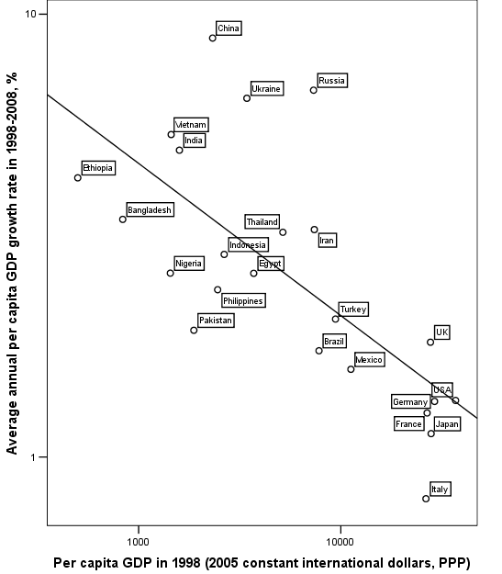
Fig. 19. Correlation between per capita GDP in 1998 and average annual per capita GDP growth rates in 1950–1970. For countries with population of no less than 50 million (in 1998) (double logarithmic scale). Scatterplot with fitted power-law
regression line
Note: r = – 0.62, p = 0.002. R² = 0.38 (linear model); R² = 0.51 (power-law model),
p = 0.0001.
Source: World Bank 2010.

6. Discussion
Thus for the period after 1998 we find rather strong evidence for the unconditional convergence among all the larger countries comprising the overwhelming majority of the world population and producing the overwhelming part of the world GDP.
Note that our findings are not as incongruent with the results of the previous convergence research as one may think. Indeed this research did not deny the convergence phenomenon per se, but rather insisted on its conditionality, whereas the main conditions of the convergence with the high-income economies were identified, first of all, as (1) a sufficiently high level of development of the human capital (comparable with the one of the high-income economies) (e.g., Barro 1991; Mankiw, Romer, and Weil 1992; Cohen 1996); (2) a sufficient degree of economic openness (e.g., Ben-David 1993: 653; Sachs et al. 1995: 199; etc.); (3) a sufficient degree of law and order (e.g., Milanovic 2005; Owen, Videras, and Davis 2009).
By 1998 all the major developing economies of the world satisfied those conditions much better than they did in the divergence era. Sachs and Warner might not be entirely satisfied yet with the degree of economic openness of, say, Russia, China, or Ethiopia. But they would hardly argue against the point that Chinese and Russian economies are radically more open now than they were in the 1960s, whereas the Ethiopian economy is radically more open now than it was in the late 1970s. On the other hand, the evidence that we present suggests that Sachs et al. (1995) appear to have exaggerated the degree of economic openness that is necessary for the convergence phenomenon to develop.
We believe that of special importance is the fact that between 1950–1960 and the late 1990s we observe a radical decrease of the gap between the ‘First’ and ‘Third’ world with respect to the level of development of the human capital (see Figs 20–21).
Fig. 20. Decrease of the gap between the Western Europe (and off-shoots)
and the main Third World macroregions/countries with respect to the literacy rates, per cent points, 1950–2000
Data source: Morrison and Murtin 2006.
Fig. 21. Decrease of the gap between the USA and some Third world regions/countries with respect to the life expectancy, 1960–2000
Data source: World Bank 2010.
Thus the switch from the conditional to unconditional convergence pattern that we appear to be recently observing seems to be accounted for by the point that by the late 1990s all the major countries and economies of the world began to satisfy (more or less) the major conditions of the conditional convergence.

7. Conclusions
1. It does not appear reasonable to try to find the only and for ever answer to the question ‘Is there an unconditional convergence?’ In general, such an unspecific question does not appear to be correct at all. The point is that the answer to this question would be very different depending on the period of the World System history to which the question refers.
2. As we could see, the 1950s and 1960s were characterized by a pattern of general divergence, whereas in 1998–2008 a pattern of general convergence definitely prevailed.
3. For 1998–2008 a pattern of unconditional convergence can be detected for all the large countries (with population of no less than 50 million in 1998). It can be also detected for all the middle and large economies of the world.
4. These conclusions are not as incongruent with the results of the previous convergence research as one may think. In fact, this research did not deny the convergence phenomenon per se, but rather insisted on its conditionality, whereas we suggest that the world-wide switch from the conditional to unconditional convergence pattern that we appear to be recently observing seems to be accounted for by the point that by the late 1990s all the major developing countries and economies of the world began to satisfy (more or less) the major conditions of the conditional convergence.

NOTES
1 As Abel and Bernanke (2005: 235) state, the ‘spirit’ of Solow's model supports the idea of generality of convergence.
2 Much the same conclusion was made by Ben-David, who stated that there existed ‘a strong link between the timing of trade reform and income convergence among countries’ (Ben-David 1993: 653).
3 Note that Sachs et al. quite remarkably state at this point: ‘This is now changing with the spread of trade liberalization programs, so that presumably the tendencies toward convergence will be markedly strengthened’ (Sachs et al. 1995: 3).
4 Which in our previous research was operationalized to consist of Western Europe, Western European off-shoots, and Japan.
5 Thus, excluding the former Soviet Union, and the former Communist countries of the Eastern Europe (the Second World). For our analysis these countries could not be included into the core due to a relatively low level of their economic development, on the other hand they could not be included in the Third World due to their high advancement in demographic transition (incomparable to the Third World, but quite comparable with the First World).
6 We have suggested accordingly that Protestantism has indeed influenced positively the capitalist development of respective social systems not so much through the ‘Protestant ethics’ (as was suggested by Weber 2003 [1905]) but rather through the promotion of literacy (Korotayev, Malkov, and Khaltourina 2006: 87–91).
7 Calculated in dollars of GDP growth per a dollar of investments.
8 Which were operationalized as the ones with per capita GDP in 1950 less than 20 % of the USA in 1950.
9 Which were operationalized as the ones with per capita GDP in 1950 no less than 20 % of the USA in 1950.
1⁰ Which were operationalized as the ones with per capita GDP in 1998 less than 20 % of the USA in 1998.
1¹ Which were operationalized as the ones with per capita GDP in 1998 no less than 20 % of the USA in 1998.
1² The phenomenon of unconditional divergence will be treated in more detail below in Appendix 2.
1³ With less than 40 billion of GDP (in 2005 dollars, PPP) in 1998.
1⁴ With per capita GDP in 1998 less than $10,000.
1⁵ With more than 40 billion of GDP (in 2005 dollars, PPP) in 1998.
1⁶ With less than 75 billion of GDP (in 1990 international dollars, PPP) in 1998.
¹⁷ With per capita GDP in 1998 less than $10,000.
1⁸ With more than 75 billion of GDP (in 1990 international dollars, PPP) in 1998.
¹⁹ Note that World Bank 2010 and Maddison 2010 use somehow different units of measurement for GDP (in PPP). The former employs 2005 constant international dollars (PPP), whereas the latter uses 1990 international dollars. However, for the sake of simplicity we decided to use the same cut-off levels for both datasets.
2⁰ r = – 0.275, p = 0.004 (two-tailed throughout) for World Bank 2010, and r = – 0.184, p = 0.05 for Maddison 2010.
2¹ r = – 0.329, p = 0.002 for World Bank 2010, and r = – 0.281, p = 0.009 for Maddison 2010.
2² r = – 0.406, p = 0.0002 for World Bank 2010, and r = – 0.401, p = 0.001 for Maddison 2010.
2³ r = – 0.514, p < 0.0001 for World Bank 2010, and r = – 0.446, p = 0.0002 for Maddison 2010.
²⁴ r = – 0.554, p < 0.0001 for World Bank 2010, and r = – 0.526, p = 0.0002 for Maddison 2010.
2⁵ r = – 0.644, p = 0.001 for World Bank 2010, and r = – 0.623, p = 0.003 for Maddison 2010.
2⁶ R² = 0.57 (linear model); R² = 0.67 (power-law model).
2⁷ Note that respective countries comprise three quarters of the world population and produce more than 91 % of the world GDP. Note also that this approach is quite congruent with Sala-i-Martin's reasoning regarding the straightforward use in the convergence/divergence studies of individual ‘countries as their unit of analysis. This is the correct approach when, for example, one tries to test theories of economic growth because aggregate growth theories tend to predict that growth depends on “national factors” such as policies, institutions, and other elements determined at the economy wide level. To the extent that those determinants are independent across nations, each country can be correctly treated as an independent data point of an economic “experiment”. Using countries as units of analysis, however, is not useful if one worries about human welfare because different countries have different population sizes. After all, there is no reason to down-weight the well-being of a Chinese peasant relative to a Senegalese farmer just because the population in China is larger than that of Senegal’ (Sala-i-Martin 2006: 352).
2⁸ Though, naturally, the exponent b1 in the power-law model in case of divergence pattern is positive, whereas in case of convergence pattern it is negative.

References
Abel, A. B., and Bernanke, B. S.
2005. Macroeconomics. 5th ed. Boston, MA: Pearson/Addison Wesley.
Abramovitz, M.
1986. Catching Up, Forging Ahead, and Falling Behind. The Journal of Economic History 46(2): 385–406.
Acemoglu, D.
2009. Introduction to Modern Economic Growth. Princeton, NJ: Princeton University Press.
Barro, R. J.
1991. Economic Growth in a Cross Section of Countries. The Quarterly Journal of Economics 106(2): 407–443.
Baumol, W. J.
1986. Productivity Growth, Convergence, and Welfare: What the Long-Run Data Show. American Economic Review 76(5): 1072–1085.
Ben-David, D.
1993. Equalizing Exchange: Trade Liberalization and Income Convergence. The Quarterly Journal of Economics 108(3): 653–679.
Bernard, A. B., and Durlauf, S. N.
1995. Convergence in International Output. Journal of Applied Econometrics 10(2): 97–108.
Bernard, A. B., and Jones, C. I.
1996a. Productivity across Industries and Countries: Time Series Theory and Evidence. The Review of Economics and Statistics 78(1): 135–146.
1996b. Comparing Apples to Oranges: Productivity Convergence and Measurement across Industries and Countries. American Economic Review 86(5): 1216–1238.
Bianchi, M.
1997. Testing for Convergence: Evidence from Non-Parametric Multimodality Tests. Journal of Applied Econometrics 12(4): 393–409.
Caggiano, G., and Leonida, L.
2009. International Output Convergence: Evidence from an Autocorrelation Function Approach. Journal of Applied Econometrics 24: 139–162.
Canova, F., and Marcet, A.
1995. The Poor Stay Poor: Non-convergence across Countries and Regions. Barcelona: Universitat Pompeu Fabra.
Caselli, F., Esquivel, G., and Lefort, F.
1996. Reopening the Convergence Debate: A New Look at Cross-Country Growth Empirics. Journal of Economic Growth 1(3): 363–389.
Cetorelli, N.
2002. Could Prometheus be Bound Again? A Contribution to the Convergence Controversy. Journal of Economic Dynamics & Control 27: 29–50.
Chesnais, J. C.
1992. The Demographic Transition: Stages, Patterns, and Economic Implications. Oxford: Clarendon Press.
Cohen, D.
1996. Tests of the ‘Convergence Hypothesis’: Some Further Results. Journal of Economic Growth 1(3): 351–361.
Coulombe, S., Tremblay, J. F., and Marchand, S.
2004. Literacy Scores, Human Capital and Growth across Fourteen OECD Countries. Ottawa: Human Resources and Skills Development Canada, Statistics Canada.
De Long, J. B.
1988. Productivity Growth, Convergence, and Welfare: Comment. American Economic Review 78(5): 1138–1154.
De Long, J. B., and Summers, L. H.
1991. Equipment Investment and Economic Growth. Quarterly Journal of Economics 106(2): 445–502.
Denison, E.
1962. The Source of Economic Growth in the United States and the Alternatives before US. New York, NY: Committee for Economic Development.
Desdoigts, A.
1994. Changes in the World Income Distributions: A Non-parametric Approach to Challenge the Neo-classical Convergence Argument. Berlin: Humboldt Universitaet Berlin.
Dobson, S., and Ramlogan, C.
2002. Economic Growth and Convergence in Latin America. The Journal of Development Studies 38(6): 83–104.
Dowrick, S., and Nguyen, Duc-Tho
1989. OECD Comparative Economic Growth 1950–85: Catch-Up and Convergence. American Economic Review 79(5): 1010–1030.
Durlauf, S. N., and Johnson, P. A.
1995. Multiple Regimes and Cross-Country Growth Behaviour. Journal of Applied Econometrics 10(4): 365–384.
Ember, C. R.
1977. Cross-Cultural Cognitive Studies. Annual Review of Anthropology 6: 33−56.
Epstein, P., Howlett, P., and Schulze, M. S.
2007. Trade, Convergence, and Globalisation: The Dynamics of the International Income Distribution, 1950–1998. Explorations in Economic History 44: 100–113.
Frantzen, D.
2004. Technological Diffusion and Productivity Convergence: A Study for Manufacturing in the OECD. Southern Economic Journal 71(2): 352–376.
de la Fuente, A.
2003. Convergence Equations and Income Dynamics: The Sources of OECD Convergence, 1970–1995. Economica 70: 655–671.
Galvao, Jr., A. F., and Reis Gomes, F. A.
2007. Convergence or Divergence in Latin America? A Time Series Analysis. Applied Economics 39: 1353–1360.
Gaulier, G., Hurlin, C., and Jean-Pierre, Ph.
1999. Testing Convergence: A Panel Data Approach. Annales d'Économie et de Statistique 55/56: 411–427.
Gerschenkron, A.
1952. Economic Backwardness in Historical Perspective. In Hoselitz, B. F. (ed.), The Progress of Underdeveloped Areas. Chicago, IL: University of Chicago Press.
Howitt, P., and Mayer-Foulkes, D.
2004. R&D, Implementation and Stagnation: A Schumpeterian Theory of Convergence Clubs. Cambridge, MA: NBER.
Islam, N.
2003. What have We Learnt from the Convergence Debate? Journal of Economic Surveys 17(3): 309–362.
Jones, Ch.
1997a. Convergence Revisited. Journal of Economic Growth 2(2): 131–153.
1997b. On the Evolution of the World Income Distribution. Journal of Economic Perspectives 11: 19–36.
King, R. G., and Levine, R.
1993. Finance and Growth: Schumpeter Might be Right. Quarterly Journal of Economics 108(3): 717–737.
Korotayev, A., Malkov, A., and Khaltourina, D.
2006. Introduction to Social Macrodynamics: Compact Macromodels of the World System Growth. Moscow: KomKniga/URSS.
Lee, K., Hashem Pesaran, M., and Smith, R.
1997. Growth and Convergence in a Multi-Country Empirical Stochastic Solow Model. Journal of Applied Econometrics 12(4): 357–392.
Levine, R., and Renelt, D.
1992. A Sensitivity Analysis of Cross-Country Growth Regressions. American Economic Review 82(4): 942–963.
Li, Haizheng, and Xu, Zhenhui
2007. Economic Convergence in Seven Asian Economies. Review of Development Economics 11(3): 531–549.
Lim, L. K., and McAleer, M.
2004. Convergence and Catching Up in ASEAN: A Comparative Analysis. Applied Economics 36: 137–153.
Lucas, R.
1988. On the Mechanisms of Economic Development. Journal of Monetary Economics 22: 3–42.
Luria, A. R.
1976. Cognitive Development. Cambridge, MA: Harvard University Press.
Maddison, A.
1995. Monitoring the World Economy, 1820–1992. Paris: OECD.
2001. Monitoring the World Economy: A Millennial Perspective. Paris: OECD.
2003. The World Economy: Historical Statistics. Paris: OECD.
2010. World Population, GDP and Per Capita GDP, A.D. 1–2008. URL: www.
ggdc.net/maddison.
Malkov, A. S., Bogevolnov, Yu. V., Khaltourina, D. A., and Korotayev, A. V.
2010. Toward the System Analysis of the World Dynamics: Interaction of the World System Core and Periphery. In Akayev, A. A., Korotayev, A. V., and Malinetsky, G. G. (eds.), Forecasting and Modeling Crises and World Dynamics (pp. 234–248). Moscow: LKI/URSS. In Russian (Малков, А. С., Божевольнов, Ю. В., Халтурина, Д. А., Коротаев, А. В. К системному анализу мировой динамики: взаимодействие центра и периферии Мир-Системы. Прогноз и моделирование кризисов и мировой динамики / Отв. ред. А. А. Акаев, А. В. Коротаев, Г. Г. Малинецкий, c. 234–248. М.: Издательство ЛКИ/URSS).
Malkov, A. S., Korotayev, A. V., and Bogevolnov, Yu. V.
2010. Mathematical modeling of the Interaction of the World System core and periphery. In A. A. Akayev, A. V. Korotayev, and G. G. Malinetsky (eds.), Forecasting and Modeling Crises and World Dynamics (pp. 277–286). Moscow: LKI/URSS In Russian (Малков, А. С., Коротаев, А. В., Божевольнов, Ю. В. Математическое моделирование центра и периферии Мир-Системы. Прогноз и моделирование кризисов и мировой динамики / Отв. ред. А. А. Акаев, А. В. Коротаев, Г. Г. Малинецкий, c. 277–286. М.: Издательство ЛКИ/URSS).
Mankiw, N. G.
2008. Principles of Macroeconomics. 5th ed. Boston, MA: South-Western College Publishing.
Mankiw, N. G., Romer, D., and Weil, D. N.
1992. A Contribution to the Empirics of Economic Growth. The Quarterly Journal of Economics 107(2): 407–437.
Meliantsev, V. A.
1996. East and West in the Second Millennium. Moscow: Moscow State University. In Russian (Мельянцев, В. А. Восток и Запад во втором тысячелетии. М.: МГУ).
Milanovic, B.
2005. Why did the Poorest Countries Fail to Catch Up? Carnegie Paper 62. Washington, DC: Carnegie Endowment for International Peace.
Morrison, Ch., and Murtin, F.
2006. The World Distribution of Human Capital, Life Expectancy and Income: A Multi-Dimensional Approach. Paris: OECD.
Naudé, W. A.
2004. The Effects of Policy, Institutions and Geography on Economic Growth in Africa: An Econometric Study Based on Cross-Section and Panel Data. Journal of International Development 16: 821–849.
Owen, A. L., Videras, J., and Davis, L.
2009. Do all Countries Follow the Same Growth Process? Journal of Economic Growth 14(4): 265–286.
Paap, R., and van Dijk, H. K.
1994. Distribution and Mobility of Wealth of Nations. Working papers Tinbergen Institute, Erasmus University. October.
Petrakos, G., and Artelaris, P.
2009. European Regional Convergence Revisited: A Weighted Least Squares Approach. Growth and Change 40(2): 314–331.
Quah, D. T.
1996a. Twin Peaks: Growth and Convergence in Models of Distribution Dynamics. The Economic Journal 106(437): 1045–1055.
1996b. Convergence Empirics across Economies with (Some) Capital Mobility. Journal of Economic Growth 1(1): 95–124.
1996c. Empirics for Economic Growth and Convergence. European Economic Review 40(6): 1353–1375.
1997. Empirics for Growth and Distribution: Polarization, Stratification, and Convergence Clubs. Journal of Economic Growth 2(1): 27–59.
Rapacki, R., and Prochniak, M.
2009. Real Beta and Sigma Convergence in 27 Transition Countries, 1990–2005. Post-Communist Economies 21(3): 307–326.
Rassekh, F.
1998. The Convergence Hypothesis: History, Theory, and Evidence. Open Economies Review 9: 85–105.
Rogoff, B.
1981. Schooling and the Development of Cognitive Skills. Handbook of Cross-Cultural Psychology. Vol. 4. Developmental Psychology (pp. 233−294). Boston, MA: Oxford University Press.
Romer, P. M.
1986. Increasing Returns and Long-Run Growth. The Journal of Political Economy 94(5): 1002–1037.
Romero-Avila, D.
2009. The Convergence Hypothesis for OECD Countries Reconsidered: Panel Data Evidence with Multiple Breaks, 1870–2003. The Manchester School 77(4): 552–574.
Sachs, J. D., Warner, A., Aslund, A., and Fischer, S.
1995. Economic Reform and the Process of Global Integration. Brookings Papers on Economic Activity 1(25): 1–118.
Sadik, J.
2008. Technology Adoption, Convergence, and Divergence. European Economic Review 52: 338–355.
Sala-i-Martin, X. X.
1996. The Classical Approach to Convergence Analysis. The Economic Journal 106(437): 1019–1036.
2006. The World Distribution of Income: Falling Poverty and … Convergence, Period. The Quarterly Journal of Economics 121(2): 351–397.
Samuelson, P. A., and Nordhaus, W. D.
2005. Economics. 18th ed. Boston, MA: McGraw-Hill.
Scholing, E., and Timmermann, V.
1988. Why LDC Growth Rates Differ. World Development 16: 1271–1294.
Schultz, T.
1963. The Economic Value of Education. New York, NY: Columbia University Press.
Seshanna, Sh., and Decornez, S.
2003. Income Polarization and Inequality across Countries: An Empirical Study. Journal of Policy Modeling 25: 335–358.
Solow, R. A.
1956. A Contribution to the Theory of Economic Growth. Quarterly Journal of Economics 70: 65–94.
UNESCO
2005. Education for All. Literacy for Life. EFA Global Monitoring Report – 2006. Paris: UNESCO.
2010. Estimates and Projections of Adult Illiteracy for Population Aged 15 Years and above, by Country and by Gender 1970–2015. URL: http://www.uis.unesco.org/
en/stats/statistics/ literacy2000.htm.
Weber, M.
2003 [1905]. The Protestant Ethic and the Spirit of Capitalism. Mineola, NY: Dover.
Williamson, J. G.
1996. Globalization, Convergence, and History. The Journal of Economic History 56(2): 277–306.
Workie, M.
2003. Absolute Convergence across Time and Space: New Empirical Evidence for an Old Debate. Ekonomicky Casopis 51(10): 1270–1291.
World Bank
2010. World Development Indicators Online. Washington, DC: World Bank, Electronic
version. http://web.worldbank.org/WBSITE/EXTERNAL/DATASTATISTICS/0,contentMDK: 20398986~pagePK:64133150~piPK:64133175~theSitePK:239419,00.html.
Yifu Lin, J.
2003. Development Strategy, Viability, and Economic Convergence. Economic Development and Cultural Change 53(2): 277–308.
Zhang, Zh.
2003. Can the Rest of East Asia Catch up with Japan: Some Empirical Evidence. Japan and the World Economy 15: 91–110.
Appendix 1
Is unconditional convergence observed after 1998 among middle economies?
The negative correlation between per capita GDP in 1998 and economic growth rates in 1998–2008 for large economies is so stronger than for the sample comprising both large and middle economies, that it seems natural to wonder if the significant medium-strength correlation in the latter sample is not just an artifact of the very strong unconditional convergence observed after 1998 among the large economies. Hence, it seems necessary to test if the unconditional convergence was observed in 1998–2008 among the medium-size economies. We have tested the respective hypothesis with respect to the economies with 1998 GDP in the range between $40 billion and $200 billion. The results of this test are presented below in Fig. 22.
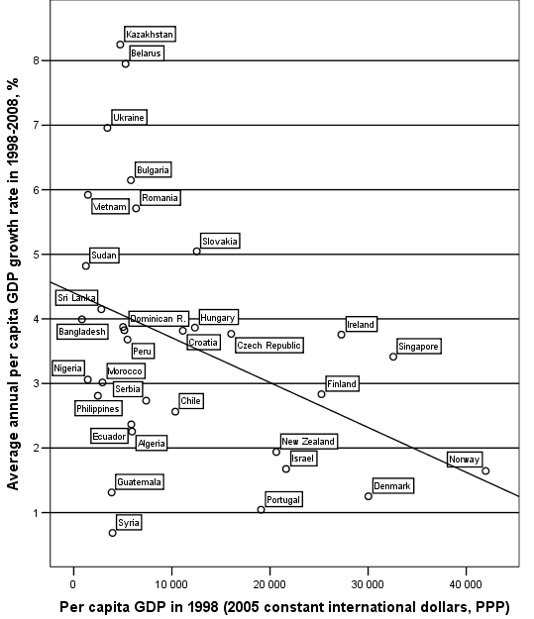
Fig. 22. Correlation between per capita GDP in 1998 and average annual per capita GDP growth rates in 1998–2008. For medium-size economies (with total GDP volumes in the range between $40 billion and $200 billion Т (for 1998).
Scatterplot with fitted regression line
Note: r = – 0.39, p = 0.03. Source: World Bank 2010.
As we see, the unconditional convergence pattern is observed after 1998 for medium-size economies quite clearly. The negative correlation for this sample is statistically significant and quite strong; however, of course, the unconditional convergence pattern is here much weaker (and less significant) than the one observed for large economies (let us recollect that, e.g., for economies with more than $400 billion of total GDP it reaches the level of – 0.7 with significance of 0.002).
Appendix 2
General divergence pattern of 1950–1970
A rather special pattern of general divergence in 1950–1970 becomes visible quite clearly as soon as we leave in the sample countries with population (in 1950) of no less than 20 million (see Fig. 23).
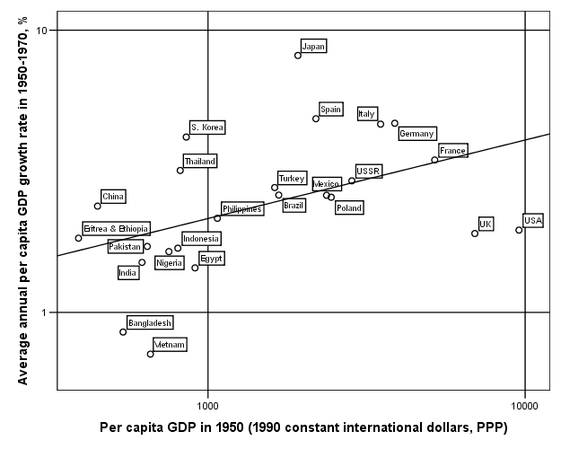
Fig. 23. Correlation between per capita GDP in 1950 and average annual per capita GDP growth rates in 1950–1970. For countries with population of no less than
20 million (double logarithmic scale). Scatterplot with fitted power-law regression line
Note: R² = 0.21 (power-law model), p = 0.025. Data source: Maddison 2010.
It can be seen rather clearly that the general pattern is composed of two sub-patterns:
1) a rather strong divergence among the low- and middle-income countries (see Fig. 24);
2) a rather strong convergence among the middle- and high-income countries (see Fig. 25).
In fact, this was the combination of the above-mentioned patterns that led to the formation by the late 1960s of the famous ‘twin peaked’ distribution (Quah 1996a, 1997; Jones 1997b).
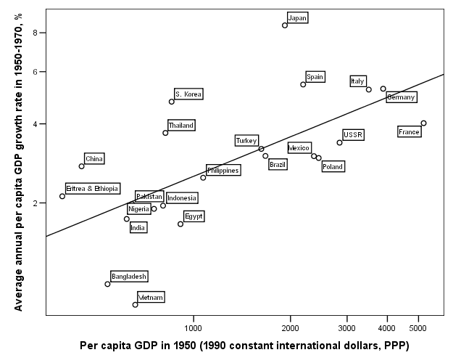
Fig. 24. Correlation between per capita GDP in 1950 and average annual per capita GDP growth rates in 1950–1970. For low- and middle-income countries with population of no less than 20 million (in 1950) (double logarithmic scale). Scatterplot with fitted power-law regression line
Note: r = – 0.56, p = 0.09. R² = 0.31 (linear model); R² = 0.40 (power-law model), p = 0.05. We denote as ‘low-income countries’ the ones with per capita GDP in 1950 less than 20 % of the USA in 1950. We denote as ‘middle-income countries’ the ones with per capita GDP in 1950 between 20 and 60 % of the USA in 1950. Data source: Maddison 2010.
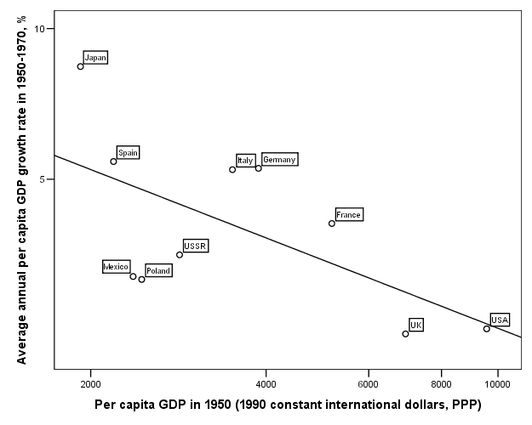
Fig. 25. Correlation between per capita GDP in 1950 and average annual per capita GDP growth rates in 1950–1970. For middle- and high-income countries with population of no less than 20 million (in 1950) (double logarithmic scale). Scatterplot with fitted power-law regression line
Note: r = + 0.53, p = 0.01. R² = 0.28 (linear model); R² = 0.40 (power-law model),
p = 0.002. We denote as ‘high-income countries’ the ones with per capita GDP in 1950 no less than 60 % of the USA in 1950. Data source: Maddison 2010.
Note also that for 1950–1970 both divergence (though, naturally, the exponent b1 in the power-law model in case of divergence pattern is positive, whereas in case of convergence pattern it is negative) and convergence patterns are again described more accurately by power-law rather than linear models (see Figs 24–25 above as well as Table 4 and Fig. 26 below):
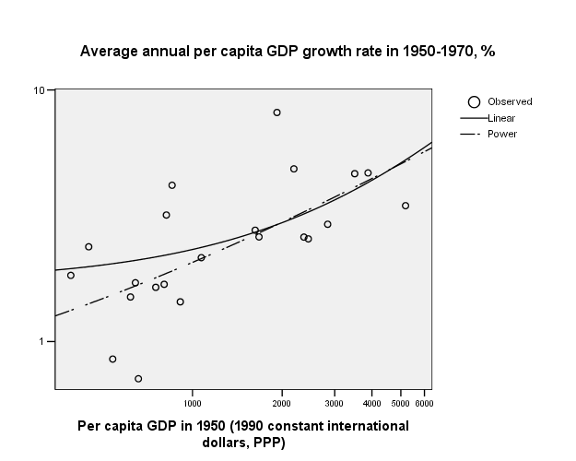
Fig. 26. Correlation between per capita GDP in 1950 and average annual per capita GDP growth rates in 1950–1970. For low- and middle-income countries with population of no less than 20 million (in 1950). Comparison between linear and power-law models (double logarithmic scale)
Table 4
Comparison between linear and power-law models for low- and middle-income countries with population of no less than 20 million (in 1950)
Model Summary and Parameter Estimates
Dependent Variable: Average annual per capita GDP growth rate in 1950–1970, %
Equation | Model Summary |  |  |  |  | Parameter estimates
Equation | R Square | F | df1 | df2 | Sig. | Constant | b1
Linear | ,282 | 7,845 | 1 | 20 | ,011 | 1,988 | ,001
Power | ,400 | 13,347 | 1 | 20 | ,002 | ,063 | ,529
The independent variable is Per capita GDP in 1950 (1990 constant international dollars, PPP).

