MEASURING GLOBALIZATION – OPENING THE BLACK BOX.

A critical analysis of globalization indices
Axel Dreher, Noel Gaston, Pim Martens, and Lotte Van Boxem*
Indices of globalization are employed in various ways. This paper discusses the measurement of globalization with a view to advancing the understanding of globalization indices. Our assessment is that a true understanding of globalization must be an interdisciplinary enterprise. Moreover, it would be fruitful if academics, both quantitative experts and theoreticians, can work together on this challenge. Despite the different methodologies, choice of variables and weights, in order to study and measure globalization meaningfully, new co-operative frameworks are needed.
Keywords: globalization, measurement, globalization indices.
Introduction
The objective assessment of both the causes and consequences of globalization is
an essential agenda for contemporary societies. Positive economic, social and political analyses require data and globalization indices are a most promising means for providing objective data. Existing indices of globalization are employed in various ways. Apart from academic analysis, globalization indices are used in business analysis, mass and specialized media, as well as policy circles.
In business analysis, indices can be employed for gaining insight into the investment climate, the current developments of growth, and for helping business understand the global environment in which it now operates. In the mass media, the latest release of
a globalization index can be the subject of a short news item or a feature article. It can also serve as an illustration for news coverage on related topics, such as technological developments. In policy circles, globalization indices provide a world view which reinforce the global context that policy makers work within.
This paper discusses the measurement of globalization with a view to advancing the understanding of globalization indices. Can globalization be better understood by measuring it? What are the intellectual and political implications of the existing globalization indices? We will discuss the attributes and limitations of globalization indices. A central theme of our argument is what we perceive to be the considerable gap between the quantitative and the qualitative analysis of globalization.
We critically analyze the types of index that can contribute to the debate on globalization. By the ‘globalization debate’ we mean the different viewpoints and facts about globalization that circulate between citizens, academics, scientists, politicians, media and business institutions. We argue that if globalization indices are to make a substantive contribution, they ought to bridge some existing gaps in our understanding of globalization. For example, if cultural transformation is important to globalization, can we include indicators of this transformation in the measurement of globalization? Obviously, the indices need to make a transparent and significant contribution to the debate. Finally, we look at the fields in which indices of globalization can be used. Stepping outside the realm of the indices, and considering the contribution to the wider debate, is a useful step to better understanding of the (im-)possibility of measuring globalization. Next, we discuss the most prominent indices of globalization.
Globalization indices
In what follows, we discuss two indices of globalization developed by two of the authors.¹ The Maastricht Globalization Index, or MGI, developed by Martens and Zywietz (2006), and Martens and Raza (2009) refers to a cross-section of 117 countries, while
the 2002 KOF Index of Globalization constructed in Dreher (2006) covers 122 countries for the period from 1970 to 2002. We also present the most recent KOF index that is based on the 2002 KOF Index of Globalization, covering 158 countries. Decisions are made concerning which variables should focus on the extensity, intensity, velocity or impact of the measured aspect as well as whether to adjust the variables for the geographical characteristics of a country, among others (Held et al. 1999). While the MGI and KOF indices are very similar in many respects, there are notable methodological differences. For example, the MGI explicitly includes an environmental dimension. The latter is outcome-based and therefore excluded from the KOF Index. These differences partly reflect disagreements about the relative merit of various methodological options. Differences have also arisen due to the simultaneous and independent development of the indices. However, the resulting rankings do not crucially depend on the specific methodological choices made.
Another major difference is the adjustment of variables included in the indices for the geographical characteristics of countries. Controlling for these factors might improve the understanding of the other, more subtle determinants of globalization (e.g., past and present policy choices) that might ultimately be more interesting. Given the geographical characteristics of a country, these policy choices also affect economic development (e.g., GDP per capita). ‘Stripping out the effects of economic development from the various measures of globalization would in fact be removing valuable information from these measures’ (Lockwood 2004), which is why they should be included. Pritchett (1996) argues that, when comparing countries' trade intensity, account needs to be taken of obvious structural features of the economy, such as the size and differences in transportation costs. Intuitively, these factors will also affect the other measures of globalization. For example, the trade intensity of Panama of 201.6 % in 1998 was more than eight times higher than the 24.4 % of the United States according to ATK/FP (2002). Whether Panama is eight times more economically globalized than the United States is debatable. The geographical location of Panama at one of the major crossroads of international trade, its size and its history are likely to be primary factors in its openness. However, one could equally well argue that the reasons for a country's openness should not matter for its globalization score. Put differently, the fact that Panama is more open than
the United States because it is at one of the major crossroads of international trade does not change the fact that it is indeed more open and – by definition – more globalised. Whether correcting for such exogenous factors is a priori desirable is an open question. Correcting some variables included in globalization indices while not correcting others makes the results hard to interpret. The preferable option might be to control for these factors statistically when analysing the causes and consequences of globalization rather than correcting the index a priori. While the MGI opts to correct for such exogenous factors, the KOF Index does not.
The construction of an index requires that the measures be normalised. If this were not done, then relatively small variations in one component or its distribution might completely swamp relatively larger variations in others. However, different methods for normalising the data have significantly different impacts on the outcome, that is why the choice is important. On the one hand, when normalising data from several years at
the same time, termed panel normalisation, the results are well-behaved in terms of sensitivity to extreme values. On the other hand, changes in one year could affect the ranking of countries in another year – a decidedly undesirable property. For this reason Lockwood (2004) proposes annual normalisation, i.e., the data are normalised for each year. Normalisation with different parameters (mean, variance, extreme values) for each year can have the effect of ‘moving the goal posts’; in effect letting a country slip in the rankings despite absolute gains in integration. However, Noorbakhsh (1998a: 522) argues that ‘in an international context the goal posts are in fact moving’. If the extant rest of the world is becoming more globalized, a country whose integration is less than
the rest of the world is being left behind. Different scales, means and distributions will alter any weights that are assigned to the different index components and therefore change the relative composition of the index. As described in more detail below,
the KOF Index uses panel normalisation. The MGI uses a cross-section of data, so panel normalisation is not an issue. Both indices normalise the original variables before including them in the respective indices.
Another issue refers to how the variables included in the index should be weighted. There are several options for assigning these weights, all with their advantages in certain situations. For human development, for example, there might be subjective reasons for assigning a priori weights (e.g., the belief that education is equally important as life expectancy). For globalization, however, the case is less clear-cut. Since there is no universal agreement on what globalization is, and even less agreement on the relative importance of its components, some authors have advocated the use of statistical methods to derive weights for the index components (e.g., Noorbakhsh 1998b; Lockwood 2004; Dreher 2006). They evaluate the impact of using statistically optimal weights instead of a priori weights as significant but small in absolute terms. The modification adds considerable complexity to the index. It is possible that the cost in terms of complexity may fall short of the benefit. While the MGI simply adds the individual dimensions, the KOF Index uses statistical analysis to derive the weights.
The MGI: Many previous indices have a decidedly neo-liberal focus on the economic dimensions of globalization. This may stem from the definition of globalization used. As argued earlier, the definition of globalization should refer to the process in its current state, including social, cultural and environmental factors. Hence, contemporary globalization is defined as the intensification of cross-national interactions that promote the establishment of trans-national structures and the global integration of cultural, economic, environmental, political, technological and social processes on global, supra-national, national, regional and local levels (Rennen and Martens 2003). Another objective of the MGI is to broaden existing analyses of globalization by including coverage of sustainable development.
Components of the MGI: Reflecting the need for a balance between broad coverage, data availability and quality motivated the following choice of indicators, with data for 117 countries.
Global Politics: First among the indicators of political integration are the diplomatic relations that constitute a historical basis for communication between countries. Logically, the more important are the links to the outside world, the more diplomatic links will be established by countries to stay informed, protect their interests and facilitate communication. Since no aggregated statistics on diplomatic relations are available at
a global level, the number of in-country embassies and high commissions listed in the Europe World Yearbook are used. The data are available for nearly all countries world-wide, but are corrected for country size, since very small countries can rarely afford the expense of maintaining multiple embassies and often accredit one representative for several countries. Membership in international organisations is a similar measure of the extensity of the international relations and involvement of a country. Moreover, since such memberships do not necessarily entail the need to maintain expensive representations abroad, this measure is less dependent on country size.
Organised Violence: This indicator measures the involvement of a country's military-industrial complex with the rest of the world. While the quality of the data is low, they nevertheless offer an insight into weapons proliferation, international military aid and the reasons and results of international peace-keeping operations. As this dimension has not previously appeared in other globalization indices, no comparison is possible with those indices. Of the quantitative military indicators proposed by Held et al. (1999), trade in conventional arms, compiled by the Stockholm International Peace Research Institute (SIPRI), is the only variable available for a reasonable number of countries. To make the data internationally comparable, a country's trade in conventional arms is related to its military expenditure. Since a large share of the trade is in ‘big-ticket’ items and programmes that are approved and recorded in one year may actually take several years to deliver and service, a moving three-year average is used. The period is arbitrary but offers a reasonable compromise between data availability and the need to smooth the data for infrequent, large purchases.
Global Trade: Like other globalization indices, trade intensity is included as
a measure of the intensity of economic globalization. Trade intensity is the sum of a country's exports and imports of goods and services as a share of GDP. The data in this domain have been documented thoroughly over an extended period, in many cases extending back to the nineteenth century. Trade in services has brought new challenges to the statistical process, as it is far easier to value goods physically crossing border checkpoints than, e.g., data processing or telecommunications, or even outsourced management consultancy services. Nevertheless the data are widely available and generally reliable.
Global Finance: Foreign direct investment (FDI), representing financial enmeshment, is the primary indicator. Gross FDI, used here, is the sum of the absolute values of inflows and outflows of FDI recorded in the balance of payments financial accounts. It includes equity capital, reinvestment of earnings, as well as other long-term and short-term capital. This indicator differs from the standard measure of FDI, which captures only inward investment. For the measurement of globalization, however, the direction of the flow is less important than the volume. FDI is the long-term involvement of a foreign firm in a country and has cascading effects throughout an entire economy. It exposes local companies to foreign technical innovations, management styles, techniques as well as increased competition. Because of these long-term effects and the high volatility of the flows in the face of changing economic conditions, a trailing three-year average instead of single-year figures is used.
The second measure of financial interdependence used is gross private capital flows (as a percentage of GDP). This is the sum of the absolute values of direct, portfolio and other investment inflows and outflows recorded in the balance of payments financial accounts, excluding changes in the assets and liabilities of monetary authorities and the government. It measures the wider involvement of international capital in an economy and complements the FDI data. Once again, trailing three-year averages are employed.
People on the Move: This measure encapsulates migration and the international linkages that come with the movement of populations between different countries. Newly-arrived immigrants often maintain close connections to their home countries based on family ties and cultural similarities, often sending money home to their relatives and economic dependents. While a detailed analysis of migrant stocks and flows, specified by type and reason of migration would certainly be instructive, again only limited data are available on a global scale. As immigration and naturalisation policies vary widely internationally and illegal immigration is widespread, the share of foreign-born residents of a given country has to suffice as a measure of the intensity of this increasingly controversial dimension of globalization.
Tourism brings people in contact with each other. It changes attitudes and promotes understanding between cultures that would otherwise have little contact. As a major economic activity, it can bring prosperity to regions with no resources other than the natural beauty of the surroundings or the cultural value of historic sites. Tourism has grown steadily in the last century, the major impetus being cheaper air travel. It represents an important part of globalization and is therefore included in the index.
The World Tourism Organisation, the source of the data, provides the sum of international inbound and outbound tourists, i.e., the number of visitors who travel to a country other than their usual residence for a period not exceeding twelve months and whose main purpose in visiting is not employment related.
Technology: Although strongly related to GDP (with a Pearson correlation coefficient of 0.88), the share of a country's population that uses the internet still adds detail to the picture of the intensity of the technological aspect of globalization. Whether informing the international community about human rights abuses in reclusive countries or giving farmers access to commodity prices on the world's exchanges, as a global medium that transmits information cheaply over large distances it is an important factor.
The second component, international telephone traffic (again measuring intensity), can be used with fewer reservations, as the technology is older and therefore more widespread and less dependent on a country's income. International telephone traffic is defined as the sum of incoming and outgoing phone calls for a country, measured in minutes per capita (the original data are from the International Telecommunication Union).
The Environment: Overlooked by existing indices are environmental indicators, i.e., measures of the intensity of globalization in the ecological domain. Held et al. (1999: 376–378) investigate global environmental degradation and the corresponding political and societal responses. These responses, however, are very difficult to track on a country-by-country basis. A more promising approach is to measure international linkages in terms of trade of goods that have a strong environmental impact, if not a high monetary one. Trade in software, for example will generally have a far smaller impact on the environment than trade in tropical hardwoods, hazardous waste or water-intensive agricultural products.
Ecological footprint data offer a summary for many of these components since production and trade of these kinds of goods are included in a single measure. An ecological deficit (a footprint greater than the bio-capacity) indicates that a country must either ‘import space’ from somewhere (or stop ‘exporting’ it) or face rapid ecological degradation. Similarly, an ecological surplus offers opportunities to ‘export space’ by trade in space-intensive goods and services. The World Wide Fund for Nature's (WWF) Living Planet Reports provide ecological footprint and bio-capacity data in several categories (cropland, grazing land, forest, fishing grounds, energy lands and built-up land) and aggregate them into a single index, the ecological deficit. While a country with neither
an ecological deficit nor surplus could be either completely autarchic or a major trader, by definition there is less dependence on outside linkages. A higher ranking according to this indicator therefore denotes more involvement with the outside world and, accordingly, a more globalized country along this dimension.
Method of Calculation: The MGI is constructed in a four-stage process (see UNDP 2002; Martens and Zywietz 2006). The first stage is conceptual and choices are made about which variables are most relevant and should be included in the index. In the second stage, suitable quantitative measures are identified for these variables. In the third stage, following Dreher (2006), each variable is transformed to an index with a 0 to 100 scale (this differs from earlier calculations constructing the MGI, see Martens and Zywietz 2006). Higher values denote greater globalization. The data are transformed – on the domain level – according to the percentiles of the base year (2000) distribution (using the formula ((V_{i} – V_{min})/(V_{max} – V_{min})*100). In the last and final stage, a weighted sum of the measures is calculated to produce the final score, which is then used to rank and compare countries. The ‘most globalised’ country has the highest score. Within each domain, every variable is equally weighted. The MGI scores are simply added, i.e., all domains receive the same weight. The MGI is calculated for 2000 and 2008.
Underlying assumptions: Since there are missing data on the share of international linkages that are regional rather than global, it is impossible to distinguish globalization from internationalisation and regionalisation with complete certainty. Therefore, there is an assumption that countries with many international links have a correspondingly greater number of global linkages.
As expected, international statistics on 11 different indicators ranging from politics and military to the environment have widely varying degrees of data quality, reflecting the different capabilities and priorities of the organisations collecting the data. Of particular concern are the domains in which the underlying data have not been collected by official international bodies like the World Bank, IMF or UN, but by private or semi-public organisations. In addition, many countries are reluctant to share information about activities related to their national security, which creates data gaps that are not easily filled.
The fact that countries with fewer international linkages tend to publish less data and are less likely to be included in international statistics biases against states that are less globalized (see Rosendorff and Vreeland 2006). Additionally, despite being members of the UN and most other international bodies, countries with totalitarian or communist economic systems (e.g., North Korea, Cuba) are often excluded in international financial statistics. Therefore, this also leads to their exclusion due to lack of data. Finally, yet importantly, countries that are too small to collect internationally coherent statistics and/or are strongly integrated into the economies of large neighbours (e.g., Luxembourg, Monaco and Swaziland) are also missing from the statistics and therefore excluded from the MGI.
The results: The world's most globalised country is Ireland with a score of over 70. This result is driven by a top 5 score on most of the indicators. On the other hand, Ireland ranks only 67th when it comes to political integration (and also has a relatively low ranking when it comes to the ecological integration). France has the highest political integration with the rest of the world, followed by the United Kingdom, Russia and Germany. According to the political integration index, Turkmenistan is the country with the lowest score. The socio-cultural globalization ranking is headed by Kuwait, Austria, and Ireland, while Mali, Madagascar and India place at the bottom of the ranking. From a technological perspective, next to Ireland, Switzerland, New Zealand, the Netherlands, and Sweden complete the top 5 (with Bangladesh, Cambodia and Madagascar being the bottom 3). Kuwait ranks 1 on the (non-normalised) ecological index, followed by Belgium and Israel. Least ecologically integrated are Gabon and Bolivia. While Panama scores in the top 5 in terms of economic globalization, overall, they are ranked much lower. This is mainly due to their lower integration within the other domains with the rest of the world. Ireland, Belgium and the Netherlands compose the top-3 in this domain. Haiti is the country least integrated in economic terms. The world's least globalized country in 2008 is Madagascar, with an index of less than 15.
Fig. 1 shows a globalization world map, where the more globalized countries are in darker colours. Western European and North American Countries are usually the most globalized, while countries in Sub-Saharan Africa are the least globalized.
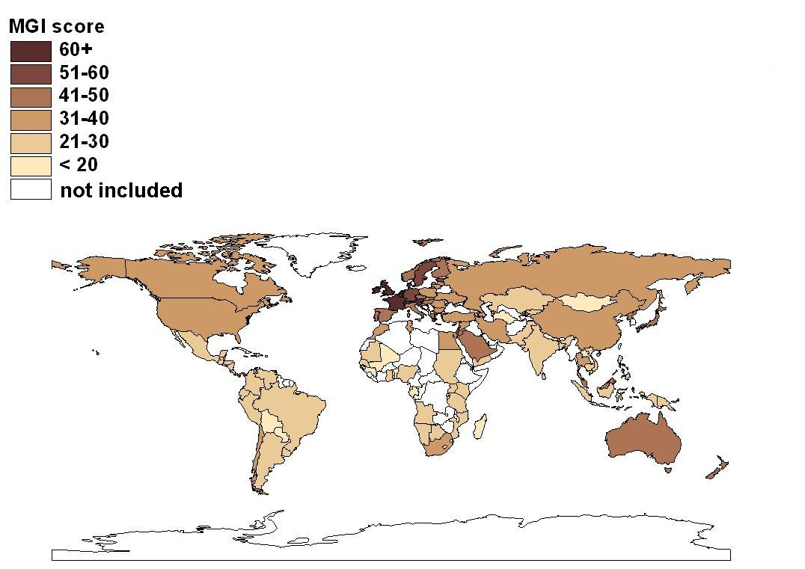
Fig. 1. Map of the MGI, 2008
As for the evolution of globalization, the overall MGI rose continuously, starting from a value of about 25 in 2000 to almost 32 in 2008. The increase is largely driven by technological and political integration. Economic and social-cultural globalization evolved similarly over time, while ecological globalization changed less (or decreased in the case of East and Northern Europe). For most countries, globalization increased.
In some cases, the increases were substantial. The biggest increase was experienced by Ireland (+20.2), followed by the Netherlands (+19.7) and Belgium (+18.5), while globalization decreased most in Turkmenistan (–3.6) and Uruguay (–5.6).
Fig. 2 displays the pattern of the overall globalization index by region.² Globalization has been relatively independent of region, even though the degree of globalization varies considerably. Overall, the index suggests that some countries are systematically more globalized than others. While in the last eight years globalization has been pronounced in all regions, some regions are more globalized than others. In particular, Western European and other industrialised countries display the greatest integration, South Asia and Sub-Saharan Africa are the regions least globalized.
The MGI has been linked with sustainability indices to analyse if more globalized countries are doing better in terms of sustainable development and its dimensions.
The results suggest that the process of globalization may render world development more sustainable (Martens and Raza 2010).
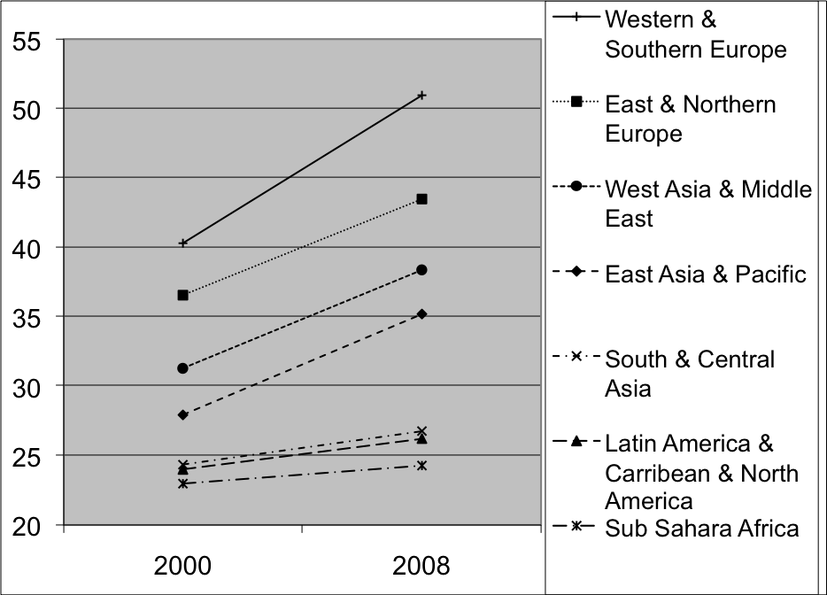
Fig. 2. Development of globalization across regions
The KOF Index: The KOF globalization index was first published in 2002 (Dreher 2006). It covers a large number of countries and has a long time span. The KOF Index also adds neglected dimensions of globalization.
The 2002 KOF Index covers 123 countries and includes 23 variables. The overall index covers the economic, social and political dimensions of globalization. Globalization is conceptualised as the process of creating networks among actors at multi-continental distances, mediated through a variety of flows including people, information and ideas, capital and goods. It is a process that erodes national boundaries, integrates national economies, cultures, technologies and governance, and produces complex relations of mutual interdependence.
More specifically, the three dimensions of globalization are defined as: economic globalization, characterised by the long distance flows of goods, capital and services as well as information and perceptions that accompany market exchanges; political globalization, characterised by the diffusion of government policies; and social globalization, expressed as the spread of ideas, information, images and people.
Economic Globalization: Economic globalization has two dimensions. First, actual economic flows are usually taken to be measures of globalization. Second, the previous literature employs proxies for restrictions on trade and capital. Consequently, two indices are constructed which include individual components suggested as proxies for globalization.
Actual flows: The sub-index on actual economic flows includes data on trade, FDI and portfolio investment. Trade is defined as the sum of a country's exports and imports and portfolio investment is the sum of a country's assets and liabilities; each measure is normalised by GDP. Included are the sum of gross inflows and outflows of FDI (again, normalised by GDP). While these variables are straightforward, income payments to foreign nationals and capital are also included to proxy for the extent to which a country employs foreign people and capital in its production processes.
International trade and investment restrictions: The second sub-index refers to restrictions on trade and capital flows using hidden import barriers, mean tariff rates, taxes on international trade (as a share of current revenue) and an index of capital controls. Given a certain level of trade, a country with higher revenues from tariffs is less globalized. To proxy restrictions on the capital account, an index constructed by Gwartney and Lawson (2002) is employed. Mean tariff rates are obtained from various sources. Gwartney and Lawson allocate a rating of 10 to countries that do not impose any tariffs. As the mean tariff rate increases, countries are assigned lower ratings. The rating declines toward zero as the mean tariff rate approaches 50 % (a threshold not generally exceeded by most countries in their sample). The original source for hidden import barriers is various issues of the World Economic Forum's Global Competitiveness Report, based on the survey question ‘Hidden import barriers – no barriers other than published tariffs and quotas [are used]’.
Social Globalization: The KOF Index classifies social globalization in three categories. The first covers personal contacts, the second includes data on information flows and the third measures cultural proximity.
Personal Contacts: This index is intended to capture the direct interaction among people living in different countries. It includes international telecom traffic (outgoing traffic in minutes per subscriber), the average cost of a call to the United States and the degree of tourism (incoming and outgoing) a country's population is exposed to. Government and workers' transfers received and paid (as a percentage of GDP) measure whether and to what extent countries interact, while the stock of foreign population is included to capture existing interactions with people from other countries.
Information flows: While personal contact data are meant to capture measurable interactions among people from different countries, the sub-index on information flows is meant to measure the potential flow of ideas and images. It includes the number of internet hosts and users, cable television subscribers, number of telephone mainlines, number of radios (all per 1,000 people) and daily newspapers (per 1,000 people). To some extent, all these variables proxy the potential for receiving news from other countries and thus contribute to the global spread of ideas.
Cultural Proximity: Cultural proximity is arguably the dimension of globalization most difficult to grasp. According to Saich (2000: 209), cultural globalization to a large degree refers to the domination of U.S. cultural products. Arguably, the United States is the trend-setter in much of the global socio-cultural realm (Rosendorff 2000: 111). As proxy for cultural proximity, the number of McDonald's restaurants located in a country is included. For many people, the global spread of McDonald's is synonymous with globalization itself.
Political Globalization: To proxy the degree of political globalization, the number of embassies and high commissions in a country, the number of international organisations in which the country is a member and the number of UN peace missions a country participated in are used.
Method of calculation: In constructing the indices of globalization, each variable is transformed to an index with a 0 to 10 scale. Higher values denote more globalization. When higher values of the original variable indicate higher globalization, the formula ((V_{i} – V_{min})/(V_{max} – V_{min})*10) is used for transformation. Conversely, when higher values indicate less globalization, the formula is ((V_{max} – V_{i})/(V_{max} – V_{min})*10).
The weights for the sub-indices are calculated using principal components analysis.
The year 2000 is used as the base year. For this year, the analysis partitions the variance of the variables used. The weights are then determined in a way that maximises the variation of the resulting principal component. Therefore, the index captures the variation as fully as possible. As Gwartney and Lawson (2001: 7) emphasise, this procedure is particularly appropriate when several sub-components measure different aspects of a principal component. The same procedure is applied to the overall index. If possible, the weights determined for the base year are then used to calculate the indices for each single year back to 1970. Where no data are available, the weights are readjusted to correct for this. All yearly indices are averaged over five years to avoid huge fluctuations due to changes in yearly data.
2009 KOF Index of Globalization: An updated version of the original index is presented below. In most cases, the updating simply involves using more recent data. The costs of a telephone call to the United States are no longer included in the index, however. This was done to avoid the criticism of this variable being overly-centred on the United States. The update also excludes the number of telephone mainlines, as nowadays these are not the best measure of international flows of information. Similarly, to enhance the international focus of the index, the number of newspapers sold is replaced by the number of newspapers imported and exported. In addition, a number of proxies for globalization that are not included in the original 2002 index are included: FDI stocks, international letters sent and received, the number of Ikea outlets located in
a country and trade in books and pamphlets. The number of international letters sent and received measure direct interaction among people living in different countries. Imported and exported books (relative to GDP) are used as a measure, as suggested by Kluver and Fu (2004). Traded books are intended to proxy the extent to which beliefs and values move across national borders. The number of Ikea outlets per country is motivated in
a similar fashion to the number of McDonald's restaurants. The political dimension now also includes the number of treaties signed between two or more states since 1945
(as provided in the United Nations Treaties Collection).
The 2009 index introduces a number of methodological improvements over earlier versions. Each of the variables introduced above is transformed to an index on a scale of 1 to 100, where 100 is the maximum value for a specific variable over the period 1970 to 2006 and 1 is the minimum value. Once again, higher values denote greater globalization. The data are transformed according to the percentiles of the original distribution. Compared to the previous method, this has the advantage that a variable's actual weight in the index is not overly affected by its distribution. Consequently, the results are no longer driven by extreme outlying observations and missing values. The weights for calculating the sub-indices are determined using principal components analysis for the entire sample of countries and years. This is a methodological change compared with the construction of the 2002 Index, where the weights were determined using data for
the most recent period. Employing data for the whole period yields better comparability over time. As discussed, one drawback is that the resulting globalization index is affected by the inclusion of additional countries. The analysis again partitions the variance of the variables used in each sub-group and determines the weights in a way that maximises the variation of the resulting principal component. However, compared to the 2002 index, the weights are calculated using all data currently available instead of calculating them for the base year 2000. The same procedure is applied to the sub-indices in order to derive the overall index of globalization.
Data for the 2009 index are calculated on a yearly basis. However, not all data are available for all countries and for all years. In calculating the indices, all variables
are linearly interpolated before applying the weighting procedure. Instead of linear extrapolation, missing values at the border of the sample are substituted by the latest data available. When data are missing over the entire sample period, the weights are readjusted to correct for this. As observations with value 0 do not represent missing data, they enter the index with weight 0. Data for sub-indices and the overall index of globalization are not calculated if they rely on a small range of variables in a specific year and country. Observations for the index are reported as missing if more than 40 % of the underlying data are missing or at least two out of the three sub-indices cannot be calculated. The indices on economic, social and political globalization as well as the overall index are calculated employing the weighted individual data series instead of using the aggregated lower-level globalization indices. This has the advantage that the data enter the higher levels of the index even if the value of a sub-index is not reported due to missing data.
The results: The methodological changes, new variables and data update do not substantially affect the weights of the individual dimensions of globalization. This is
an indication of the robustness of the KOF index vis-à-vis the choice of method and data. Economic and social integration obtain approximately equal weights (38 % and, respectively, 39 % in the 2009 index), while political globalization has a substantially smaller weight in the overall index (23 % in the 2009 index).
According to the 2009 KOF Indices (which refer to data for the year 2006), the world's most globalized country is Belgium with a score of almost 92. This result is driven by high economic and political integration with the rest of the world. On the other hand, Belgium ranks only tenth when it comes to social integration. France has the highest political integration with the rest of the world, followed by Italy, Belgium and Austria. Other countries ranking high on the overall index include Ireland and the Netherlands. While Singapore and Luxembourg are ranked first and second, respectively, in terms of economic globalization, they are ranked considerably lower overall. This is mainly due to their low political integration with the rest of the world. According to the political integration index, the Channel Islands, the Isle of Man and Mayotte are
the countries with the lowest score. Overall, the world's least globalized country is Myanmar with an index of less than 24. The country least integrated in economic terms is Rwanda, while Myanmar has the lowest social globalization score. Fig. 3 shows the more globalized countries in a darker colour. Once again, Western European and North American countries have usually been the most globalized, while countries in Sub-Saharan Africa are the least globalized.
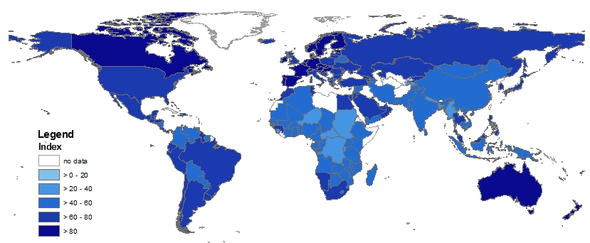
Fig. 3. Map of the KOF Index of Globalization, 2009
The evolution of globalization as measured by the KOF index has been more pronounced in the later decades. The overall index rose continuously, starting from a value of about 37 to more than 60 in 2006. Economic globalization evolved similarly over time, while social and political globalization rose less steadily.
Fig. 4 displays the pattern of the overall globalization index by income. In the last
30 years globalization has been pronounced in all income groups, however, some groups are clearly more globalized than others. As can be seen, high income OECD countries are, on average, the most globalized, while low income countries are the least globalized.
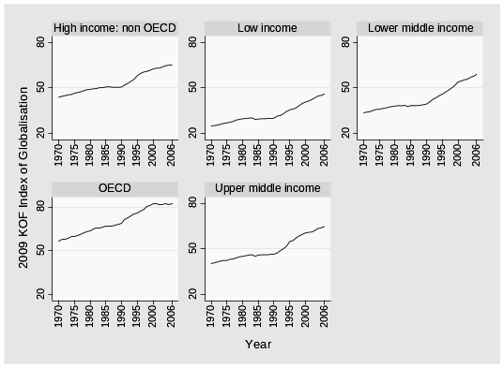

Fig. 4. Development of globalization, by income group
Overall, the index suggests that some countries are systematically more globalized than others. In particular, richer countries seem to be, on average, more globalized than poorer ones. Western industrialised countries are also more globalized than the average country. The average OECD country is far more globalized than the average non-OECD country. Table 1 displays the corresponding data on a yearly basis.
Table 1
Development of globalization, by income group
year | High income: non OECD | OECD | Low income | Lower middle income | Upper middle income
1970 | 44.02 | 56.91 | 25.02 | 33.63 | 40.38
1971 | 44.63 | 57.74 | 25.23 | 34.08 | 40.68
1972 | 44.85 | 58.03 | 25.50 | 34.43 | 41.36
1973 | 45.49 | 58.71 | 26.08 | 35.16 | 41.97
1974 | 45.81 | 59.49 | 26.81 | 35.76 | 42.31
1975 | 46.45 | 59.49 | 26.86 | 36.09 | 42.30
1976 | 47.16 | 60.51 | 27.60 | 36.45 | 43.02
1977 | 47.53 | 61.47 | 27.95 | 36.77 | 43.32
1978 | 48.35 | 62.26 | 28.95 | 37.52 | 44.13
1979 | 48.95 | 63.13 | 29.26 | 37.88 | 44.66
1980 | 49.15 | 63.80 | 29.77 | 38.02 | 45.02
1981 | 49.58 | 65.07 | 29.99 | 38.33 | 45.49
1982 | 49.59 | 65.26 | 30.19 | 38.24 | 45.83
1983 | 50.36 | 65.82 | 30.28 | 38.62 | 46.09
1984 | 50.25 | 65.98 | 29.27 | 37.88 | 45.08
1985 | 50.60 | 66.95 | 29.52 | 38.33 | 45.78
1986 | 50.90 | 67.10 | 29.70 | 38.37 | 46.15
1987 | 50.51 | 67.20 | 29.78 | 38.32 | 45.98
1988 | 50.42 | 67.59 | 29.86 | 38.54 | 45.99
1989 | 50.50 | 68.21 | 30.00 | 39.06 | 46.37
1990 | 50.70 | 68.95 | 30.15 | 39.48 | 46.41
1991 | 52.15 | 71.56 | 31.40 | 40.82 | 47.34
1992 | 52.99 | 72.97 | 31.93 | 42.61 | 48.92
1993 | 54.51 | 73.92 | 32.99 | 43.62 | 50.10
1994 | 55.75 | 75.02 | 34.64 | 44.99 | 51.78
1995 | 58.23 | 76.08 | 35.58 | 46.00 | 54.89
1996 | 59.53 | 77.26 | 35.98 | 47.25 | 55.36
1997 | 60.60 | 78.76 | 36.87 | 48.47 | 57.10
1998 | 61.02 | 80.11 | 38.33 | 50.08 | 58.56
1999 | 61.82 | 80.92 | 39.88 | 51.57 | 59.61
2000 | 62.45 | 82.48 | 40.85 | 53.97 | 60.51
2001 | 63.19 | 82.26 | 41.39 | 54.70 | 60.92
2002 | 63.11 | 81.80 | 42.46 | 55.36 | 61.10
2003 | 63.88 | 81.90 | 43.61 | 55.77 | 62.12
2004 | 64.78 | 82.21 | 44.71 | 57.21 | 63.53
2005 | 65.13 | 82.13 | 45.21 | 57.88 | 63.83
2006 | 65.29 | 82.61 | 46.07 | 58.99 | 64.61
The relevance of globalization indices
Any assessment of the relevance of the existing indices must consider the different definitions of globalization used. To facilitate comparison, the key globalization indices appear side-by-side in Table 2 from Dreher et al. (2008). As the Table indicates, the WMRC's G-index includes primarily economic factors; the ATK/FP index does so as well by an a priori weighting scheme that heavily favours economic factors. Unfortunately, with these indices, globalization is indistinguishable from internationalisation and liberalisation. This is not to say that data collected with the country as the relevant unit of analysis have no value. However, the assumptions made and the limitations of using these data for the measurement of globalization should be clearly stated – something which both indices fail to do.
Many authors examining the measurement of globalization concur with the view that ‘culture is the most visible manifestation of globalization’ (Kluver and Fu 2004). However, despite culture's importance to globalization, no index provides an adequate solution to its measurement. Martens and Zywietz (2006) side-step the issue by stating that the concepts of culture and communication are inherently intractable and difficult to quantify. Kluver and Fu (2004) construct a Cultural Globalization Index. They argue that it is impossible to directly measure the diffusion of cultural values and ideas across national borders. So they use cultural proxies: ‘the conduits by which ideas, beliefs and values are transmitted’. Although cultural globalization is adequately conceptualised, the available empirical measures once again fall short. The authors use the imports and exports of books and brochures, newspapers and periodicals because all other possible indicators lack systematic data sources. Countries at the top of the cultural rankings are generally affluent and English-speaking. One danger of the failure to measure cultural factors is the risk of dismissing the importance of culture. In our opinion, we should be asking why it is that we know so little about what should be discussed. Clearly, it would
be useful if the publication of the indices include some discussion of cultural globalization.
The KOF Index includes some cultural indicators in the ‘social globalization’ sub-index. The indicators that have been included are the number of McDonald's restaurants per capita, the number of Ikea outlets per capita and the number of books traded (as
a percentage of GDP). This sub-index can indicate the extent to which cultural globalization matters for economic and social phenomena.
Rather inevitably, the ‘top 10’ countries in the leading indices are usually lauded. An exception to this is the MGI because it has integrated two variables – the environment and organised violence – that change the meaning of the overall outcome. Notwithstanding, it is useful to consider what it means to be at the top, middle or bottom of a globalization ranking.
The inclusion of new indicators, that cannot be considered ‘positive’, changes the discussion about a country's ranking according to an index. For example, if the Netherlands ranks highly in every index of globalization is that something to be applauded? It does imply, of course, that this country has many linkages with the world outside its national borders. According to the MGI, the Netherlands, e.g., ranks fourth in both the overall rank and in the environmental rank. It is placed fortieth in the ‘organised violence’ rank. This implies that the Netherlands has a large ecological footprint and relatively intense trade in conventional arms. It also scores well in other areas such as capital flows, trade, and telephone traffic.

Table 2
Existing globalization indices and criteria for good composite indices
Category | Sub-category | WMRC (Randolph 2001) | ATK  (A.T. Kearney / Foreign Policy 2007) | MGI  (Martens and Raza 2009) | KOF  (Dreher 2006)
Relevance | Definition of  globalization used | Very narrow, only economic | Medium | Very broad | Very broad
Relevance | Differentiation of globalization from internationalisation | No differentiation | No differentiation | No differentiation | No differentiation
Relevance | Type of change measured | Extensity,  intensity | Extensity,  intensity | Extensity,  intensity | Extensity,  intensity
Relevance | Geographical  adjustment | No | No | Yes | No
Relevance | Coverage | 185 countries | 72 countries | 117 countries | 122 countries
Relevance | Correlation with economic development | Low | High | High | High
Robustness | Sensitivity to  extreme values | Method not published | High  (cross-panel normalisation) | Low | Low
Robustness | Sensitivity to year-to-year data variations | Very high (exclusive use of strongly fluctuating indicators) | High (some indicators with lower fluctuation) | Low (indicators with high fluctuations are averaged) | High (some indicators with lower fluctuation)
Robustness | Method for determining weights | A priori, with normative  discussion | A priori, with normative  discussion | Equal weights | Principal  components analysis
Robustness | Weight distortion | Method not published | Some distortion | No distortion | Some distortion
Added value | Correlation with own components | High | Low | Some | Some
Added value | Correlation among components | Not published | Not published | Moderate | Moderate
Transparency | Transparency of methodology | Moderate | High | High | High
Transparency | Data published | Partially | Yes | Yes | Yes
Note: Relevance is concerned with whether the index is really measuring globalization (instead of, for example, internationalisation).
Robustness is concerned with the reliability of the measurement under adverse circumstances; how sensitive to extreme values and year-to-year variations is the index.
To add value, the index should help us understand globalization better than we could by just looking at its components.
Transparency helps others to judge how valuable the index is for their purposes; whether the index, based on readily available data and literature, is reproducible; and whether the underlying assumptions are made explicit.

A large ecological footprint implies a large ecological deficit, which needs to be compensated for by ‘space’ outside the country's territory. In this way, the growth in transport is connected to the exploitation of natural resources (Martens and Rotmans 2005), for instance. So while this helps to elevate the Netherlands to the top ranking of this index, it also raises questions about the relationship between globalization, economic growth and the environment. Unlike the other variables in the index, this environmental factor appears to be a consequence of globalization rather than a driving force. However, as the globalizing processes intensify over time, the ‘indirect impacts of human-induced disruption of global biogeochemical cycles and global climate change start to become apparent’ (Martens and Rotmans 2005).
If consumerism and global economic processes have polluting side-effects, it needs to be asked which direction these dynamics need to take for a sustainable future. With the environment integrated into the index, the long-existing ‘environment versus growth’ tension can be exposed, for which the term ‘sustainable development’ is often used (Ibid.). The demands for environmental protection and economic development are said to be competing. Some claim an eternal competition, while others emphasise a possible win-win situation (Van Kasteren 2002).
Since globalization implies inter-connectedness and complexity, its various aspects need to be considered. The environment cannot be treated separately from everything else that is global. Moreover, an integrated index of globalization can stimulate a new framework of analysis for the market system, recognising the need to integrate ecological costs in trade and consumption (Ibid.).
The inclusion of trade in conventional arms in the MGI also serves to highlight such trade. Do global mechanisms promote production and open gateways to trade in arms? Clearly the issue is complicated as it involves economic costs and benefits, political risks, social tensions and ethical values. While such issues are far from being resolved, the way the addition of such indicators influence the relevance of a measurement of globalization needs to be emphasised.
An important criticism of many indices, such as the MGI and the ATK/FP, is that, strictly speaking, they measure internationalisation and regionalisation rather than globalization. For example, the MGI's ‘top 10’ is composed of European nations which reinforces an impression of increased regionalisation.
All indices have component indicators and data that fail to distinguish between globalization and internationalisation (or liberalisation) to some degree. They also fail to include supra-territorial indicators. For example, while the number of embassies a country has abroad may mirror increasing co-operation and even integration, these data have a territorial base.
Even leaving the problem of ‘methodological territorialism’ to one side, the epistemology of globalization makes one doubt the possibility of measuring it. Globalization occurs at levels that make measurement difficult, e.g., trans-border environmental issues, cultural transformations and a so-called ‘global consciousness’. Those features of globalization are obviously interesting and new to us which, in turn, is one reason why they are so difficult to capture.
The ‘qualitative’ side of research generally focuses on multi-dimensional analyses of globalization by constructing frameworks and concepts. This is useful, but does not provide a solid scientific footing with which to evaluate the over-arching phenomenon of globalization. On the other hand, the ‘quantitative’ side of research, with its focus on data, statistics and indices, runs the risk of over-simplification.
As we have argued, to confront new questions on the essential nature of globalization requires an interdisciplinary approach. Sociologists, critics of science and techno-logy, and economists and others need to work on dimensions of the same questions.
A composite index of globalization can reconcile multi-facetted approaches. An index needs to be conceptually analysed and formulated and this leads to the issue of measurement. Instead of questioning the adequacy of measuring globalization, a certain degree of optimism is vital for making the improvements in measurement, which are necessary to advance an understanding of the globalization phenomenon.
Can we really measure globalization?
As we have discussed, the measurement of globalization should try to include the essential features of contemporary globalization. However, when we think about a possible methodology, we face a greater problem which applies to existing indices of globalization – classic or modified. Even if we could manage to find suitable supra-territorial indicators and indicators that portray cultural and other complex global features, how could such measures fit in with the rest of the existing measures, since the end result is still country-based? This dead end in the measurement of globalization is well described by Caselli (2006).
Given this situation, it is paradoxical and misconceived to insist on studying reality in general, and globalization all the more so, with instruments that take the nation-state as their unit of analysis. It is at most possible to study internationalization in this way, but not globalization. In other words, the globalization measures currently available are vitiated by what has been variously called methodological nationalism (Beck 2004), embedded statism (Sassen 2000), or methodological territorialism (Scholte 2000) – a perspective which distorts the essence of globalization precisely when its study begins, and which yields data that ‘in the best of cases are irrelevant and in the worse misleading, or even false’ (Beck-Gernsheim 2004, as cited by Caselli 2006: 20).
Those features of globalization that are essentially new to us are those which are most difficult to measure by means of data collection and index construction. If the current epistemological basis of measuring globalization is so theoretically unsatisfactory and empirically problematic, we need to question why we should pursue the construction and maintenance of globalization indices which may be too narrow to understand globalization.
A possible solution to these issues is to assess globalization by thematic order. For example, we can measure how globalized our worldwide politics are. Bauman's (1998) idea of a new class division between the globalized upper classes and the localised lower classes may also be promising. This leads to the proposal to measure globalization along individual lines, or along the lines of demographic groups. We could also measure the amount of supra-territorial institutions, both formal and informal. However, once again the problem rises of fitting in these trans-border results with a country-based index.
Is the measurement of globalization a dead end?
The measurement of globalization contains so many pitfalls that it is tempting to retreat to purely qualitative analyses. However, this would burn the fragile bridge between the qualitative and quantitative analysis of globalization. The qualitative side of research generally focuses on a multi-dimensional analysis of globalization, by constructing frameworks and concepts through which to understand it. This provides some tools, but not a solid scientific footing which can fully comprehend the entire phenomenon of globalization. It is simply theory without measurement; running the risk of unsubstantiated and unscientific speculation. The quantitative side of research assesses the state of play about globalization using data, statistics and indices. While this approach runs the risk of oversimplification and may take on an overly enthusiastic air of truth, its transparent use of the available data is its ultimate salvation.
There is a possibility to bridge the gap between theory and measurement. Composite indices of globalization can provide the meeting place or forum for both approaches. Composite indices need matters to be conceptually analysed and continually reformulated. Instead of rejecting the possibility of measuring globalization adequately, the measurement of globalization needs to be, and can be, improved upon. A new mode of thinking, such as supra-territoriality, can trigger new ideas on both the analysis and quantification of globalization.
The confrontation with new questions on the essential nature of globalization needs to be an interdisciplinary co-operation. It would be fruitful for academics from the quantitative side (modelling, conclusive statements, certainty and proofs) and qualitative side (analysis, discussion, conceptual revision, background and textual form) to sit together and work on the challenges. Despite the different methodologies, choice of variables and weights, and so on, they need to recognise that in order to study globalization concisely, new co-operative frameworks are needed.
Sociologists, critics of science and technology and economists need to work on dimensions of the same questions. For instance, an interdisciplinary review of science and technology analyses different lines of approach and formulates conceptual criticism to technical problems. It provides an overview of possible solutions and elaborates upon quantitative issues. Rather than handing over responsibility from discipline to discipline, what is required is tackling collectively the measurement of globalization. In this case, the whole is greater than the sum of the individual parts. The study and ultimate understanding of globalization requires academics and professionals alike to step outside their own narrow disciplinary boundaries.
ACKNOWLEDGEMENT
We thank Mohsin Raza for his help in analyzing the MGI.
notes
* The authors contributed equal shares to this article; the order of names is chosen alphabetically.
1 Arguably, the best-known indices of globalization are the ATKearney/Foreign Policy globalization index, which we abbreviate as ‘ATK/FP’; the Maastricht Globalization Index, the ‘MGI’;
the World Market Research Centre G-index; and the KOF index of globalization produced by the KOF Swiss Economic Institute. The latter index is extensively used in academic analysis. Dreher et al. (2008: 75–78) list 36 journal articles published between 2003 and 2008 that employ the KOF index in statistical analyses. Some of the material in this section is drawn from Dreher et al. (2008); readers requiring greater detail are referred there. More information on the MGI, including its related publications, can be found on www.globalizationindex.info; more details on the KOF Index of Globalization are provided at http://globalization.kof.ethz.ch/
2 The regions are based on http://www.un.org/depts/dhl/maplib/worldregions.htm

References
A. T. Kearney / Foreign Policy
2002. Globalization Index. Washington, D.C.: Carnegie Endowment for International Peace.
2007. Globalization Index. Washington, D.C.: Carnegie Endowment for International Peace.
Bauman, Z.
1998. Globalization: The Human Consequences. USA: Columbia University Press.
Beck, U.
2004. Der kosmopolitische Blick oder: Krieg ist Frieden. Frankfurt am Main: Suhrkamp Verlag.
Beck-Gernsheim, E.
2004. Wir und die Anderen. Frankfurt am Main: Suhrkamp Verlag.
Caselli, M.
2006. On the Nature of Globalization and its Measurement. UNU-CRIS Occasional Papers. Milano: Università Cattolica del Sacro Cuore. URL: http://www.cris.unu.edu/admin/ documents/20060220113557.O-2006-3.pdf
Dreher, A.
2006. Does Globalization Affect Growth? Evidence from a New Index of Globalization. Applied Economics 38(10): 1091–1110.
Dreher, A., Gaston, N., et al.
2008. Measuring Globalization: Gauging its Consequences. New York: Springer.
Gwartney, J., and Lawson, R.
2001, 2002. Economic Freedom of the World: Annual Report. URL: http://www. freetheworld.org
Held, D., McGrew, A. G. et al.
1999. Global Transformations: Politics, Economics and Culture. Stanford: Stanford University Press.
Kluver, R., and Fu, W.
2004. The Cultural Globalization Index. Foreign Policy online Web Exclusive. URL: http://www.foreignpolicy.com/story/cms.php?story_ id=2494
Lockwood, B.
2004. How Robust is the Kearney/Foreign Policy Globalization Index? The World Economy 27: 507–524.
Martens, P., and Raza, M.
2009. Globalization in the 21st Century: Measuring Regional Changes in Multiple Domains. The Integrated Assessment Journal 9(1): 1–18.
2010. Is Globalization sustainable? Sustainability 2: 280–293.
Martens, P., and Rotmans, J.
2005. Transitions in a Globalizing World. Futures 37: 1133–1144.
Martens, P., and Zywietz, D.
2006. Rethinking Globalization: A Modified Globalization Index. Journal of International Development 18: 331–350.
Noorbakhsh, F.
1998a. A Modified Human Development Index. World Development 26(3): 517–528.
1998b. The Human Development Index: Some Technological Issues and Alternative Indices. Journal of International Development 10(5): 589–605.
Pritchett, L.
1996. Measuring Outward Orientation in LDCs: Can it be Done? Journal of Development Economics 49(2): 307–335.
Randolph, J.
2001. G-Index: Globalization Measured. Retrieved 03.10.2002. URL: http://www. wmrc.com/
Rennen, W., and Martens, P.
2003. The Globalization Timeline. Integrated Assessment 4(3): 137–144.
Rosendorf, N. M.
2000. Social and Cultural Globalization: Concepts, History and America's Role. In Nye, J. S., and Donahue, J. D. (eds.), Governance in a Globalizing World (pp. 109–134). Washington, D.C.: Brookings Institution Press.
Rosendorff, B. P., and Vreeland, J. R.
2006. Democracy and Data Dissemination: The Effect of Political Regime on Transparency. Memphis, TN: Mimeo.
Saich, T.
2000. Globalization, Governance, and the Authoritarian State: China. In Nye, J. S., and Donahue, J. D. (eds.), Governance in a Globalizing World (pp. 208–228). Washington, D.C.: Brookings Institution Press.
Sassen, S.
2000. New Frontiers Facing Urban Sociology at the Millennium. British Journal of Sociology 51: 1.
Scholte, J. A.
2000. Globalization – a Critical Introduction. Hampshire; New York: Palgrave.
United Nations Development Programme (UNDP)
2002. Human Development Report 2002. New York: Oxford University Press.
Van Kasteren, J.
2002. Duurzame Technologie. In Dutch. Amsterdam: Uitgeverij Natuur & Techniek.

